

המחלקה להנדסת חשמל ואלקטרוניקה

מערכות לומדות ולמידה עמוקה (31245)

Lab 7 report

פרנסיס עבוד

Prepared for: Dr. Amer Adler

Date: 24/05/2025

In this lab we will implement a CNN for classifying 10 objects classes from CIFAR10 dataset, each image in the datasets is 32 X 32 pixels in RGB:
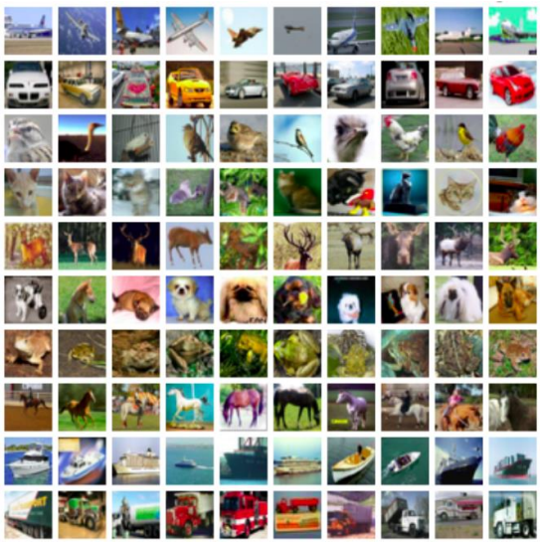

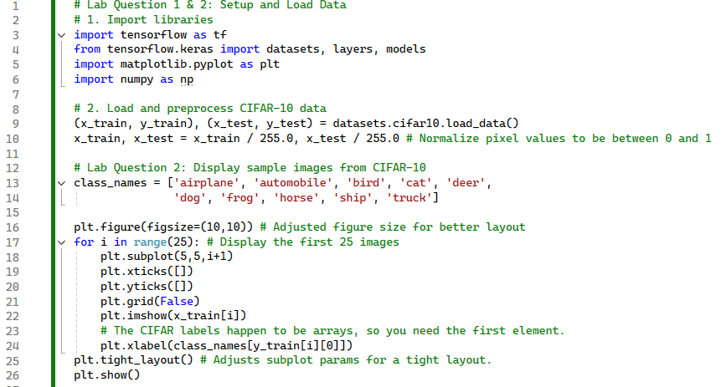
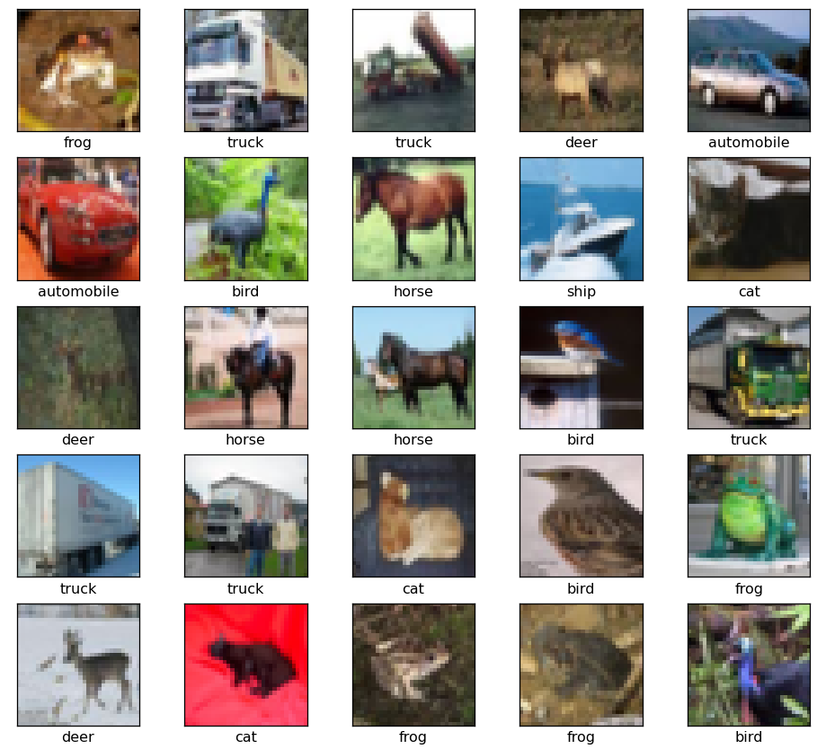
Ex.3:

The network model is given by:
model = models.Sequential()
model.add(layers.Conv2D(32, (3, 3), activation='relu', input_shape=(32, 32, 3)))
model.add(layers.MaxPooling2D((2, 2)))
model.add(layers.Conv2D(64, (3, 3), activation='relu')) model.add(layers.MaxPooling2D((2, 2)))
model.add(layers.Conv2D(64, (3, 3), activation='relu'))
model.add(layers.Flatten())
model.add(layers.Dense(64, activation='relu'))
model.add(layers.Dense(10)
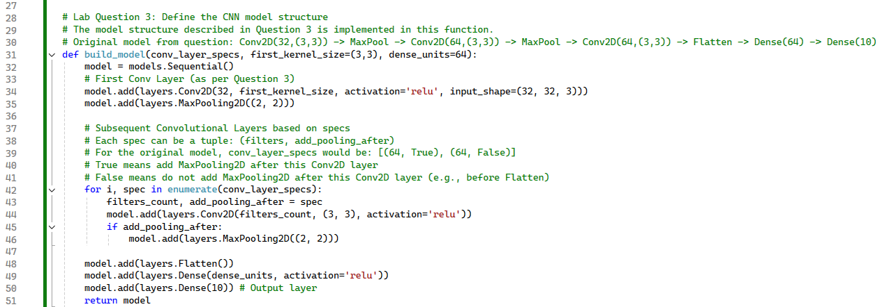
Code:

Ex.4:
Train the given network, using stochastic gradient descent with 20 epochs:
- Replace the optimizer in the method “compile()” to ‘sgd’.

- In the method “fit()” Change the validation set to be 2.5% of the training data, using “validation_split = 0.025”, and set the number of epochs to 20.

- Plot a graph of the training & validation accuracy vs. number of epochs.

- Report the testing set accuracy.

Code:

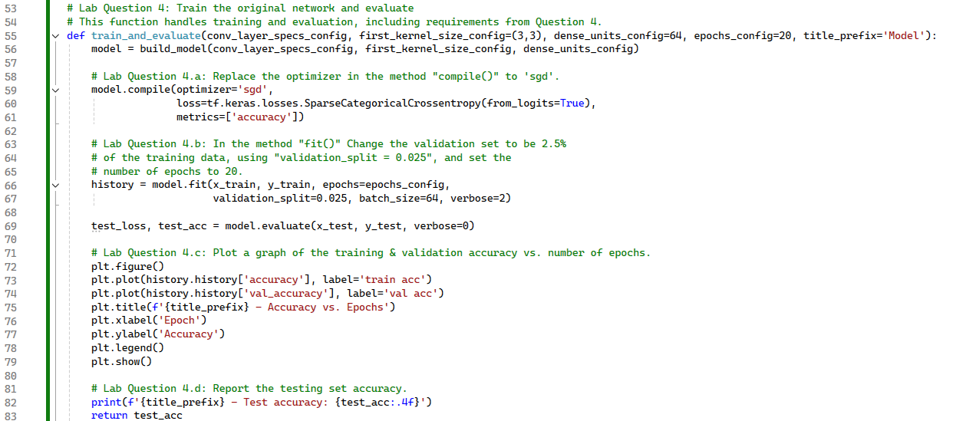
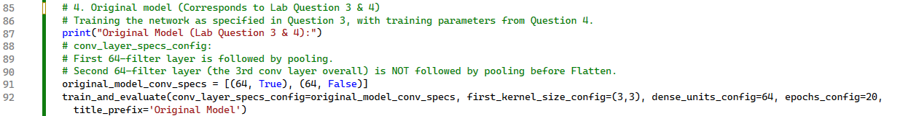
Output:

Test accuracy= 0.6653

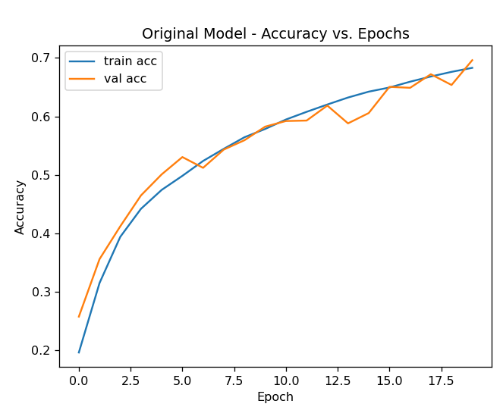

Ex.5:
Evaluate the impact on CIFAR-10 classification accuracy (measured on the testing set) of the following modifications to the network (you must re-define the CNN for each modification, otherwise, learned weights are kept). For each modification Plot a graph of the training & validation accuracy vs. number of epochs.
a. Removal of the second convolutional layer
b. Removal of the third convolutional layer
c. Removal of the second and third convolutional layer
d. Increase and decrease the kernel size of the first CNN layer.
e. Increase and decrease the kernel size of the first convolutional layer.
f. Increase and decrease of the number of perceptrons in the Dense layer (currently 64).

A.Code:

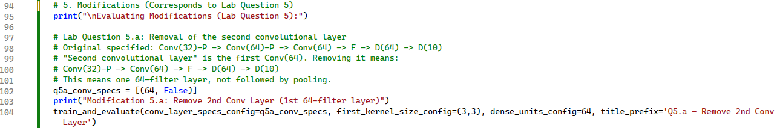
A.Output:

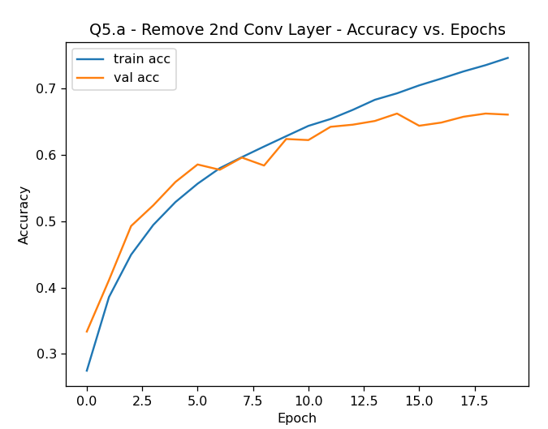
Test accuracy = 0.6683
B.Code:

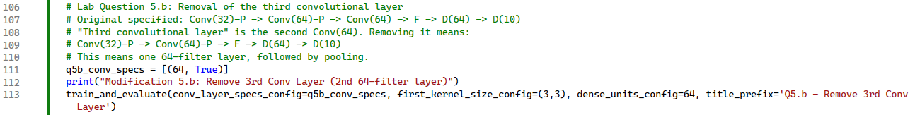
B.Output:

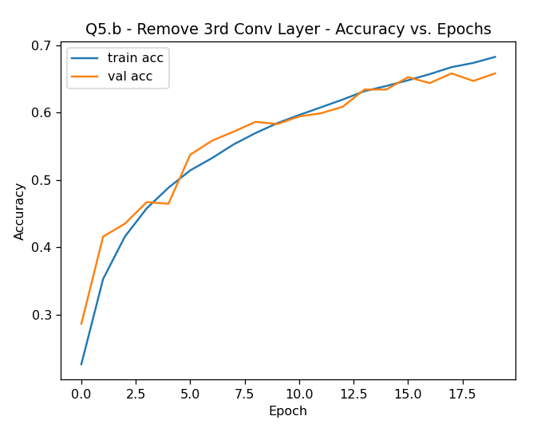
C.Code:

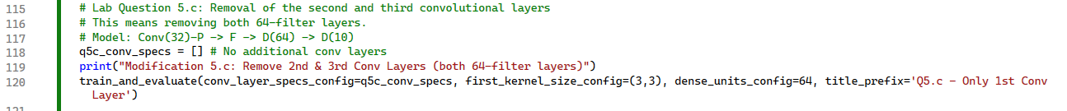

C.Output:

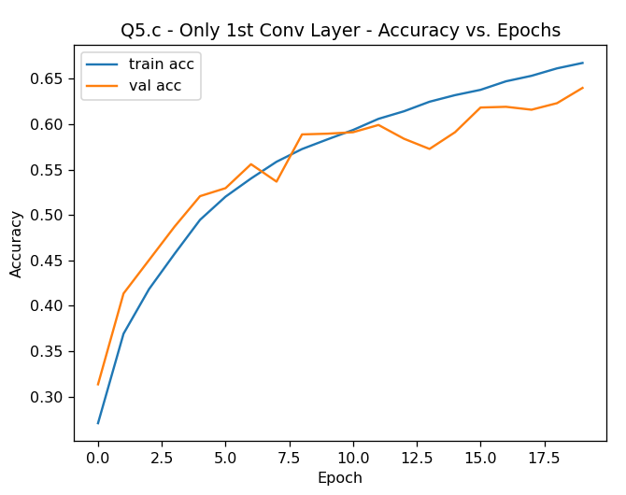
D. and E. Code:

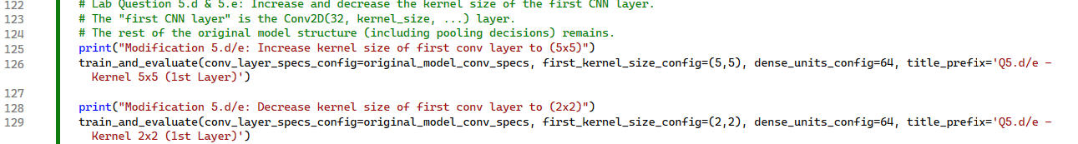

D.Output:

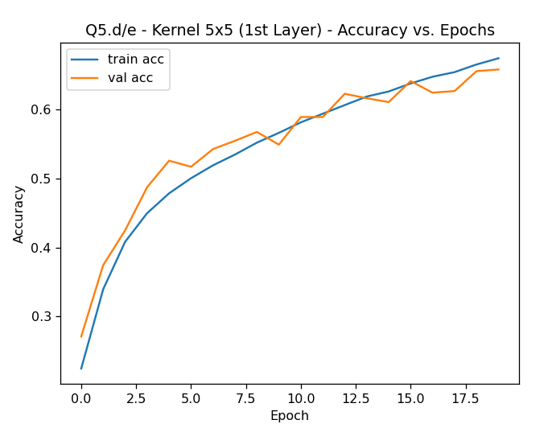

E.Output:

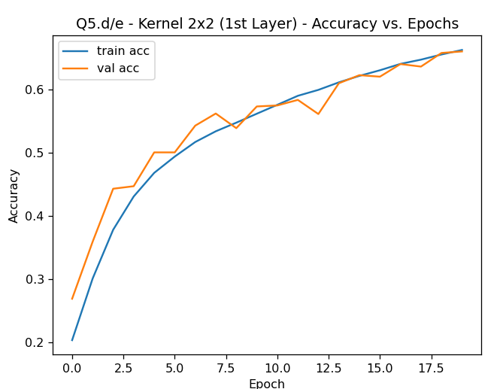
F.Code:

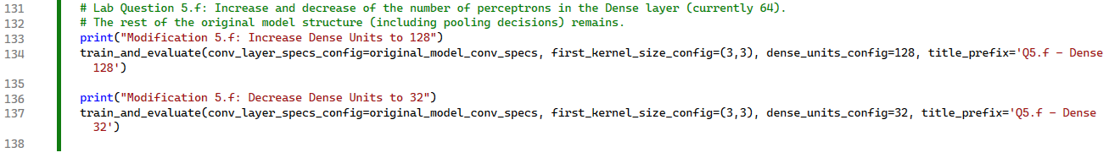
F.Output Increase:
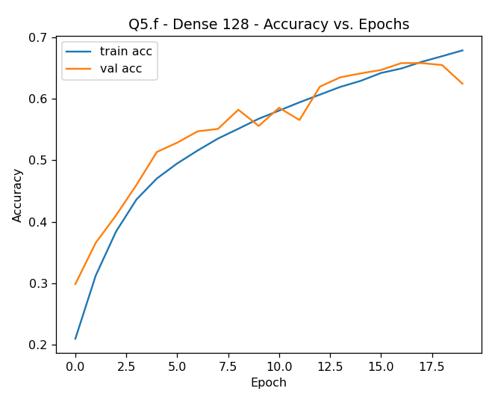
F.Output Decrease:

