**Install plumed patched GROMACS (Ubuntu)**

1. Download plumed (v2.5.4):

<https://www.plumed.org//download.html>

1. Unzip the .tgz file to the desired location
2. Run:

./configure --prefix=/usr/local

Or

./configure --disable-mpi (if mpi is not used, but gromacs has to be complied without mpi)

make -j 4

make install

1. Type:

plumed

If installed successfully, you get:

Nothing to do. Use 'plumed help' for help

**Install GROMACS patched with plumed (Ubuntu):**

1. Download latest plumed supported GROMACS (GROMACS 2019):

<http://manual.gromacs.org/documentation/2019/download.html>

1. Unzip the .tgz file to the desired location
2. Install with plumed patch:

cd gromacs-2019

mkdir build

plumed patch –p (plumed has to be correctly installed on the system first!)

cd build

cmake .. -DGMX_BUILD_OWN_FFTW=ON -DREGRESSIONTEST_DOWNLOAD=ON (add “-DGMX_MPI=off “ if mpi is not used, add “- -DGMX_GPU=on” if using nvcc)

make

make check

sudo make install

source /usr/local/gromacs/bin/GMXRC

1. Type:

gmx

If installed successfully, you get:

:-) GROMACS - gmx, 2019 (-:

…. followed by a bunch of descriptions and a GROMACS reminds you: “Some famous quotes” ending

To activate plumed in gromacs, use the –plumed flag followed by the filename of the plumed.dat file

**Flowchart**

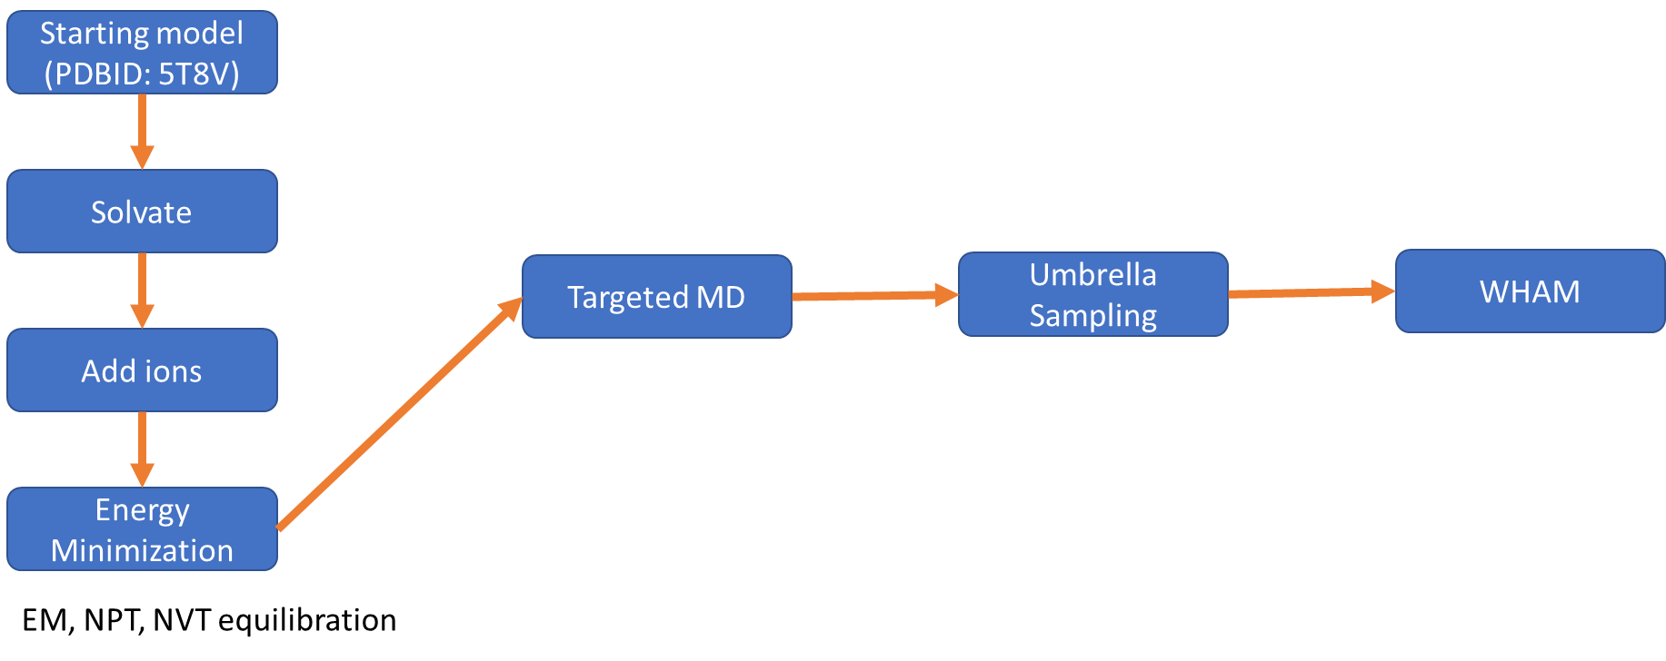

**Set up PDB files for simulation (Mis4 models: 5t8v and gripping)**

1. Check the PDB files have the same atom numbers
2. gmx pdb2gmx -f 5t8v.pdb -o 5t8v.gro -p topol.top -ignh (ignore the original hydrogens, if any, and us the added hydrogen form the selected force field)
3. Choose force field AMBER99SB-ILDN protein, nucleic AMBER94, and spc water
4. You'll get the files: 5t8v.gro, topol.top and posure.itp
5. Run the same protocol for gripping model gmx (add hydrogens, and export to PDB file format)
6. Add box:

gmx editconf -f 5t8v.gro -o 5t8v_newbox.gro -c -d 1.0 -bt cubic

1. Add solvents:

gmx solvate -cp 5t8v_newbox.gro -cs spc216.gro -o 5t8v_solv.gro -p topol.top

1. Add ions:

gmx genion -s ions.tpr -o 5t8v_solv_ions.gro -p topol.top -pname NA -nname CL -neutral

1. Run Energy Minimization:

gmx grompp -f minim.mdp -c 5t8v_newbox.gro -p topol.top -o em.tpr (might get a warning about net charge, if so, use –maxwarn1 to flag off the warning)

gmx mdrun -v -deffnm em (add -nt: to specify number of CPUs)

1. Run NVT Equilibration

gmx grompp -f nvt.mdp -c em.gro -r em.gro -p topol.top -o nvt.tpr

gmx mdrun -deffnm nvt

1. Run NPT Equilibration

gmx grompp -f npt.mdp -c nvt.gro -r nvt.gro -t nvt.cpt -p topol.top -o npt.tpr

gmx mdrun -deffnm npt

1. Align the gripping structure with the final structure (em.gro), save as gripping_align.pdb
2. Check the gripping_align.pdb. occupancy and beta factor column (last two column), if set to 0.00, then the atoms would not be included for RMSD calculation or other steps in plumed), I set them to 1.00 by:

sed -i 's/ 0.00 0.00/ 1.00 1.00/g' gripping_align.pdb

**Run targeted molecular dynamics using plumed**

1. Setup a plumed.dat input file, I used the whole molecule for RMSD alignment, and setup a simulation to increase force constant from 0 to 100 steps, then maintain the force constant throughout the process where RMSD gets decreased to the target, and lowers the force constant to zero in the final 100 steps:

UNITS LENGTH=A TIME=ps ENERGY=kcal/mol

WHOLEMOLECULES ENTITY0=1-21543

RMSD REFERENCE=gripping.pdb TYPE=OPTIMAL LABEL=rmsd

# the movingrestraint

restraint: ...

MOVINGRESTRAINT

ARG=rmsd

AT0=11.9 STEP0=0 KAPPA0=0

AT1=11.9 STEP1=100 KAPPA1=300

AT2=0.0 STEP2=1999900 KAPPA2=300

AT3=0.0 STEP3=2000000 KAPPA3=0

...

PRINT ARG=* FILE=COLVAR STRIDE=1000

PRINT ARG=restraint.* FILE=restraint.dat STRIDE=1000

1. Run md simulation with gromacs and plumed:

gmx grompp -f md.mdp -c em.gro -p topol.top -o md.tpr

gmx mdrun -deffnm md –plumed plumed.dat

1. Analyze the output with vmd (em.gro, md.xtc, gripping_align.pdb):
2. Plot RMSD (with gripping_align.pdb):

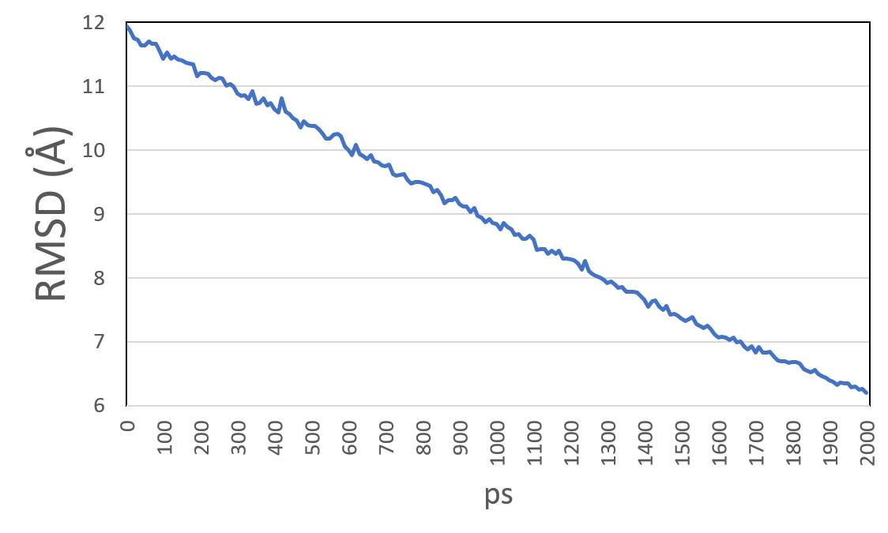

1. Extract the window structures from md.xtc (Save coordinates every 4 frames (total 51 poses):

trjconv -s md.tpr -f md.xtc -skip 4 -o conf.gro -sep

**Umbrella Sampling preparation**

1. The output files contain filenames conf0.gro, conf1.gro.....to conf50.gro
2. Prepare the plumed files for umbrella sampling (make_plumed.sh)

#!/bin/sh/

a=0

for AT in All the CV

do

cat >plumed$AT.dat << EOF

RESTART (add this line for continue job)

UNITS LENGTH=A TIME=ps ENERGY=kcal/mol

WHOLEMOLECULES ENTITY0=1-21543

RMSD REFERENCE=../gripping.pdb TYPE=OPTIMAL LABEL=rmsd

# Impose an umbrella potential on CV

# with a spring constant of 10 kcal/mol

# at fixed RMSD

restraint: RESTRAINT ARG=rmsd KAPPA=10.0 AT=$AT

# monitor RMSD and the bias potential

PRINT STRIDE=1000 ARG=rmsd,restraint.bias FILE=COLVAR$a

EOF

mv plumed$AT.dat plumed$a.dat

let a=a+1

done

1. Do energy minimization on the structure files (em.sh)

cd $SLURM_ARRAY_TASK_ID

echo "Starting minimization for lambda = $SLURM_ARRAY_TASK_ID..."

gmx grompp -f minim.mdp -c ../conf$SLURM_ARRAY_TASK_ID.gro -p ../topol.top -o em$SLURM_ARRAY_TASK_ID.tpr

mpirun gmx_mpi mdrun -deffnm em$SLURM_ARRAY_TASK_ID

cd ../

(slurm script, emrun.sh)

#!/bin/bash

#SBATCH --job-name=colvar

#SBATCH --time=3-00:00:00

#SBATCH --array=0-50

#SBATCH --ntasks=4

#SBATCH --partition=cpu

module load GROMACS

export CORES=$SLURM_NTASKS

./em.sh $SLURM_ARRAY_TASK_ID

1. Do MD simulation (2 ns) on the structures using the created plumed files (md.sh)

cd $SLURM_ARRAY_TASK_ID

echo "Starting minimization for lambda = $SLURM_ARRAY_TASK_ID..."

gmx grompp -f ../md.mdp -c em$SLURM_ARRAY_TASK_ID.gro -t em$SLURM_ARRAY_TASK_ID.cpt -p ../topol.top -o md$SLURM_ARRAY_TASK_ID.tpr

mpirun gmx_mpi mdrun -v -deffnm md$SLURM_ARRAY_TASK_ID -cpi md$SLURM_ARRAY_TASK_ID.cpt (add this line for continue job) -plumed ../plumed$SLURM_ARRAY_TASK_ID.dat

cd ../

(slurm script, mdrun.sh)

#!/bin/bash

#SBATCH --job-name=colvar

#SBATCH --time=3-00:00:00

#SBATCH --array=0-50

#SBATCH --ntasks=4

#SBATCH --partition=cpu

module load GROMACS

export CORES=$SLURM_NTASKS

./md.sh $SLURM_ARRAY_TASK_ID

**WHAM Umbrella Sampling simulation**

1. collect all the frames:

gmx trjcat -f traj*.xtc -cat -o concatenated.xtc

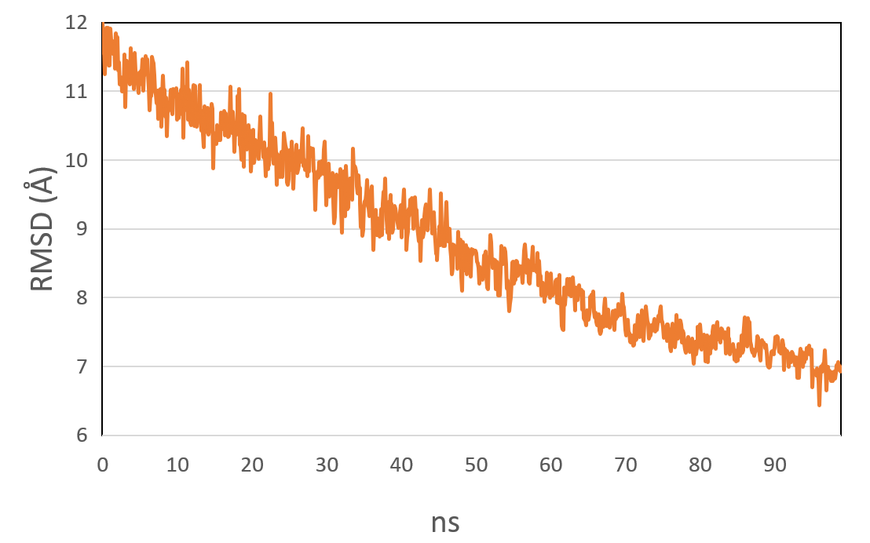

1. compute all bias potential on the entire trajectory (make_plumed_umbrella.sh)

#!/bin/sh/

a=0

for AT in All the CV

do

cat >plumed$AT.dat << EOF

UNITS LENGTH=A TIME=ps ENERGY=kcal/mol

WHOLEMOLECULES ENTITY0=1-21543

RMSD REFERENCE=../gripping.pdb TYPE=OPTIMAL LABEL=rmsd

# Impose an umbrella potential on CV

# with a spring constant of 10 kcal/mol

# at fixed RMSD

restraint: RESTRAINT ARG=rmsd KAPPA=10.0 AT=$AT

# monitor RMSD and the bias potential

PRINT STRIDE=10 ARG=rmsd,restraint.bias FILE=ALLCOLVAR$a

EOF

mv plumed$AT.dat plumed$a.dat

let a=a+1

done

1. Calculate all values for employed biases (wham.cpp, downloaded online) (wham.sh, downloaded online, modified as follow):

# count how many simulations have been done

nsym=$(echo "$@" | wc -w)

# feed the wham executable with bias, in kbT units, depends on the unit of your bias (kcal/mol, in this case)

paste "$@" | grep -v \# | awk '{for(i=1;i<=NF/3;i++) printf($(i*3)/0.593" ");printf("\n");}' | ./wham.x -n $nsym > weights

# this is dumping time, phi, and psi on another file

cat "$1" | grep -v \# | awk '{print $1,$2}' > first

# the two files are pasted, producing a file with 3 columns

# time, rmsd, and weight. notice that the latter is written as kT*log(w)

paste first weights | awk '{print $1,$2,0.593*log($3)}'

use the command:

g++ -O3 wham.cpp -o wham.x

./wham.sh ALLCOLVAR* > colvar

1. Plot *k*BTlog*w* (*w* = bias potential) as a function of RMSD:

