The MSTPump: Open source syringe pump

Xavier Cano-Ferrer, George Konstantinou & Albane Imbert

The Making STP, The Francis Crick Institute

One of the most common devices used in microfluidics flow rate controlled experiments are the syringe pumps. These types of pumps are able to control the fluid flow rate by controlling accurately a stepper motor attached to a lead screw which transfers the rotational movement of the motor shaft into a linear translation of a platform that slides across low friction element rail or slide bar. In this article we present a teensy 3.2 development board based robust and precise syringe pump that can be build using digital manufacturing techniques such as laser cutting and 3D printing.

**Introduction**

Over the last decade, several research labs, individual researchers or even makers have developed rapid manufactured syringe pumps. This list includes the model from the from the Janelia research campus [1], Jakob Voigts design [2], the Poseidon syringe pump system developed on California Institute of Technology [3], the Open-source syringe pump from the Michigan Tech's Open Sustainability Technology Lab [4], the 3D Printed Syringe Pump Rack by Aldricnegrier [5] or the DIY Syringe Pump by Naroom [6]. The MSTPump takes the advantage of using the highly reliable and precise stepper motor control provided by the teensystep.h library [7] to achieve high performance device.

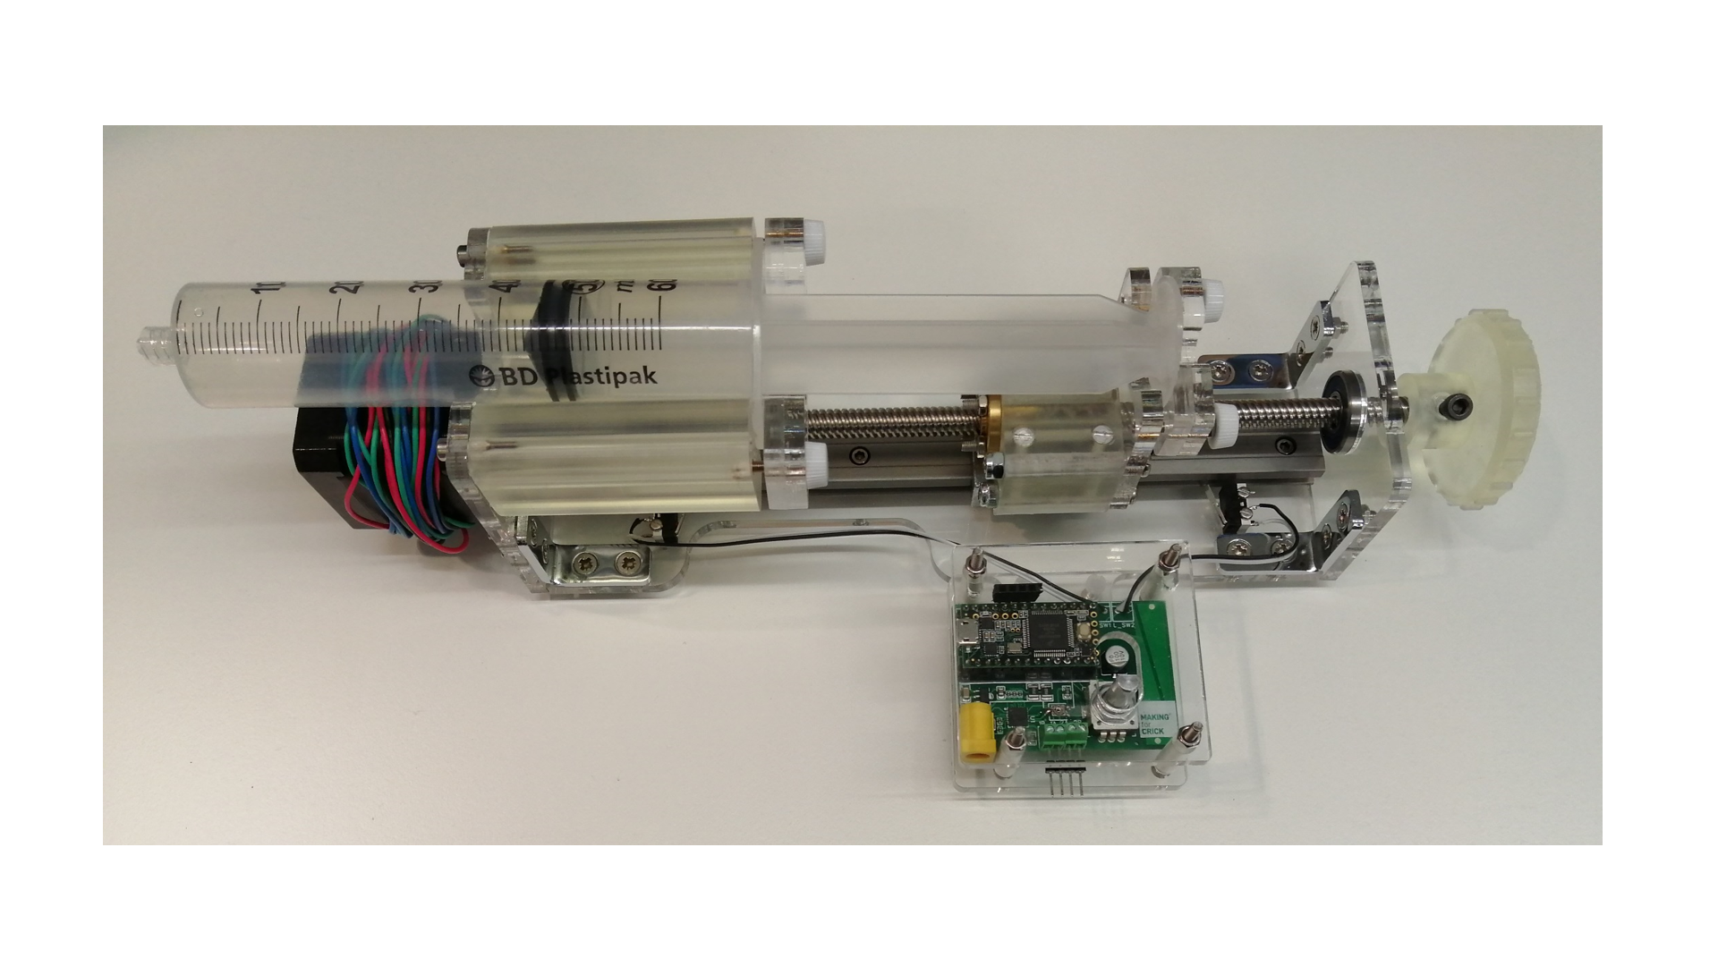

Figure 1: Syringe pump prototype.

**Device description**

The syringe pump has been conceived to operate with a BD Plastipak 60 mL syringe and therefore a 26.72 mm internal diameter [8]. That dimension has been used to calculate the area of the fluid that is displaced every step, being this one 560.74 mm^2. The resolution is changeable by defining the state of MS1, MS2 or MS3 to HIGH or LOW. The resolution at which currently the device operates is 3200 pulse/revolution. The lead size depends on the desired application and can be changed to 1,2,4 or 8 mm on the program the default is 1 mm. The resolution expressed in minimum volume that can be ejected depends on the selected and it ranges from 1.40 to 0.18 mm^3 for 1 and 8 mm leads respectively. The pump firmware has two main functions that convert the desired volume (µL) and flow rate (µL/s) into rotational displacement (steps) and rotational speed (steps/s) at a given acceleration. The default acceleration is set to 5000 steps/s^2.

The volumetric resolution () is calculated as the minimum volume that can be delivered with a certain lead (), syringe cross sectional area () and stepping resolution ().

The function which returns the number of steps () by a given volume () in µL:

The function which returns the number of steps per second () by a given flow rate () in µL/min:

**Experimental methods**

The precision and repeatability of the two pumps has been evaluated with two different lead screws, with coarse (8mm) and fine (1mm) leads respectively. In order to precisely measure the quantity of water ejected by the pump, ten 1.5 mL falcon tubes were marked with a number and weighted three times with a precision scale (Sartorius Analytic A 200S), the average of the three measurements was taken. The syringe pump was programmed to eject 1000 µL of water at three different flow rates: 1, 10 and 100 mL/min. Each of the ten previously mention tubes were filled with this volume of water. The procedure was performed for the 1 and 8 mm leads.

**Results and discussion**

The experimental results with the lead screw with 8 mm lead (Four start) have shown an average volume of 982±15 µL with a relative error of 1.78% from the desired volume of 1000 µL (Figure X).

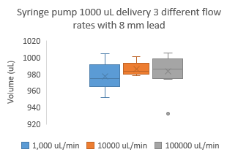

Figure 2: Ejected volumes at three different flow rates (1, 10 and 100 mL/min with an 8 mm lead screw (N = 10).

In the case of the 1 mm lead screw the average volume has been 977±32 µL with a relative error of 2.25% from the desired volume of 1000 µL (Figure X).

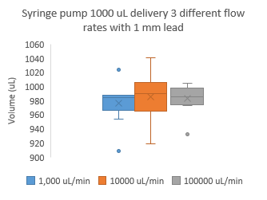

Figure 3: Ejected volumes at three different flow rates (1, 10 and 100 mL/min with a 1 mm lead screw (N = 10).

The Pump shows a better precision and repeatability with the 8 mm lead screw. On the other hand, with the 8mm lead it is not possible to achieve flow rate regimes lower than 86.4 µL/min. On the other hand, with the 1 mm lead screw, a wider range of flow rates can be achieved precisely, from 10.8 µL/min to 86.4 mL/min and even higher flow rates making it suitable for the microfluidic scale but also for millilitre scale experiments. The high resolution and small volume enable scientists to perform experiments of long duration (almost 4 days) with small flow rates (10.5 uL/min).

# **References**

|  |  |
| --- | --- |
| [1] | K. lab, "https://karpova-lab.github.io/syringe-pump/index.html," [Online]. |
| [2] | J. Voigts, "http://jvoigts.scripts.mit.edu/blog/low-cost-syringe-pump/," [Online]. |
| [3] | A. S. Booeshaghi, E. d. V. Beltrame, D. Bannon, J. Gehring and L. Pachter, "Principles of open source bioinstrumentation applied to the poseidon syringe pump system," *Scientific Reports,* vol. 9, no. 12385, 2019. |
| [4] | M. T. O. S. T. Lab, "https://www.appropedia.org/Open-source_syringe_pump," [Online]. |
| [5] | "https://www.instructables.com/3D-Printed-Syringe-Pump-Rack/," [Online]. |
| [6] | "https://hackaday.com/2017/02/26/diy-syringe-pump-saves-big-bucks-for-hackers-lab/," [Online]. |
| [7] | Luni64, "https://luni64.github.io/TeensyStep/," [Online]. |
| [8] | "https://www.chemyx.com/support/knowledge-base/syringe-library/bd-plastic-syringe-minimum-maximum-flow-rates/," [Online]. |