**CHAPTER I**

**THE PROBLEM AND ITS BACKGROUND**

This chapter shows the overview of the proposed study, background of the study, statement of the problem, scope and limitations, and significance of the study.

**1.1 Background of the study**

In agreement to the World Health Organization (WHO), the quantity of individuals of any age living with loss of sight is assessed to be 285 million, of who 39 million are visually impaired as the years go by (World Health Organization, n.d.). Among various suppressions wandered by a visually impaired individual, the test of self-reliant exploration and mobility is well known. Generally, visually impaired individuals figure out how to establish their sensibilities by methods for human help, dog guides, and stick or cane in finding their direction when going outside. It implies that visually impaired individuals do not have the ability to discover their way without somebody or without utilizing something to lead them in their outside exploration. The major distress of visually impaired individuals is exploring complicated road courses alone with the assistance of cane to lead them through it. Almost many people who are visually impaired refuse to utilize a cane. Indeed, just an expected 2 percent to 8 percent do (World Health Organization, n.d.). The remaining people depend on useable vision, a dog guide and a person that can guide them.

Prior to the development of innovation, a smart cane was presented in France (d'Herbemont, 1931). He propelled the principal national white stick development for visually impaired individuals. The initial two white canes were given by Guilly d'Herbemont to visually impaired individuals, within the sight of a few French ministers. 5,000 increasingly white canes were later sent to visually impaired French veterans from World War I and visually impaired regular people. The white cane's purpose is to recognize them as the "white sticks of the agents" their canes was designed to distinguish them as visually impaired people inside the populace and to allow them while raising it to make the vehicles and driver stop when crossing the intersection over through pedestrian paths.

Chaudary and Pulli performed a study about the Smart Cane Outdoor Navigation System for Visually Impaired Deaf-visually impaired and Blind Persons (Chaudary & Pulli, 2014). The reason for conducting the study is to fabricate an outdoor exploration framework to help Visually Impaired people's route freely in urban territories paying little mind to their visual and hearing status. It centers around helping visually impaired individuals explore complicated courses with the help of smart cane with gps navigation framework.

As innovation keeps on developing, a smart cane was presented that can detect obstacle, navigation through GPS (global positioning system) and activity voice coordinated (WeWalk, n.d.). SmartCane, a sensor-empowered cane proposed to improve the usefulness of the regular white cane utilized by numerous individuals who are visually impaired or blind. Vibration engines is added in the cane's handle to notify that there are hindrances to the person along the way. Ultrasonic sensor is added to the cane that could identify impediments over the chest level the thought was based upon the conventional white cane.

The first issue concerns how the visually impaired person navigates outdoor regarding their safety. The trouble in the navigation of visually impaired individuals is an essential issue they are encountering in their regular day to day activity, their safety when navigating outside due to their everyday schedules is placing them in danger without an appropriate direction on the ways and courses they take. Impediments and other various blocks may hinder them in their navigation or most least it can place them in danger. Different reasons for accidents were tumbling from stairs, falling into openings or pits, bumping into objects in trails, falling onto underground rails, falling into holes among transports and their foundation and bumping upon structure frameworks and glass entryways.

The second issue includes having efficient navigation. Different innovations broadly utilized are the Radio Frequency Identification (RFID), utilizing radio waves radiated from a remote LAN passages, Infrared (IR), Bluetooth, and Ultrasound Based Identification (USID). On the other hand, these advancements and navigation technologies help experience the ill effects of specific restrictions for being an ideal answer for the navigation help assistance structure for the VI people. With respect to the GPS, the apparent exactness isn't constantly adequate for the visually impaired navigation in urban territories. This is to a great extent because of satellites perceivability issue due to tall and clogged structures.

The last issue involves other smart cane technologies not being able to satisfy visually impaired people. Almost all the smart canes that was develop since the first cane was not able to satisfy the visually impaired people through its lack of simple object recognition. Visually impaired people cannot recognize the things and objects that they encounter in their navigation outdoor resulting to dissatisfaction in their smart cane.

With the purpose to solve the issues, the proponents developed a smart cane named “iCane” that is ergonomically convenient, easy to train and adapt to with (GPS) global positioning system navigation, object detection, solar powered charging and simple object height recognition to help visually impaired people to navigate independently without sighted assistance even in unstructured environments, avoiding awkward collisions, way finding in narrow pathways and even to detect movements of human beings.

**1.2 Statement of the Problem**

This study aims to develop an intelligent cane (iCane) that will help the visually impaired person to travel several distances and to help them navigate outdoors independently. This answers the following questions:

1. How to develop the following modules:
2. Object and wet surface detection module
3. Charging system module
4. Notification module
5. How to program the following modules:
6. Image recognition module
7. Image to words processing module
8. How to integrate the different modules to develop the proposed system?

**1.3 Scope and Limitations**

**Scope**

1. It is capable to detect objects through Sharp IR Sensor with the range of 50cm up to 60cm and it automatically vibrate once the sensor detects objects.
2. It is capable to captured images of car, person, chair, and sofa through Pi Camera with the range of 50cm up to 60cm and it also converts the images into words through earphones.
3. It is capable of charging the power bank through solar power.
4. It is capable to send an SMS message to the family or response personnel by clicking a button during emergency situation.
5. It is capable of detecting wet surfaces.

**Limitation**

1. It is not capable to get the location of the user indoors.
2. It is limited to detect car, person, and objects.
3. It is limited to 1 frame per second so there is a delay to identify objects in image recognition.

**1.4 Significance of the Study**

This study will be beneficial to the following

* **Visually Impaired Person**

This study will benefit visually impaired person because this study aims to help them by using iCane that will help them to move around their environment safely.

* **Proponents**

This study will benefit the proponents doing this research, the proponents will acquire new knowledge in this study, and it will also help the proponents to pass and submit the requirements of this subject.

* **University**

The university will benefit from this study, because it will be published in the school and can be added to the thesis studies in the library, it will provide information regarding development of the iCane.

* **Students**

This study will benefit the students, since it will serve as a reference guide that will provide information and data regarding to iCane.

* **Future Researchers**

This study would help the future researchers to be more knowledgeable about iCane. The study will serve as a future reference for more studies in the future.

**1.5 Operational Definition of Terms**

**GPS (Global Positioning System).** iCane is also capable of sending the user’s location during emergency situation to the family or the response personnel by just pressing the button designed for sending the location of the iCane.

**GSM (Global System for Mobile Communications).** iCane can send notification to the emergency contact when the emergency button is pressed.

**iCane.** This device is the upgraded stick, because it covers different capabilities that is designed to help visually impaired person like obstacle detection and conversion of image to words via earphones etc.

**IDLE.** It is the integrated development environment of python that will develop the image processing system.

**Image Recognition.** It covers conversion of words from image using image processing, the camera will capture objects and classify them accordingly like doors, chairs, etc. and will be able to convert the image into words and transmit to user using earphones.

**Intelligent.** Why intelligent? Because this iCane covers a variety of technology that is designed to help visually impaired person.

**Obstacle Detection.** The iCane covers the detection of an obstacle using the sharp IR sensors and will alert the user through vibration in iCane.

**OpenCV.** Is an open source computer vision that will be used to extract video streams for real time object detection.

**Python.** It is the programming language that will be used to develop the software in image processing.

**Raspberry pi.** It is the device that is capable of processing captured images and convert it into words.

**Solar Power.** iCane can charge itself by utilizing the sunlight and converting them to electricity using solar panels.

**Stick.** It is a device that can be used in self-defense or accessories, but primarily it is used to give support to the user in walking, it offers a stability for the user to maintain a good posture while walking.

**Visually Impaired.** People who suffers from eye disease not literally blind, but it involves blindness, color blindness, and partial blindness.

**CHAPTER II**

**REVIEW OF RELATED LITERATURE AND STUDIES**

This chapter covers the review of related literature and studies that will help the researchers gain useful knowledge and data that will complete the study about the iCane. The synthesis of the related studies is also included.

**2.1 Sensors for object detection**

In the magazine entitled “the next generation of sensory substitution technology” sounds could be a way for visually impaired people to imagine his/her environment. There is a sensory device called “the voice” it is invented by neuroscientist at the Hebrew University of Jerusalem, this device will let visually impaired people to discern its surroundings using sounds, this device work as translator of pictures into sounds (Smith, 2014).

The article “Enhanced white cane for visually impaired people*”* mentioned that 285 billion people around the world suffer from visual ailments. Most of visually impaired people face hazardous challenges in their everyday life. In this article two sensors are studied Ultrasonic Sensor and Raindrop Sensor. Ultrasonic sensor is used for detecting objects while the Raindrop Sensor is utilized for detecting wetness in the surface (Maymounah et al., 2018).

In the study ultrasonic range finderdiscussed how ultrasonic sensor works. It simply shoots a high frequency sound wave that comes from one speaker, and that sound wave will be deflected by the object and it will be rebounded to other speaker and the time it takes before it is reflected will be calculated (Whitney et al., n.d.).

Infrared sensors are related to ultrasonic sensors because both are used to detect objects around its environment. But instead of throwing sound waves, Infrared Sensors releases infrared waves. It is also mentioned in this study that infrared sensors are used in robotics to monitor its surroundings (Goldman, 2010).

In the article about optical fiber sensor, it states that optical fiber sensor is the most outstanding sensing method. Its capabilities are utilized in different areas like in medicines, defense, bioprocessing and food industries (Pradeep et al., 2018).

Infrared lights can now be a way for detecting wetness in road surfaces. Infrared lights can calculate the intensity of infrared radiation from the road. It is mentioned in this article that Infrared lights can differentiate dry and wet surfaces by calculating the infrared radiation reflected from the road (Silion & [Foşalău](https://ieeexplore.ieee.org/author/37375463800), 2014).

**2.2 Object Detection and Recognition for obstacles**

Visually impaired people mostly depend on their other senses like touching or smelling it is their way to perceive things. If they are not able to touch or smell objects in front of them, they will have difficulties visualizing it. So, a system is developed for the visually impaired person. It is a live object recognition, it features a neural system for recognizing pre-trained objects through the database. And these images can be converted into the form of audio (Kedar et al., 2018).

In this study it is still related in object recognition. It is mentioned that a portable camera is used to identify objects to help blind people in his/her everyday life. By using K-means clustering background, the camera will be able to separate the object that is needed to be recognize and the unnecessary background. And then another technique is which is called SIFT by pointing out the key-points of the image it will then match the data to the database and will produce a speech that help blind person to recognize the object (Mohane & Gode, 2016).

The focus of object recognition study is to simply recognize a single object and match the object to the database and produce an audio or speech to help the blind person, while this study introduces to recognize various indoor objects, and keeping the processing time as fast as single object recognition but it does sacrifice some information. By recognizing multiple images, the blind person will visualize more of its surroundings. The problems risen from coarse description is settled using two image multilabeling strategies that is different from traditional way of image closeness is computed. There are two ways to compute the similarities of the images, either make use of Euclidean distance measure or semantic similarity measure modeled by Gaussian process estimation. To attain the fastest computation proficiency. They will depend on compact image representation based on compressive sensing (Mekhalfi et al., 2014)

The study talks about how Object Identification is a big help for visually impaired people. A device that has an integrated camera that recognize objects that help visually impaired person to become self-supporting doing his everyday task. In this study coarse description technique algorithm is used. There are different ways for this algorithm to work it can be applied either Euclidian distance measurement method or semantic similarity measure modeled by means of gaussian process estimation (Jothimani et al., 2016).

**2.3 Voice Guidance and GPS Navigation**

There are millions who are visually impaired people worldwide, there is a crucial need for an assistive device that allows the blind people to navigate freely. Location information for indoor environment is limited. Radio Frequency Identification (RFID) tags is an effective way of giving location information to the users. Gharat and others created an RFID based system for independent navigation in a building for blind or visually impaired people. The conversion of speech to text is carried out using speech recognition software modules. This system is initiated by providing a voice command and specifying the destination to be reached by the blind person. This navigation system will guide the blind person along the path by providing audio navigation assistance to reach the desired destination. To avoid collision ultrasonic sensor will be interfaced with the Raspberry Pi. By implementing the above technique, blind people can navigate independently, and they can acquire information about their current location within the intended building (Madhura et al., 2017).

The visually impaired are at a considerable disadvantage because they often lack the information for avoiding obstacles and hazards in their path. They have very little information on self-velocity, objects, direction - which is essential for travel. Previously developed navigation systems use costly equipment which is often not affordable by the common blind community. The navigation systems available are heavy and very complicated to operate. Sreedevi and others conducted a research aimed at design and development of a smart and intelligent cane which helps in navigation for the visually impaired people. The navigator system designed will detect an object or obstacle using ultrasonic sensors and gives audio instructions for guidance. The signals from the ultrasound sensor are processed by a microcontroller in order to identify sudden changes in the ground gradient and/or an obstacle in front. The algorithm developed gives a suitable audio instruction depending on the duration of ultrasound travel which in turn is made available by an mp3 module associated with the system (Ananth et al., 2014).

To survey the utilization of Global Positioning System collector (GPS) determined execution measures for separating between various open-air exercises in solid mutts, sound canines and those with osteoarthritis, and osteoarthritic dogs when treatment with non-steroidal mitigating absence of pain must utilize gps route. Well dogs were strolled on a standard course on-lead, off-lead and exposed to playing action (pursuing a ball) while wearing a GPS neckline. Each dog was strolled for five successive days. Dogs with OA were exposed to a solitary off-lead walk while wearing a GPS neckline, and afterward controlled oral Carprofen absence of pain day by day for about fourteen days. OA dogs were then exposed to a similar walk, again wearing a GPS neckline. GPS inferred proportions of physical execution in dogs are objective, simple to measure, and can be utilized to check the impacts of infection and achievement of clinical medications. Explicit upgrades can be utilized to adjust physical execution past oneself represented limits that dogs will normally express when permitted to practice uninhibitedly without incitement (Bruno et al., 2015).

**2.4 Synthesis**

In this study, the proponents aim to create a device named “iCane” to help visually impaired people to navigate, feel, hear and sense their environment to provide them safe traveling and promote individuality on visual impaired people. As said by Dana Smith sound can be used to make a visual thinking of its surroundings to its visually impaired person (Smith, 2014). The Enhance white cane for visually impaired people depicts the use of ultrasonic sensors to sense objects from a distance and additional water sensor to detect wetness in an area (Maymounah, 2018). This particular device has its own different range of sensors to help the user to track distances of objects using video to audio output, preventing collisions onto them and causing tripping, which may be cause of accidents on some blind people who mostly depends on using a regular blind cane. In the study ofultrasonic range finderthat uses the technology of ultrasonic sensors but with a detailed working state, which it shoots a high frequency sound that converts time travelled by the sound wave which detected by the sensor to distance (Whitney, n.d.). The sensor used in this project of Lisa Goldman is sharpinfrared*,* it is used to calculate the range of the robot around its environment, it produces infrared waves that are being reflected or bounced back to the sensor, capable of detecting 10cm to 80cm distance (Goldman, 2010).

Additional features include a GPS tracker, which lets the guardian of the user track his/her own location with the GPS module installed in the device, improving safe navigation by letting the user’s guardian or companion know his/her location.This research aspires also to prevent those smart canes that runs out of battery without the user’s knowledge and provide also an eco-friendly aspect of using solar power to recharge the device power to implement additional feature which the user will be using the device without worrying about the batteries going out without the knowledge of the user.

**2.6 Conceptual Framework**

**Figure 2.1** *Conceptual Framework*

Figure 2.1 shows the outline on how the proponents will conduct the study using hardware and software components that will be used in this project, and the process that will be performed to develop the iCane.

This study aims to create a navigation device named “iCane” for visually impaired people that will detect nearby objects using sensors such as infrared sensors. It is capable of recognizing the height of the objects using a pi camera and deliver voiced guidance through an earphone, recharging the battery with the use of solar panel, providing exact location via GPS module, sending notification to the emergency contact using GSM module, alerting the user using vibration through mobile phone flat vibration motor and detecting wet surfaces using water detection sensor. The input for the software will fulfill the requirements in utilizing the sensors, camera, earphones and GPS/GSM module for the object detection, object recognition, sending notification and providing location via the GPS technology with the help of raspberry pi 3 model b. The hardware inputs battery, solar panel. Provided below how the project will achieve its aim.

In the process stage, the proponents will concentrate on the development of project planning, data gathering, software development, hardware design, prototyping, testing, evaluation and deployment to be able to attain the desired output. The proponents will develop the project in a disciplined timeframe by dividing the task equally. The proponents have studied the designs of different canes and evaluate what features are lacking and what is important this will serve as a reference on our design on what is needed to be improve. For the development of software design the proponents will use python language and python IDLE which is the IDE for python. Hardware design focuses on the integration of all hardware components to the iCane to produce the expected output. After producing the device, several testing methods will be performed to see if it is functioning base on the requirements. After testing the device and satisfying the requirements, the proponents will deploy the product to be used by the visually impaired people for them to freely navigate outdoors safely, efficiently, and satisfied. After deploying, we will evaluate the functionality of the hardware and software of the prototype, and then we will evaluate what possible improvements are need to be done for the prototype to work efficiently base on the feedback of the user.

**Chapter III**

**RESEARCH METHODOLOGY**

This chapter presents the research methodology and project development used in the study. It also includes the project planning and management, testing and evaluation procedures and the expected output of the study.

**3.1 Research methodology**

In this study the proponents will elaborate what methods should be used to gather information, data of the system and what is the most efficient methods for the proponents to complete the research.

The proponents use Descriptive method research. From the word descriptive it is basically describing what the research is, it does not answer how/when/why. After collecting data, the proponents used this method to describe the existing features of the device. Present features were not changed in this study and several developments will be added in the proposed study.

**3.2 Project Development**

To complete this research the proponents decided to use the Agile model. The research will be iterative, meaning the research will be done by part where each part of the project is studied by the proponents, so if errors is found in the project it will be fix immediately to avoid huge complications.

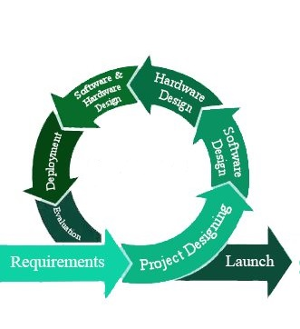

Testing

**Figure 3.1** *Agile Process*

Figure 3.1 represents the development process that was used in this project.

**Requirements**

For the proponents to complete this research, the proponents must collect information and datas related to the research topic by reading articles, magazines, literatures and related thesis papers. By collecting sufficient data, the proponents will be able to show the result of the study.

**Project Designing**

By using the articles and papers about the smart canes and white canes. The proponents have studied the designs of different canes and evaluate what features are lacking and what is important. This will serve as a reference on our design on what is needed to be improve.

**Software Design**

For the development of the software, python will be used as the programming language and IDLE (Integrated Development Learning Environment) is where the software will be develop.

**Hardware Designing**

For the designing of the hardware, autoCAD software is used to help the proponents visualize and design the iCane and properly place all of the hardware that will be use to produce the prototype.

**Software and Hardware Testing**

Numerous test will be conducted for the hardware and the software. In hardware, the components of the iCane will be tested if it will meet the requirements for the design and will be upgraded or replace by other component that will fulfill the design requirements. For the software, it will be tested in trials if the source code is properly functioning and delivering the desired outcome. It will be restructured and further develop should it fail to perform its supposed capability.

**Deployment**

After testing both hardware and software. The prototype will be deployed and will be used. The proponents will analyze and evaluate the output of the prototype whether it will encounter errors or deficiencies.

**Evaluation**

After deploying the prototype we will evaluate the functionality of the hardware and software of the prototype, and then will evaluate what possible improvements are need to be done for the prototype to work efficiently.

**3.3 Project Planning and Project Management**

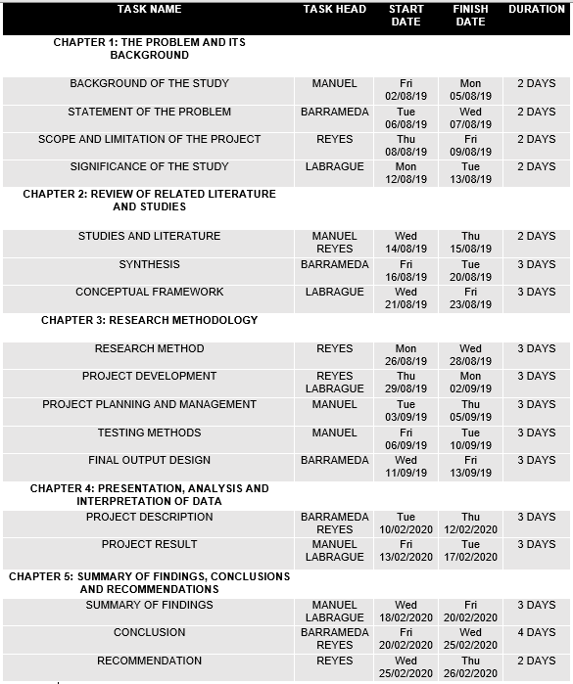**3.3.1 Work Breakdown Structure**

**Table 3.1** *Work breakdown structure*

Table 3.1 shows the different tasks that was divided to the proponents equally, and the start to finish date that the proponents was able to finish the tasks.

**3.3.2 Gantt Chart**

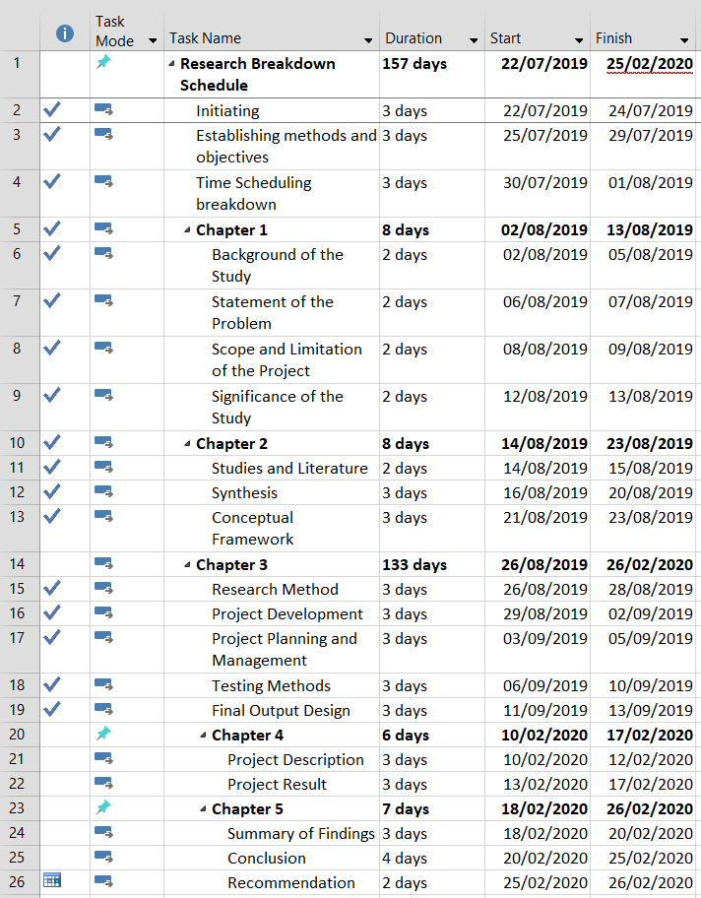

**Figure 3.2** *Gantt chart*

Figure 3.2 shows the extent of work done by the proponents in a fixed time that was planned for each task.

**3.4 Testing and Evaluation Procedures**

The proponents shall conduct tests before putting the iCane into use to prove that the iCane is ready to be use. The purpose of test and evaluation procedures is to evaluate the hardware and software’s performance and compare it to the output requirements that this project needs. The objective of conducting functionality experiment is to remove problematic issues on how the users will experience their outdoor navigation independently.

**3.4.1 Functionality Testing**

This procedure will test if the device has all the functionalities required specified within its functional requirements.

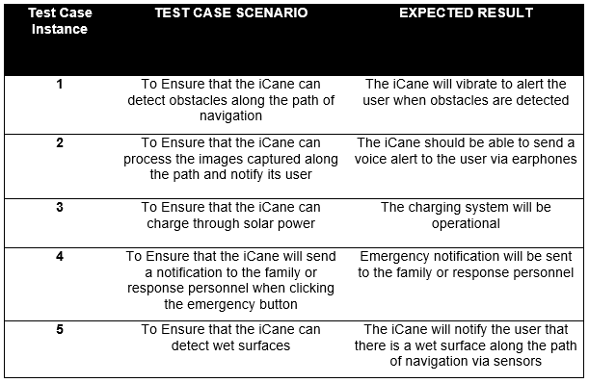

**Table 3.4.1** *Functionality Testing Test Case*

Table 3.4.1 indicates the test case scenarios in which the iCane will be tested to accomplish the expected output result.

**3.5 Expected output**

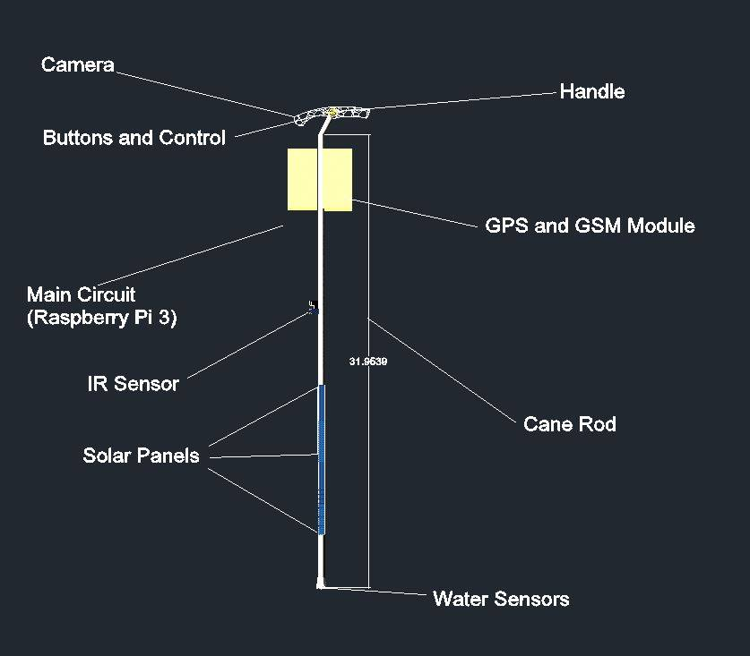

**Figure 3.5** *Expected output* *for* *the iCane*

Figure 3.5 shows the expected output result for the iCane. The wristband and eyeglasses are sub components which will provide an important role as the accessories of the iCane. Buttons and control function as an emergency button that will notify the emergency contact of the user. Sharp IR sensor that will detect the object within a distance will be placed along with the solar cell and power supply which serves as the main circuit. Water sensor which will detect wet surfaces will be placed at the bottom of the iCane.

**CHAPTER 4**

**PRESENTATION, ANALYSIS AND INTERPRETATION OF DATA**

In this chapter the proponents present all the testing required to see possible errors and prevent it. This chapter also elaborate how the hardware are used to create a functional iCane, what software is used to make iCane work accordingly and also the limitation and capabilities of iCane.

**4.1 Project Description**

The main purpose of the iCane is to help visually impaired person to navigate its surroundings using its capabilities to detect obstacle, converting images into audio, send emergency notification to response personnel, detects wet surfaces, and charge the power source using sunlight.

The sharp infrared sensor is placed in middle part of the cane to maximize its sensory capability. iCane also features image recognition, where it captures images using the pi camera and convert it into audio form. A button is installed in the cane which will allow the user to send SMS message of his/her location. It is also capable of detecting wet surfaces using wires as a sensory tool. Lastly, iCane features solar panels which will collect the heat from the sunlight and to use it as a way to charge the power bank.

Using the Raspberry Pi, we program and manage develop the image recognition, converting images into words, wet surfaces detection, and obstacle detection. We also used Arduino Nano for the SMS and GPS modules. While the solar panel is separated from the Raspberry Pi and Arduino because it is only used for the charging of the power bank. And with that we are able to develop a functional iCane.

**4.2 Project Results**

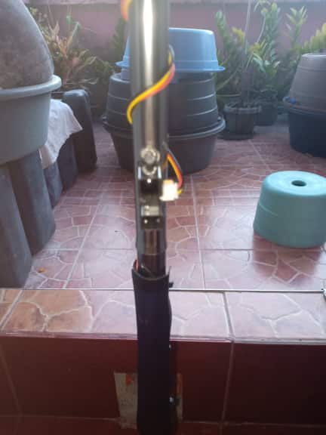**Development of object detection module**

**Figure 4.1** *Sharp IR Sensor*

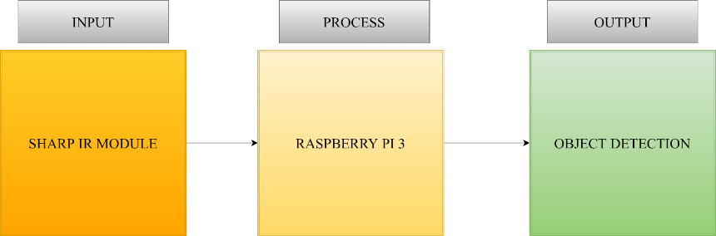

**Figure 4.2** *Object Detection Module*

The object detection module for the iCane was develop by connecting the Sharp IR sensor to the Raspberry Pi 3 and programming it to detect objects whenever an object is present in front of the sensor.

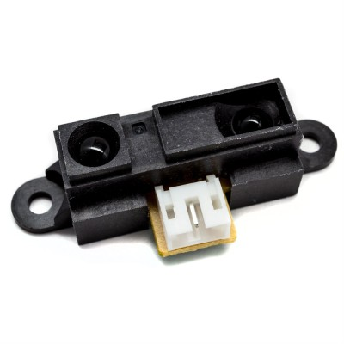

**Figure 4.3** *Sharp IR sensor*

Sharp IR sensor is capable of detecting obstacle up to 1.5 meters. It detects the object by radiating or emitting infrared radiation to an object. The proponents used this sensor to detect objects in front of the user.

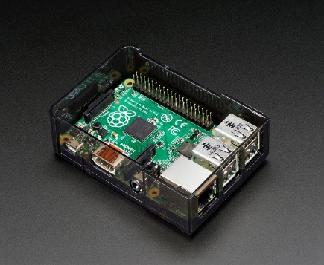

**Figure 4.4** *Raspberry Pi 3*

Basically, Raspberry Pi is a mini computer that helps people learn how to program in languages like Python and Scratch. The proponents used the pi to program the sharp ir to detect objects.

**Development of wet surface detection module**

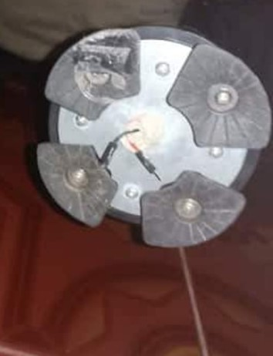

**Figure 4.5** *Wet Surface Detection Sensor*

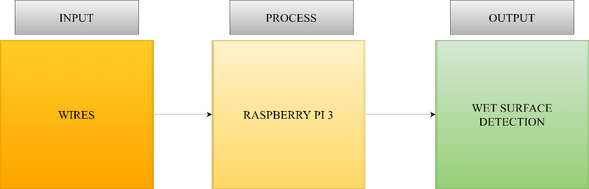

**Figure 4.6** *Wet Surface Detection Module*

The wet surface detection module for iCane was develop by connecting the wires to the Raspberry Pi 3 and programming it to detect wet surfaces.

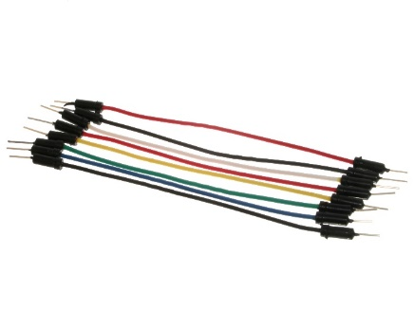

**Figure 4.7** *Connecting Wires*

Connecting wires allow an electrical current to travel from one point to another because electricity needs a medium through which it can move. The proponents used wires to develop wet surface detection for iCane.



**Figure 4.8***Raspberry Pi 3*

Basically, Raspberry Pi is a mini computer that helps people learn how to program in languages like Python and Scratch. The proponents used the pi to write a program that interprets the wires output to detect wet surface

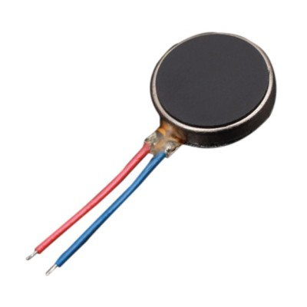

**Figure 4.9** *Vibration Motor*

Vibration motor is a compact size coreless DC motor used to inform the users of receiving the signal by vibrating. The proponents used the vibration motor as a notification for the user once the cane detects wet surface

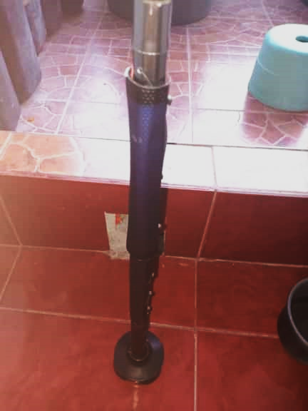**Development of charging system module**

**Figure 4.10** 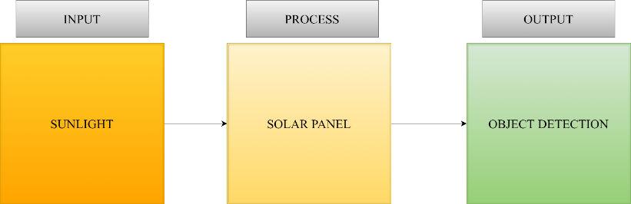*Solar Panels*

**Figure 4.11** *Charging System Module*

To develop charging system module for the iCane, the proponents installed solar panels in the lower part of the cane and used the electrical current stored in the solar panels to charge the power bank.

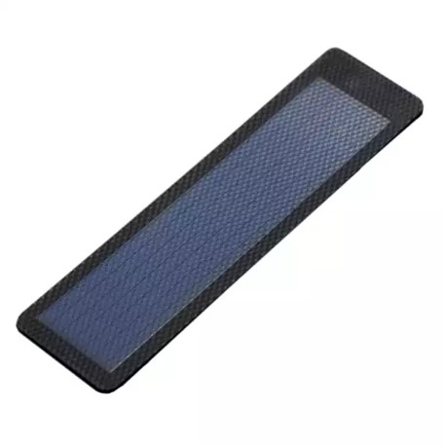

**Figure 4.12***Solar Panel*

The solar panel harnesses heat from the sunlight and store electrical currents produce by the solar cells and those electrical currents are used to charge the power bank of the iCane.

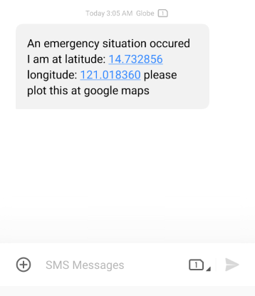**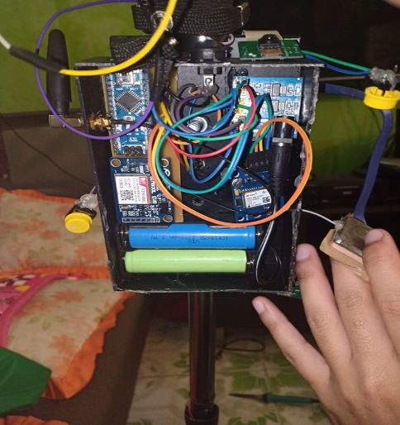Development of notification module**

**Figure 4.13** *Actual SMS message* **Figure 4.14** *GSM and GPS module*

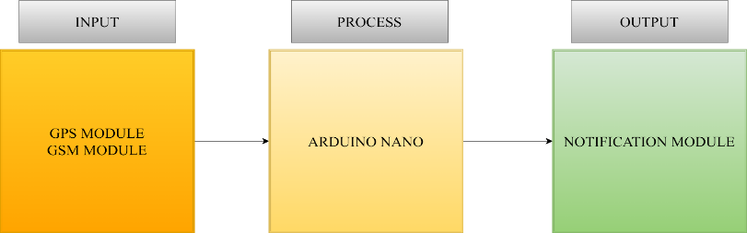

**Figure 4.15** *Notification Module*

To develop the notification module for the iCane, the proponents used GSM and GPS module and programming it using Arduino Nano to send SMS messages.

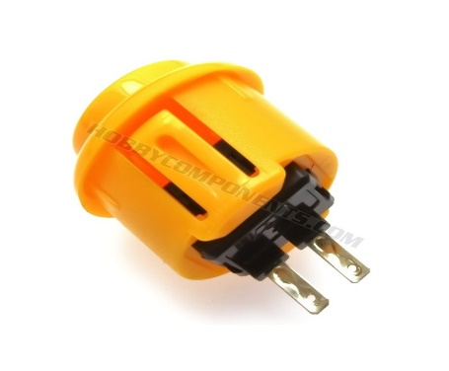

**Figure 4.16** *Button*

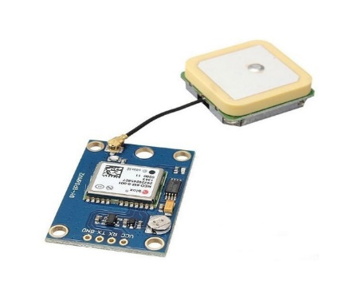A push button switch is a small, sealed mechanism that completes an electric circuit when you press it. The proponents used the button as a trigger to send the message.

**Figure 4.17** *GPS module*

The GPS receiver gets a signal from GPS satellites. The satellites transmit the exact time the signals are sent. The proponents used the GPS module to collect the longitude and latitude where the user is at.

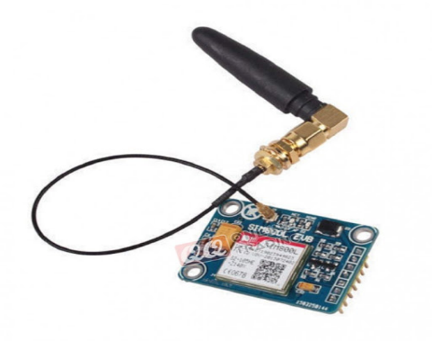

**Figure 4.18** *GSM module*

GSM modules are standard cellular radios that can transmit IP data and SMS on the GSM cellular network. The proponents used the GSM module the send the location of the user of the iCane in a text message.

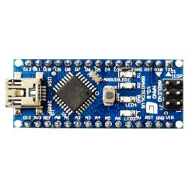

**Figure 4.19** *Arduino Nano*

Arduino Nano is a microcontroller kit that is used to program digital devices, and electronic modules. The proponents used the Arduino Nano to write a program that will let the GSM and GPS module to coordinate and develop a notification module for the iCane.

**Programming of the following modules**

* **Image recognition module**

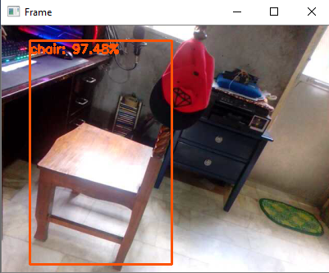

**Figure 4.20** *Image recognition* **Figure 4.21** *OpenCV*

To develop the image recognition module of iCane the proponents utilized the object detection for computer vision using a pre – trained MobileNetSSD object detection model and a computer vision library, namely OpenCV to process the images captured from the pi camera and input it into the model.

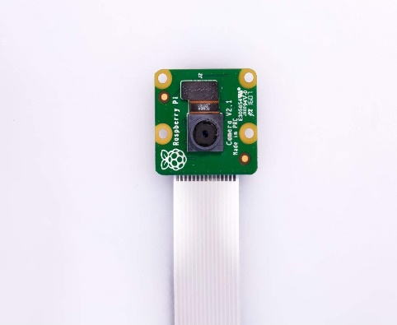



The Pi camera module is a portable light weight camera that supports Raspberry Pi. It communicates with Pi using the MIPI camera serial interface protocol. The proponents used the pi camera to get the frames from the live video feed to input in object detection module.

* **Image to words processing module**

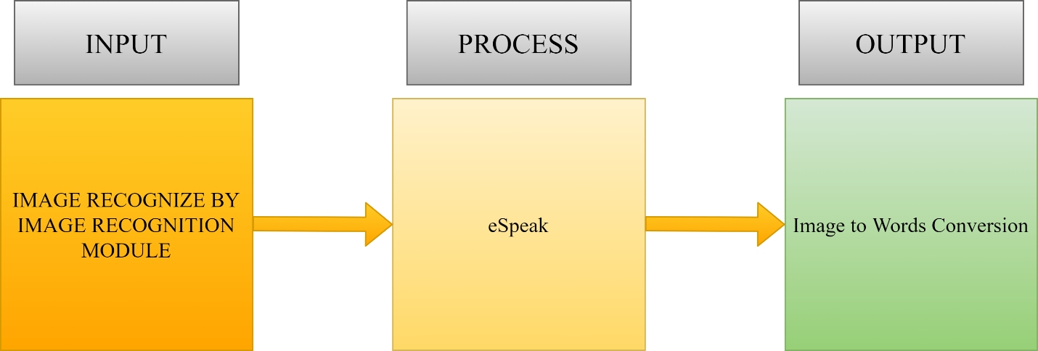

**Figure 4.24** *Image to words conversion process*

Using the output from image recognition namely the classification of images recognized, the proponents used it as an input to the program of eSpeak and eSpeak is the one that processes the conversion of image classifications into audio/speech for voiced guidance.

**Integration of the different modules**

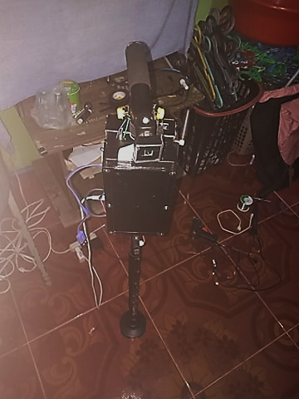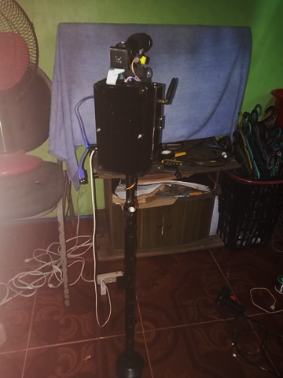

**Figure 4.25** *Actual iCane* **Figure 4.26** *Actual iCane*

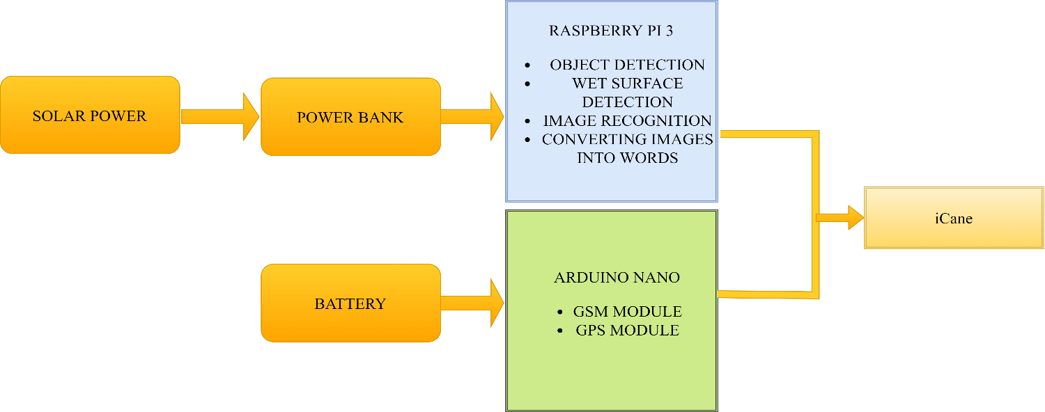

**Figure 4.27** *Integration of Modules*

Icane is divided into two parts that manages modules of the system which is Raspberry Pi 3 and Arduino Nano. The power bank powers up the Raspberry Pi 3 which then gives source to the subsystem of the pi which is the object detection and wet surface detection module, image recognition, and converting of images into words and also the solar panel serve as a way of charging to the power bank. On the other hand, separate battery powers up the Arduino Nano which holds the GSM and GPS module. And then the proponents integrate the Arduino and Raspberry Pi to develop a functional iCane.

**Testing the system functionality**

After all the hardware and software part of the system is integrated, the proponents tested all the functionality of iCane. The proponents tested the image recognition module using the pi camera to capture images from a video feed and identify it whether it is a person, chair, car, sofa and table, using the captured images classification as an input to eSpeak it converted the images into audio using earphones. The next one is the notification module, using the buttons installed in the iCane the proponents are able to send the user’s location through SMS message. The next one is the object detection module, using the sharp IR sensor the iCane is able to detect objects in front of the sensor the proponents also tested the wet surface detection module, the proponents dip the tip of the wires beneath the iCane and it detects the wet surfaces and vibrates to alert the user. The last thing proponents tested is the charging system module, the proponents exposed the solar panels to sunlight to gather sunlight and charge the power bank of the iCane.

**Results of testing:**

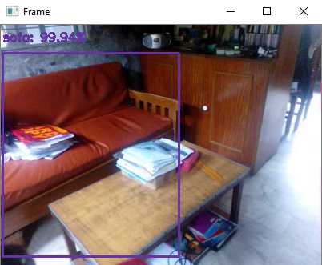

**Figure 4.28** *Image Recognition Module* **Figure 4.29** *GSM and GPS module*

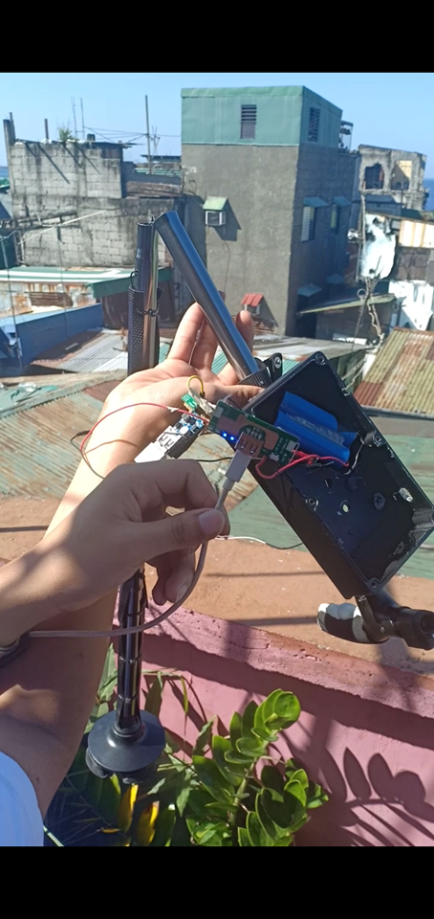

**Figure 4.30** *Charging System Module*

**Test cases**

The proponents developed test cases and tested the project based on functionality testing test case. The results are the following:

**Functionality testing**

**Actual Testing:**

**Test Case Instance #1: To ensure that iCane can detect obstacles along the path of navigation**

% of Executed Test Cases = # of Test Cases Executed / # of planned Test Cases X 100%

% of Executed Test Cases = 10/10 X 100%

% of Executed Test Cases = 100%

% of Passed Test Cases = # of passed / Total number of Executed Test Cases X 100%

% of Passed Test Cases = 10/10 X 100%

% of Passed Test Cases = 100%

% of Failed Test Cases = # of failed / Total number of Executed Test Cases X 100%

% of Failed Test Cases = 0/10 X 100%

% of Failed Test Cases = 0%

**Figure 4.31** *Test Case Passed vs. Failed of Test Case#1*

The proponents tested the object detection module ten times and the object detection module is able to pass all the testing executed.

**Test Case Instance #2: To ensure that iCane can process the images captured along the path and notify its user**

% of Executed Test Cases = # of Test Cases Executed / # of planned Test Cases X 100%

% of Executed Test Cases = 10/10 X 100%

% of Executed Test Cases = 100%

% of Passed Test Cases = # of passed / Total number of Executed Test Cases X 100%

% of Passed Test Cases = 8/10 X 100%

% of Passed Test Cases = 80%

% of Failed Test Cases = # of failed / Total number of Executed Test Cases X 100%

% of Failed Test Cases = 2/10 X 100%

% of Failed Test Cases = 20%

**Figure 4.32** *Test Case Passed vs. Failed of Test Case#2*

The proponents tested the image recognition module ten times and the object detection module is only able to pass eight out of ten executed tests.

**Test Case Instance #3: To ensure that iCane can charge through solar power**

% of Executed Test Cases = # of Test Cases Executed / # of planned Test Cases X 100%

% of Executed Test Cases = 10/10 X 100%

% of Executed Test Cases = 100%

% of Passed Test Cases = # of passed / Total number of Executed Test Cases X 100%

% of Passed Test Cases = 10/10 X 100%

% of Passed Test Cases = 100%

% of Failed Test Cases = # of failed / Total number of Executed Test Cases X 100%

% of Failed Test Cases = 0/10 X 100%

% of Failed Test Cases = 0%

**Figure 4.33** *Test Case Passed vs. Failed of Test Case#3*

The proponents tested the charging system module ten times and the charging system module is able to pass all the testing executed.

**Test Case Instance #4: To ensure that the iCane will send a notification to the family or response personnel when clicking the emergency button**

% of Executed Test Cases = # of Test Cases Executed / # of planned Test Cases X 100%

% of Executed Test Cases = 10/10 X 100%

% of Executed Test Cases = 100%

% of Passed Test Cases = # of passed / Total number of Executed Test Cases X 100%

% of Passed Test Cases = 10/10 X 100%

% of Passed Test Cases = 100%

% of Failed Test Cases = # of failed / Total number of Executed Test Cases X 100%

% of Failed Test Cases = 0/10 X 100%

% of Failed Test Cases = 0%

**Figure 4.34** *Test Case Passed vs. Failed of Test Case#4*

The proponents tested the notification module ten times and the notification module is able to pass all the testing executed.

**Test Case Instance #5: To ensure that iCane can detect wet surfaces**

% of Executed Test Cases = # of Test Cases Executed / # of planned Test Cases X 100%

% of Executed Test Cases = 10/10 X 100%

% of Executed Test Cases = 100%

% of Passed Test Cases = # of passed / Total number of Executed Test Cases X 100%

% of Passed Test Cases = 10/10 X 100%

% of Passed Test Cases = 100%

% of Failed Test Cases = # of failed / Total number of Executed Test Cases X 100%

% of Failed Test Cases = 0/10 X 100%

% of Failed Test Cases = 0%

**Figure 4.35** *Test Case Passed vs. Failed of Test Case#5*

The proponents tested the wet surface detection module ten times and the wet surface detection module is able to pass all the testing executed

**CHAPTER 5**

**SUMMARY OF FINDINGS, CONCLUSIONS AND RECOMMENDATIONS**

In this chapter, it covers the summary of findings, conclusion, and recommendation of the proposed study “iCane” based on the functionality test done by the proponents.

**5.1 Summary of Findings**

The proponents used Sharp IR Sensor to develop object detection module and programmed it using the Raspberry Pi 3 and installed in middle part of the cane to detect objects in front of the user.

While proponents used wires for wet surface detection module and place it underneath the iCane to sense wet surfaces.

With the used of the solar panels and integrating it to the model of the iCane, the proponents are able to gather solar power and charge the power bank of the iCane.

For notification module the proponents integrated GSM and GPS module and programming it using Arduino Nano it is able to send SMS messages to response personnel through the click of a button.

The proponents used the pi camera was used to capture and identify images from a video feed and using a pre - trained object detection model iCane were able to identify captured images whether it is a person, car, chair, sofa and table.

For converting images into words, using eSpeak as a process and using the identified images as an input the proponents were able to convert images into audio via earphones.

To integrate all the modules of the iCane the proponents utilized the serial UART communication to integrate all the hardware and software part of the iCane.

**5.2 Conclusion**

Utilizing the capabilities of the Raspberry Pi 3 to program electronic components, the proponents used it to program the Sharp IR sensor and to develop the object detection module for iCane.

The proponents used wires and Raspberry Pi 3 to create the wet surface detection module, by connecting the wires to the Raspberry Pi 3 and programming it the proponents develop wet surface detection module for iCane

The proponents installed solar panels in the bottom part of the iCane to maximized its capabilities to gather solar power and through that the proponents develop charging system module for iCane.

With the used of Arduino Nano, the proponents programmed the GSM, GPS, and Buttons thus creating notification module for iCane.

The proponents utilized the object detection for computer vision and through a pre-trained model object detection and a library of computer vision the proponents develop image recognition module for iCane.

Utilizing the output of the image recognition which is the classification of images recognized, the proponents used it as an input to the program of eSpeak and processed it to convert it into words via earphones thus creating the Image to words processing module for iCane.

iCane is divided into two parts which is the Raspberry Pi 3 and the Arduino Nano and by utilizing the serial UART communications the proponents are able to integrate all the features of the iCane thus developing a functional iCane.

After conducting several times of testing of each functionality as well as addressing each test cases for the system, we could therefore conclude that the proponents were able to develop a functional iCane that detects objects and wet surfaces, captured images and identify its classification, convert images into words and solar power charging with the use of Raspberry Pi 3, and also to create a notification module that is able to send an SMS message with the use of Arduino Nano.

**5.3 Recommendation**

To furthermore elevate the capabilities of the iCane, here are several limitations that is needed more improvements.

1. Further improvements in program for the image recognition to identify words or letters.
2. Improve the GPS module that can fetch signals indoors.
3. Train more objects for the image recognition module.
4. Improve the hardware especially the raspberry pi 3 to improve the frame per seconds of the camera and to decrease the delay to recognize the objects.