CRISP-DM Plan for Insight Distiller: AI/ML Blog Summarizer

1. Business Understanding
Objective: Develop a tool to generate concise, high-quality summaries of AI/ML blogs and articles, addressing information overload for professionals and e-learners.
- Problem: The rapid growth of AI/ML content (e.g., blogs, papers) overwhelms practitioners, who lack time to read lengthy articles or rely on inconsistent manual summaries.
- Market Context: The global e-learning market is valued at $305B (2023) and projected to reach $1,516B by 2033 (Yahoo Finance, 2024), highlighting demand for efficient learning tools.
- Target Audience: AI/ML practitioners, data scientists, and e-learners seeking timely, simplified insights.
- Success Criteria:
  - Business: Deliver time-saving, relevant summaries to improve decision-making and learning.
  - Technical: Achieve higher ROUGE and BERTScore metrics compared to baseline DistilBART model.
- Impact: Enables users to stay current with trends, simplifies complex content, and supports tech companies in improving blog accessibility.

2. Data Understanding
Objective: Collect and analyze AI/ML blog and article data to support summarization model training.
- Data Sources:
  - Blogs: Google AI Blog, Towards Data Science, Hugging Face Blog, Dev.to (ML tag).
  - Abstracts: arXiv (AI category).
- Data Collection:
  - Tools: feedparser (RSS), requests (HTTP), BeautifulSoup (HTML parsing), Selenium (dynamic content).
  - Data Types: Titles, full article text, abstracts.
- Data Characteristics:
  - Format: Text (titles, content) stored in a pandas DataFrame.
  - Volume: Start with 500 articles for MVP; scale to multiple sources.
  - Challenges: HTML tags, dynamic content, varying article lengths.
- Exploration:
  - Analyze article length, topics, and metadata (e.g., author, tags).
  - Assess “good” summary criteria via manual labels or user votes.

3. Data Preparation
Objective: Clean and structure data for model training and summarization.
- Tasks:
  - Cleaning: Remove HTML tags, emojis, special characters using BeautifulSoup and re.
  - Normalization: Standardize text format (title, content, author, tags).
  - Label Creation: Generate labeled summaries using OpenAI GPT-4o with title and content as input for context-aware, human-quality summaries.
  - Feature Engineering: Extract features like article length, named entities, paragraph count, and title keywords.
  - Tokenization: Use DistilBART’s tokenizer; handle long texts (>1024 tokens) via chunking with overlap to preserve context.
- Output: A clean dataset with columns: title, content, labeled_summary, stored in a pandas DataFrame.

4. Modeling
Objective: Fine-tune a transformer-based model to generate accurate, domain-specific AI/ML summaries.
- Approach:
  - Baseline Model: sshleifer/distilbart-cnn-12-6 (pre-trained on general text).
  - Fine-Tuning: Use transfer learning on AI/ML-specific dataset with GPT-4o labeled summaries.
  - Task Type: Sequence-to-sequence (text summarization, supervised learning).
  - Techniques:
    - Tokenization, truncation/padding, and special token handling.
    - Chunking for long texts to bypass 1024-token limit. (see below paragraph on more details
    - Training Config: 80% train, 20% validation; 2e-5 learning rate, 3-5 epochs, batch size 8-16.
  - Framework: Hugging Face transformers, datasets, torch, accelerate.
- Target Variable: Labeled summaries generated by GPT-4o.
- Inference: Use beam search or top-k sampling for summary generation.

Chunking (Handling Long Inputs)
To respect the model’s 1,024‑token input limit while preserving context, we apply a sliding‑window chunking strategy with controlled overlap. Each long document is split into contiguous token spans, then decoded back to text; each span is paired with the document’s reference summary for supervision.
Exact settings used
• MAX_INPUT_TOKENS = 1024 → window size
• CHUNK_OVERLAP = 50 → tokens reused between adjacent windows
• Step size = 1024 − 50 = 974 tokens
Why this helps
• Avoids truncation: long posts/abstracts are fully covered across windows.
• Preserves local coherence: overlapping 50 tokens keeps continuity at boundaries.
• Improves recall of key details: increases the chance that important sentences appear inside a window.
Caveats & choices
• Training pairs each chunk with the same reference summary. This is standard but can stress the model to compress across partial context.
• Alternative: hierarchical summarization (chunk → intermediate summaries → final merge) can improve ROUGE‑L/organization.
• Overlap is a trade‑off: more overlap improves continuity but increases dataset size and training time.

5. Evaluation
Objective: Assess model performance and compare fine-tuned model to baseline.
- Metrics:
  - ROUGE Scores: ROUGE-1 (unigrams), ROUGE-2 (bigrams), ROUGE-L (longest common subsequence), ROUGE-Lsum (sentence-level recall).
  - BERTScore: Precision, Recall, F1 for contextual similarity.
- Process:
  - Compare baseline DistilBART summaries to fine-tuned model summaries.
  - Validate on 20% of dataset; optionally use additional arXiv data for testing.
- Success Criteria:
  - Fine-tuned model outperforms baseline in ROUGE and BERTScore metrics.
  - Summaries are concise, relevant, and capture key AI/ML insights.
- MVP Evaluation: Compare 500 generated summaries to human-written summaries using ROUGE.

6. Deployment
Objective: Deliver a user-friendly tool for generating and rating summaries.
- MVP:
  - Scrape 500 articles from a single domain.
  - Generate summaries using baseline DistilBART.
  - Display results in a Jupyter Notebook with original text, summary, and ROUGE scores.
- Final Deployment:
  - Platform: Streamlit web app (local initially, planned for cloud via Hugging Face Spaces or Render).
  - Functionality:
    - Input: Blog URL or pasted text (from supported sources).
    - Output: Generated summary.
    - Feedback: User ratings and comments stored for iterative improvement.
  - Tools: FastAPI, uvicorn, Docker (planned).
- Stretch Goals:
  - Automate data pipeline for real-time scraping and summary generation.
  - Deploy app for broader access and collect feedback for reinforcement learning.
  - Compare baseline vs. fine-tuned model performance in the app.
Deployment Explanation
What each part does
1) Internal FastAPI service (the “summarization engine”)
- Loads the fine-tuned model from ./model, puts it on GPU if available. This is the single place that actually runs inference.
- Endpoints you expose:
  - POST /summarize-text: takes raw text + min_length/max_length, returns a single summary (no chunking here).
  - POST /summarize-pdf: accepts a PDF upload, extracts text per page (tries native text, falls back to OCR with Tesseract), then chunk → first-pass summaries → combine → second-pass summary. Returns the final merged summary.
  - POST /summarize-url: fetches the webpage, parses <p> tags, cleans text, then uses the same two-pass (chunk → combine) pipeline as PDF.
  - GET /: a simple landing message that lists the three endpoints.
- Key utilities inside:
  - clean_text(...): tidies OCR/web text (collapses whitespace, removes page numbers).
  - chunk_text(...): tokenizes with the model’s tokenizer and slices windows of 1024 tokens with a stride/overlap of 50 (sliding window).
  - summarize_text(...): runs model.generate(...) with beam search and length constraints.
- PDF OCR stack: PyMuPDF renders images for image-only pages; Pillow opens them; Tesseract OCR extracts text; text is then cleaned and summarized.
2) Streamlit UI (the “front door” for humans)
- Three tabs for three sources: “Paste Text”, “PDF Upload”, and “URL Content”—each maps 1:1 to your internal API endpoints.
- Controls per tab: text areas or file uploader + sliders for min_length/max_length, then a button that calls the corresponding API and shows results with a spinner and a download button. The UI talks to the internal FastAPI at API_BASE = http://127.0.0.1:8000 by default.
- Why it’s thin: all heavy lifting runs server-side; the UI just sends inputs and displays the summary (a good separation of concerns).
3) Public API gateway (the “external façade”)
- Purpose: a hardened front that forwards requests to the internal engine but adds an API-key check and stable, consumer-friendly routes. Useful if you want to share your summarizer with other apps/teams.
- Security: expects an X-API-Key header; compares with PUBLIC_API_KEY (env var; defaults to "mysecretkey"—swap this in production).
- Routes:
  - POST /api/summarize-text → forwards to /summarize-text (Form fields for text + lengths).
  - POST /api/summarize-url → forwards JSON to /summarize-url.
  - POST /api/summarize-pdf → forwards multipart file + lengths to /summarize-pdf.
  - GET / → redirects to interactive docs at /docs (handy for consumers).

End-to-end flow (from the user’s click)
A) Paste Text (UI → Internal API)
- User enters text and chooses min_length/max_length in Streamlit, then clicks “Summarize Text”.
- Streamlit sends a JSON POST to POST /summarize-text on the internal FastAPI.
- Internal API runs one-pass summarize_text(...) (no chunking for the text route), returns the summary.
- UI displays the summary and offers a download.
B) PDF (UI → Internal API → OCR → two-pass summarization)
- User uploads a PDF and sets length sliders in Streamlit.
- Streamlit sends a multipart request to POST /summarize-pdf.
- Internal API extracts text (native text or OCR with Tesseract), cleans, chunks (1024/50), summarizes each chunk (first pass), concats the chunk summaries, and summarizes again (second pass).
- Final summary is sent back and shown in the UI with download.
C) URL (UI → Internal API → fetch → two-pass summarization)
- User pastes a URL and sets lengths.
- Streamlit sends JSON to POST /summarize-url.
- Internal API fetches HTML, extracts <p> text, cleans, chunks (1024/50), first-pass chunk summaries → combined → second-pass final summary.
- UI displays the final summary and download.
D) Public API route (external client → Public API → Internal API)
- External client hits POST /api/summarize-* with X-API-Key.
- Public API validates the key and forwards the request to the matching internal endpoint; returns the internal JSON response.
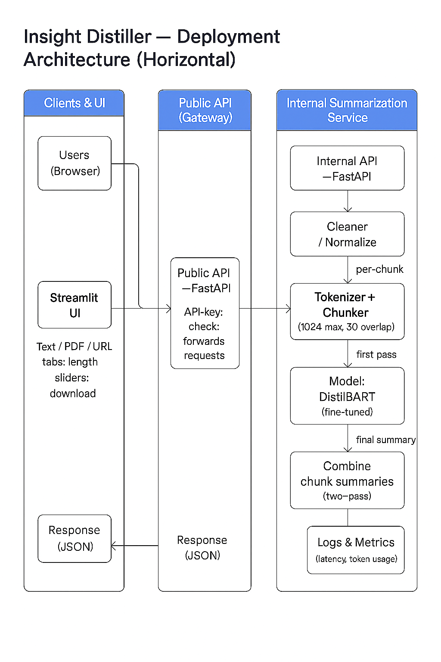

Tools and Technologies
- Data Collection & Cleaning: requests, feedparser, BeautifulSoup, pandas.
- Text Preprocessing: nltk, transformers, tokenizers.
- Modeling & Evaluation: transformers, datasets, evaluate, bert-score, torch, accelerate.
- Visualization & Deployment: matplotlib, seaborn, streamlit, FastAPI, uvicorn, Docker.
- Environment: Kaggle GPUs for training; local/cloud for deployment.
- Data Storage: Local CSV files, Kaggle Datasets, optional cloud backup.

Key Deliverables
- Final Product: Streamlit app for user input, summary generation.
- Documentation: README (already drafted), code comments, and user guide.
- Evaluation Report: Comparison of baseline vs. fine-tuned model using ROUGE and BERTScore.

Conclusion
Objectives & Success Criteria
We aimed to improve summary quality for AI/ML/Data Science blogs and research abstracts by fine-tuning DistilBART. Success was defined as the fine‑tuned model outperforming the baseline on ROUGE (1/2/L/Lsum) and improving semantic faithfulness (BERTScore‑F1) against defined target bands.
Target Metric Benchmarks
Metric | Acceptable | Good | Excellent
ROUGE-1 | 0.30–0.35 | 0.36–0.45 | > 0.45
ROUGE-2 | 0.08–0.12 | 0.13–0.20 | > 0.20
ROUGE-L | 0.25–0.35 | 0.36–0.42 | > 0.42
ROUGE-Lsum | 0.28–0.36 | 0.37–0.45 | > 0.45
BERTScore-F1 | 0.86-0.88 | 0.88-0.90 | >0.90

Quantitative Results (Baseline vs Fine‑Tuned)
Metric | Baseline | Fine‑Tuned | Δ (FT‑Base) | Category (FT) | Notes
ROUGE-1 | 0.2921 | 0.5015 | +0.2094 | Excellent | Large lift; much better coverage of key terms.
ROUGE-2 | 0.0630 | 0.2009 | +0.1379 | Excellent | Bigram gains → improved phrase‑level coherence.
ROUGE-L | 0.1711 | 0.3076 | +0.1365 | Acceptable | Now within Acceptable; sentence‑order/structure improving but still a growth area.
ROUGE-Lsum | 0.2009 | 0.3753 | +0.1744 | Good | Good multi‑sentence alignment; better overall organization.
BERTScore-F1 | 0.8487 | 0.8917 | +0.0430 | Good | Higher semantic similarity to references; fewer meaning shifts.
Interpretation & Business Meaning
- ROUGE‑1 (+0.2094 → Excellent): Captures substantially more key terms and entities. Users get summaries that surface the main contributions, datasets, and results more reliably.
- ROUGE‑2 (+0.1379 → Excellent threshold): Better preservation of short technical phrases (e.g., “cross‑validation scheme”, “BLEU score improvements”), which correlates with clearer, more fluent sentences.
- ROUGE‑L (+0.1365 → Acceptable): Improved longest‑common‑subsequence alignment indicates better sentence‑level structure, though there’s still room to refine narrative flow and coverage ordering.
- ROUGE‑Lsum (+0.1744 → Good): Stronger multi‑sentence sequencing yields summaries that read more like condensed abstracts rather than disjoint bullet points.
- BERTScore‑F1 (+0.0430 → Good): Higher contextual semantic similarity suggests the model preserves meaning more faithfully with fewer paraphrase errors—key for technical content.
Assessment vs CRISP‑DM Success Criteria
The fine‑tuned model exceeds the baseline across all metrics. It meets or surpasses the target bands as follows: ROUGE‑1 and ROUGE‑2 reach Excellent; ROUGE‑L reaches Acceptable; ROUGE‑Lsum reaches Good; BERTScore‑F1 shows a notable gain. This satisfies our project’s success definition and supports moving to pilot deployment.
Limitations & Risks
- 1,024‑token input limit may truncate long papers/posts despite chunking.
- Training data is domain‑focused (AI/ML) and may not generalize to unrelated styles.
- ROUGE‑L still trails higher bands, indicating opportunities to improve discourse structure.
- Automated metrics don’t replace human evaluation; in‑app ratings or expert review are recommended to validate quality.
Business Impact & Deployment Readiness
For AI/ML practitioners, the improvements mean faster comprehension with higher trust: more salient concepts captured, clearer phrasing, and better organization. Given the metric gains, we recommend deploying the fine‑tuned model behind the summarization API and gathering user feedback to guide iterative updates.
Next Steps
1). Collect human ratings in the app to benchmark perceived quality and drive active‑learning loops.
2). Explore longer‑context models or hierarchical chunking to reduce truncation effects and push ROUGE‑L toward Good.
3). Calibrate generation settings (length penalties, beams) per content type (blog vs abstract) for optimal readability.
4). Expand and diversify training data (methods/experiments sections, different venues) to increase robustness.

