MongoDb

Introduction
MongoDB (de l'anglais humongous qui peut être traduit par « énorme ») est un système de gestion de base de données orienté documents, répartissable sur un nombre quelconque d'ordinateurs et ne nécessitant pas de schéma prédéfini des données.

Installation

Il est possible d’installer une version community.

https://www.mongodb.com/try/download/community

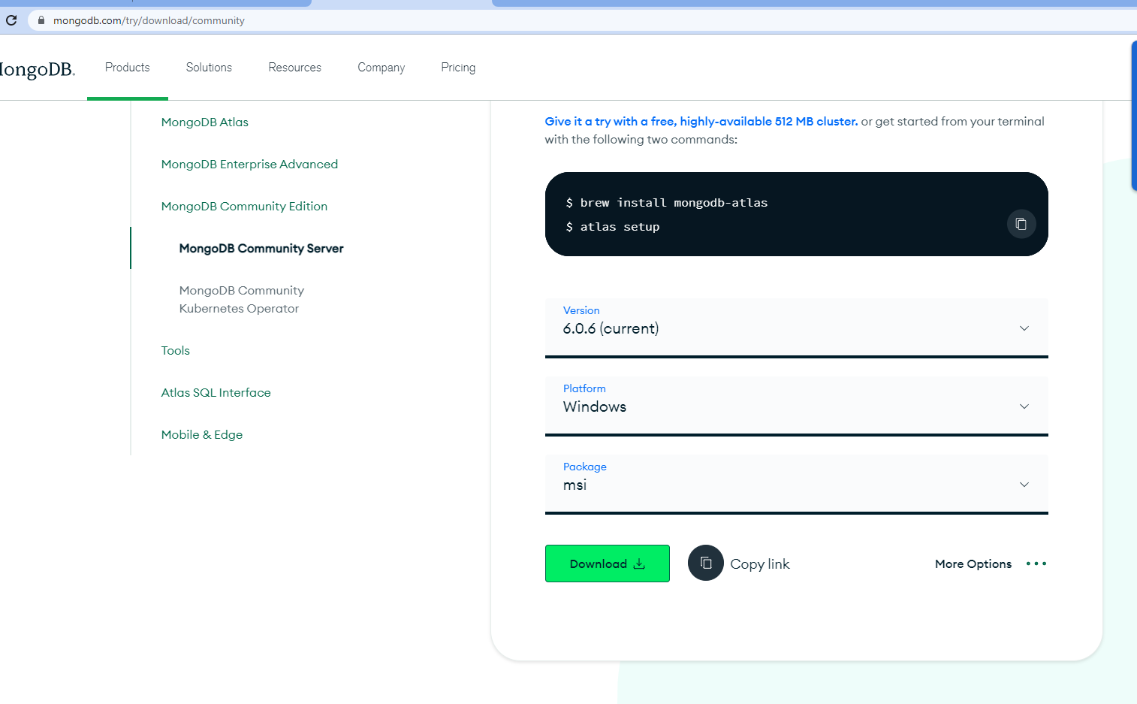
Intallation
Complète
En tant que services

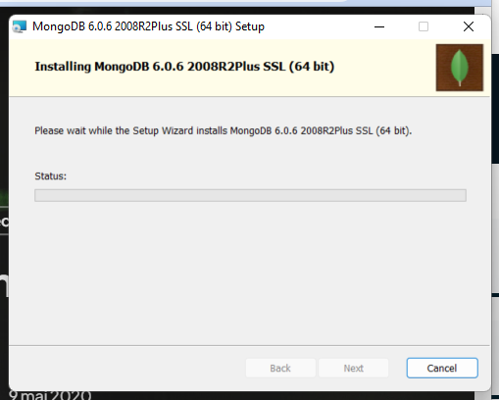

Base de données relationnelles versus NoSql

SGBD | NoSQL
Relationnel | Non relationel
Sacalable verticalement | Sacalable horizontalement
Permet des requêtes de jointures complexes | Ne Permet des requêtes de jointures complexes

Structure des informations

Avec MongoDB le premier niveau est la base de données. Les informations sont stockés dasn des documents (clé:valeur) qui sont eux même stockée dans des collections.

- database
  - collection
    - document (key:value)

Les commandes

Use
Pertmet de sélectionner et de créer une base
use db taskdb
prépare une base ou accède à une base

Créer une collection
db.CreateCollection(‘macollection’)
find
db.find({_id:ObjectId("64790de750e7cb6b869c4b23")})

Operation | Syntax | Example | RDBMS Equivalent
Equality | {<key>:{$eg;<value>}} | db.mycol.find({"by":"tutorials point"}).pretty() | where by = 'tutorials point'
Less Than | {<key>:{$lt:<value>}} | db.mycol.find({"likes":{$lt:50}}).pretty() | where likes < 50
Less Than Equals | {<key>:{$lte:<value>}} | db.mycol.find({"likes":{$lte:50}}).pretty() | where likes <= 50
Greater Than | {<key>:{$gt:<value>}} | db.mycol.find({"likes":{$gt:50}}).pretty() | where likes > 50
Greater Than Equals | {<key>:{$gte:<value>}} | db.mycol.find({"likes":{$gte:50}}).pretty() | where likes >= 50
Not Equals | {<key>:{$ne:<value>}} | db.mycol.find({"likes":{$ne:50}}).pretty() | where likes != 50
Values in an array | {<key>:{$in:[<value1>, <value2>,……<valueN>]}} | db.mycol.find({"name":{$in:["Raj", "Ram", "Raghu"]}}).pretty() | Where name matches any of the value in :["Raj", "Ram", "Raghu"]
Values not in an array | {<key>:{$nin:<value>}} | db.mycol.find({"name":{$nin:["Ramu", "Raghav"]}}).pretty() | Where name values is not in the array :["Ramu", "Raghav"] or, doesn’t exist at all

Aggregation

db.task.aggregate([
{$match:
{
'point': { $gt: 0 }
} },
{$group:
{_id: "$description",
total:{ $sum: "$point"}}}
])

Expression | Description | Example
$sum | Sums up the defined value from all documents in the collection. | db.mycol.aggregate([{$group : {_id : "$by_user", num_tutorial : {$sum : "$likes"}}}])
$avg | Calculates the average of all given values from all documents in the collection. | db.mycol.aggregate([{$group : {_id : "$by_user", num_tutorial : {$avg : "$likes"}}}])
$min | Gets the minimum of the corresponding values from all documents in the collection. | db.mycol.aggregate([{$group : {_id : "$by_user", num_tutorial : {$min : "$likes"}}}])
$max | Gets the maximum of the corresponding values from all documents in the collection. | db.mycol.aggregate([{$group : {_id : "$by_user", num_tutorial : {$max : "$likes"}}}])
$push | Inserts the value to an array in the resulting document. | db.mycol.aggregate([{$group : {_id : "$by_user", url : {$push: "$url"}}}])
$addToSet | Inserts the value to an array in the resulting document but does not create duplicates. | db.mycol.aggregate([{$group : {_id : "$by_user", url : {$addToSet : "$url"}}}])
$first | Gets the first document from the source documents according to the grouping. Typically this makes only sense together with some previously applied “$sort”-stage. | db.mycol.aggregate([{$group : {_id : "$by_user", first_url : {$first : "$url"}}}])
$last | Gets the last document from the source documents according to the grouping. Typically this makes only sense together with some previously applied “$sort”-stage. | db.mycol.aggregate([{$group : {_id : "$by_user", last_url : {$last : "$url"}}}])

Limit

db.task.find().limit(2)

limit et match et group

db.task.aggregate([

{ $limit : 2 }
,
{$match:
{
'point': { $gt: 0 }
} },
{$group:
{_id: "$description",
total:{ $sum: "$point"}}}
])

