Home Base: front page roadmap
Oct 6, 2026 · @Francis

Vision and principles
Home Base is a private start page on francistsoi.com. It holds your toolbox, files, to-dos and loose thoughts as tiles on one drag-and-drop grid, with a separate layout for each scenario: Work, Idea and PhD.
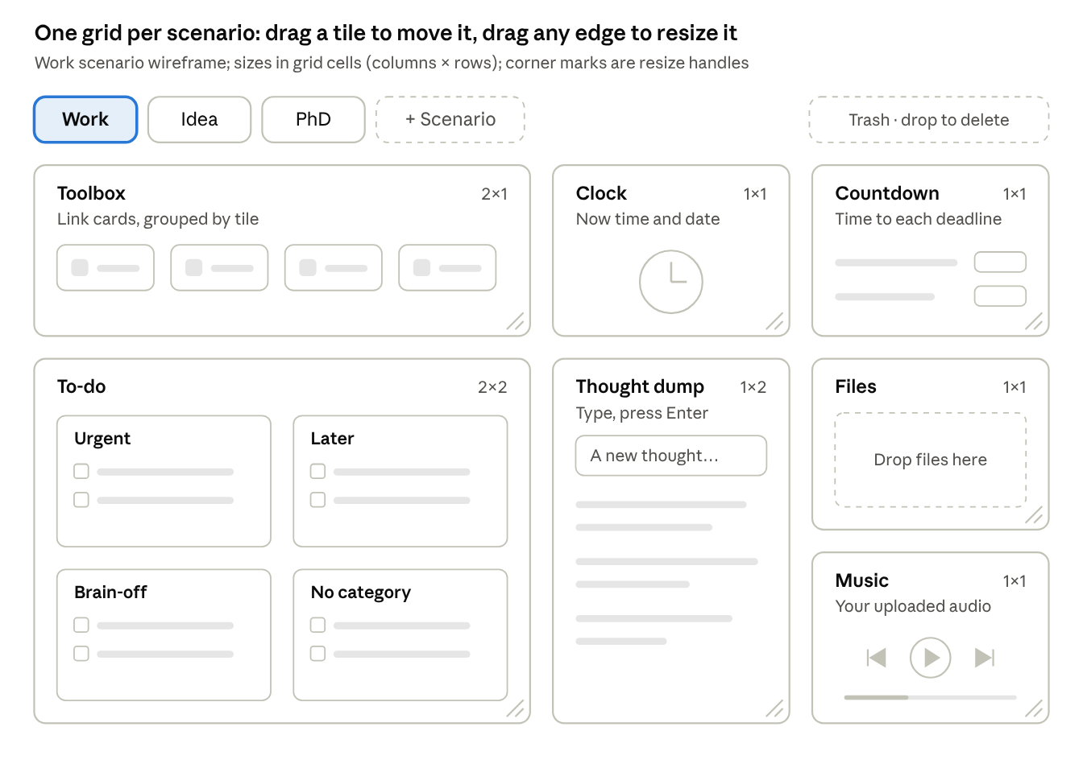
wireframe · Work scenario, 7 tiles
Drag a tile by its title to move it, pull any edge or corner to resize it, and drop it on Trash to delete it. Idea and PhD each keep their own set of tiles.
- Drag first. Move, resize, group, upload and delete with the mouse. A right-click menu does the same when dragging is awkward.
- Freely resizable. Drag any edge or corner of a tile to resize it. Sizes snap to whole grid cells, from 1×1 up to the full width, and the grid uses 12 columns on a wide screen and fewer on a narrow one.
- One layout per scenario. Switch with the tabs or the keys 1, 2, 3. Each scenario remembers its own tiles, and you can add more scenarios.
- Instant. It is your browser's start page, so it draws from a local cache first and syncs in the background.
- Nothing gets lost. Every change autosaves; deletes go to a trash you can restore from; Ctrl+Z undoes recent changes.
- Private. The page sits behind a login. The database password and your files never reach the browser.

Architecture
A small PHP gateway on your own host sits between the page and the data. It keeps the database password and your files away from the browser, and saves each change as one row in a MySQL database you manage in phpMyAdmin.
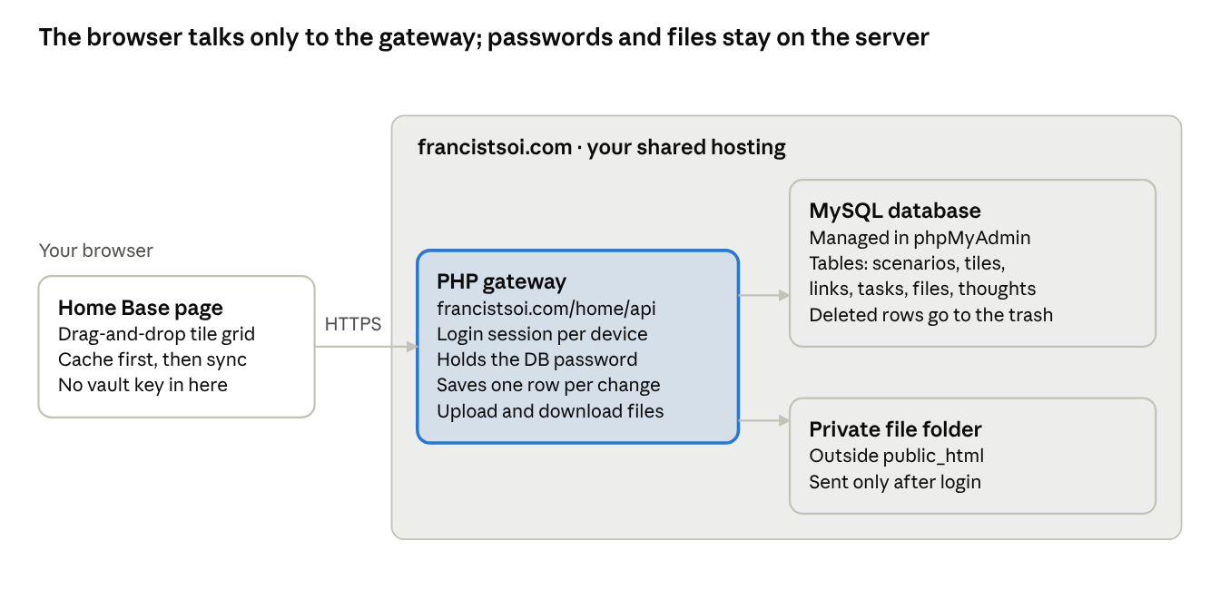
architecture · page, gateway, vault, file folder
The gateway is the only new server piece: it checks your login, reads and writes the database, and serves files on the page's behalf.
Decision | Choice | Why
Where it lives | francistsoi.com/home (proposed) | Same server as your database; PHP already runs there.
Data | MySQL, managed in phpMyAdmin (see below) | Each drag saves one row, with no document-size limit.
Secrets | Database password in the gateway's .env, outside public_html | Browser code is public.
Login | One passphrase, stored hashed; a long-lived session per device; 5 wrong tries then a 15-minute pause | Keeps the page private without daily friction.
Files | A private folder outside public_html, served by the gateway only after login; one database row per file | Files stay private; the database holds only their records.
Saving | The screen updates at once; the change goes out 1 s after you stop dragging | Small writes, so two devices rarely collide.
Sync across devices | Re-read when the tab regains focus, and every 30 s while it is visible | Picks up changes made on another device.
Grid | GridStack.js: drag to move, drag any edge or corner to resize, 12 columns on a wide screen and fewer on narrow ones | A mature library that already handles snapping, collisions and screen widths.
Lists | SortableJS for links and tasks | Drag within and between buckets and tiles.
No build step | Plain JavaScript files | Uploads straight to shared hosting, and fewer files for Claude to read each session, which saves tokens.

Storage: MySQL instead of JSON Vault
Recommendation: switch to MySQL, managed in phpMyAdmin. The gateway is PHP anyway, and a drag-heavy page makes many small changes, which a database saves one row at a time. JSON Vault stays as it is for your other apps.
Need | MySQL (phpMyAdmin) | JSON Vault
Saving one dragged task | Updates one row | Rewrites the whole bin
Two devices editing | Only edits to the same item collide | Last write wins; needs merge code
Size limit | Your hosting disk quota | 2048 KB per bin
Search (Phase 5) | One SQL query | Load every bin and scan it
History | Trash and in-session undo; more only if needed | Last 20 versions, free
Setup | Create a database and user, run one schema file | Create bins and an access key
Code to write | Less: no merge or version-check logic | More

Prioritised features
The rule: P0 makes the page usable every day, P1 is everything else you asked for by name, P2 makes it nicer, P3 waits until it is needed. Effort is relative: S is a day or less of focused work, L is the largest pieces.
Feature | Priority | Phase | Effort
Database tables, login and PHP gateway; the password stays on the server | P0 Must | 1 | M
Load and autosave through the gateway, one row per change | P0 Must | 1 | M
Bento grid: drag to move, drag any edge or corner to resize, add and remove tiles | P0 Must | 2 | L
Scenarios Work, Idea, PhD: add, rename, reorder; one layout each | P0 Must | 2 | M
Toolbox tile: link cards, drag to reorder or into another tile | P0 Must | 2 | M
To-do tile: Urgent, Later, Brain-off, No category; drag between buckets | P0 Must | 2 | M
Thought dump tile: type, press Enter, timestamped | P0 Must | 2 | S
Clock tile: current time and date | P0 Must | 2 | S
Upload by dropping files on a tile or anywhere on the page | P1 Core | 3 | L
File tiles: open, download, rename, drag between tiles | P1 Core | 3 | M
Drag to trash; restore within 30 days | P1 Core | 3 | M
Groups and categories: colour labels, group headers, tags | P1 Core | 4 | M
Countdown tile: several named deadlines | P1 Core | 4 | S
Music player tile: a playlist of your uploaded audio | P1 Core | 4 | M
Undo (Ctrl+Z) for recent changes | P1 Core | 4 | M
Dark mode and tile colours | P2 Nice | 4 | S
Search and command bar (Ctrl+K) across links, files, tasks, thoughts | P2 Nice | 5 | M
Phone and tablet layout with touch drag | P2 Nice | 5 | L
Backup: export everything as JSON plus a zip of the files | P2 Nice | 5 | S
Items shared across scenarios (one to-do list on Work and PhD) | P3 Later | 5 | M
File previews (images, PDF) inside tiles | P3 Later | 5 | M
Chunked upload for large files | P3 Later | 5 | M
In Phase 2 a tile already works as a group (a tile of links is a category); Phase 4 adds colours and tags on top. The countdown is small enough to pull into Phase 2 if you want it sooner. Scenarios are P0 because they shape the data model and are costly to add later.

Roadmap
Six phases take Home Base from setup to extras. It becomes your daily start page at the end of Phase 2, before files and gadgets are added.
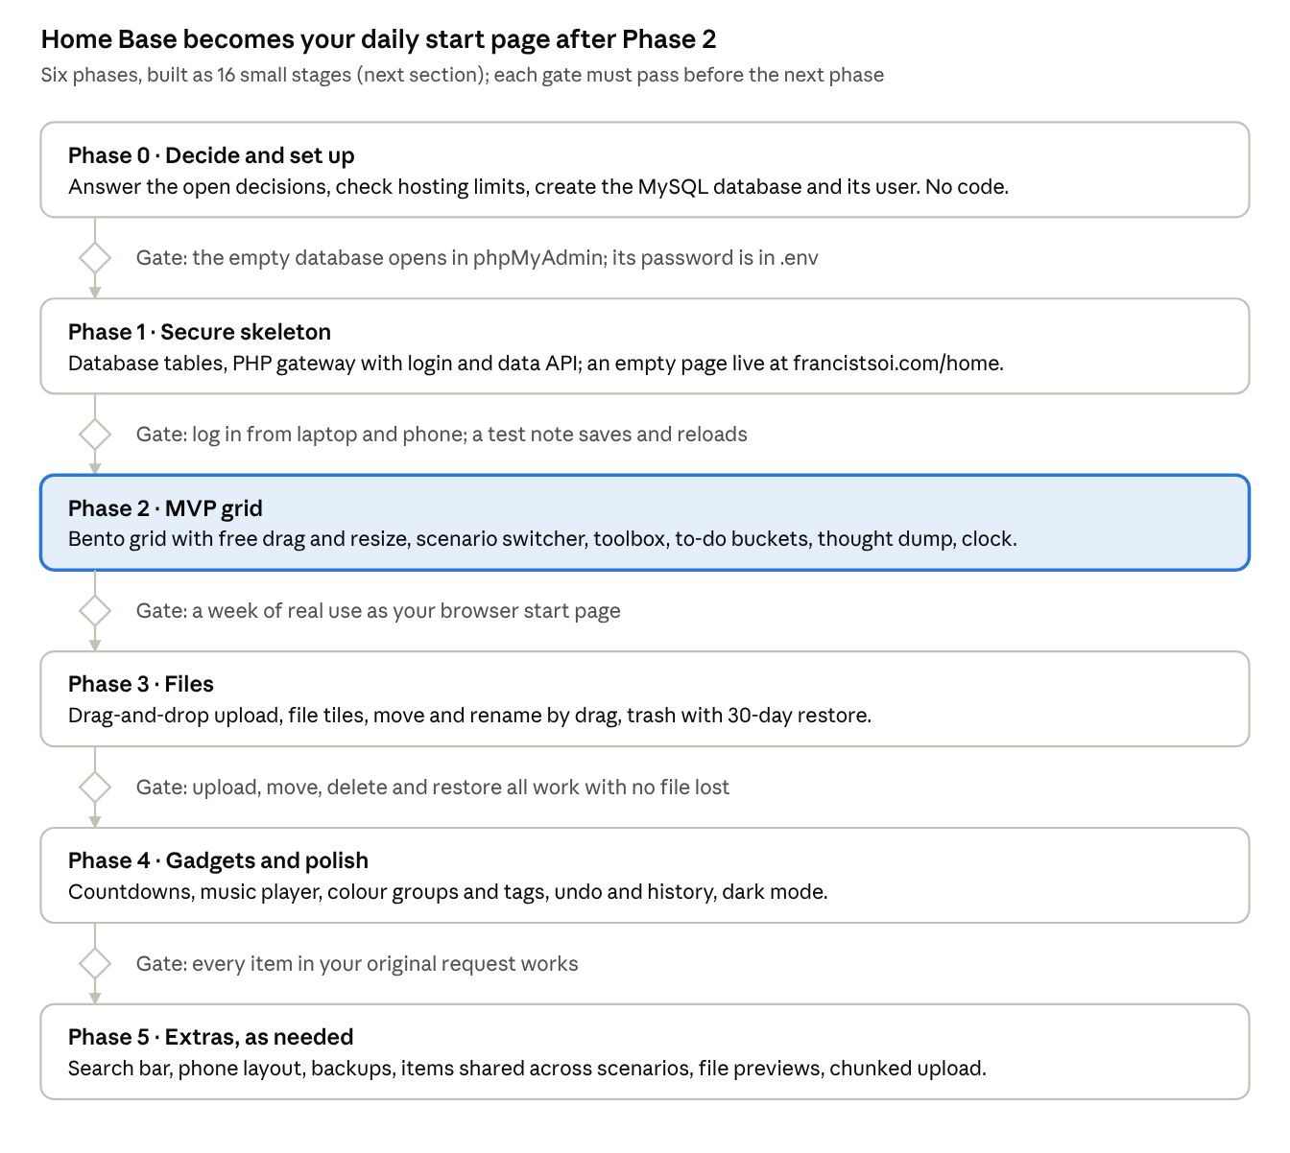
roadmap · 6 phases, 5 gates
The Phase 2 gate is a week of real use, which shows what to fix before files arrive. Phase 5 has no gate: pick from it as needs come up.

Build stages
Each stage is one Claude Code session that ends in a working, tested state, so a usage limit never leaves a change half done. Aim for one or two stages per five-hour usage window. Size: S is a short session, M one full session, L two sessions split at the point named.
Stage | Builds | Done when | Size | Model
S0 · you, no Claude | Hosting check, MySQL database and user, .env, passphrase | The empty database opens in phpMyAdmin | – | –
S1 | Folder layout, CLAUDE.md, schema.sql, config loader | You run schema.sql in phpMyAdmin and see 7 tables | S | Sonnet
S2 | Gateway: login, logout, sessions, rate limit, data API for the tables | You log in on laptop and phone; the API lists the 3 scenarios | M | Sonnet
S3 | Page shell and grid: drag to move, free resize, add and remove empty tiles, positions saved | The layout survives a reload | L, split after drag and resize, before saving | Sonnet
S4 | Scenario tabs: switch, add, rename, reorder, keys 1 to 3 | Each scenario keeps its own layout | M | Sonnet
S5 | Toolbox tile: link cards, add and edit, drag to reorder or into another tile | Links survive a reload in the right order | M | Sonnet
S6 | To-do tile: four buckets, add, tick, drag between buckets | A task dragged to Later is still there after a reload | M | Sonnet
S7 | Thought dump and clock tiles; local cache for instant load | The page draws before the network answers | M | Sonnet
S8 | Upload endpoint and drop-to-upload anywhere on the page | A dropped PDF appears in a Files tile and downloads intact | L, split after the PHP endpoint | Sonnet
S9 | File tiles: open, rename, drag between tiles | Renamed and moved files still open | M | Sonnet
S10 | Trash: drag tiles, links, tasks or files to delete; restore; purge after 30 days | A deleted item comes back from the trash | M | Sonnet
S11 | Countdown tile | Days left roll over at midnight | S | Haiku
S12 | Music player tile on your uploaded audio | The playlist plays, skips and keeps its order | M | Sonnet
S13 | Colour labels, group headers, tags; dark mode | Colours and tags survive a reload | M | Sonnet
S14 | Undo (Ctrl+Z) for recent changes | Undo reverses a move, a resize and a delete | M | Sonnet
S15+ | Phase 5 extras, one per session: search, phone layout, backup export, shared items, previews, chunked upload | Each extra works on its own | S or M each | Sonnet
S0 to S7 is the MVP; stop there for the one-week gate before starting S8.

Working with Claude on a Pro plan
Build in Claude Code with Sonnet, starting each stage in plan mode. Pro usage is shared between the Claude apps and Claude Code and is measured over a five-hour window plus a weekly limit, so the habits below stretch it furthest.
Use | For | Why it saves usage
Claude Code in your project folder | Every build stage | Claude reads and edits files by path instead of you pasting whole files into a chat
Sonnet | Most stages | Handles most coding well and costs less than Opus
Opus, if your plan offers it | Only when stuck, or for a wide change | Uses up a limit fastest
Haiku | Small mechanical work (S11, quick fixes) | The lightest model
Plan mode (Shift+Tab) | The start of each stage | A plan costs a few hundred tokens; a wrong 400-line change costs thousands
Chat or Cowork | Planning and this doc | Keeps design talk out of coding sessions
Each session:
- Start clean with /clear, then say: "Read CLAUDE.md, then do stage S5" and paste only that stage's row, never the whole roadmap.
- Point at files by path ("edit public/js/todo.js") rather than pasting them.
- Test the stage's "Done when" before moving on. Press Esc the moment Claude heads the wrong way; /rewind undoes it.
- End by asking Claude to update CLAUDE.md with what was built and what's next, then /clear.
- Keep CLAUDE.md under about 200 lines, since it is sent with every turn.
- Check /usage before an L stage, and lower /effort for small ones.

Data model
Seven MySQL tables hold everything. Each change touches one row, so moving a tile never rewrites a task you just ticked.
Table | Holds | Main columns
scenarios | Work, Idea, PhD and any you add | name, position
tiles | Each tile on a scenario's grid | scenario, type, x, y, width, height, title, colour, settings (JSON)
links | Toolbox link cards | tile, name, URL, icon, position
tasks | To-do items | tile, bucket, text, position, done at
files | Uploaded file records | tile, original name, stored name, size, type, tags
thoughts | Thought dump entries | scenario, text, created at
settings | Page-wide preferences | key, value
Every table except settings also has an ID, created and updated times, and a deleted time that marks an item as in the trash. Countdown dates and playlist order live in a tile's settings. Stage S1 writes all of this as one schema.sql file you run in phpMyAdmin.

Before coding: your decisions and setup
Seven decisions shape the build. Each has a recommended default, so a quick "yes to all" works; change any row you disagree with.
Decision | Recommended | Alternative
URL | francistsoi.com/home | A subdomain such as home.francistsoi.com
Storage | MySQL, managed in phpMyAdmin | JSON Vault bins
Music source | Your own uploaded audio files | Spotify or YouTube embeds, run by their player rather than yours
Devices for v1 | Desktop and laptop; phone in Phase 5 | Phone from day one, which adds touch-drag work to S3 to S6
To-do buckets | Your four as defaults, renamable, more can be added | A fixed set of four
Login | One passphrase; each device stays signed in for 90 days | Enter it every session
Front-end stack | Plain JavaScript, GridStack.js, SortableJS | React with react-grid-layout and dnd-kit: more tooling, a build step, and more files for Claude to read
Setup for stage S0, all on your side:
- ☐ Check the host: PHP 8 or later, MySQL or MariaDB version, upload_max_filesize, post_max_size, disk quota, and a writable folder outside public_html.
- ☐ In the hosting panel, create a MySQL database and a user with rights on that database only.
- ☐ Put the database name, user and password in the gateway's .env yourself, outside public_html, rather than pasting them into a chat.
- ☐ Choose the login passphrase; you will store only its hash, in S2.
- ☐ Install Claude Code and make an empty project folder for Home Base.

Risks
The biggest risk in a drag-and-drop page is losing something by accident, so safety nets come before features.
Risk | Mitigation
A drag deletes something by mistake | Trash with 30-day restore, undo for recent changes, and a database export in the Phase 5 backup
Two tabs or devices edit at once | Each change writes one row, so only edits to the very same item collide; re-read on tab focus
The page, files or database are exposed online | Login checked on every request; password and files outside public_html; a database user limited to this one database; HTTPS only
Shared-hosting upload limits are too low | Checked in S0; chunked upload in Phase 5 if needed
A usage limit stops Claude mid-stage | Small stages that each end in a tested state; CLAUDE.md records where you stopped
Scope creep stalls the MVP | Phase gates: S8 does not start before the one-week gate passes
A slow start page on shared hosting | Draw from the local cache first and sync after; static files cached by the browser

Sources
- Use Claude Code with your Pro or Max plan: usage shared between Claude and Claude Code
- Usage limit best practices: five-hour and weekly limits in Settings > Usage
- Models, usage, and limits in Claude Code: model choice, plan first, CLAUDE.md size
- Manage costs effectively: /clear, plan mode, /effort, /usage

