**ESE 2025 – Embedded Operating Systems.**

**LAB 3.**

**Akhil George - C0748466**

**Francis Vijith – C0742980**

1)

putty commands:

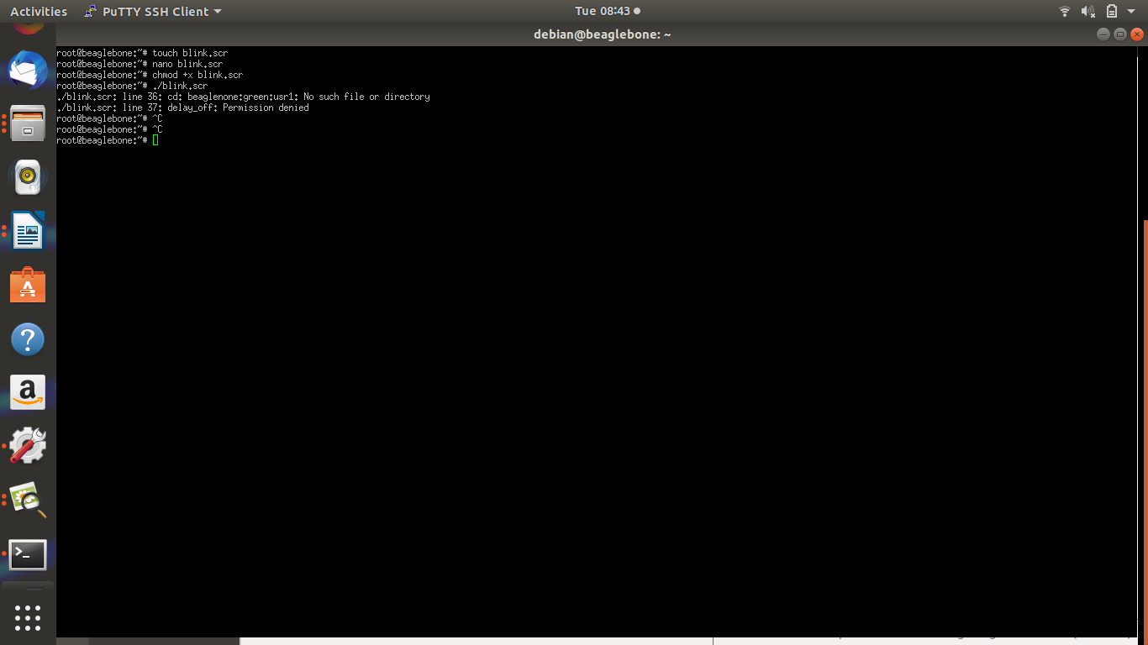

script file:

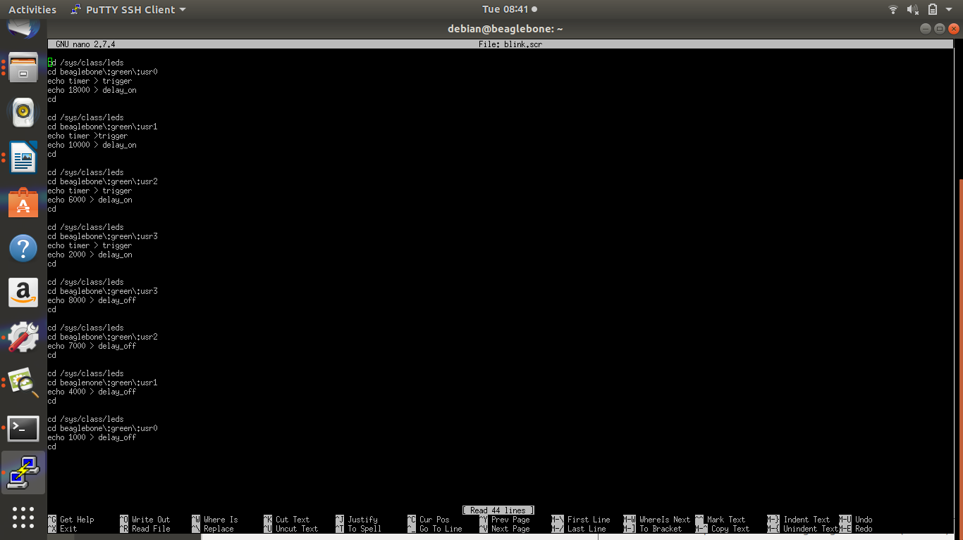

video link: https://www.youtube.com/watch?v=og7cH0sr_Hc

2.

**FLASHING THE IMAGE TO SD CARD:**

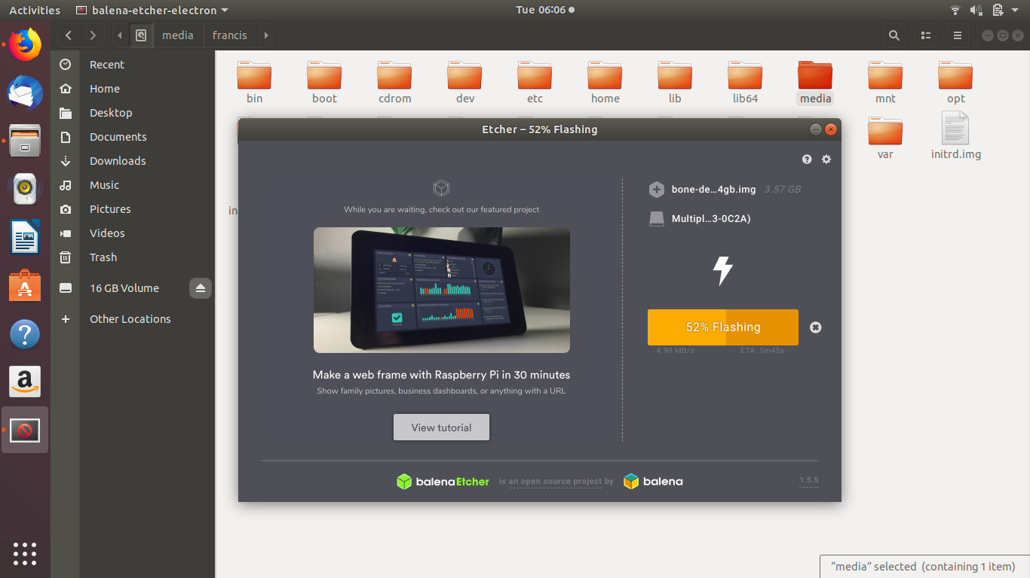

**CURRENT IMAGE FILE**

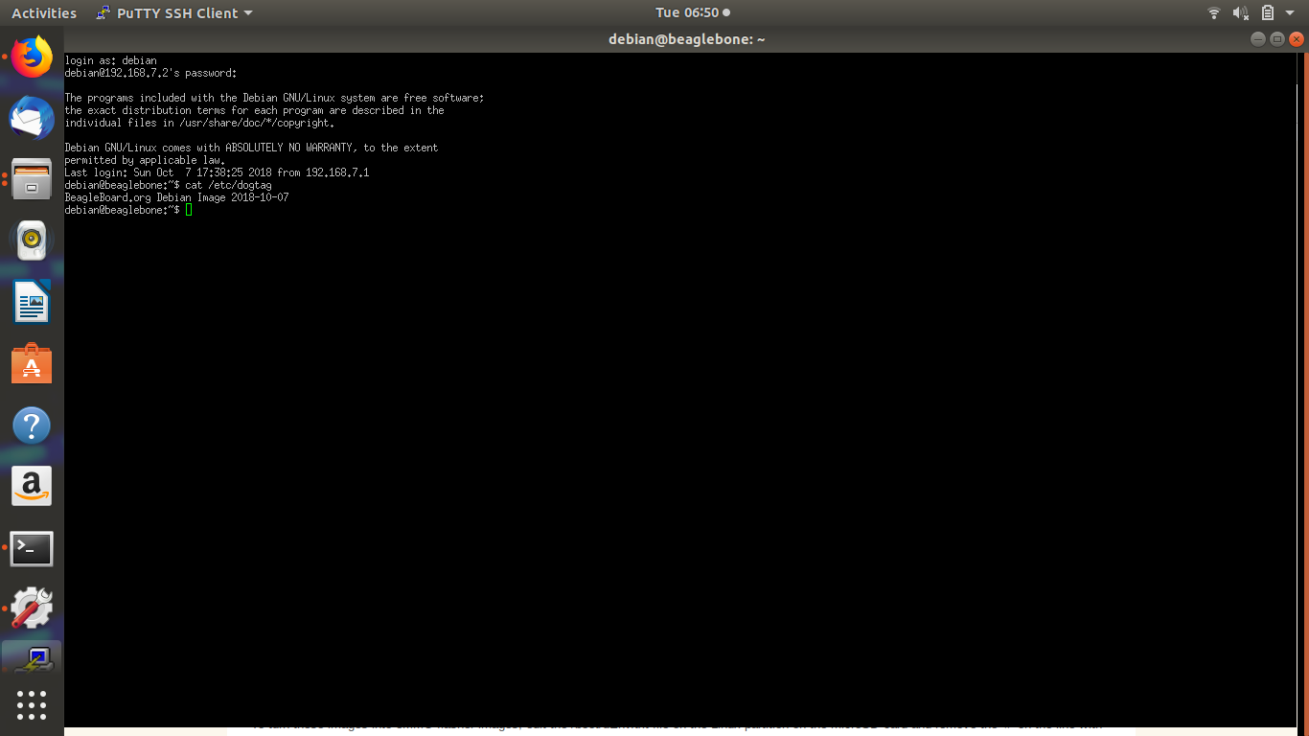

**LATEST IMAGE FILE:**

