**ESE 2025 – Embedded Operating Systems.**

**LAB 1.**

**Akhil George - C0748466**

**Francis Vijith – C0742980**

* 1. **Minicom**

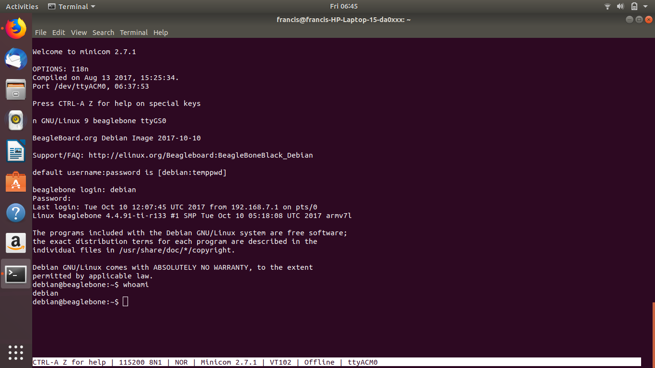

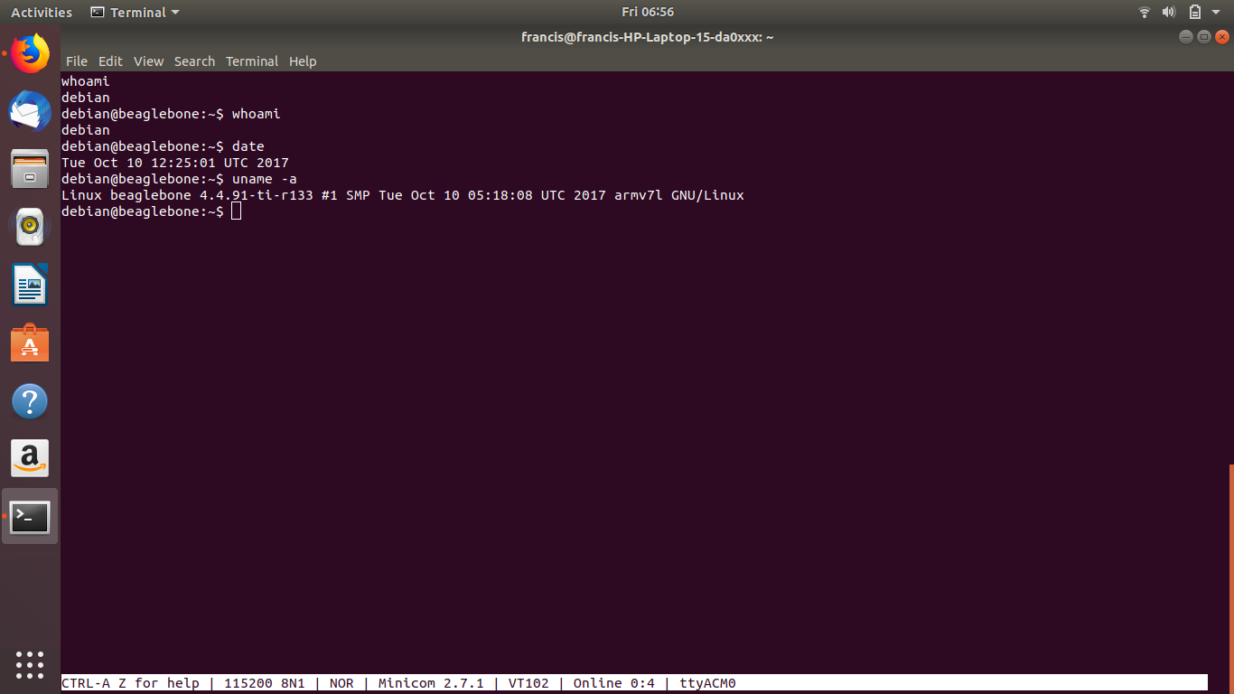

**0.2 SSH connection using Putty**

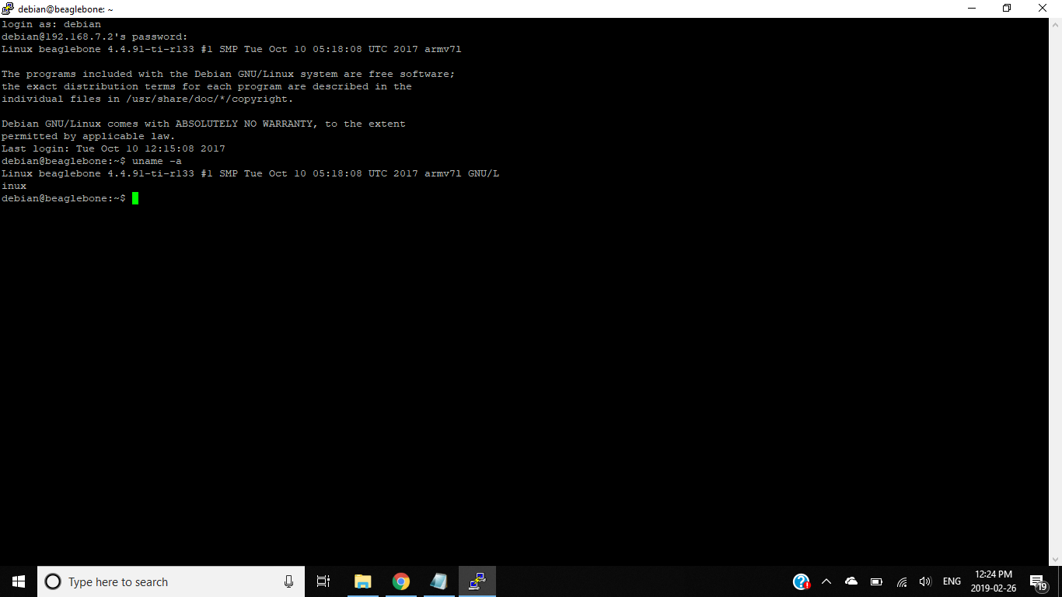

**0.3 Cloud9**

