
Program:

Course Number | 1444
Section Number | 1
Course Title | Mathematics for Embedded Systems
Semester/Year | WINTER/2019

Instructor | Mohsen Salahi

Lab No. | 2

Submission Date | 02/07/2019
Due Date | 02/07/2019

Student Name | FRANCIS VIJITH | NIBIN SOBY | AKHIL GEORGE | VIJAYAPRAKASH
Student ID | C0742980 | C0741660 | C0748466 | C0744450
Signature* | FV | NS | AG | VI

*By signing above you attest that you have contributed to this submission and confirm that all work you have contributed to this submission is your own work. Any suspicion of copying or plagiarism in this work will result in an investigation of Academic Misconduct and may result in a “0” on the work, an “F” in the course, or possibly more severe penalties.

Lab #6
Finding roots
1.
BISECTION METHOD

#include"pch.h"
#include <iostream>
#include<cmath>

using namespace std;

//Function to find the value of equation (x^5) + (x^3) + 3
double f(double);

int main()
{
float a = -2; //interval1
float b = 2; //interval2
float c;
double ba = (b - a) / 2;

//bisection method
for (int i = 1; i<=5; i++)
{
c = (a + b) / 2; //mid point c
cout << "--Iteration number" << i << "--" << endl;
cout << "a"<<i<<" = " << a << endl;
cout << "b"<<i<<" = " << b << endl;
cout << "c"<<i<<" = " << c << endl;
cout << "f"<<i<<"(c) = " << f(c) << endl;

// checking for the condition 1
if (f(a) * f(c) < 0)
b = c;

// checking for the condition 2
else if (f(a) * f(c) > 0)
a = c;
cout << "New - a = " << a << endl;
cout << "New - b = " << b << endl;
//Finding the error
ba = (b - a) / 2;
cout << "(b - a) / 2 = " << ba << endl;
cout << endl;
}
//Displaying the root of equation
cout << endl;
cout << "The root of the equation (x^5) + (x^3) + 3 using Bisection method = " << c << endl;

return 0;
}

//Function returns the value of equation (x^5) + (x^3) + 3
double f(double x)
{
return (pow(x, 5) + pow(x, 3) + 3);
}
OUTPUT: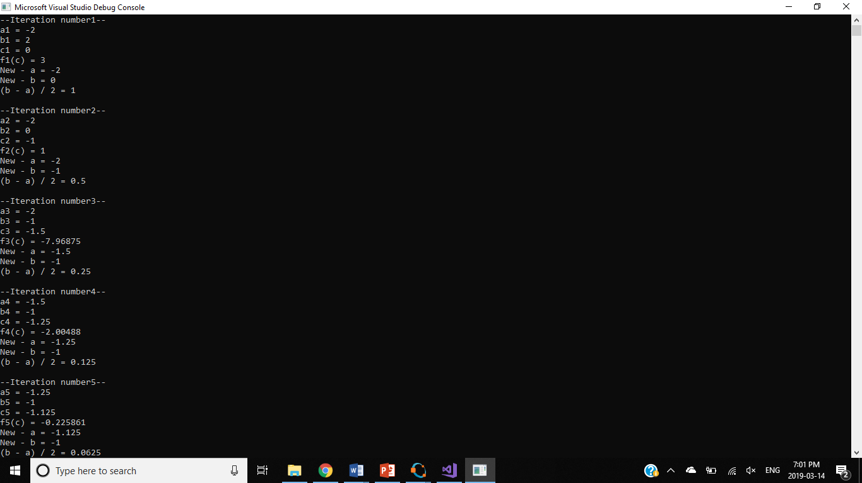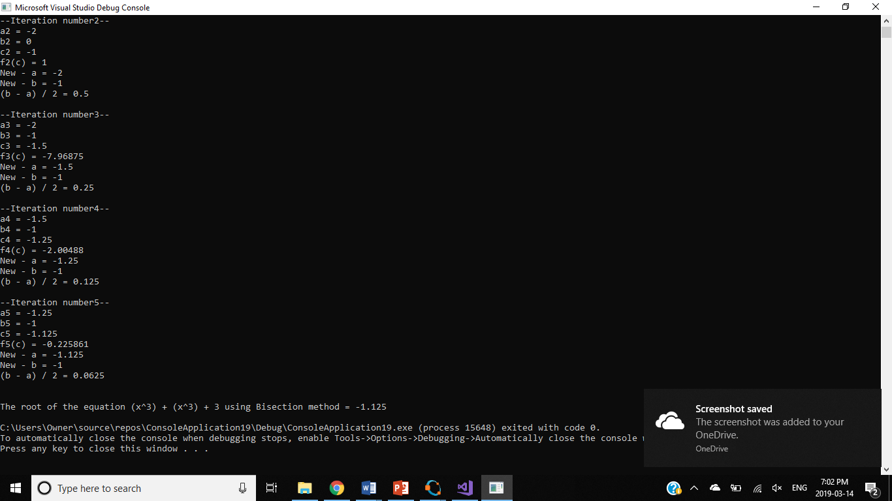

2.NEWTONS’S METHOD

#include"pch.h"
#include <iostream>
#include<cmath>
#include<iomanip>

using namespace std;

double f(double); //(x^5) + (x^3) + 3
double df(double); //derivative of (x^5) + (x^3) + 3

int main()
{
float x0 = -2; //Intial guess value
float x; //X(k+1)
float E = 0.001; //Predefined Error
float error = 1; //Calculated error

for (int i = 0; error > E; i++)
{
//Calculating x(k+1)
x = x0 - (f(x0) / df(x0));
cout << "x" << i + 1 << " = " << x << endl;;
//Calculating x(k+1)-x(k)
error = x0 - x;
if (error < 0)
error *= (-1); //Finding true error
cout << "error = " << error << endl;
cout << endl;
x0 = x; //x(k+1) = x
}
//Displaying the root of equation
cout << endl;
cout << "The root of the equation (x^5) + (x^3) + 3 using Newtons Method = " << x0 << endl;
return 0;
}

//(x^5) + (x^3) + 3
double f(double x)
{
return ((pow(x, 5)) + (pow(x, 3)) + 3);
}

//derivative of equation (x^5) + (x^3) + 3
double df(double x)
{
return (5 * (pow(x, 4)) + 3 * (pow(x, 2)));
}

OUTPUT
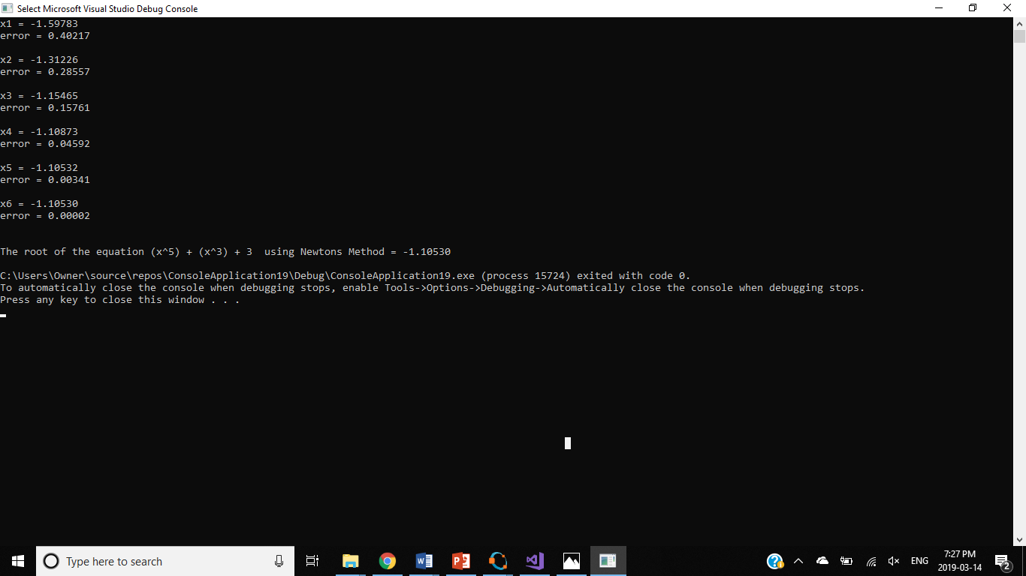

3.SECANT METHOD

#include"pch.h"
#include <iostream>
#include<cmath>
#include<iomanip>

using namespace std;

double f(double); //(x^5) + (x^3) + 3

int main()
{
double x0 = -1;
double x1 = -1.1;
double x = 0;
double error = 1;
double E = 0.001;

for (int i = 0; error > E; i++)
{
x = x0 - (f(x0) * ((x0 - x1) / (f(x0) - f(x1)))); //Iteration
error = x - x0;
if (error < 0)
error *= -1; //Finding the modulus of error

x0 = x;
x1 = x0;
}
cout << endl;
cout << "The root of the equation (x^5) + (x^3) + 3 using Secant method = " << x << endl;
}

//Function returns the value of equation (x^5+ (x^3) + 3
double f(double x)
{
return ((pow(x, 5)) + (pow(x, 3)) + 3);
}

