
Program:

Course Number | 1444
Section Number | 1
Course Title | MATHEMATICS FOR EMBEDDED SYSTEMS
Semester/Year | WINTER/2019

Instructor | Mohsen Salahi

Lab No. | 1

Submission Date | 01/22/2019
Due Date | 01/23/2019

Student Name | FRANCIS VIJITH | NIBIN SOBY | AKHIL GEORGE | VIJAYAPRAKASH
Student ID | C0742980 | C0741660 | C0748466 | C0744450
Signature* | FV | NS | AG | VI

*By signing above you attest that you have contributed to this submission and confirm that all work you have contributed to this submission is your own work. Any suspicion of copying or plagiarism in this work will result in an investigation of Academic Misconduct and may result in a “0” on the work, an “F” in the course, or possibly more severe penalties.

PROGRAM CODE:

#include "pch.h"
#include <iostream>
using namespace std;

int main()
{
float epsilon = 1; //assigning epsilon equals to 1
while (1 + epsilon > 1) //checking the conditions
{

epsilon = epsilon / 2;
cout << epsilon << endl;

}
cout << "the amount of round off error is " << epsilon << endl;
//printing the result
}

RESULT

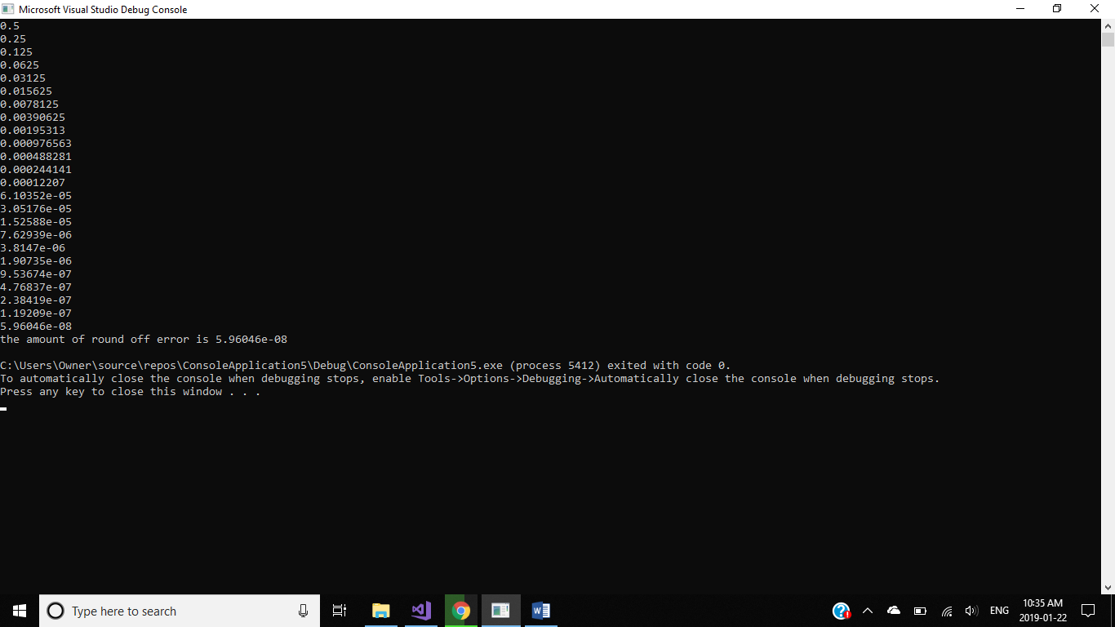

FLOWCHART
