**A PROPOSED OFFERING OF A HOTEL RESERVATION MANAGEMENT SYSTEM FOR EUROTEL NORTH EDSA**

A Project Proposal Presented to the

Faculty of Datamex College of Saint Adeline, Inc.

In Partial Fulfillment of the Requirements for the

Degree ofBachelor of Science in Information Technology

By:

Adarayan, Jessie

Anacta, Francis Rico

Bernadas, Marjorie

Pedro, Pamela Anne

**INTRODUCTION**

In the hotel industry, the reservation process is one of the most important parts of daily operations. It is usually the first step that guests encounter before staying in a hotel, and it can affect their overall experience. A smooth and well-organized reservation process gives a good impression to the customers and makes hotel operations easier for the admin. However, if the process is slow or confusing, it can cause delays, errors, and dissatisfaction for both guests and employees. Because of this, many hotels are now shifting from traditional manual booking methods to computerized reservation systems. The system is designed to make the process faster, more accurate, and more convenient for everyone involved.

The Hotel Reservation Management System is designed to help improve and simplify the reservation process for both walk-in and online guests. It provides an easier and more reliable way for customers to secure a room and for hotel admin to manage bookings efficiently. This project specifically focuses on developing a reservation system for Eurotel North Edsa Hotel to improve how their front desk operates on a daily basis. The system will allow real-time monitoring of room status—whether a room is available, occupied, or under maintenance. It will handle both online and walk-in bookings and make check-in and check-out procedures faster and more organized. Guests will be required to settle their payment upon arrival to confirm their booking. The system will also keep a secure and organized database of guest details and booking records, which will help the hotel admin provide better service and manage operations more smoothly.

This project focuses on the Eurotel North Edsa Hotel, where the front desk plays a big role in handling guest reservations. Every day, the admin needs to manage different tasks, such as assisting walk-in guests, confirming online bookings, keeping track of which rooms are available or occupied, and processing check-ins and check-outs. Doing all of these manually takes a lot of time and effort, and there is a higher chance of mistakes like double bookings or lost records. With the proposed system, these challenges can be solved by automating many of the tasks that are usually done by hand.

Another important part of the system is its organized database. All guest details and booking records will be stored in a secure and systematic way. This will help the admin access information quickly whenever needed and provide better service to guests. It also reduces the risk of losing important data since everything is recorded digitally. The database can also serve as a reference for future transactions, allowing the hotel to build guest profiles and improve customer service in the long run.

By using this system, the hotel will benefit from faster transactions, fewer manual tasks, and more accurate records. Admin will be able to save time and focus more on assisting guests instead of doing repetitive paperwork. At the same time, guests will enjoy a smoother experience since check-in and check-out will be more organized and hassle-free.

Overall, the Hotel Reservation Management System is not only designed to make reservations easier but also to support the hotel’s daily operations more effectively. It improves accuracy in booking management, secures guest information, and helps admin work more efficiently. For the guests, it provides convenience, reliability, and a better overall hotel experience. For the hotel, it ensures smoother operations and a more professional image. This project shows how technology can modernize hotel services and provide benefits for both customers and employees.

**CLIENT INFORMATION**

This section provides background about the client organization, including its business focus, market, and key stakeholders. It outlines the client’s role, their service offerings, and the primary contact person for the project. This information ensures that the system is developed according to the client’s needs, goals, and operational requirements.

Our client for this system is Eurotel North Edsa, one of the branches of Eurotel Hotel Corporation. The key stakeholder for this project is Mr. Jhay Sanchez, who can be contacted at 0992-511-7431 or through his official Facebook page at Eurotel North Edsa Hotel.

Eurotel Corporation, founded in 2009, is a well-established company in the hospitality industry. Headquartered in Almanza Uno, Las Piñas, Metro Manila, the company has built a strong reputation for providing exceptional hospitality services to its guests. Over the years, Eurotel has positioned itself as a premier destination for both local and international travelers, offering luxurious accommodations and top-notch amenities at competitive prices.

In the Philippines, Eurotel has grown into a hotel chain that blends European-inspired design with affordability. Its primary market consists of middle-class clients, making it a practical yet elegant choice for travelers. Aside from lodging services, Eurotel generates revenue through its food and beverage offerings, event space rentals, and hotel reservations. The brand continuously adapts to the evolving needs of its customers by upgrading hotel facilities and focusing on convenience and client satisfaction.

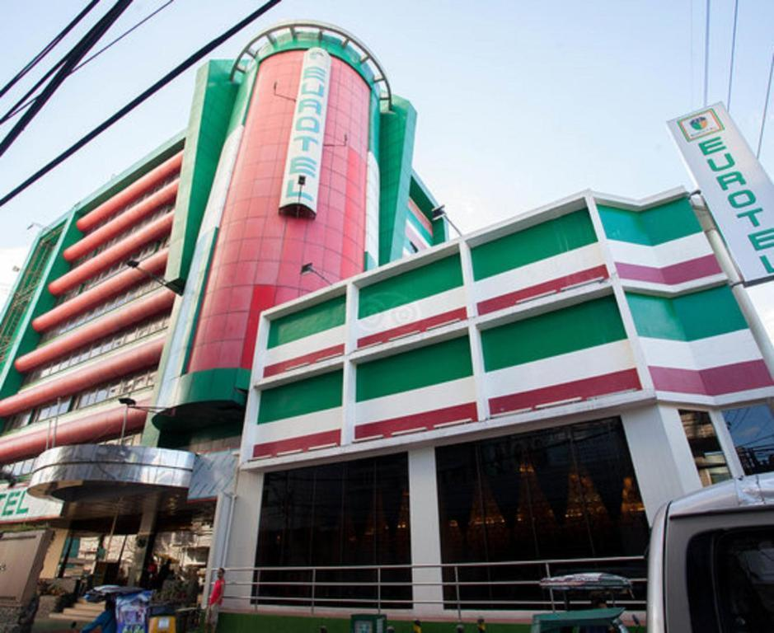

*Figure 1. Client Information*

**PROJECT SCOPE**

This section defines the overall objectives and boundaries of the project. It outlines the specific goals to be achieved, the features and functions to be included, and the limitations of the system. It also identifies the assumptions made during development and the constraints that may affect design, performance, and implementation.

The project aims to enhance the operational efficiency of Eurotel North Edsa through the development of a reliable and user-friendly hotel management system This system is designed to streamline the reservation process, ensure greater accuracy of information, and improve admin productivity integrating faster guest transactions enhanced resource accountability, and real-time updates the system will support more effective decision-making and operational management These improvements are expected to minimize errors save time and foster a smoother workflow Ultimately, the project seeks to provide both admin and guests with a more seamless efficient and satisfying hotel experience.

● Improve the efficiency of admin workflows in managing the hotel reservation.

● Enhance monitoring to minimize manual errors and save time.

● Establish accountability for the usage of laboratory equipment.

● To simplify and speed up the check-in and check-out process for guests.

● To provide accurate, real-time information on room availability and pricing.

● To handle cancellations, rebooking, and reservation changes efficiency.

INCLUSIONS:

* The system will allow online and walk-in guests to make reservations.
* Room availability and pricing will be updated in real-time.
* The system will support check-in and check-out transactions for faster guest service
* Admin will be able to manage reservations, cancellations, rebooking, and changes efficiently.
* Guest accounts and personal details can be stored securely for future reference.
* Payment records will be included but limited to over-the-counter transactions.
* Reports on occupancy, reservations, and transactions will be generated for management use.
* User authentication will be implemented to ensure secure access for administrators.

EXCLUSIONS:

* The system will not support online payment.
* The system will not manage payroll, or human resource activities.
* Marketing and promotional features such as email campaigns or loyalty programs are not included.
* External system integration (e.g., airline booking or third-party travel apps) is excluded.

ASSUMPTIONS:

* Guests using the system will provide accurate and valid personal information during registration.
* Walk-in reservations will be directly encoded by hotel admin into the system.
* Stable internet connection and functional computer terminals will be available for the system to operate properly.
* Administrators will undergo basic training to use the system effectively.
* Over-the-counter payments are assumed to be verified manually by admin.

CONSTRAINTS:

* The system will run only on the hotel’s local network and approved devices.
* Only authorized personnel can access the administrative functions of the system.
* System development must align with the hotel’s existing hardware and infrastructure.
* The project budget and timeline may limit the inclusion of advanced features

**PROJECT APPROACH**

This section explains the strategy and methodology used in developing the system. It outlines the chosen framework, key phases of work, and major activities to be carried out. The approach highlights how the project will be planned, executed, tested, and refined to ensure successful implementation and alignment with client needs.

The goal of the Hotel Reservation Management System project is to create a reliable and efficient platform where guests can easily book rooms, and hotel admin can manage reservations, guest records, billing, and availability. The system will enhance the efficiency of hotel operations, reduce human error, and improve customer satisfaction by allowing real-time access to booking information.

**Methodology and Framework**

The project will use the Agile Methodology, which supports step-by-step development and continuous improvement. This approach allows the team to work closely with stakeholders, adjust based on feedback, and deliver usable parts of the system gradually. By doing so, the system can be refined throughout development, leading to better results and fewer delays.

**Key Activities and Milestones:**

● Requirements Gathering - Identify and document the features needed by the hotel, such as room booking, guest information, payment tracking, and admin controls.

● System Design -Create the overall structure and user interface of the system, ensuring it is user-friendly and tailored to hotel operations.

● Development Phase - Begin building the system in parts, starting with core features like online reservations, followed by guest records and admin tools.

● Testing and QA - Test each part of the system to ensure functionality, accuracy, and security. Fix any issues or bugs found during this phase.

● Client Review & Feedback - Present the system to hotel admin or stakeholders for feedback and make improvements based on their suggestions.

● Deployment -Launch the system for actual use in the hotel environment.

● Post-Deployment Support -Monitor the system, provide updates if needed, and ensure it continues to meet the needs of the users

**PROJECT TEAM**

This section describes the group responsible for developing the system. It highlights the team’s skills, roles, and collaborative efforts in planning, designing, and implementing the project. The team is tasked with ensuring the system is reliable, efficient, and aligned with the client’s operational needs.

Our team consists of dedicated and skilled individuals with strengths in software engineering, system analysis, and data gathering. We work together on project planning and the development of a Hotel Reservation Management System that simplifies the reservation process, efficiently manages room status, and improves overall guest satisfaction. We are committed to building a reliable, user-friendly, and efficient system that meets the operational needs of hotels while ensuring a seamless and convenient reservation experience for guests.



**ANACTA, FRANCIS RICO G.**

Roles: Software Engineer, System Analyst

Skills & Experience: Skilled in building the system and

checking if it works well based on user and business needs.

**BERNADAS, MARJORIE**

Roles: System Analyst, Software Engineer

Skills & Experience: Studies how the system should work, plans how it will be used, and also helps in creating and implementing the system.

**PEDRO, PAMELA ANNE D.**

Role: Data Gatherer

Skills & Experience: Collects important information

needed for the system and helps organize it so the team knows what to include.

**ADARAYAN, JESSIE**

Role: Data Gatherer

Skills & Experience: Gathers and presents data that helps in planning the system and ensuring everything is complete and clear.

**PROJECT TIMELINE**

This section outlines the schedule of the project. It presents the sequence of phases, key milestones, and expected deliverables to ensure the system is developed and implemented within the planned timeframe.

The project will follow the Software Development Life Cycle (SDLC), with each phase building upon the last. This timeline highlights key milestones, deliverables, and dependencies essential to the system's successful delivery.

|  |  |  |  |  |
| --- | --- | --- | --- | --- |
| **Phase** | **Duration** | **Start Date** | **End Date** | **Milestones/ Deliverables** |
| 1.Brainstorming | 1 days | July 10, 2025 | July 11, 2025 | Identify system purpose, target users ( admin),define basic features (booking, availability) |
| 2.Requirements Gathering | 5 days | July 12, 2025 | July 16, 2025 | List of features, client needs, and initial system requirements |
| 3. System Design | 1 week | July 17, 2025 | July 23, 2025 | System layout, wireframes,  database structure, and interface designs |
| 4.Front-End Development | 2 weeks | July 24, 2025 | August 6, 2025 | Design and code user interface: home page, booking form, login page |
| 5.Database  Development | 1 week | August 7, 2025 | August 13, 2025 | Build tables for rooms, guests, bookings, admins |
| 6.Back-End Development | 2 weeks | August 14, 2025 | August 27, 2025 | Implement logic: booking  validation, search, user login, admin functions |
| 7.Testing & Debugging | 1 week | August 28, 2025 | September 3, 2025 | Simulate bookings, test invalid cases, fix errors |
| 8.Finalization & Deployment | 1 week | September 4, 2025 |  | Clean up UI, finalize functions, submit system, and document |

**Dependencies:**

* Brainstorming - This is where we start the planning and thinking of ideas for the system, including its purpose and basic features.
* Requirements Gathering - Depends on brainstorming because we need to have a clear idea of the system’s features and flow before gathering the full requirements.
* System Design - Depends on the requirements since the design (like layout and database structure) should match what the client wants.
* Front-End Development - Depends on the system design so we know exactly how the interface should look and function before coding it.
* Database Development - Depends on the system design since the database structure needs to match how the system will store and organize data.
* Back-End Development - Depends on both the front-end and database. The logic behind the system connects what the user sees with the data stored.
* Testing & Debugging - Depends on the development phase. We can only test the system properly once the features are complete and working.
* Finalization & Deployment - Depends on testing. After fixing bugs and getting feedback, we can finalize and submit the system.

**Critical Path**

* Phase 1: Brainstorming – Establishes the core ideas, vision, and objectives for the system.
* Phase 2: Requirements Gathering – Identifies user needs, hotel admin requirements, and overall system goals.
* Phase 3: System Design – Creates the visual layout and structural design, serving as a blueprint for development.
* Phase 4: Front-End Development – Builds the user interface (UI) that guests and admin will directly interact with.
* Phase 5: Back-End Development – Implements the system’s core logic and functionalities, ensuring proper operations.
* Phase 6: Testing & Debugging – Examines the system for errors, bugs, and inconsistencies, then applies necessary fixes.
* Phase 7: Finalization & Deployment – Completes final adjustments, installs the system, and makes it ready for use.

**PROJECT RESOURCES**

This section identifies the hardware, software, and human resources required for the project. It specifies the tools, equipment, and team members necessary to design, develop, and implement the system. The resources outlined ensure that the project has the proper support, budget, and technical capabilities to achieve its goals.

Hardware:

● Minimum intel core i5 10th gen - The device that will be used for the system to work. A maximum of 3 devices for the department is needed.

Software:

● Visual Studio Code- To create dynamic, interactive, and engaging user experiences on the computer laboratory management system. It is a versatile, client-side/server-side scripting language that works alongside HTML and CSS to provide functionality and interactivity.

● MySQL– MySQL is a widely open-source database, which is good for students, and small businesses without licensing issues. And also, VS CODE is easy to connect to MySQL

Human Resources:

* Project Manager – Handles the overall planning, monitoring, and organization of project tasks to make sure the system is completed on time.
* System Developers – Create and implement both the front-end and back-end features of the hotel reservation system.
* Interface Designer – Focuses on creating a simple and user-friendly layout for guests, and administrators.
* Database Manager – Designs, maintains, and secures the hotel’s database for accurate storage of guest and reservation records.
* Technical Support Team – Provides assistance in system troubleshooting, maintenance, and user concerns after deployment.

|  |  |  |  |  |
| --- | --- | --- | --- | --- |
| **Category** | **Purpose** | **Description** | **Unit Cost** | **Total Cost** |
| Hardware | To enable hotel admin to work efficiency | 3 PC/ LAPTOP + extra monitors | ₱25,000 | ₱75,000 |
| Print reservation receipts and reports | 1 Printer | ₱12,000 | ₱10,000 |
| For documents backups | 1 USB/Flash Drive | ₱3,000 | ₱3,000 |
|  |  |  | Total | ₱88,000 |

**RISK MANAGEMENT**

Risk Management is essential in ensuring the success of the Hotel Reservation Management System project by identifying, analyzing, and mitigating potential issues that may affect the project's timeline, quality, or objectives. The following outlines the key risks, their potential impacts, and corresponding mitigation strategies.

**Identified Risks:**

1. **Incomplete or Misunderstood Requirements** - There is a risk that the information provided may be unclear, incomplete, or inconsistent, which could lead to the development of incorrect or unnecessary system functionalities.

2. **Delays in Project Timeline**: Unexpected circumstances like technological issues, a lack of resources, or team members'personal affairs might cause delays in reaching project goals.

3. **Technical Limitations**: The development team might face difficulties working with VB.NET, SQL Server, or while integrating the front-end and back-end components of the system.

4. **System Downtime**: Unplanned outages or server crashes can halt hotel operations.

5. **Data Breach**: Unauthorized access to guests' personal and payment information.

6. **Double Booking**: System errors leading to multiple reservations for the same room.

7. **User Error**: Mistakes made by hotel admin due to lack of training or poor UI.

8. **Failure Integration**: Issues connecting the system with third-party services (e.g., payment gateways, OTA platforms

9. **Scalability Limitations**: Systems might not perform well during peak seasons with high user demand.

**Mitigation strategies for addressing identified risks:**

1. **Clarify and Validate Requirements**: Conduct regular consultations and feedback sessions with stakeholders. Use mock-ups and system flow diagrams to confirm requirements before development.

2. **Strict Timeline Monitoring**: Follow a detailed project timeline based on SDLC. Use Agile methodology to track progress and make necessary adjustments weekly.

3. **Enhance Technical Skills**: Provide quick technical upskilling sessions or access to learning resources. Assign tasks based on individual team strengths.

4. **System Downtime:** Implement cloud-based infrastructure with auto-scaling and regular backups.

5. **Data Breach:** Encrypt sensitive data, apply strict user authentication, and follow GDPR/data protection compliance.

6. **Double Booking:** Implement real-time room availability updates and automatic conflict checks.

7. **User Error:** Provide comprehensive training and develop an intuitive user interface with error validation.

8. **Integration Failure:** Conduct thorough API testing and maintain fallback protocols for critical services.

9. **Scalability Limitations:** Use modular architecture and load testing to ensure the system can grow with demand.

**COMMUNICATION PLAN**

Effective communication is essential to our group to maintain smooth collaboration and avoid misunderstandings. This communication plan outlines how collected data information will be shared, how meetings will be conducted to have a successful execution of our project Hotel Reservations Management System for Eurotel North Edsa.

FREQUENCY AND FORMAT OF PROJECT MEETINGS

KEY STAKEHOLDERS AND THEIR COMMUNICATION PREFERENCES

|  |  |  |  |  |
| --- | --- | --- | --- | --- |
| **Name of Meeting** | **Participants** | **Purpose** | **Frequency** | **Type** |
| **Brainstorming** | All Members | Discussion and decision  making to improve our Project | Daily | Group Chat |
| **Weekly Status Update** | All Members | Discuss progress issue and reviews address | Weekly | In-Person Meeting |
| **Project Risk Management** | All Members | Evaluation progress against project’s goals and objectives | Monthly | In-Person Meeting |

**PROJECT GOVERNANCE**

The Hotel Booking Management System project will be governed collaboratively by all group members, with different roles to ensure accountability and efficiency. We will conduct a weekly group meeting to monitor the progress, resolve problems, and see if there's a necessary plan to adjust. Decisions will be made through discussion and in case of disagreement, each member in our group will vote.

|  |  |  |  |
| --- | --- | --- | --- |
| **Stakeholder** | **Role** | **Preferred Communication** | **Notes** |
| Hotel Management (Eurotel) | Eurotel’s Manager | Weekly email updates, summary meetings | Focus on project status, milestones, and budget |
| Development Team | Build the system. Oversees project execution. | Stand-ups, code reviews, Slack/Teams | Needs technical clarity and timely feedback |
| Admin | End User | Testing logs, email,  meetings | Requires access to test builds and change logs |

Effective communication is essential to our group to maintain smooth collaboration and avoid misunderstandings. This communication plan outlines how collected data information will be shared, how meetings will be conducted to have a successful execution of our project Hotel Reservations Management System for Eurotel North Edsa.

ROLES AND RESPONSIBILITIES OF PROJECT STAKEHOLDERS

* DEVELOPMENT TEAM - Responsible for designing and implementing the software components of the system using Microsoft Visual Basic 2010. Also, design and manage the SQL Server database, including table structures, security and performance.
* PROJECT MANAGER – Responsible for coordinating with developers, stakeholders, and users.
* BUSINESS OWNER/CLIENT – Responsible in alignment with Eurotel’s strategic goals.
* QA/TESTER – Conduct testing of system to ensure its functionality before deployment
* ADMIN (END USERS) – Involves in conducting a testing to ensure system functionality and usability. Also, will provide a feedback session

**APPENDIX**

The appendix provides supplementary materials that support the main content of the study. It contains additional references, research summaries, task distributions, diagrams, and other supporting documents that give readers deeper insights without overcrowding the main sections. These materials are essential for validating the research, showing related works, and presenting detailed data that may be too lengthy for the core chapters.

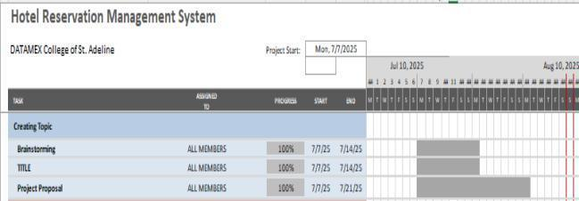

*Table 1: Gantt Chart of HRMS*