Locomotive: RENFE 333.3 and 333.4 | Track: 2% Grade (CTN test route) | Load: 600 t | Date: May 2026
1. Introduction
During the calibration of the 333.3 and 333.4 locomotives using the Teluroncio Method, anomalous behaviour was detected: the equilibrium speed on the 2% grade with 600 t was lower than expected according to the rated power of the diesel engine (2,237 kW). It was suspected that the ORTSMaxTractiveForceCurves parameter present in the .inc files — added by an unidentified third party at an unknown date — was artificially limiting tractive effort. This experiment compares the performance of both locomotives with and without said curves.
2. Materials
• Locomotives: 333.3 and 333.4 Series (2,237 kW, 120 t, previously calibrated with the Teluroncio Method except regarding the curves).
• Standardised test: CTN test route by Peter Newell on a 2% grade with a trailing load of 600 t. ( link to route )
• Software: Open Rails New Year MG 171.3.
• Tools: Open Rails HUD (speed, tractive effort, rail horsepower).
3. Empirical Method
An A/B comparison is carried out for each locomotive:
• Configuration A: With the ORTSMaxTractiveForceCurves (...) block present in the .inc file (original values, with a peak of 345 kN).
• Configuration B: Without the ORTSMaxTractiveForceCurves block (deleted or commented out ).
Procedure:
1. Load the locomotive with Configuration A in the standardised test (2% grade, 600 t).
2. Progressively apply 100% throttle from speed 0 and wait for the speed to stabilise.
3. Record the HUD values: speed (km/h), tractive effort (kN), and rail horsepower (kW).
4. Observe and qualitatively note the stability of the tractive effort (whether it oscillates or remains constant).
5. Modify the .inc file by removing the ORTSMaxTractiveForceCurves block.
6. Repeat steps 1 to 4 with Configuration B.
7. Compare results.
4. Results
4.1 Locomotive 333.3
Parameter | Configuration A (with curves) | Configuration B (without curves) | Difference
Stabilised speed (km/h) | 40.1 | 45.0 | +4.9 (+12.2%)
Rail horsepower (kW) | 1,957 | 2,222 | +265 (+13.5%)
Max. tractive effort (kN) | 345 (limited) | unlimited | —
Stability | Periodic oscillations | Stable | —
Table 1: Stabilised speed, rail power, tractive effort, and stability on a 2% grade with a 600 t trailing load. Comparison between original ORTSMaxTractiveForceCurves (A) and without them (B). Locomotive: RENFE 333.3. Dry conditions.
4.2 Locomotive 333.4
Parameter | Configuration A (with curves) | Configuration B (without curves) | Difference
Stabilised speed (km/h) | 44.4 | 45.1 | +0.7 (+1.6%)
Rail horsepower (kW) | ≈1,960 | ≈2,222 | +262 (+13.4%)
Max. tractive effort (kN) | 345 (limited) | unlimited | —
Stability | Periodic oscillations | Stable | —
Table 2: Stabilised speed, rail power, tractive effort, and stability on a 2% grade with a 600 t trailing load. Comparison between original ORTSMaxTractiveForceCurves (A) and without them (B). Locomotive: 333.4. Dry conditions.
5. Analysis
The original ORTSMaxTractiveForceCurves imposed a maximum limit of 345 kN on tractive effort. At speeds of 30–45 km/h, the rated power of 2,237 kW would theoretically allow efforts exceeding that value (P = F × v). The curve therefore acted as an artificial "ceiling" preventing the diesel engine from delivering its full power.
The behaviour observed in the HUD with Configuration A was cyclical: effort rose to 345 kN, the curve cut it back, power dropped, speed decreased slightly, and the cycle repeated. This generated the oscillations visible on the effort indicator. A detailed study of the curve showed that, although the tractive effort graph comprised a section limited by the adhesion coefficient and a parabola, with both curves joined at the continuous effort speed, the power curve displayed irregular behaviour (as previously observed on the HUD), tending to increase where a constant power curve would be expected.
With Configuration B, the limit set by the parameter having disappeared, the locomotive could convert all the diesel power into tractive effort, stabilising at a higher speed. The improvement was more notable in the 333.3 (+12.2%) than in the 333.4 (+1.6%), probably because the latter had a far less restrictive curve.
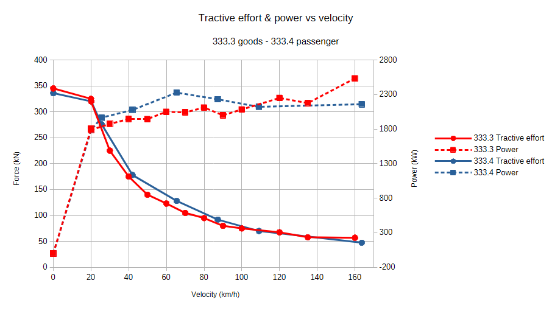
Figure 1: Original ORTSMaxTractiveForceCurves digitised from the respective .inc files. Both curves share an identical peak of 345 kN at low speed, despite corresponding to locomotives with the same prime mover (2,237 kW) and weight (120 t). The 333.4 curve descends more steeply in the 20–40 km/h range, consistent with its higher continuous speed design for passenger service. At high speed, both curves exhibit unphysical power oscillations (visible as irregular steps in the force curve) instead of a smooth constant-power hyperbola. This figure is the starting point for the diagnosis carried out in Experiment #2.
6. Conclusions
• The originally established ORTSMaxTractiveForceCurves block throttled rail horsepower by approximately 13.5% (-265 kW), significantly reducing the equilibrium speed on the grade.
• Removing this block allows the locomotive to express its full rated power, stabilise the tractive effort, and eliminate unrealistic oscillations.
• The improvement is especially relevant in locomotives whose original curve was more restrictive (333.3), as it had a less natural layout in the mechanical plane.
• Teluroncio Method recommendation: If an abnormally low stabilised speed with oscillations on the HUD is observed during calibration, remove ORTSMaxTractiveForceCurves as the first diagnostic step.
Note (June 2026): Subsequent investigation revealed that the original 2015 release of this locomotive did not include ORTSMaxTractiveForceCurves. The curves analysed in this experiment were most probably generated by the author of this report at an earlier stage of the project, using estimation tools without empirical validation. The Teluroncio Method made it possible to detect and correct this error, demonstrating the importance of experimental validation over purely theoretical estimation. The diagnosis and conclusions presented here remain valid: the curves restricted performance, and their removal improved it.
7. References
dell´Olio, L., Oreña, B. A., Moura Berodia, J. L. Tracción y adherencia, Ferrocarriles. Apuntes de clase. Universidad de Cantabria. 2023.
Open Rails Team. Open Rails 1.6.1 manual. Release 1.6.1.0. 2026.

May 2026

