Locomotive: RENFE 333.4 | Track: Level (CTN test route) | Traction curves: Pre-existing, without, custom | Date: May 2026
1. Introduction
In Experiment #2, it was demonstrated that the ORTSMaxTractiveForceCurves present in the .inc files of the 333.3 and 333.4 — added by an unidentified third part — contained an irregularly constructed curve, with a restrictive peak of 345 kN that acted as an artificial ceiling. This throttled the rail power to 1,950 kW (well below the nominal 2,237 kW) and generated severe oscillations in the recorded tractive effort data (HUD and logs).
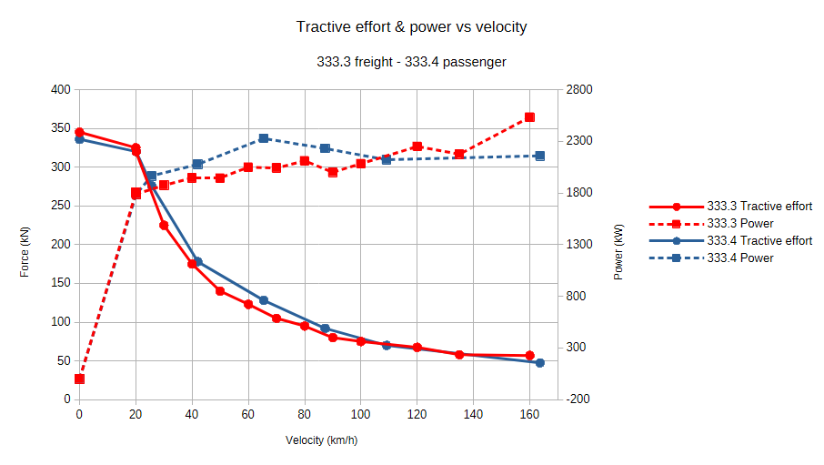
Figure 1: Pre-existing ORTSMaxTractiveForceCurves for the RENFE 333.3 (freight) and 333.4 (passenger) series, digitised from their respective .inc files. Both curves share an identical peak of 345 kN at low speed, despite corresponding to locomotives with the same prime mover (2,237 kW) and weight (120 t). At high speed, both exhibit unphysical power oscillations (visible as irregular steps) instead of a smooth constant-power hyperbola. This figure motivates the investigation carried out in Experiment #3.
As a natural evolution of the method, the objective of Experiment #3 was not simply to eliminate the faulty curve, but to construct, from authentic technical documentation, a mathematically and physically correct curve that reflects the real capabilities of the locomotive. This document covers the entire process: the fundamental theory, the construction of the curve by resolution of physical equations using a symbolic calculus engine, its implementation in the simulator, and its final validation through the standardised Teluroncio Method test.
Note (June 2026): The pre-existing 2015 release of this locomotive did not include any ORTSMaxTractiveForceCurves. The curve replaced in this experiment was most probably generated by the author of this report at an earlier stage of the project, using estimation tools without empirical validation. The Maxima-generated curve remains physically correct and empirically validated, and the process of detecting and correcting this error underscores the core principle of the Teluroncio Method: experimental validation over theoretical estimation.
2. Materials
• Locomotive: RENFE 333.3 Series (2,237 kW, 120 t).
• Standardised Test: Peter Newell's CTN test route on a 2% grade with a trailing load of 600 t.
• Software: Open Rails NewYear MG 171.3, Maxima/WxMaxima (symbolic calculation).
• Tools: HUD (speed, tractive effort, power, consumption), logs and screenshots. The complete logs for all six test runs (A1–A6) and the corresponding HUD screenshots are available in the `/OpenRails-Logs/` folder of this repository.
3. Empirical Method
3.1 Theoretical Foundation: The Three Zones of a Real Tractive Effort Curve
A correct diesel-electric locomotive curve is defined by the physical limit of two variables: the available adhesion and the nominal engine power. This results in three distinct zones:
• Zone 1 — Adhesion Limit (Low Speed): The maximum force is that which the wheel-rail contact can transmit. If the engine develops more force, it causes wheel slip. It follows a decreasing function with speed according to the Curtius-Kniffler model: F_adh = (m·g·μ) / (1 + 0.01·V).
• Zone 2 — Power Limit (Medium/High Speed): A point is reached where the engine's nominal power is insufficient to maintain the force demanded by the adhesion limit. From this precise point, the "hyperbola of constant power" begins: F_pot = P_nom / V.
• Transition Point (Continuous Effort Speed): This is the exact speed where the adhesion curve and the power hyperbola intersect. It is the locomotive's optimal operating point.

3.2 Mathematical Construction of the Curve
Instead of imposing visual points, the curve was generated by solving the system of equations directly in the Maxima/WxMaxima symbolic engine.
Input Data (Real Documentation):
• Locomotive mass, m: 120 t
• Gravity, g: 9.81 m/s²
• Adhesion coefficient, μ: 0.33 (calibrated in CK)
• Nominal rail power, P_nom: 2,237 kW
• Maximum speed: 160 km/h
Numerical Resolution:
The transition point V_trans is found by equating the adhesion force and the power force:
m·g·μ / (1 + 0.01·V_trans) = 3.6·P_nom / V_trans
The algorithm solves this non-linear equation iteratively to obtain the exact continuous effort speed and its corresponding force, F_trans.
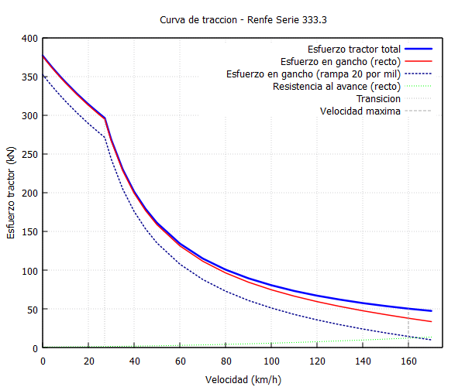
Figure 2: Complete tractive effort analysis for the RENFE 333.3 generated by version 0.2 of the Maxima/WxMaxima program (Teluroncio Method). The graph displays: total tractive effort (solid blue line), drawbar force on level track (solid red line), drawbar force on a 20‰ grade (dashed blue line), running resistance on level track (dashed green line), continuous-effort transition point (dotted grey vertical line), and maximum speed limit (dashed grey vertical line). The 32-point curve is constructed automatically by solving the adhesion and power equations; the transition speed is calculated via numerical root-finding. This plot serves as visual inspection of the curve before its implementation in the simulator. Program and source code available in /Curvas-Traccion/.
Generation of CSV Points:
Once V_trans is found:
• For V < V_trans: the theoretical adhesion curve is imposed.
• For V > V_trans: the theoretical power hyperbola is imposed.
The curve was generated using version 0.2 of the Maxima/WxMaxima program developed for the Teluroncio Method. This version introduces two key improvements over the initial prototype:
• Automatic transition point calculation: the exact continuous-effort speed (v_trans_kmh) is computed via numerical root-finding (find_root) rather than manual estimation, ensuring the adhesion-limited and power-limited zones intersect precisely where the locomotive's physics demand.
• Dual output format: in addition to the documented CSV with seven columns (speed, force, power, drawbar force at 0‰ and 20‰, etc.), the program now generates a second file (curva_traccion_OR.txt) containing exclusively speed-force pairs in a format ready for direct copy-paste into the ORTSMaxTractiveForceCurves parameter block of the .inc file. This eliminates transcription errors and streamlines the calibration workflow.
The program requires only six input parameters (mass, gravity, adhesion coefficient, nominal rail power, maximum speed, and Davis coefficients) to generate the complete curve for any diesel locomotive. The source code and documentation are available in the /Curvas-Traccion/ folder of this repository.

ORTSTractionCharacteristics(333.3_Custom
...
ORTSMaxTractiveForceCurves(
0.00 376704
0.28 372974
0.56 369318
0.83 365732
1.11 362215
1.39 358766
1.67 355381
1.94 352060
2.22 348800
2.50 345600
2.78 342458
4.17 327569
5.56 313920
6.94 301363
7.55 296172
8.33 268440
9.72 230091
11.11 201330
12.50 178960
13.89 161064
16.67 134220
19.44 115046
22.22 100665
25.00 89480
27.78 80532
30.56 73211
33.33 67110
36.11 61948
38.89 57523
41.67 53688
44.44 50332
)
)
Code 1: Custom ORTSMaxTractiveForceCurve for the RENFE 333.3, generated by version 0.2 of the Teluroncio Method Maxima/WxMaxima program. The 32 points include the automatically calculated continuous-effort transition point. Values formatted for direct copy-paste into the .inc file. Blank line between point groups indicates the transition between adhesion zone and constant-power hyperbola.

3.3 Validation in the Simulator
The standardised Teluroncio Method test (2% grade, 600 t) was applied to three configurations to close the comparative cycle:
• Configuration A: Third part curve (345 kN peak).
• Configuration B: Without ORTSMaxTractiveForceCurves.
• Configuration C: Own curve (generated by Maxima, 376.7 kN peak).
To obtain a comprehensive view, each configuration was tested with WSP (Full) and without WSP (Unknown), also recording fuel consumption.
4. Results
Table 1: Consolidated Data from the Six Test Runs
ID | Configuration | WSP | v(km/h) | ET (kN) | P (kW) | Comsuption (L) | Distance (km) | Efficiency (L/km) | Stability
A1 | Pre-existing | Yes | 39.7 | 164.0 | 1,950 | 69.9 | 3,920 | 17.83 | Oscillates
A2 | Pre-existing | No | 39.7 | 163.9 | 1,948 | 79.3 | 4,513 | 17.57 | Oscillates
A3 | Without curve | Yes | 45.4 | 164.8 | 2,223 | 56.5 | 3,522 | 16.04 | Stable
A4 | Without curve | No | 44.9 | 166.1 | 2,223 | 58.7 | 3,626 | 16.19 | Stable
A5 | Own curve | Yes | 45.5 | 164.6 | 2,228 | 60.1 | 3,774 | 15.92 | Stable
A6 | Own curve | No | 45.1 | 165.8 | 2,228 | 64.3 | 4,008 | 16.04 | Stable

Log Analysis:
The internal Open Rails logs corroborate the correct interpretation of the new curve:
A5/A6 (Own Curve): Diesel Force Settings: Max Starting Force 84.4 klbf (≈ 376.7 kN).
A1/A2 (Pre-existing): Diesel Force Settings: Max Starting Force 77.5 klbf (≈ 345 kN).
The log confirms that the simulator recognised the 84.4 klbf (376.7 kN) as the new design limit, and the "Slip control system" reflects its active ("Full") or inactive ("Unknown") state as configured.

5. Analysis
5.1 Performance Comparison
The results are conclusive. Both Configuration B (without curves) and Configuration C (own curve) unblock the 12.2% speed loss that the pre-existing curve caused. The own curve not only matches the performance of "without curves" (45.3 km/h average vs. 45.2 km/h), but does so by fulfilling an essential technical function: providing a documented safety ceiling.

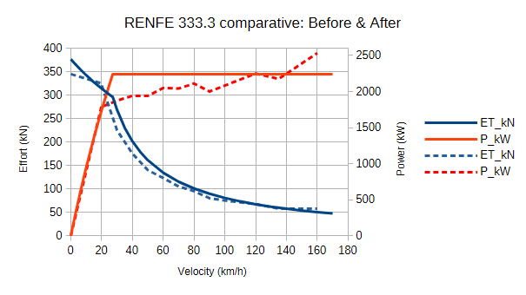
Figure 3: Comparison of the pre-existing ORTSMaxTractiveForceCurve (dashed line, 345 kN peak, manual construction) and the custom curve generated by the Teluroncio Method (solid line, 376.7 kN peak, 32 points, mathematical construction). The custom curve delivers 9.2% more starting tractive effort (+31.7 kN) and eliminates the power deficit of 265 kW (13.5%) visible in the pre-existing between approximately 25 and 90 km/h. Both curves correspond to the RENFE 333.3 (2,237 kW, 120 t).
5.2 Impact on Energy Efficiency
The pre-existing curve (A) showed a consumption of about 17.7 L/km. Configurations B and C reduced this value to around 16.0 L/km. This represents a 10% improvement in fuel efficiency. The reason is clear: by being able to develop all its power, the locomotive climbs the ramp faster and, although the instantaneous flow is the same at full throttle, the total consumption to complete the test section is lower.

5.3 Behaviour with and without WSP
In dry conditions, the presence or absence of WSP has no significant impact on speed or power. There is no wheel slip. This validates the calibration of the adhesion coefficient and confirms that the own curve, with its 376.7 kN at standstill, is below the dry adhesion limit (approx. 388 kN for 120 t and μ=0.33), which is technically impeccable.
6. Conclusions
1. Technical Resolution: A physically correct tractive effort curve has been successfully constructed from the resolution of traction and adherence equations, completely replacing the irregular pre-existing curve.
2. Validated Performance: The new curve allows the locomotive to deliver its full potential (2,228 kW at the rail), matching the performance of the configuration without curves (45.5 km/h on the 2% grade with 600 t), but with the enormous advantage of having a mathematical limit that prevents unrealistic overloads.
3. Energy Efficiency: The use of the correct curve improves fuel consumption efficiency by 10% compared to the pre-existing.
4. Professional Methodology: The generation of the curve using Maxima/WxMaxima reinforces the professional nature of the Teluroncio Method: the parameters are not "drawn", they are calculated from the physical and documentary data of the real machine.
5. Teluroncio Method Recommendation: This experiment completes the diagnostic cycle of Experiment #2. Before eliminating a curve, an attempt should be made to reconstruct it from equations. The generated .wxmx file is offered as a reproducible model for any diesel locomotive in the repository.
7. References
dell´Olio, L., Oreña, B. A., Moura Berodia, J. L. Tracción y adherencia, Ferrocarriles. Apuntes de clase. Universidad de Cantabria. 2023.
Maxima/WxMaxima. Symbolic Computation System. SourceForge. 2024.
Open Rails Team. Open Rails 1.6.1 manual. Release 1.6.1.0. 2026.
Yuan, Z., Wu, M., Tian, C., Zhou, J., & Chen, C. (2021). A Review on the Application of Friction Models in Wheel-Rail Adhesion Calculation. Urban Rail Transit, 7(1), 1–11. https://doi.org/10.1007/s40864-021-00141-4

May 2026

