CYBERSECURITY HOME LAB SETUP GUIDE
Personal Virtual Environment Setup, VMware Configuration & Kali Linux Installation
Author: | Francisco Elroy Afonso
Qualifications: | Aspiring Penetration Tester | Practical Ethical Hacker (PEH) | Google Cybersecurity Professional
Host System: | Windows 11 25H2
Hypervisor: | VMware Workstation Pro 17.6.3
Guest Virtual Machine: | Kali Linux 2026.2 (XFCE Desktop Environment)

1. Overview & Purpose
This document records the deployment and configuration of my personal cybersecurity lab environment. The lab consists of a Kali Linux virtual machine running under VMware Workstation Pro on a Windows host. It provides a local, controlled workspace for practicing Linux system administration, network utilities, shell environments, and security tools.
1.1 Core Objectives
1. Perform manual operating system installations from ISO image files.
2. Configure virtual hardware resources and hypervisor networking.
3. Install and configure guest integration drivers (open-vm-tools-desktop).
4. Establish VM snapshot management procedures for baseline restoration.
5. Troubleshoot guest display rendering and input issues.
2. Environment Specifications
Environment Parameter | Configuration Specification
Host Operating System | Windows 11 25H2
Hypervisor Platform | VMware Workstation Pro 17.6.3
Guest Virtual Machine | Kali Linux 2026.2 (XFCE Desktop)
Hardware Resource Allocation | 3 GB RAM | 2 vCPU Cores | 80 GB Thin Provisioned Disk | NAT Network

3. VMware Workstation Configuration
1. Memory Allocation: 3 GB (3072 MB) allocated for smooth execution of Kali Linux XFCE.
2. Processor Allocation: 1 CPU, 2 vCPU Cores assigned for optimal tool execution.
3. Storage Provisioning: 80 GB Thin Provisioned Virtual Disk.
4. Network Connection: NAT mode providing outbound internet reachability while protecting host LAN.
5. Display Settings: 3D Graphics acceleration disabled to prevent driver rendering bugs.
6. Snapshot Strategy: Created baseline clean restore point ('Baseline Clean Setup') immediately post-installation.
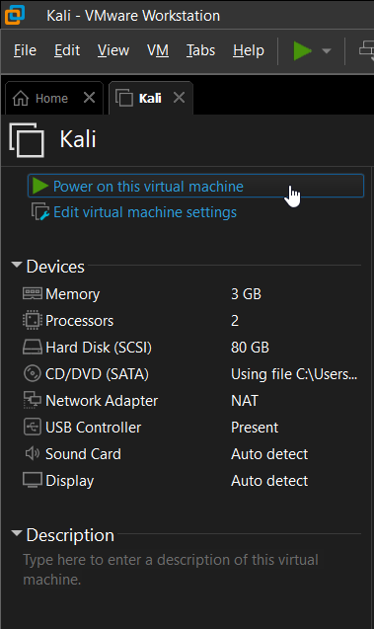
Figure: VMware Workstation Pro library showing virtual machine configuration.
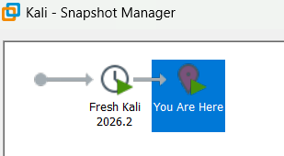
Figure: VMware Workstation Snapshot Manager showing clean baseline restore point.
4. Kali Linux Installation & System Verification
1. Booted virtual machine attached to official kali-linux-2026.2-installer-amd64.iso.
2. Completed Graphical Installation wizard: Hostname (kali-attack), User (kali), Guided disk partitioning (Ext4).
3. Installed software components (XFCE Desktop & default toolset) and installed GRUB bootloader to /dev/sda.
4. Installed guest utilities (open-vm-tools-desktop) for display resolution auto-fitting and clipboard integration.
5. Verified system details via terminal (whoami, hostnamectl, uname -a, ip a).
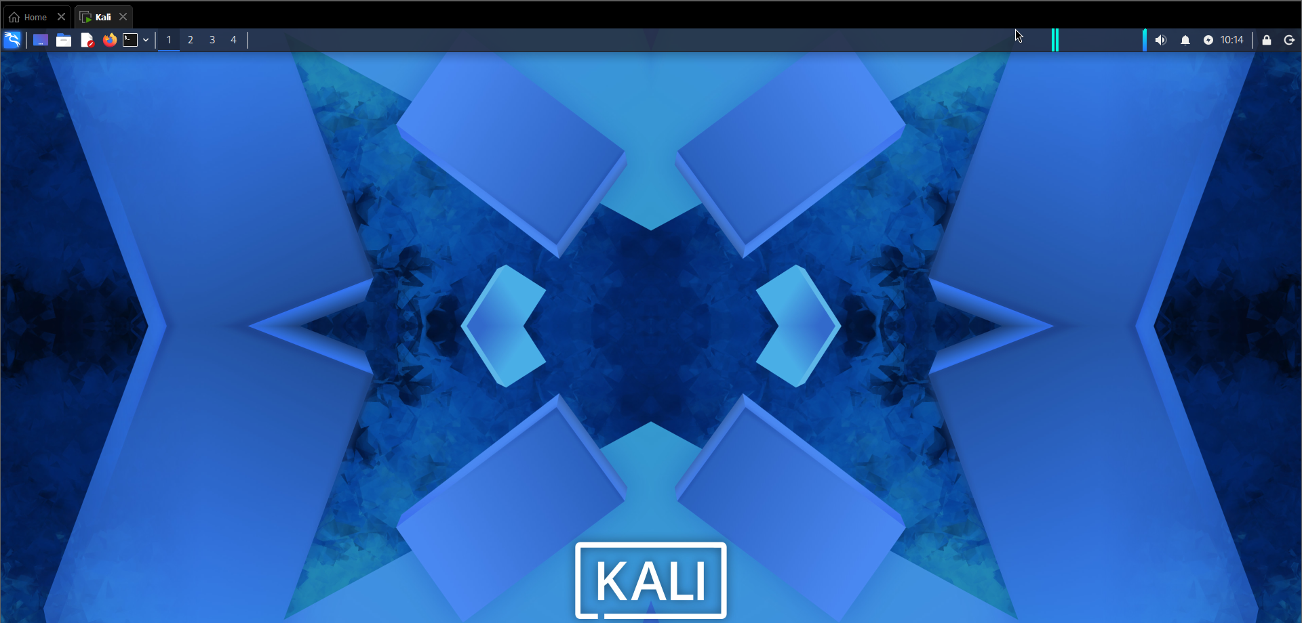
Figure: Kali Linux XFCE desktop environment.
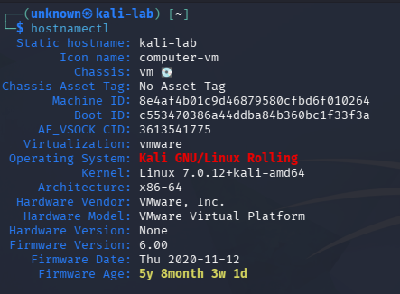
Figure: System information verification showing kernel and OS details (hostnamectl, uname -a).
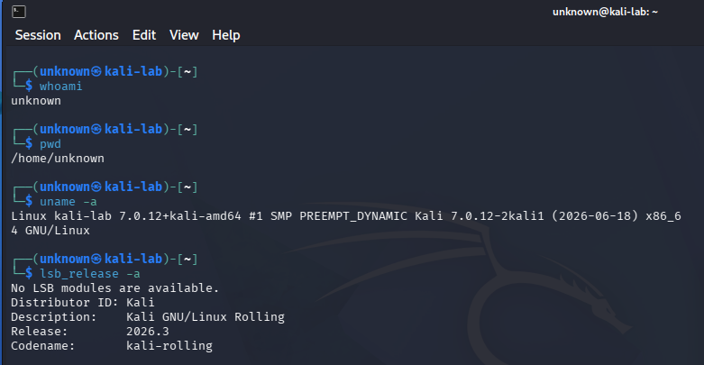
Figure: Terminal execution and user account verification (whoami).
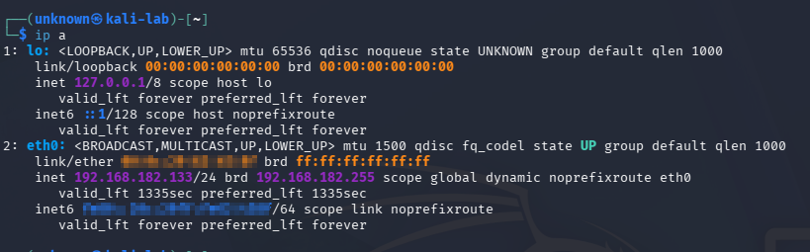
Figure: Network interface configuration verification (ip a).
5. Troubleshooting: Invisible Mouse Cursor Resolution
Documenting technical hurdles and verified fixes demonstrates practical problem-solving capabilities.
Issue: Invisible Mouse Cursor in Kali Linux Virtual Machine
• Environment: Windows 11 25H2, VMware Workstation Pro 17.6.3, Kali Linux.
• Symptom: Upon importing the pre-built Kali VMware appliance (.ova/.vmx), the mouse cursor was completely invisible inside the guest desktop.
• Attempted Fixes: Reinstalling open-vm-tools-desktop, disabling 3D graphics acceleration, and modifying .vmx configuration parameters failed to restore the cursor.
• Verified Fix: Installing Kali Linux from the official Installer ISO (kali-linux-2026.2-installer-amd64.iso) completely resolved the cursor rendering issue.
LESSON LEARNED: Pre-packaged VM appliances offer fast deployment, but driver conflicts with host graphics or hypervisor versions can introduce unneeded bugs. Installing manually from an Installer ISO grants total control over disk partitioning and display drivers—ensuring environment stability.

