Projeto IS
Integração Sistemas



Francisco Barão 2016238992
Pedro Ribeiro 2016218753

Index

Conditions of experiment ----------------------------------------- 3

Client-Server -------------------------------------------------------- 4
Client functions --------------------------------------------- 4
Server functions --------------------------------------------- 4
Time measuring --------------------------------------------- 4

Google Protocol Buffer --------------------------------------------- 5
Data Structure ------------------------------------------------ 5

XML -------------------------------------------------------------------- 6
Data Structure ------------------------------------------------ 6

Trials ------------------------------------------------------------------- 7-9
Tables ----------------------------------------------------------- 7-8
Graphs ---------------------------------------------------------- 9

Conclusion ------------------------------------------------------------- 10

Advantages ------------------------------------------------------------ 10

Conditions of Experiment

Computer characteristics:
1) Processor: i7-8565U Quad Core 1.8-4.6 GHz
Ram: 8GB

Tecnologies:
Java (version) – 8.0 (jdk: 1.8.0.222)
gRPC framework to connect client-server services (version) – 1.24.1
Maven for dependecies – 4.0.0 version
Google protocol Buffer and XML

How to run:
Server : mvn exec:java -Dexec.mainClass=com.assign_1.ProjectIsServer
Client : mvn exec:java -Dexec.mainClass=com.assign_1.ProjectIsClient

Changeable Parameters:
-Port (Currently on port 5682)
-Number of random generated client/cars per client
-Number of Clients to be requested to the server
-Client/Car parameters to be retrieved

Client - Server

All Client-server communication is done using gRPC framework which is used to efficiently and easily connect these two.

Client Functions:

The client starts by creating the message to be sent to the server. This message is either a XML String or a Protocol Buffer message containing Id’s of clients to be returned.
The client will use Stub to call a remote function from the server to request owner and car information.
After receiving the information, the client will then deserialize or unmarshal the messages and record the endTime/packageSize.

Server Functions:

After the server has been created and its service added, the server either generates clients or retrieves them from an object file working as a database. When a client connects the server, it will receive the clients Ids and procceed to find the owners and their cars. When found, the server either creates the Reply message by creating the cars and owners builders and attaching them to the message or it creates the XML String to be sent to the client and recording the startTime after Marshaling.

Measuring Package Size:

Package Size is measured at the client when he receives the package from the server.

Measuring Time:

startTime is recorded when the server ends marshalling/serializing the information to be sent to the client.(Fig. 1)

EndTime is recorded when the client finishes unmarshalling/deserializing. (Fig. 2)

Finally we subtract startTime to the endTime.
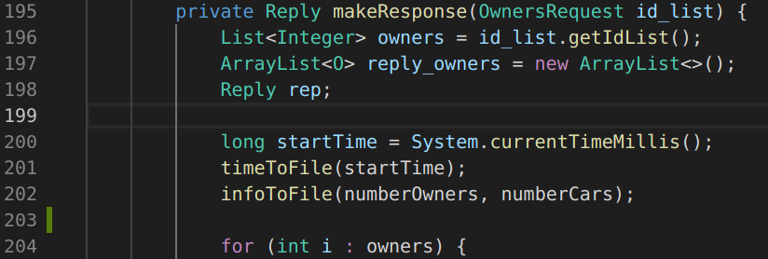
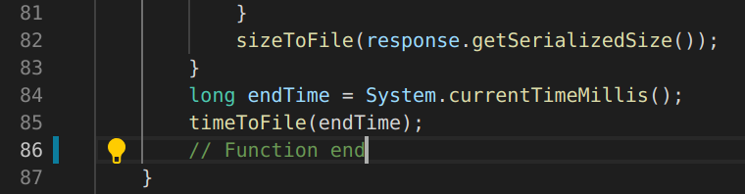
Fig.1 – startTime on file(“ProjectIsServer”)
Fig.2 – endTime on file(“ProjectIsClient”)

Google Protocol Buffer

Data structures:

message OwnersRequest - Request message that contains array of client ids to be retrieved from the server.

message Reply – Reply message that contains array of owners and necessary information to be retrieved.

message O – Message definining each owner contained in Reply.
Each owner contains:
-id | name | telephone | address | Cars

message C – Message defining each car contained in an Owner.
Each car contains:
-id | brand | model | engineSize | power | consumption | plate

XML

Data Structures:

We used java classes with the javax xml annotations to create the XML (JAXB). In order to create a list of Owners we had to create another class that contains a list of owners, which each owner has a list of cars. Using the Xml attribute and element annotations, the creation of the XML is automated and contains every piece of information we needed.

OwnerList class that has an ArrayList of Owners.

Owner class has an ArrayList of Cars, an id, a name, a telephone number and an address.

Cars class has an id, a brand, a model, engine size, power, consumption, plate and belongs to an owner.

Trials

Tables
Input Variables:
-Number of Owners (with 10 cars each owner):
We ran each test 5 times to have more precise values.
Values : 50 | 150 | 300 | 500 | 1000 | 3000 | 5000 | 7500 | 10000
Output Variables:
startTime || endTime || Size

Protocol Buffer XML

Fig.3 – Protocol Buffer table values
Fig.4 – XML table values

From the tables (Fig. 3 and Fig. 4 ) we calculated the average times (startTime. EndTime and also Time which consists of endTime - startTime) and the average packages’ size of the serilazitations in question.

Protocol Buffer:
Fig.5 – Protocol Buffer average values table

XML:

Fig.6 – XML average values table

From this Tables(Fig.5 and Fig.6), we were already able to see that for the same input values, XML takes longer to marshal/unmarshal and the packages are way bigger than Protocol Buffer.
With the Graphs below, we hoped to improve our understanding of these results.

Graphs
Fig.7 – Time comparison of Protobuffer and XML
Fig.8 – Package size comparison of Protobuffer and XML

Conclusion

From the graphs (Fig 7. and Fig 8.) we are able to visualize how badly XML performs compared to protocol buffer. In regards to Marshaling/Unmarshaling times, for a low amount of objects, the results are similar. However, as the number of owners increases we can easily see that XML gets exponentially bigger in size and takes longer to send.
This is because XML needs to be transformed to a string before being sent (which already is an extra step) and it is also human readable, which means its needs more information than protobuf (which is not human readable). The difference is only visible with bigger requests, clarified via the charts.

Advantages
The combination of the results and our experience with both serialization methods, lead us to the following advantages of protocol buffer over XML:
-Protocol Buffer is Simpler to implement since most classes are generated automatically
- It is 5 to 10 times smaller in size

- For bigger packages, it is at least 10 times faster

