CSC309: Programming for the Web

Assignment 2

Tumblr Trackr

Francisco Canas (g1canasf)
Sasa Milics (c0milics)
Zizhou Wang (g2zizhou)
Zhanara Orazbayeva (g2zhan)

Server Design
The server was written in Python using the Django 1.5 framework, and broken up into two major components found in the handlers.py and tracker.py files for responding to user requests, and for gathering data from blogs and posts from tumblr, respectively.
The following sequence diagram models the Trackr Server subsystems. See pdf for higher resolution version.

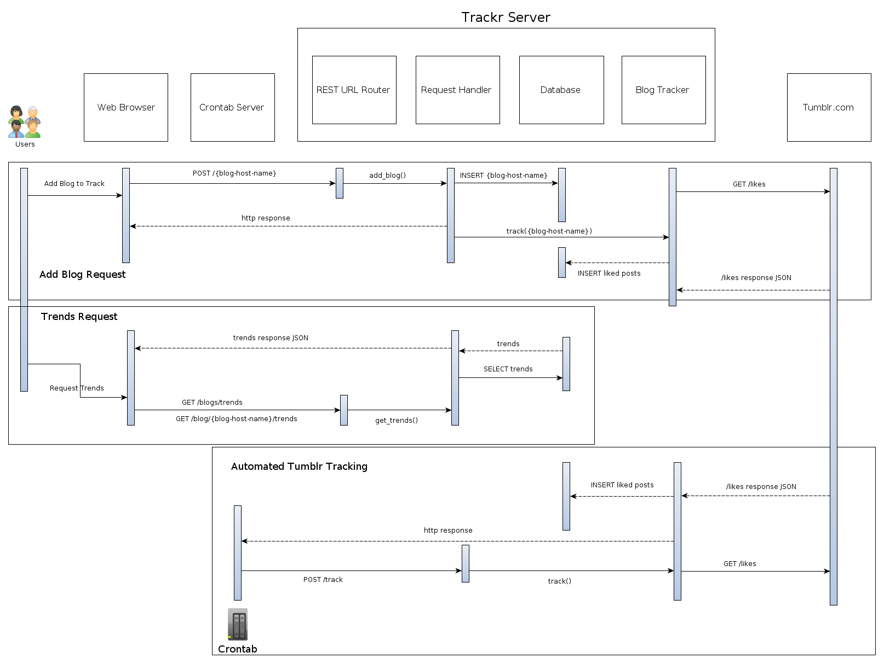

User Request Handlers:
The handlers.py contains methods for responding to user requests to add new blogs to track, and for getting trending posts.
For order=Trending requests, we are returning a list of posts sorted in decreasing order by the number of likes the post has received in the last hour.
For order=Recent requests, we are returning a list of posts by most recently-posted.

Automated Tumblr Tracking:
The tracker.py file contains the functions that send the appropriate AJAX requests to the Tumblr api and then parse the responses. The tracker flows in this order:
- Iterate over every blog in the database that has not been tracked in the previous hour:
  - For each blog, update it's last_tracked status and retrieve a list of all of its likes from the tumblr api.
  - For each post in the json received from tumblr that has not been tracked in the last hour:
    - Create a new entry in its Tracking table.
    - Update its note_count, last_track, and increment in note_count since last track.
    - If this is a new post not already in the database, then store its meta-information in the database: The post txt, images if available, the url, and note_count. Different types of posts contain different elements, and are therefore handled individually by the tracker code.

The above sequence is first called when a new blog is added to the database by a user request, but is run only on the specific new blog to collect the preliminary data on the new blog and its liked posts.
The whole sequence is called on all blogs by a cron job running on the server every 10 minutes. Because the job runs every 10 minutes but we only update blogs and posts every hour, requests sent to tumblr are distributed over the course of the hour rather than being sent all at once. This probabilistic load distribution of course depends on user requests for new blogs being sent uniformly over time, and not all at once at some specific time.

Database Design
Django allows us to model our DB as python objects, which get automatically synchronized with the underlying database. In this case, we chose to use sqlite3 because it was already installed and working on CDF and did not require any additional plugins to work with Django and Python. MySQL required a python library which we had no permission to install on CDF.

The server used the following models:
Blog: models a blog being tracked by the user.
Post: models a specific Tumblr post, its meta-information, and some of its statistics.
Tracking: models an object to keep track of every time we update information for a post.

Blogs and Posts are related via an implicitly-defined Likes table, which maps the many-to-many relationship between blogs that like posts and vice-versa.

Supporting Systems

Crontab Script:
As mentioned, the automated tracking loops are triggered by a script run every 10 minutes by Crontab. The same crontab script also pings the server to ensure it is still running, and restarts the server if the ping requests return an incorrect response code. The script logs the tracking requests to a file in the project folder.

Project Source Tree

trackr/ -- Project root folder.
manage.py -- Utility used to make project setting changes.
livedb -- A file containing the mysqlite database.
trackr/ -- Folder containing project source files.
handlers.py -- Code for our user request handlers lives here.
tracker.py -- Code for our blog tracking lives here.
models.py -- Classes defined for the database to be created on syncdb.
__init__.py -- Empty file. Informs python this folder is a package.
settings.py -- Configuration file for project.
urls.py -- Contains the URL service request router code!
wsgi.py -- For WSGI projects.
project_vars.py -- Variables used globally across project files.

