Inspection

Inspector: Kevin Duy

Team: 4

|  |  |
| --- | --- |
| Github |  |
| Requirements 7/10 | Bad location of the file, it is not inside the correct folder.  It does not clarify what type of format or standard for the requirements. The type of entry or exit is missing and if not is, it should be mentioned. Requirement actors and a short description are missing.  Clarify what the Type refers to. |
| Any Design 10/10 | Good Database design CDM - PDM |
| URIs design 5/10 | Bad design URIs |
| DB (SLQ/NoSQL) 5/10 | No SQL insert data found |
| Rest Service 17/20 | Problems with GET by ID,  no consist |
| Web Client 10/10 | Good design |

DB (SLQ/NoSQL)

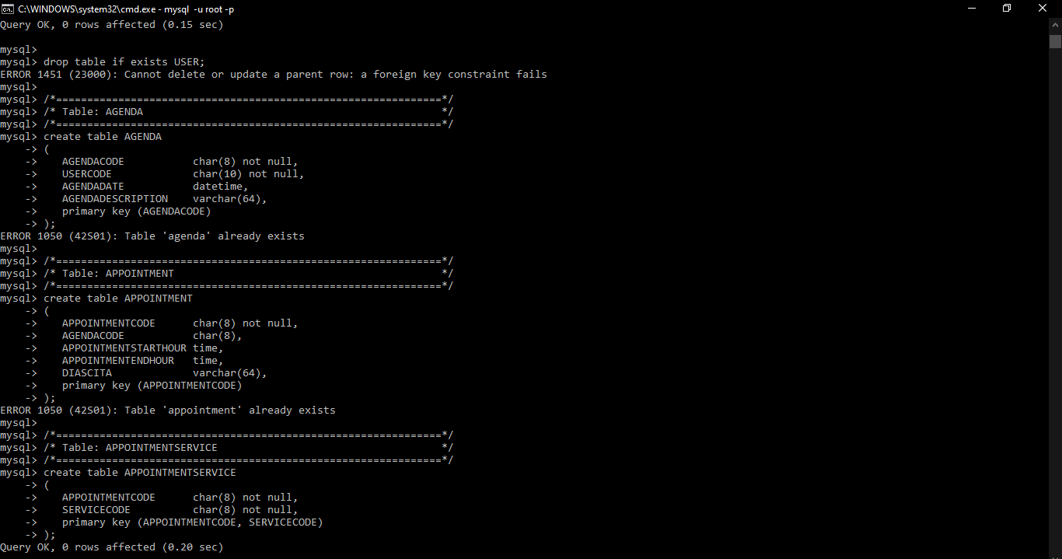

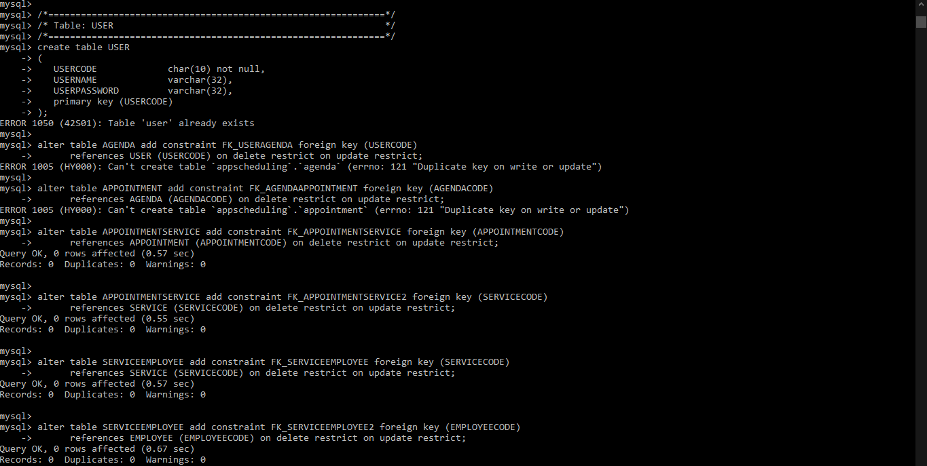

Rest Service

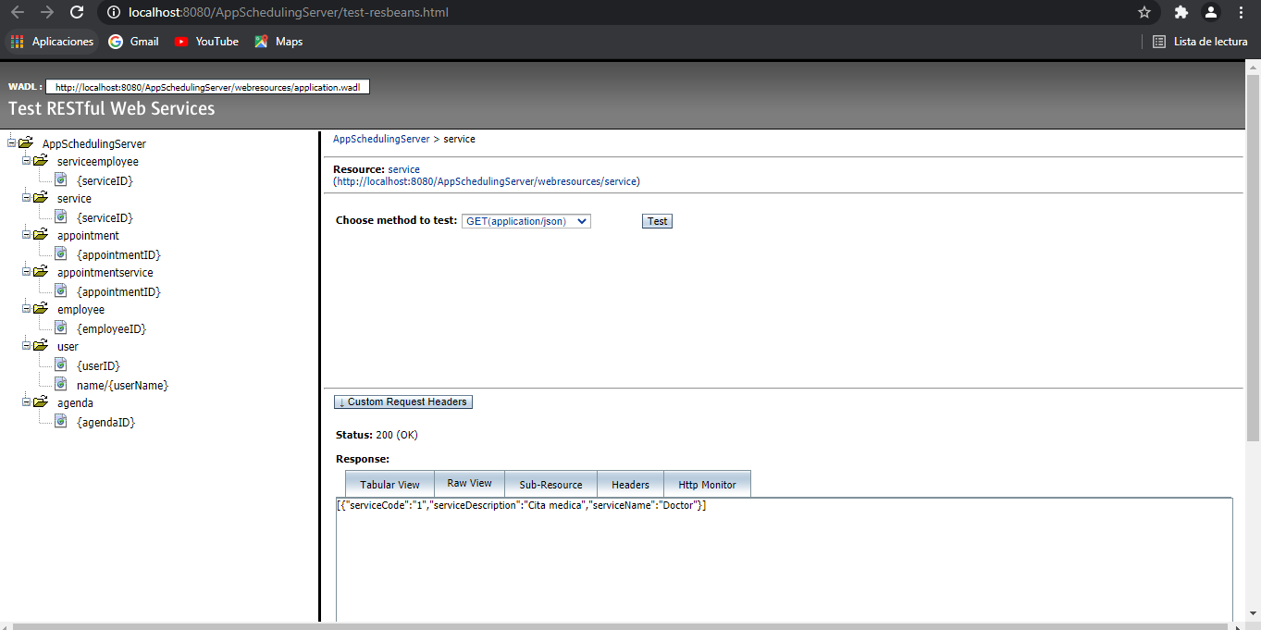

Web Client

