**Deliverable**

Francisco Contreras

**Table of Contents**

*Executive Summary………………………………………………………………………………………….*4

*Introduction*……………………………………………………………………………………......6

**Marketing Deliverable**

Distribution………………………………...………………………………………………...……7

Pricing……………………………………………………………………………………..………8

Promotion……………………………………………………………………………..………...…9

**Supply Chain Deliverable**

Labor Requirements.…………………………….…………………………….………………....10

Resource Plan………………………………………………………………….............................12

Distribution Plan...………………………………………………………….................................14

Sourcing Plan……………………………………………………………….................................15

**Team Dynamic Deliverable**

Organization Structure and Chart…………………………………………..................................16

Organizational Characteristics.……………………………………………..................................19

*Conclusion*……………………………………………………………………………………….21

**References**

Appendix A: Perceptual Map……………………………………….………………………..…..22

Appendix B: Persona……………………………………………………….……………….…...24

Appendix C: Total Staffing Report. ……………………………………………….…………….25

Appendix D: Sales Forecast Excel Spreadsheet……………………………………...………….26

Appendix E: Value-Based Pricing…………………………………………………...………….27

Appendix F: Competitive Based Pricing…….……………………………………....………….28

Appendix G: Cost-Based Pricing…………….………………………………….…...………….29

Appendix H: Marketing Promotion………….………………………………….…...………….31

Appendix I: Unit Forecast and Materials Direct Variable Costs……………...……...………….32

Appendix J: Direct Capital Spending and Total Direct Cost…………...…….……...………….33

Appendix K: Variable Costs Per Units...…….………………………………...…....….……….34

Endnotes…………………………………………………………………….................................35

**Executive Summary**

In this Deliverable, the primary focus will consist of Marketing, Supply Chain Management, Finance, and Team Dynamics and Leadership. The product being introduced, Wonder Wall Decals of Sherwin Williams, has reached the production point. The objective of this Deliverable is to create an analysis of the explicit process of decal production. Value will be added to variables associated with product costs, revenue and expenses. In relation to the distribution aspect of marketing, Wonder Wall Decals uses a direct distribution channel in order to eliminate intermediaries and provide a direct communication channel between the product and the consumers. Using direct distribution channels will grant Sherwin Williams complete control of Wonder Wall Decals and allow further development in product quality and customer service. While observing the competitive market, Sherwin Williams has taken the brand image and a value-based strategy in determining the selling price for a small and large variation of Wonder Wall Decals. See Appendix G: Cost-Based Pricing for more information on pricing. In order to uphold the Sherwin Williams brand image, Wonder Wall Decals will be produced with 3M™ vinyl to maintain the quality recognition Sherwin Williams is known for.

Sherwin Williams has developed a three-year marketing strategy, which incorporates digital marketing, mass media marketing, trade show, and an in-store salesforce to increase awareness of Wonder Wall Decals and Sherwin Williams core values. After accounting for all aspects involved in the production and distribution of Wonder Wall Decals, Sherwin Williams has formulated a staffing plan based on employee experience for production and management operations. Sherwin Williams has completed a resource plan to analyze Wonder Wall Decals using a sales forecast to predict required materials and costs corresponding with the estimated unit of sales. See Appendix I: Unit Forecast and Materials Direct Variable Costs, Appendix J: Direct Capital Spending and Total Direct Cost and Appendix K: Variable Costs Per Units for more information. The resource plan displays an in-depth evaluation of fixed costs, investment in capital assets, and start-up costs needed for the operation of Wonder Wall Decals.

Factoring in benefits and risks involved with distribution. Sherwin Williams has taken the accountability to personally deliver Wonder Wall Decals to local Sherwin Williams stores. Wonder Wall Decals Store Supply leaders will manage inventory at local stores and request stock whenever necessary. Sherwin Williams will be introducing Wonder Wall Decals as a new product in the DIY product line. To produce a new product, Sherwin Williams will acquire various pieces of equipment that differ from what is normally used in their company. These new pieces of equipment will be used to print designs, cut vinyl and deliver shipments of finished products to local Sherwin Williams stores.

Sherwin Williams has completed a financial analysis in order to calculate operating cash flows, net working capital, and capital spending associated with Wonder Wall Decals, which can be found in the attached excel document. Within Sherwin Williams’ organizational structure the Wonder Wall Decals will be an addition to The Americas Group within the Do-It-Yourself division.1 Wonder Wall Decals will be introduced as a consumer-friendly product for home improvement. In the Team Dynamics and Leadership analysis, it has classified Wonder Wall Decals as long-linked technology. Sherwin Williams’ company has a centralized system where the Operations Manager handles decisions and processes at the higher level and corresponds with top management as needed.2

**Introduction**

This Deliverable continues with the analysis of Wonder Wall Decals in Marketing, Supply Chain Management, Finance, and Team Dynamics and Leadership. The marketing segment starts with the analysis of product distribution. After production, Wonder Wall Decals will be delivered to a Sherwin Williams store location with two different size options. A value-based pricing strategy was used to develop a price for the small and large sizes of the Wonder Wall Decal. The final section of the marketing is promotion where a 36-month marketing strategy was created to present the Wonder Wall Decals to the market.

The Supply Chain Operations portion of the Deliverable begins with a description of labor requirements for the Wonder Wall Decal warehouse employees. Direct and indirect labor is discussed then is followed by a resource plan. This resource plan is associated with Sherwin-Williams’ fixed costs, capital investment and start-up expenses. Supply Chain Operations will also cover the distribution and sourcing plans. The distribution plan describes how the consumers will purchase the product and the sourcing plan consists of what products need to be purchased to produce Wonder Wall Decals.

Sherwin Williams has completed a financial analysis in order to calculate operating cash flows, net working capital, and capital spending associated with Wonder Wall Decals, which can be found in the attached excel document.

Team Dynamics and Leadership will be the final section discussed. The organizational structure of Sherwin-Williams is shown along with the advantages and disadvantages of the organizational structure. This in-depth analysis of Wonder Wall Decals will show why Sherwin Williams should consider this project for future investments.

**Marketing Requirements**

**Distribution**

Having a direct distribution channel, Wonder Wall Decals will be self-manufactured and sold directly to consumers. Raw materials needed for Wonder Wall Decals include the ink and 3M™ Controltac™ Graphic Film with Comply™ Adhesive. Materials needed for the decal packaging are informational labels, and the informational sheet which will be acquired for before assembling the product.3 Through the production stage, the product will be well inspected at every stage. There is a warehouse worker that is assigned to watch the decal as it is coming off the printer to verify there are no flaws. Once each product has been completed, it will be delivered directly to a local Sherwin Williams store in Indianapolis. Using a business to consumer approach, limitations for a direct distribution channel would include reduced distribution channel options, increased internal workload, and a raise in fulfillment costs. There may be a limit in opportunity cost due to consumers only being able to purchase the decals at Sherwin Williams stores. However, a few advantages of a direct distribution channel would include, higher direct consumer contact, increased control over the product, and the elimination of intermediary expenses as well. Eliminating intermediaries will enable Sherwin Williams to excel in product expertise and customer service. The business to consumer approach also condenses the possibility of product damage. This course of action allows Sherwin Williams to receive direct feedback from consumers and achieve consistency and surpass competitors in product quality.

**Pricing**

Sherwin Williams has developed a selling price of $50 for a small (30in x 30in) decal and $120 for a large (30in x 100in) decal.  Sherwin Williams used three different pricing strategies to develop price points that would not only appeal to their targeted market but also bring financial benefits to their company.  A value-based strategy was applied to the current Wonder Wall Decal product line with consideration to our competition-based pricing as well.

Sherwin Williams's focuses on value-based pricing was determined by five overall characteristics: trustworthiness, experience, design, quality, and convenience. Wonderwall decals will appear to many customers as trustworthy and experience based upon Sherman Williams's well-known brand recognition within a majority of the market. As Wonder Wall Decals grow, so does the intricate and more complex designs that possibly could be offered in other markets. The current designs offered are unique and designed to be combined with Sherman Williams's current line of paint and interior coatings. Compared to other traditional wall decals or stickers, Sherman Williams uses top industry standard 3M vinyl for printing Wonder Wall Decals. The decision to use high-quality vinyl in all our decals will not only set Sherwin Williams Wonder Wall Decals apart from the competition but will also earn recognition from a quality standpoint among our customers. Sherwin Williams has a wide reach in multiple markets across the Americas division, including online but also conveniently located brick and mortar stores across the country. Wonder Wall Decals will be placed in current Sherman Williams stores compared to a traditional e-commerce selling platform of competitors.

Sherwin Williams Wonder Wall Decals were developed and priced to bring Sherman Williams industry old quality, design, and experience to the hands of not only DIYers but also households with children. Wonder Wall Decals infuse price and quality that can be potentially rolled out to various Sherman Williams stores around the nation and potentially even more designs at various price points could also be considered. To see all pricing strategies, see Appendices, E: Value-Based Pricing, F: Competitive Based Pricing and G: Cost-Based Pricing.

**Promotion**

Sherwin Williams has developed a 36-month marketing strategy that will increase awareness of Wonder Wall Decals while aiding customers to acknowledge Sherwin Williams as a timeless, innovative brand. During the process of developing the line of Wonder Wall Decals, Sherwin Williams strived to capture the quality of materials that were used. Wonder Wall Decals present an ability to match one of the five designs with the current product line of internal paints and coatings that come in thousands of different colors. Wonder Wall’s marketing strategy focuses on digital marketing, printed/mass media marketing, trade shows, and an in-store salesforce. Our four marketing approaches will give Sherwin-Williams and Wonder Wall Decals an omnichannel marketing present.

Digital marketing will be used to interact with a large percentage of the market while also allowing our marketing team to target multiple demographics. The usage of commercial printed mass media marketing will help attain a wide audience in the Indianapolis market. This approach will also help broaden sales to non-DIYers or households without children. During our research of the market, Sherwin Williams found that Indianapolis is a city in which several home improvements and building materials trade shows reside. Wonder Wall Decals can potentially reach B2C customers as well as B2B building and design firms with the home improvement shows established in Indianapolis. Sherwin Williams prides itself in top quality, customer service, and the Wonder Wall Decals line will expand our already world-class service. Sherwin Williams will place a sales and customer service leader in each store to guide the current store team to become versed with the Wonder Wall Decals along with serving as customer service agents for any design related assistance. Detailed marketing breakdown with price estimates can be found Appendix H: Marketing Promotion

Sherwin Williams believes that introducing Wonder Walls Decals to the Indianapolis market could potentially lead to new marketing and public relations opportunities after the Initial three-year marketing plan. One event includes a possible partnership with HGTV’s Good Bones tv series which was established in Indianapolis around Fountain Square. The proposal would include featuring Wonder Wall Decals as their team works to rebuild parts of the city.

**Supply Chain Requirements**

**Labor Requirement**

The labor requirements for Wonder Wall Decals exist in various forms of direct and indirect labor. Direct labor for Wonder Wall Decals will include acquiring raw materials. A Work force for production and distribution processes will also need to be obtained. Meanwhile, indirect labor consists of an Office Assistant and an Operations Manager. The staffing plan for Wonder Wall Decals has been developed to cover all aspects from production to internal operations in a cost-effective perspective. The proposal presents multiple variations of labor requirements to operate and produce Wonder Wall Decals.

Direct labor for the production of Wonder Wall Decals will begin with the one Operations Manager placing orders for raw materials of 3M™ Controltac™ Graphic Film With Comply™, HP latex ink, and cardboard tubes as needed.4 The Operations Manager will observe the production line workers and input the size and designs to be printed on a daily basis. The Operations Manager can change the printer settings and create one of the 5 Designs in the Wonder Wall Decal line. The five designs include: Jungle, Outer Space, Princess, Sports, and Dinosaurs. The production line will begin with one employee preparing the vinyl material to enter the printing machine. Once the decal is through the HP printing machine, the same employee will move it to the HP cutting solution machine. The printer chosen for this operation includes a special feature in which a barcode will be placed under each print. As printing is completed, the printed decals will enter the cutting machine where the barcode will be read. The cutting machine will recognize the design from the barcode and cut it accordingly. As the completed products come off the line, two employees will be assigned for packaging. The first employee in the packaging stage will roll up the decal and insert it into the cardboard tube along with an informational booklet. The second employee will enclose the tube with the cap and place sticker labels onto the tubes. The warehouse will also employ a Warehouse Worker. The Warehouse Worker will be responsible for moving batches of the finished product into storage areas and deliver shipments of finished products to local Sherwin Williams stores as orders are placed.

Indirect labor for Wonder Wall Decals production will include an Operations Manager, an Office Assistant, and a Store Supply Leader. Wonder Wall Decals will hire an Operations Manager to oversee operational and financial objectives. The Operations Manager will be responsible for implementing warehouse training as well as handling warehouse employee relations. Paperwork for new hires and terminations, incident reports and preparing employee benefits packages are also components of the Operations Manager job description. They will also track inventory to know when to order raw materials for production. The Operations Manager will also be responsible for scheduling deliveries to Sherwin Williams stores in Indianapolis. A key role played by the Operations Manager to oversee employee interactions within the workplace while providing a smooth functioning workflow. In addition to the Operations Manager, Wonder Wall Decals will employ an Office Assistant, who will perform various clerical and customer service activities within the workplace. They will coordinate with the Store Supply Leader to place orders and post inventory and shipment activities in the operations system. The Office Assistant will also handle phone calls and be responsible for keeping the office area clean. Another essential part of Wonder Wall Decals’ indirect labor is the Store Supply Leaders. They will travel to different Sherwin Williams locations to manage inventory levels, provide expertise of the decals to consumers, and report feedback of the product directly to the Operations Manager. Wonder Wall Decals will be employing the Store Supply Leader because they will have significant knowledge of the product and will be able to answer questions that consumers have within the store. They will also provide information on how to apply the decals directly to the consumer. For more information on employee wages, See Appendix C: Wonder Wall Decals Total Staffing Report.

Since Wonder Wall Decals will be a product primarily used indoors, it will not experience seasonality. Even though most home improvements occur during seasons with warm weather, consumers are always interested in indoor home improvements in every season. Wonder Wall Decals will remain in production and be available for sale all year round.

**Resource Plan**

In the Resource Plan in, we determined the calculations for our total direct material costs in reference to our Variable and fixed costs per unit table. I involved all of the costs from this table to identify the direct cost per unit based on our sales forecast. See Appendix I: Unit Forecast and Materials Direct Cost for more information. We took all of our variable and fixed costs per unit and times them by our accumulated variable and fixed costs for Small and Large sizes of our units. We also included our separate direct costs that are in the capital spending of the project. We included these costs because they are a part of our production line for Wonder Wall Decals. In the end we added all of our direct costs up and came out to a total of $679,884.41. See Appendix I: Unit Forecast and Materials Direct Cost, Appendix J: Direct Capital Spending and Total Direct Costs and Appendix K: Variable Cost Per Unit for more information on Resource Plan costs

Fixed costs that are associated with Wonder Wall Decals employees are salary and benefit expenses for employees. Monthly full-time salaries and benefits expenses are $14,274. See Appendix C: Wonder Wall Decals Total Staffing Report for more information. The fixed costs that are associated with production are monthly lease payments for the warehouse space, renter’s insurance for the warehouse space, and car insurance for the delivery van. Wonder Wall Decals will lease a warehouse space at a central location between Sherwin Williams Pendleton Pike and Washington Street locations. The monthly rent will be $2510.5 Renter’s insurance expense is $190 per month.6 Wonder Wall Decals will also have a fixed cost of $90 a month for car insurance for our delivery van.7 The total monthly fixed costs for Wonder Wall Decals is $17,064.

Investment in capital assets that are associated with Wonder Wall Decals will include: vinyl printer and cutter, office equipment, stock shelving, and a delivering van.8 Wonder Wall Decals will purchase these assets as a long-term investment in the first year. Wonder Wall Decals will expense $58,000 as the investment in capital assets.

The start-up costs for Wonder Wall Decals are as follows: promotional expenses, advertising expenses (in year one), stock shelving, and office supplies. Startup costs for the warehouse is $2000 for shelving to hold excess inventory.9 Wonder Walls Decals will spend $80 in office supplies.11 Promotional and advertising costs in year one will be $11,000 which will include digital, trade shows and printed marketing. See Appendix H: Marketing Promotion for more information.

**Distribution Plan**

Wonder Wall Decals is an exclusive addition to the Sherwin Williams DIY product mix. This product will only be available at local Sherwin Williams stores in Indianapolis. The brand will be starting with two locations in Indianapolis. Sherwin Williams will manufacture and distribute Wonder Wall Decals to Sherwin Williams stores as a direct distribution channel in order to sell directly to the consumer. The Store Supply Leader will be responsible for maintaining inventory within Sherwin Williams stores. They will place orders with the warehouse Office Assistant. As the Office Assistant receives orders, the orders will be posted into the computer so the Operations Manager can schedule deliveries. This plan allows Sherwin Williams to keep the distribution process in-house. A major benefit of this plan is having complete control over the product and minimizing unexpected damages.

**Sourcing Plan**

Sherwin Williams has not produced wall decals in the past. Wonder Wall Decals will need resources that have not been used by Sherwin Williams before. Sherwin Williams will be required to purchase a HP latex print and cut solution machine, HP latex ink, 3M™ Controltac™ Graphic Film with Comply™, and cardboard tubes for the production of Wonder Wall Decals. All other materials such as sticker labels and delivery vans are normally used by Sherwin Williams.

**Team Dynamic Requirements**

**Organization Structure and Chart**

Sherwin Williams current organizational structure is a functional structure that follows the Executive Chairman, President and CEO, Executive President and COO followed by the Americas Group, Consumers Brands Group and the Performance Coatings Group. Wonder Wall Decals will become part of The Americas Group within the Do-It-Yourself division.11 Sherwin Williams organizational structure is centralized with high formalization. Their company environment is stable and predictable while also having an organizational culture of hierarchy and market.12

Wonder Wall Decals will be a member of the Do-It-Yourself division within the Americas Group. This product has been designed to be a user-friendly product available for home improvements. Consumers will be able to have a simple hands-on experience with the product to apply it without help. Some benefits of Wonder Wall Decals joining the Do-It-Yourself division include the fact that it is a cost-effective home improvement that gives consumers the opportunity to apply wall decals for future home improvements.

**Organizational Characteristics**

Since long-linked technology refers to technology that is applied to a series of programmed tasks performed in a predetermined order, it is the best operating system to be used for the manufacturing of Wonder Wall Decals. The structure of long-link operations has low flexibility and a foundation of coordination of planning and supervisory control.

Wonder Wall Decals will be centralized; therefore, all the decisions and processes are handled at the higher level. The Operations Manager at Wonder Wall Decals will be responsible for the day to day decision making and will provide direction for all the warehouse employees. The Operations Manager will work with top management if they need support. Top management will step in as needed if a breakdown in communication occurs between the production process, warehouse employees, and store locations.

**Advantages:**

1. **Business Decision Making:** Centralized organizations can be extremely efficient regarding business decisions.13
2. **Efficiency:** Could enhance the work efficiency and productivity due to the specialized skills and technology.14

**Disadvantages:**

1. **Time management:** Business owners responsible for making every decision in the company may require more time to accomplish these tasks, which can result in sluggish business operations.15
2. **Communication:** It could lead to poor communication and coordination across functional units.16

The advantage of Wonder Wall Decals operation will be efficiency. Efficiency in decision making is important for the operations manager. Having a functional organizational structure and centralized management puts Wonder Wall Decal and Sherwin Williams at an advantage regarding decision making and efficiency across the board.

The disadvantage Wonder Wall Decals will most likely face is communication error. A disadvantage in a centralized organization is the potential result of poor communication and coordination across functional units. One example of a distinctive moving part includes confirming appropriate amounts of raw materials for inventory. Communication channels are constantly developing between Sherwin Williams stores in arrangement of delivery and the set up of Wonder Wall Decals displays. It is possible to experience a breakdown in communication across all channels.

**Conclusion**

In this Deliverable, Sherwin Williams developed a strategic plan for operations, distribution, marketing, and evaluated cash flows throughout a five-year period. Wonder Wall Decals’ operation plan consisted of creating a manufacturing system with one line of workers to produce the Wonder Wall Decals for distribution within the Indianapolis area. The Wonder Wall Decal distribution system consists of a Warehouse Worker that would also function as a driver that delivers to the two test stores in the Indianapolis market. Keeping the operation and distribution network small for this test market, allows Sherwin Williams to manufacture Wonder Wall Decals without incurring large amounts of capital spending and networking capital. Sherwin Williams also developed a marketing and promotion schedule for Wonder Wall Decals focusing on the Indianapolis DMA. Digital marketing, trade shows, printed media, and in-store sales staff make up the four components of a three-year strategic marketing plan. This $32,000 marketing plan will increase the total market and brand recognition for Sherwin Williams Wonder Wall Decals while also allowing Sherman Williams to analyze market research during this five-year test market. Finally, Sherwin Williams analyzed the financial impact that Wonder Wall Decals would have throughout the five-year test market. The analysis of the decal markets’ five-year potential sales forecast compared to the total cost to manufacture and operate Wonder Wall Decals shows a potential profit. In the two Indianapolis stores, the financial analysis has estimated a potential profit for the total five-year span at $356,000.

**Appendices**

Appendix A: Perceptual

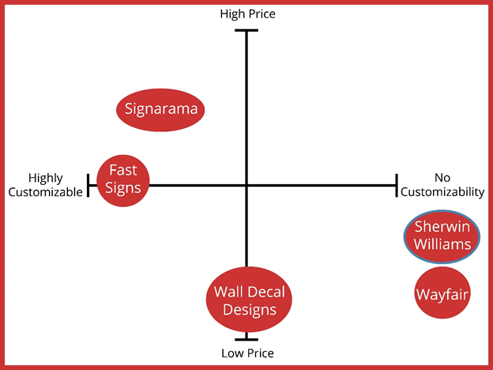

1. “Sherwin Williams, Paints, Stains, Colors and Supplies.” Accessed on February 16, 2020.<https://www.sherwin-williams.com/>
2. "Wall Decals." Wayfair. Accessed March 4, 2020. https://www.wayfair.com/decor-pillows/sb0/wall-decals-c504340.html
3. "Create Your Own Custom Wall Decal." Wall Decal Studios.com. Accessed March 4, 2020.<https://www.walldecalstudios.com/>.
4. "Wall Decals." Wayfair. Accessed March 4, 2020.<https://www.wayfair.com/decor-pillows/sb0/wall-decals-c504340.html>
5. Francisco Contreras. “Store Manager, Signarama” February 20, 2020
6. Francisco Contreras. “Store Manager, Fast Signs” February 20, 2020

Appendix B: Persona

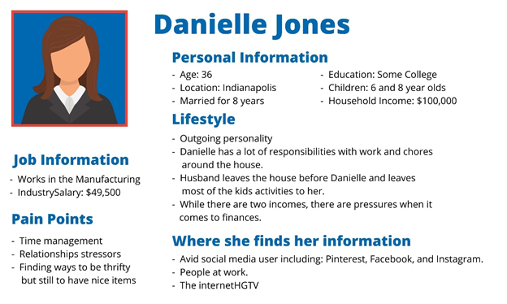

1. Rohan Jaura. “Paint Stores in the US, IBIS World Industry Report.” December 2019. IBIS World

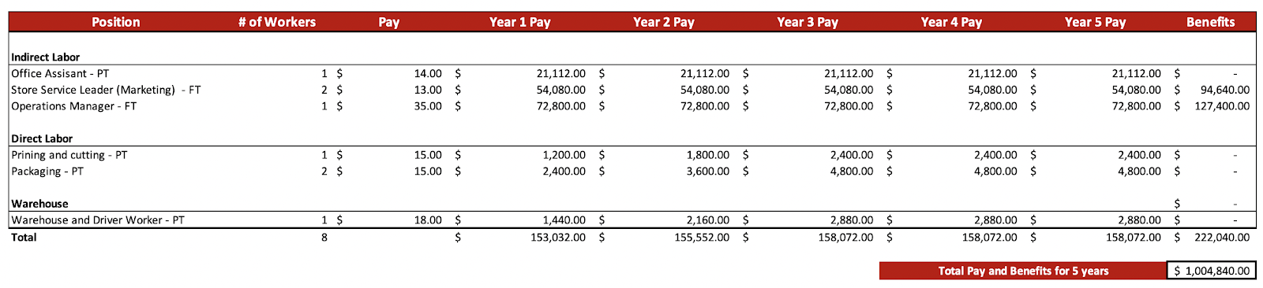Appendix C: Wonder Wall Decals Total Staffing Report

1. “Average Hourly Rate for Sherwin Williams Co. Employees.” PayScale. Accessed April 19, 2020. https://www.payscale.com/research/US/Employer=Sherwin_Williams_Co./Hourly_Rate.

Appendix D: Sales Forecast

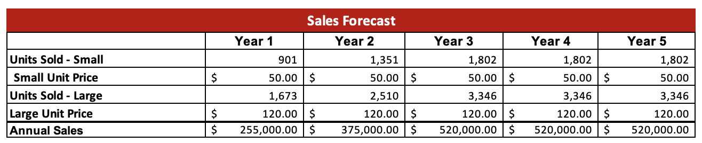

1. “U.S. Census Bureau QuickFacts: Indiana.” Census Bureau QuickFacts IN. Accessed April 3, 2020. <https://www.census.gov/quickfacts/IN> ; “SHW's Competition by Segment and Its Market Share.” CSIMarket. Accessed April 3, 2020. <https://csimarket.com/stocks/competitionSEG2.php?code=SHW> ; “SHW's Competition by Segment and Its Market Share.” CSIMarket. Accessed April 3, 2020. <https://csimarket.com/stocks/competitionSEG2.php?code=SHW> ; “Paint and Wallcoverings, US, November 2018.” November 2018, Mintel
2. “U.S. Census Bureau QuickFacts: Indiana.” Census Bureau QuickFacts IN. Accessed April 3, 2020. <https://www.census.gov/quickfacts/IN>.

Appendix E: Value-Based Pricing

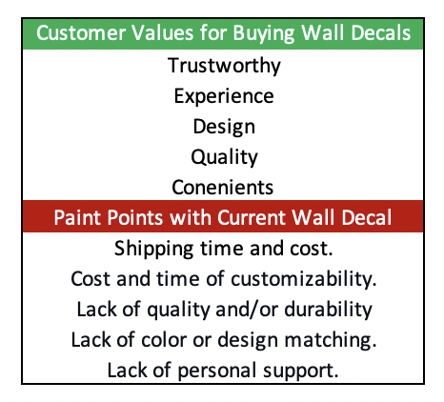

1. Dholakia, Utpal M. “A Quick Guide to Value-Based Pricing.” Harvard Business Review, August 9, 2016. https://hbr.org/2016/08/a-quick-guide-to-value-based-pricing.

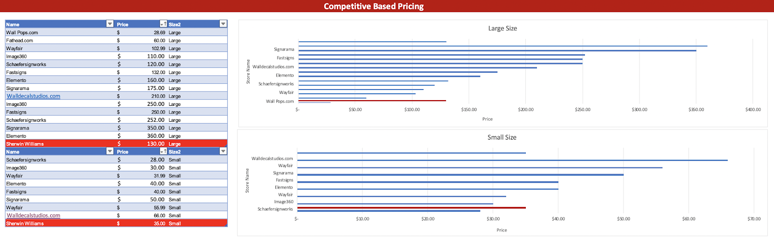Appendix F: Competitive Based Pricing

1. "Wall Decals." Wayfair. Accessed March 4, 2020. https://www.wayfair.com/decor-pillows/sb0/wall-decals-c504340.html
2. "Create Your Own Custom Wall Decal." Wall Decal Studios.com. Accessed March 4, 2020.<https://www.walldecalstudios.com/>.
3. "Wall Decals." Wayfair. Accessed March 4, 2020.<https://www.wayfair.com/decor-pillows/sb0/wall-decals-c504340.html>
4. Francisco Contreras. “Store Manager, Signarama” February 20, 2020
5. Francisco Contreras. “Store Manager, Fast Signs” February 20, 2020
6. “Wall Decals.” Wayfair. Accessed April 22, 2020. https://www.wayfair.com/decor-pillows/sb0/wall-decals-c504340.html.
7. “Pretty Peonies Wall Art Kit.” WallPops. Accessed April 22, 2020. <https://www.wallpops.com/dwpk3524-pretty-peonies-wall-art-kit>.
8. “Online Source of Officially Licensed & Custom Wall Decor.” Fathead. Accessed April 22, 2020. https://www.fathead.com/.

Appendix G: Cost-Based Pricing

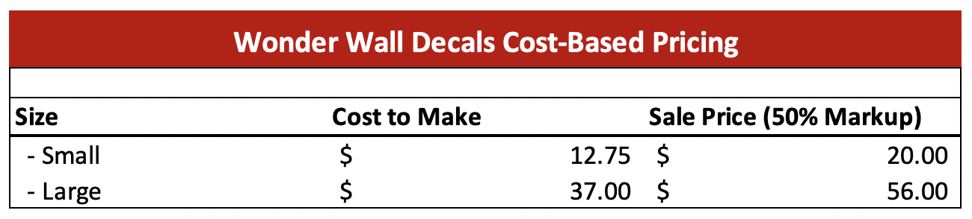

1. Sumo Group, Inc. “How To Price A Product: A Scientific 3-Step Guide (With Calculator).” Sumo. Accessed April 22, 2020. https://sumo.com/stories/how-to-price-a-product.

Appendix H: Marketing Promotion

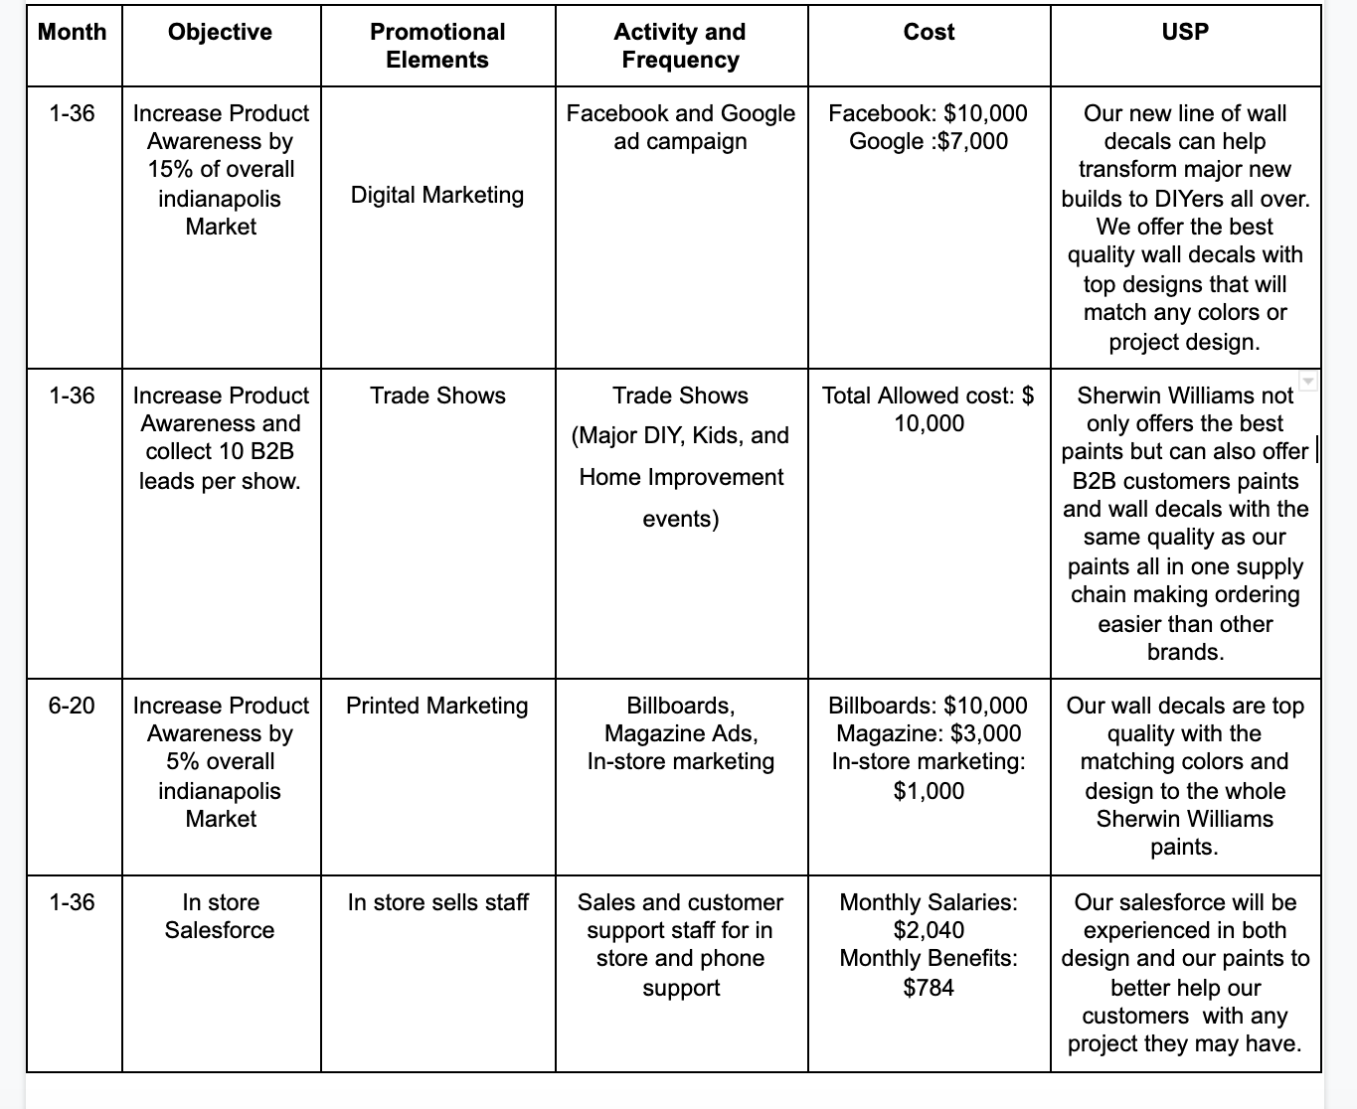

1. “Billboards In Motion.” Indianapolis Billboard Costs | Billboard Advertising in Indianapolis, IN. Accessed April 18, 2020. https://www.timesoohmedia.com/billboard-costs/in/indianapolis.php.
2. Bruce, Jenna. “How Much Does Direct Mail Marketing Cost?” Home Page. Accessed April 18, 2020. http://www.mediaspacesolutions.com/blog/how-much-does-direct-mail-marketing-cost.
3. Pearce, Sean. “Ad Rates for TV Stations in Indianapolis Indiana 888-449-2526.” Low Ad Rates - Free Professional Services | 888-449-2526, November 5, 2019. https://howtobuyradioadvertising.com/tv-advertising-ad-rates-indianapolis/.
4. “Find & Explore Colors And Stain Colors By Sherwin-Williams.” Sherwin. Accessed April 18, 2020. <https://www.sherwin-williams.com/architects-specifiers-designers/color/find-and-explore-colors>.

Appendix I: Unit Forecast and Materials Direct Cost

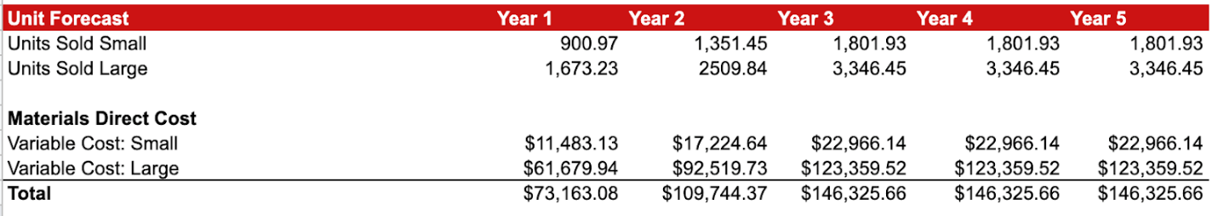

Appendix J: Direct Capital Spending and Total Direct Cost

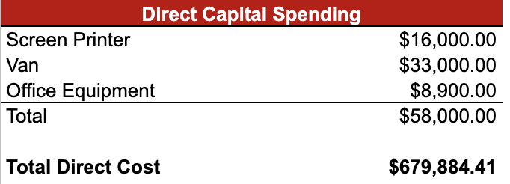

Appendix K: Variable Cost Per Unit

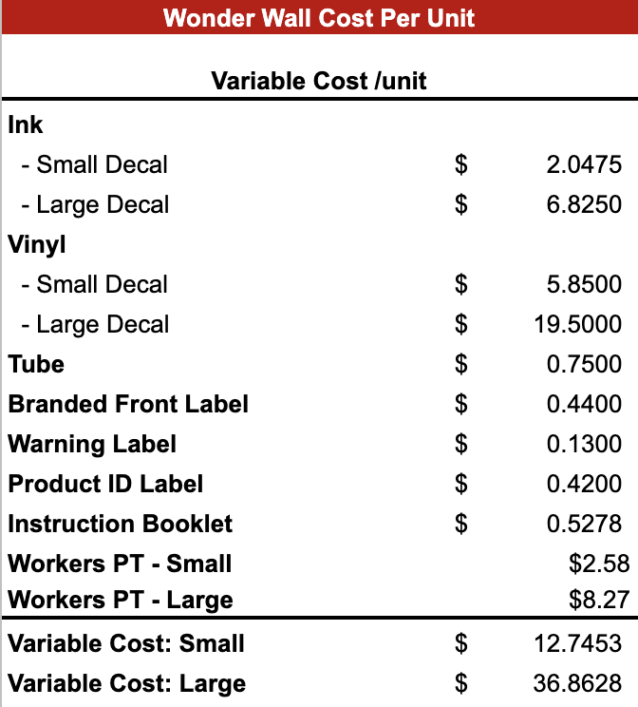

**End Notes:**

1. Brad Perraut and Jason Christensen. “Sherwin Williams I-Core Presentation.” February 3, 2020
2. “Sherwin-Williams Paint Store.” prezi.com. Accessed April 18, 2020. https://prezi.com/_t3d8nphrbhd/sherwin-williams-paint-store/.
3. “What Does Office Equipment Cost?” Office Interiors. Accessed April 21, 2020. <https://www.officeinteriors.ca/office-technology/what-does-office-equipment-cost/>; “14 Business Startup Costs Business Owners Need to Know.” Fundera. Accessed April 20, 2020. <https://www.fundera.com/blog/business-startup-costs#furniture>.
4. “WATCH NOW.” Say Yes to HP Latex Printing | HP® Official Site. Accessed April 20, 2020. [https://www8.hp.com/us/en/commercial-printers/latex-printers/say-yes-to-latex.html?jumpid=ps_e4jgk1ur2c&gclid=EAIaIQobChMIlf6Lib716AIVdQiICR0XgQTCEAAYASAAEgKUtPD_BwE&gclsrc=aw.ds#](https://www8.hp.com/us/en/commercial-printers/latex-printers/say-yes-to-latex.html?jumpid=ps_e4jgk1ur2c&gclid=EAIaIQobChMIlf6Lib716AIVdQiICR0XgQTCEAAYASAAEgKUtPD_BwE&gclsrc=aw.ds); Terry, Shellie; “Tip of the Week: How to Determine Your Cost per Print.” LexJet Blog, February 20, 2015. https://blog.lexjet.com/2015/02/20/tip-of-the-week-how-to-determine-your-cost-per-print/. “Kraft Tubes.” ULINE. Accessed April 4, 2020. <https://www.uline.com/BL_3653/Kraft-Tubes>.
5. “Home / IN / Indianapolis Warehouses / Warehouse Space for Rent / 8825 - 8909 Boehning Ln.” Indianapolis Warehouse Space for Rent - 8825 - 8909 Boehning Ln. Accessed April 20, 2020. https://warehousespaces.com/warehouse-for-rent/United-States/IN/Indianapolis/10436.
6. “General Liability Insurance.” General Liability Insure. Accessed April 20, 2020. https://generalliabilityinsure.com/small-business/warehouse-insurance.html.
7. “2020 Ram ProMaster®.” 2020 Ram ProMaster - Cargo Van Features. Accessed April 19, 2020. https://www.ramtrucks.com/ram-promaster/cargo.html.
8. “2020 Ram ProMaster®.” 2020 Ram ProMaster - Cargo Van Features. Accessed April 19, 2020. <https://www.ramtrucks.com/ram-promaster/cargo.html>; “HP Latex 315 54in Print and Cut Solution.” LexJet. Accessed April 19, 2020. <https://www.lexjet.com/hp-latex-315-54in-print-and-cut-solution?CAWELAID=320012560000714971&CAGPSPN=pla&CAAGID=61396511513&CATCI=pla-437675034177&CATARGETID=320012560000749220&CADevice=c&gclid=EAIaIQobChMInZ6rupH16AIVbCqzAB39qgi7EAYYASABEgLJq_D_BwE>: “WATCH NOW.” Say Yes to HP Latex Printing | HP® Official Site. Accessed April 20, 2020. https://www8.hp.com/us/en/commercial-printers/latex-printers/say-yes-to-latex.html?jumpid=ps_e4jgk1ur2c&gclid=EAIaIQobChMIlf6Lib716AIVdQiICR0XgQTCEAAYASAAEgKUtPD_BwE&gclsrc=aw.ds#; Terry, Shellie. “Tip of the Week: How to Determine Your Cost per Print.” LexJet Blog, February 20, 2015. <https://blog.lexjet.com/2015/02/20/tip-of-the-week-how-to-determine-your-cost-per-print/>; “2 Shelf Pallet Rack Starter Unit - 96 x 48 x 96.’” Uline. Accessed April 21, 2020. https://www.uline.com/Product/Detail/H-5716/Pallet-Racks/2-Shelf-Pallet-Rack-Starter-Unit-96-x-48-x-96?pricode=WA9922&gadtype=pla&id=H-5716&gclid=EAIaIQobChMIjcXHhvn86AIVy8DACh1v3wxtEAYYASABEgLpifD_BwE&gclsrc=aw.ds.
9. “2 Shelf Pallet Rack Starter Unit - 96 x 48 x 96.’” Uline. Accessed April 21, 2020. <https://www.uline.com/Product/Detail/H-5716/Pallet-Racks/2-Shelf-Pallet-Rack-Starter-Unit-96-x-48-x-96?pricode=WA9922&gadtype=pla&id=H-5716&gclid=EAIaIQobChMIjcXHhvn86AIVy8DACh1v3wxtEAYYASABEgLpifD_BwE&gclsrc=aw.ds>.
10. Bean-Mellinger, Barbara. “The Average Cost Per Month for Office Supplies.” Small Business - Chron.com. Chron.com, March 8, 2019. <https://smallbusiness.chron.com/average-cost-per-month-office-supplies-12771.html>.
11. See Note 1 above.
12. See Note 2 above.
13. Vitez, Osmond. “Centralized Vs. Decentralized Organizational Structure.” Small Business - Chron.com. Chron.com, February 12, 2019. https://smallbusiness.chron.com/centralized-vs-decentralized-organizational-structure-2785.html.
14. “Main Advantages of Functional Organization Structure.” Org Charting. Accessed April 19, 2020. http://www.orgcharting.com/functional-organization-structure-advantages/.
15. See Note 13 above.
16. “Main Disadvantages of Functional Organization Structure.” Org Charting. Accessed April 19, 2020. <https://www.orgcharting.com/functional-structure-disadvantages/>.