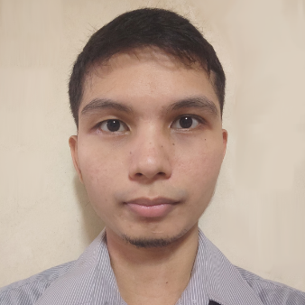
Francisco Kaleb C. Marquez
📧 franciscokaleb.marquez02@gmail.com | 🌐 github.com/FranciscoKaleb | 📍 Bay, Laguna, Philippines

Education
🎓 BS Computer Engineering | Laguna State Polytechnic University (2014-2019)

Work Experience
👨‍🏫 Assistant Instructor II | AMA College (2024)
- Taught programming, software engineering, and computer-related subjects.
- Guided students in developing projects using PHP, Laravel, C#, and databases.
- Assisted in curriculum development and course planning.
👨‍🏫 Special Science Teacher I | DepEd Senior High School (2020 – 2022)
- Instructed senior high school students in computer science and engineering-related subjects.
- Led hands-on programming activities and projects using Arduino, Python, and Java.
- Conducted troubleshooting and IT support for school systems.
👨‍🏫 OJT | Ecosystems Research and Development Bureau-DENR (2018)
- Part of a team that develops a C# program.
- Answer phone calls, print documents, edit documents.

Technical Skills
💻 Programming & Development:
- Web Development: PHP, Laravel, JavaScript, HTML, CSS
- Desktop Applications: C#, VB.NET, Java, Python, C++
- Embedded Systems: C (Arduino, microcontrollers)
- Databases: MySQL, SQLite
- Machine Learning: Fundamentals and implementation
🌐 Networking & IT:
- Basic network setup and troubleshooting (switches, routers)
- System formatting and troubleshooting
🖼️ Software & Tools:
- Microsoft Office (Word, Excel, PowerPoint, Teams)
- Google Apps (Docs, Forms, Sheets)
- Photo Editing: GIMP, Photoshop
- QGIS (Basic mapping skills)
📌 Other Skills:
- Electronics and electrical connections
- Inventory and project management

Projects & GitHub
📂 Portfolio: github.com/FranciscoKaleb

