**Behavior Driven Development**

1)

1.1 -> Create deck with full 52 values.

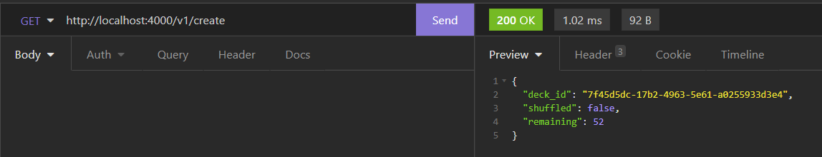

1.2 -> List deck with full 52 values.

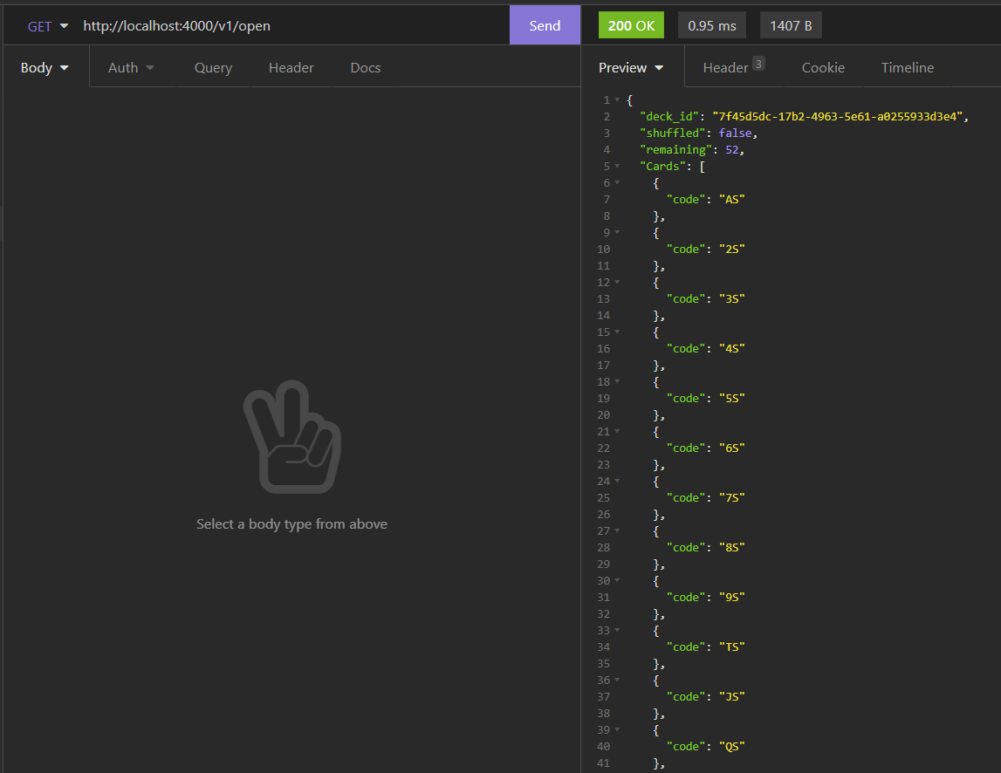

1.3 -> Shuffle cards in the deck.

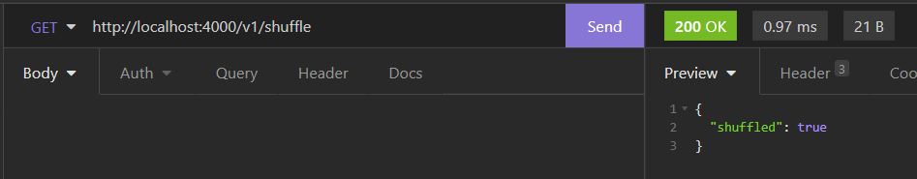

1.4 -> List shuffled cards in the deck with full 52 values.

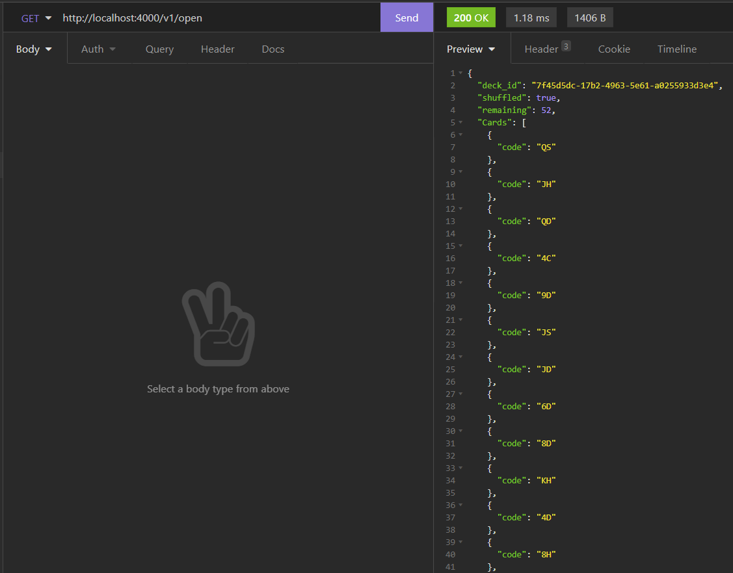

1.5 -> Draw shuffled cards in the deck using **count** param value.

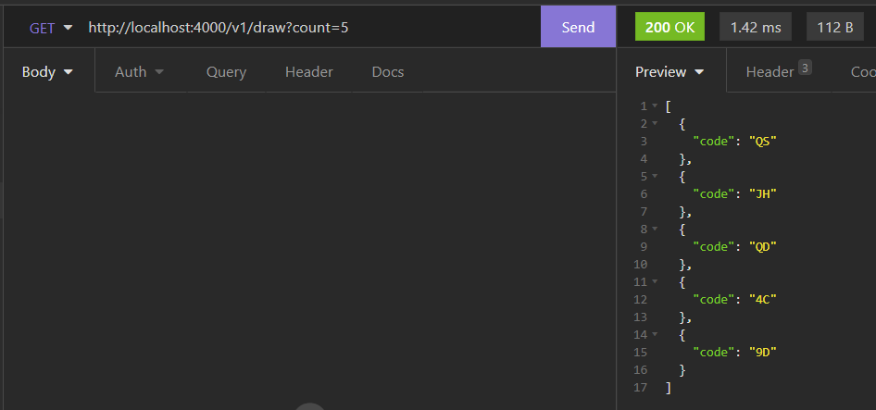

1.6 -> Validating **count** param value - blank.

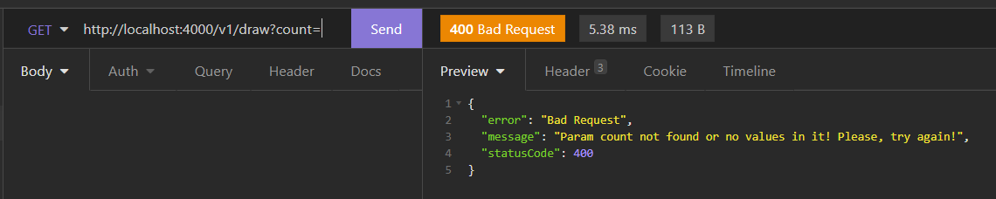

1.7 -> Validating **count** param value - characters.

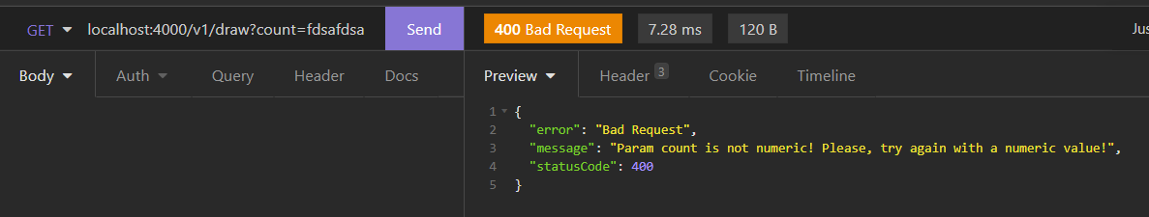

1.8 -> Validating **count** param value - negative number.

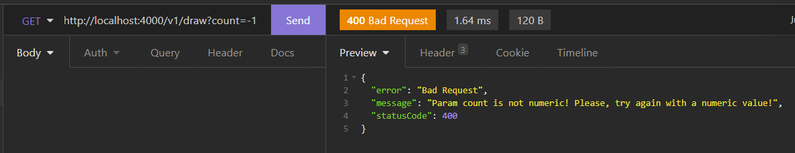

1.9 -> Validating **count** param value – value bigger then expected on deck.

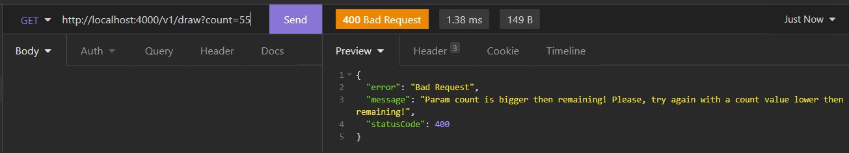

1.10 -> Validating cache expiration.

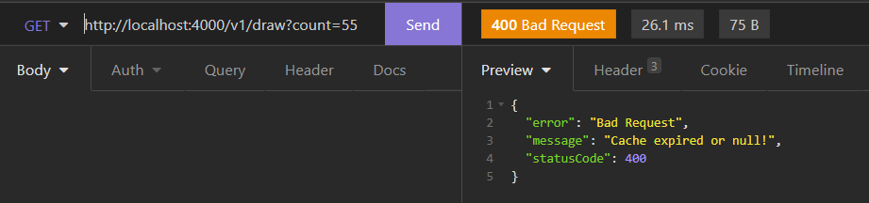

**--**

2)

2.1 -> Get all valid values and build deck of cards.

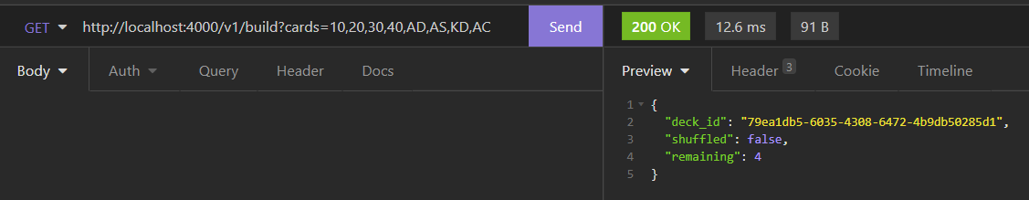

2.2 -> List deck with 4 values in this case because was created with 4.

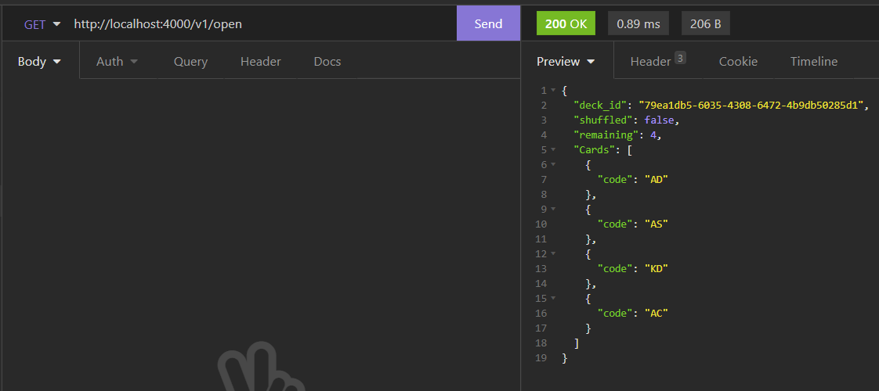

2.3 -> Validating **count** param value – value bigger then expected on deck.

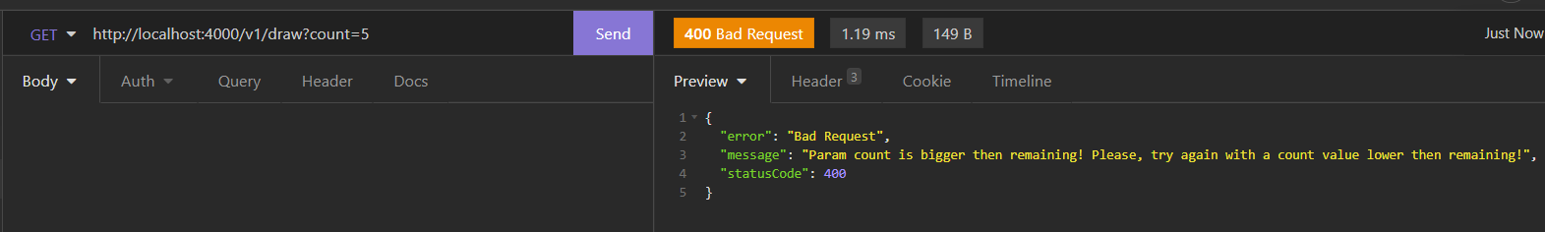

2.4 -> Draw not shuffled cards in the deck using **count** param value.

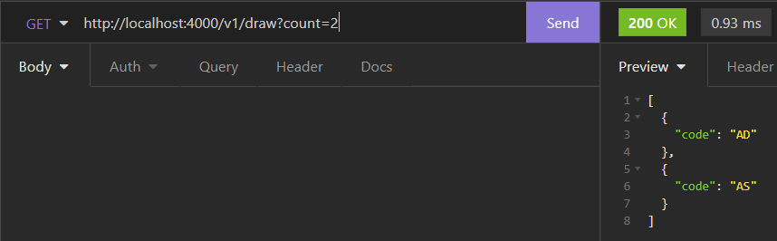

2.5 -> Shuffle cards in the deck.

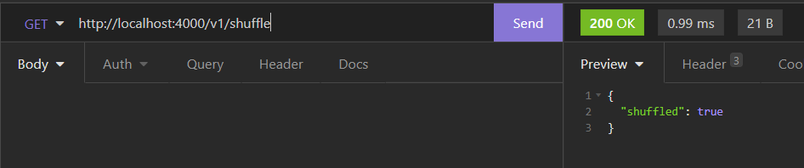

2.6 -> List shuffled deck with 4 values in this case because was created with 4.

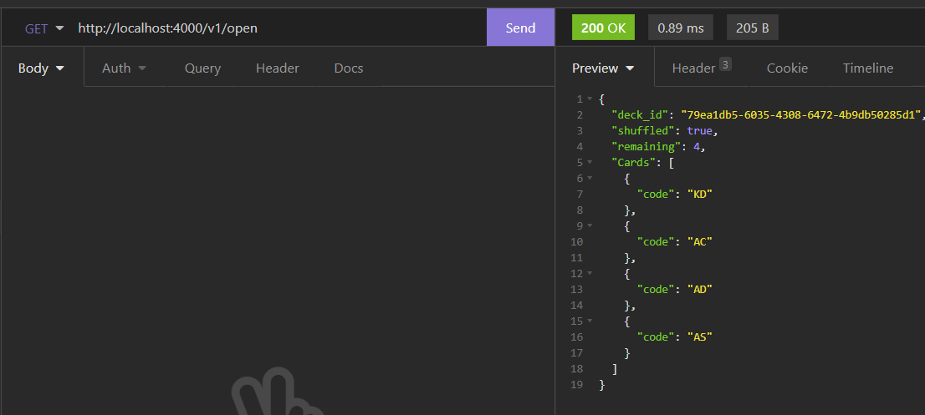

2.7 -> Draw shuffled cards in the deck using **count** param value.

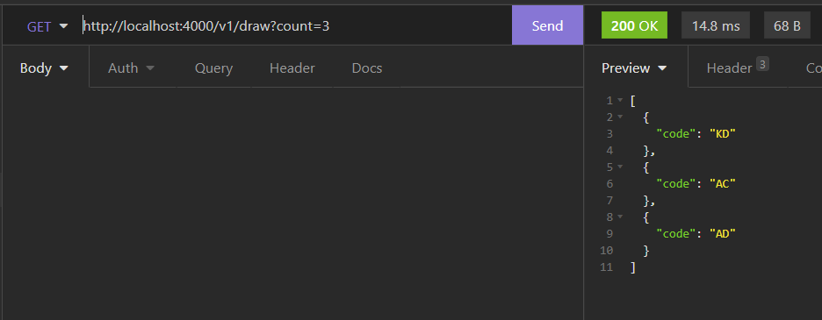

**--**

3)

3.1 -> Validating **cards** param value – no values in it.

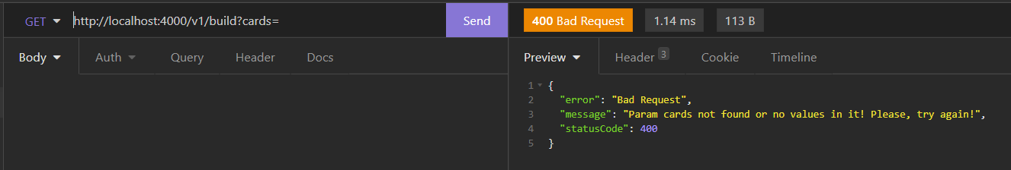

3.2 -> Validating **cards** param value – Invalid values in it.

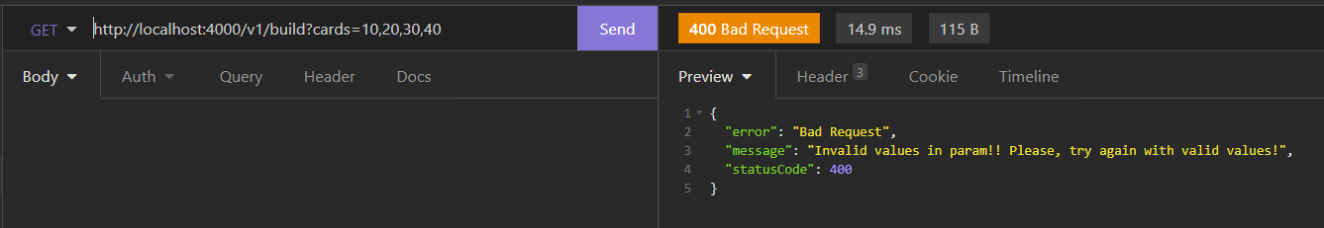

3.3 -> Validating **cards** param value – Invalid value in it (negative one).

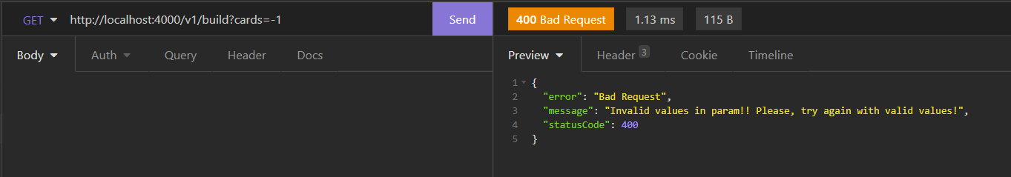

3.4 -> Creating with success because has valid values.

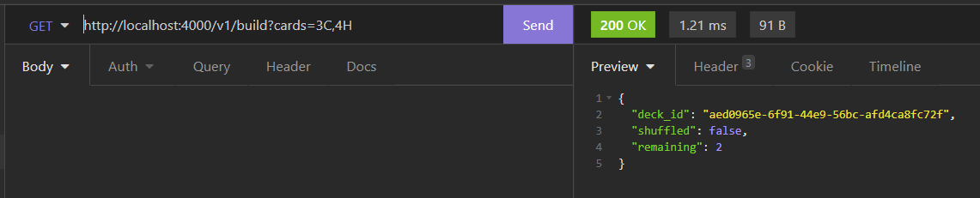

4)

4.1 -> Validating call of draw service without create a deck.

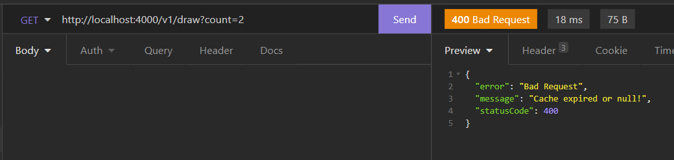

4.2 -> Validating call of open service without create a deck.

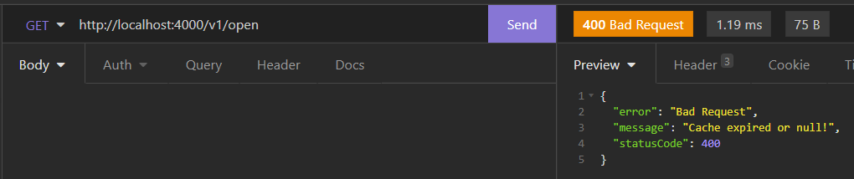

4.3 -> Validating call of shuffle service without create a deck.

