**NeuroGames: A MOBILE APP FOR PSYCHOLOGICAL TESTS**

Isnaldo Francisco de Melo jr[1]

Joaquim Pessoa Filho[2]

**Abstract:** This monograph presents an iOS app called NeuroGames. The app implements neuroscience tests for scientific divulgation. The increasing growth of smartphones in Brazilian society and the exhibition of neuroscience tests as games makes the mobile app interesting. Three tasks were executed in order to implement the app: PVT, Ebbinghaus memory test and Stroop effect. It should be used as instrument for evaluation only if under supervision of a team of Neuroscience researchers. In synthesis, this computer science application is (in a ludic way) a useful tool for scientific divulgation.

**Keywords**: Neuroscience, Mobile App, Scientific Divulgation

# 1 Introduction

There has been a significant growth of smartphone sales in Brazil in the past few years. According to the International Data Corporation consultancy (IDC, 2013), there has been a record of growth in sales in 2014, with more than 13 million of sales in the second quarter of 2013. According to IDC consultant Leonardo Munin, this is a record considering the mark of 300 million smartphones sold worldwide (MUNIN, 2013).

As IDC punctuates, there is a growing trend on Android operating systems worldwide in contrast with other systems, nearly 84% of world's consumers use Android. This is also valid in Brazil as nearly 90% of consumers use Android too.

According to some market analysis, some trends have emerged with the growing popularity of smartphones in the world, especially in Brazil. One trend in particular aims using mobile apps to different, multiple purposes, for instance, to entertainment and to multimedia as well. We can perceive that today by seeing the high percentage of conventional devices sold with both features. An app is a program that runs on a mobile phone. There is also a clear expansion of the concept and a diversification on its usage. The number of app downloads has grown considerably as showed by a chart in Antonio Wells’ website which is specialized in Android and Android Apps (Wells, 2010).

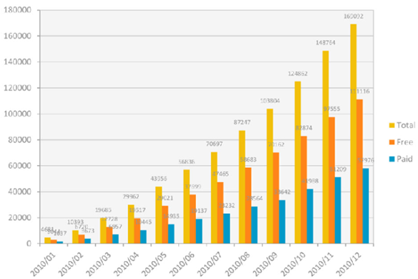

Figure 1 – Evolution of mobile apps

**Source: AndroidTapp, 2011.**

According to Figure 2, not just an expansion has happened but also a clear niche diversification. What started simply in the entertainment niche is now already part of several other niches, showing the evolution in the field and trend diversification.

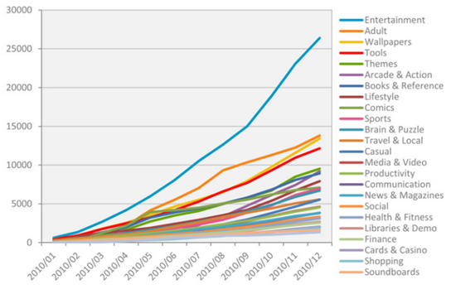

Figure 2 – Evolution on the number of apps by categories

**Source: AndroidTapp, 2011.**

According to Kantar Worldpanel consultancy (2014), people under the age of 25 holds 55% of smartphones. Screen size has also increased, 84% of the sales are made with smartphones with screens resolutions 4.0" and 4.4" (MOBIFEED, 2014). According to these data, there has been a consolidation and increase of Android as the main operating system, with also an increase of iOS system regarding previous years. From July/2014 to August/2014, world population that use iOS systems has increased from 4.6% to 5.2% (KANTAR, 2014).

With the growth of new categories of mobile apps, new app updates have been occurring. Due to competition, newly created apps need to worry not only about the design and target audience, but with interaction and usability with the user too. As Janko Jovanovic says, a limited knowledge in the design can lead to dissatisfied and frustrated users, even with the development of both front-end and back-end (JOVANOVIC, 2010).

In this diversification context, smartphones in Brazil are required by a Brazilian law called “Good Law” - number 11,196 of November 21 of 2005 – to have national mobile apps produced in Brazil. This law aims to boost the development of internal Brazilian market as a whole. The law was divided into steps and expects from December 2014 a total of 50 national mobile apps to be produced (BRAZIL, 2005).

A big technological trend is to use reduced monitors and touch screens such as those of smartphones and tablets. The latter, more specifically, was originated as a follow-up on the market after 2010, after Apple have launched the famous Ipad (G1.com, 2006).

With a market rising and a growth on national mobile apps, greater competition will be stablished between companies of the market. Therefore, professionalizing and using concepts that go beyond the usual will be vital for diversity in the market, e.g. eye fatigue minimization, user control and customization.

New approaches and evaluation strategies will be very important for this technological trend of touch screens and larger displays in each version release and for the concern with the usability and design of the apps due to increased competition. An example of this is the use of measurements and proportions on website pages such as using Golden Ratio and Fibonacci Progression. Part of these concepts have been used in the construction of screens for tests. For instance, Figure 3 exemplifies the golden ratio used on the construction of the twitter page.

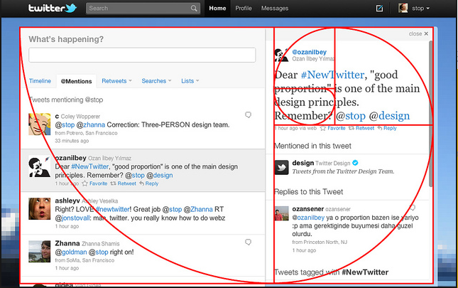

Figure 3 –Twitter page and exemplification of Golden Rule

Source: Myparadoxdream, 2014.

As showed in figure above, it is specifically possible to use psychomotor measures and consequently psychology concepts directly or indirectly in mobile apps. Although games assess motor skills and user response times, in this example, they do not necessarily show measures as variables in the game.

A psychological interpretation can be done through a "hedonic adaptation" of the Facebook most popular game named Candy Crush. In this game interpretation, there is a tendency to return to a pleasure level even despite temporary variations on the game (HAKAMATA et al., 2010). Such concept was developed by Brickman et al. in 1978 (BRICKMAN, 1978) and is an example of a psychological concept applied on games. A research on the market of the game could study a way to maximize these psychological effects to achieve better usability and playability by end users.

Mobile apps that apply psychological concepts could be directly used on psychological treatments and evaluations, a very specific segment and a target audience for this type of app. Some of related usage would be tests for proficiency, contests, or driving license. A game that uses ABMT (Attention Bias Motor Training) concepts for anxiety disorders training (HAKAMATA, LISSEK S and BAR-HAIM Y, 2010) was already developed and published on the Clinical Psychology Science journal.

In these mobile apps, metrics are adopted relating target audience with measurements of memory, attention and response time. It is just important to highlight here that a psychological test app should in addition to tests on development be validated and tested using metrics and comparative experiments. For example, the treatment for psychological disorders developed by McNally and Phil Enock of Harvard University (ENOCK and McNALLY, 2013).

CBM (Cognitive Bias Modification) was a concept developed by Colin Macleod of Western Australia University (MACLEOD and MATHEWS, 2011). Mobile apps were developed based on this concept aiming to assist modification and correction of anxiety.

Philip M. and Richard J. from Harvard University say mobile devices can provide a means to enable mental health treatments (ENOCK and McNALLY, 2013). Comparatively, our proposed work is very similar to theirs, they implemented other tasks for iPad. As Benedict Cary from New York Times stated, therapy mobile apps can help people, with appropriate restrictions, given mobile’s affordable and practical character (CAREY, 2012).

Considering the national market and the set of applications that can be developed within this context and the possibility of applying psychological concepts on mobile apps, the aim of this project is to develop a mobile app that implements psychological tests as scientific dissemination instrument in order to bring young people, i.e. the main target audience, closer to applied psychology concepts. Specifically, the aim is to develop a mobile app that presents neuroscience activities as games using measurable parameters. In order to use the app for diagnostics and clinics, tests would have to be validated.

The developed application can be applied in science divulgation, non-parameterized tests and as a basis for other games and mobile apps. The mobile app might have real patients testing its functions. By using psychological concepts and very renowned psychology tests, other groups of people can do reviews about the app, which is available for free.

This project than aims at:

* Disseminating and using psychology and neuroscience concepts;
* Applying clinical tests (if app functions were properly tested and led by a responsible group of people);
* Implementing concepts learned in class by means of a practical technological solution.

# 2 Background

This background is comprised of two main parts: one regarding psychology concepts involved in the app and the other with the technologies involved in each implementation task. We present models and framework of part of the mobile implementation at the end of this section.

**2.1 Psychology Concepts**

**2.1.1 Task 1 – Response Time: PVT**

Surveillance Test, i.e. *Psycho Motor Vigilance Task* (PVT), it is a reaction test that measures the response time for random visual stimuli. PVT is used for example at the ISS (International Space Station) to measure alert levels of the crew and according to the “MeSh D013647” classification, PVT is used in clinical tests concerning sleep deprivation.

Research has shown a correlation between worsening of tests and alert levels (BASNER, MOLLICONE and DINGES, 2011). A premise is that sleep deprivation interferes in certain cognitive functions during the test. One the main effects is the lack of attention, which can be measured in a 10-minute test using PVT.

The result of the test, in general, is analyzed by the average and the median time values, but the study changes in a regular basis. A test, analysis and prediction platform was already developed for personal computers by Khitrov et al. (2014). According to Basner and Dinges (2011), the test should be done in 10 minutes at a time, but the test developed in iOS in his project considers only a 3-minute application. According to literature, the application is designed with a red rectangle and the press of a button, as soon as a yellow stimulus appears in the CRT (Catody Radio Tube) monitor.

The app was based on Basner and Dinges (2011)’s implementation and this task was previously implemented in an Android app, and published on Google Store as *PVT Test.*

**2.1.2 Task 2 – Ebbinghaus Memory Test**

Hermann Ebbinghaus was a German psychologist who lived from 1850 to 1909 and is considered the father of experimental psychology regarding memory (DEWEY, 2007).

According to contemporary researchers, the memory is a process that receives and allocate information in such way they can be accessed retrospectively in the future. This process was becoming more complex with time; by the year of 1960, the process was already very complex (WOZNIAK, 1999). According to Spear and Muller (1994 apud SMITH; JONIDES, 1998) memory is a multi-dimensional representation of an episode in an organism. Therefore, conceptualize memory is a difficult thing to do.

This test was implemented in iOS. Immediate memory was used and related to working memory, which in turn was related to the peripheral sensory system. The test itself is the presentation of three letters, which together do not make any sense semantically. The test avoids abbreviations or acronyms, as for instance the Brazilian Company of Traffic Engineering (CET) or Register of Natural Persons (CPF – *Cadastro de Pessoas Físicas*).

**2.1.3 Task 3 – Colors Test**

The concept behind a Colors Test is called Stroop Effect and demonstrates interference on the reaction time of a task. When a sentence containing a color name is displayed with another color with a different name, interference on the human understanding of the color is generated in the brain. This has been used in a portable video game called Nintendo DS.

The test name is inspired from an English researcher called John RiddleyStroop (MACLEOD, 1991). John has published several articles in the year of 1935 formalizing these effects on colors tests. The referred article is one of the most cited articles in experimental psychology. These are the brain parties involved in these activities according to an fMRI review: Cortex pre-frontal and left anterior cingulate.

Stimuli on the Stroop Effect can be viewed in three parts: neutral, congruent and incongruent. There are some theories to explain the test effect, selective attention and parallel processing.

This activity development was based on a software version developed by the University of Washington using Java technology (Washington Edu, s.d.).

**2.2 Development**

Waterfall methodology was used in this development, even though waterfall methodology is currently declining due to the increasing adoption of agile development methodologies such as Scrum. In addition, a native platform was also used because that platform enables the use of specific iPhone features such as the Camera or the GPS (BUDIU, 2013). These sutil differences can be noticed if two similar applications, one native and the other non-native, were compared (SCHAEFER, 2004).

According to Roger S. (PRESSMAN, 1995), the waterfall model functions in a series of stages, each one with quality check, if an error occurs, previous stage should be taken. Processes used in this mobile app were respectively problem analysis, numbering of requirements, work plan development with schedule, project development, app launch and maintenance. Artifacts are generated in some of these parts.

Model View Controller (MVC) design pattern was used and implemented in iOS through an interface implementation. MVC architectural pattern was used in order to fragment the application in three parts, i.e., model, view and controller. This pattern was first introduced by Trygve Reenskaug in Smalltalk-76 in the 1970s (GAMMA, 2000). The standard was then modified over time and gave rise to other patterns too, mainly due to restrictions on the standard. More information can be found on a book called “Design Patterns: Your Brain on Design Patterns” (FREEMAN and FREEMAN, 2007).

**2.2.1 Tests**

From a technical point of view, activities are functional and tests have been successfully implemented. Regarding the technical part, some tests applied to mobile apps differ from applications on usual microcomputers, for example, according to Kumar Mohan from Infosys, it can be applied on mobile apps tests such as emulators, cloud services and the actual application itself (MOHAN, 2013). iOSFoneMonkey, UIAutomation, Frank and GTP can also be used as testing tools.

These are the tests that can be done, according to that same source:

* **Usability tests**: similar to those on desktop applications. Here, questionnaires are commonly used. It is also common to use heatmaps, scrollmaps and eyetracking on website tests.
* **Compatibility tests**: check app compatibility with other mobile devices, operating system versions, screen sizes and eventual conflicts with other apps.
* **Interface tests:** validates the app user interface from a point of view of design e performance.
* **Services tests:** check if the service is *off-line,* and delay to the database.
* **Low-level feature tests:** try to stress out the mobile app by using too much of mobile phone resources and memory.
* **Performance tests:** check a delay on Wi-Fi connection, 2G/3G, resources as cameras and GPS, GPU optimization, battery consumption, response time and how the mobile app was requested.
* **Operational tests:** check if information was stored correctly if battery is at low charge, check app updates, messages or call accesses during initialization.
* **Security tests:** test encryption or de-encryption used in mobile apps in the exchange of data and messages, e.g. recently Facebook did encrypted messages on WhatsApp.

# 3 NeuroGames Development

**3.1 App Description**

The main idea of the mobile app developed in this project is the simplicity and reliable application of psychology concepts in the same way they appear in other similar tests. We chose not to use any graphic library as resource such as the COCOS2D library since we did not need any special feature on the app. The mobile app in synthesis consists of a main menu for activity access and to describe the activities themselves implemented by a wireframe.

**3.2 Project**

A wireframe called Trello (attached in the annex) was used and brings the specifications of the mobile screens. Trello framework was used to monitor this project development, partially made abroad, while weekly tasks similarly to Scrum sprints. Lastly, the book “Mobile Design and Development” (FLING, 2009) was used to the project draft.

By aiming to demonstrate the practical application of the developed mobile app, the app could be tested in a school system to find averages for human population. Considering the results in literature, it is possible to make assumptions about the population under evaluation, however, this is not included in the scope of this graduation project.

**3.3.1 Levantamento de Requisitos**

Requirements elicitation was made based on articles that described task specifications. Functional requirements directly influence software while non-functional requirements directly influence the use of application, in addition to business rules. Business rules are sets of instructions the user provides that must be addressed to determine the behavior of system features.

* **Functional requirements**: each activity is specified considering which concept is being evaluated.
  + **PVT**: app for the response time test with an embedded schedule and an executed stop action as soon as the screen is pressed.
  + **Memory Test**: a test based on a pseudo-random generation of eight words of three letters in the format consonant-vowel-consonant (CVC), that at the end, must be selected by the user in same order they first appeared.
  + **Stroop Effect**: shows at the screen color names with font different than the color it represents; colors are randomly distributed.
* **Non-functional requirements**: should be user interactive without extrapolating the original limits of the activities. A questionnaire is proposed to an evaluation.
* **Business rules**: the app is based on the set of activity original rules and on similar implementations in the area of study.

**3.3.2 Wireframe**

A wireframe using Marvel (Annex A) was created from prerequisites in order to facilitate this project development. The wireframe was used in production of mobile apps that had greater scope and design validation and by which the development and project stakeholders were different people. Marvel framework enabled the modification and download of a version of the app for mobile phone.

**3.4 Codification**

Coding was the penultimate part of this project and developed using XCode in Objective-C programming language. The IDE (Integrated Development Environment) used was in Portuguese and developed by Apple for programming, compiling and testing native Objective-C code (Apple, 2014). This IDE is currently in version 6 and enabled this project development using Storyboards, which is a graphical representation of mobile screens as simple diagrams. Figure 5 shows the storyboard of the whole system containing both screen and their flow.

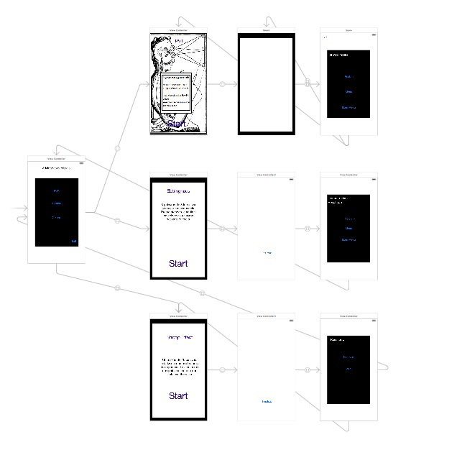

Figure 5 - Storyboard of full application

**Source: XCode Project, 2014.**

**Diagrams Simplify the System**

Diagram below showed in Figure 6 is the screen flow applied to each activity. This flow can be used to the development of other similar applications as well. Three screen were necessary to implement each activity: initial screen, application screen and score screen.

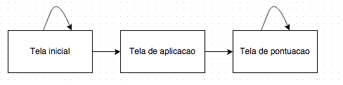

Figure 6 – Representation in each activity

**Source: Own authorship, 2014.**

**Activity 1 - PVT**

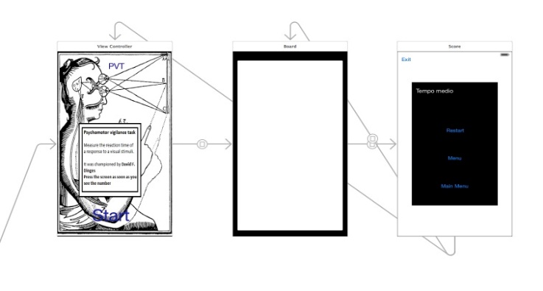

Figure 7 – Storyboard of activity 1 - PVT

**Source: NeuroGameXcode Project, 2014**.

Figure 7 shows the storyboard of the first activity. It shows the initialization screen, game screen (white screen with a board appearing with a timer in milliseconds) and average time screen.

**Activity 2 – Stroop Effect**

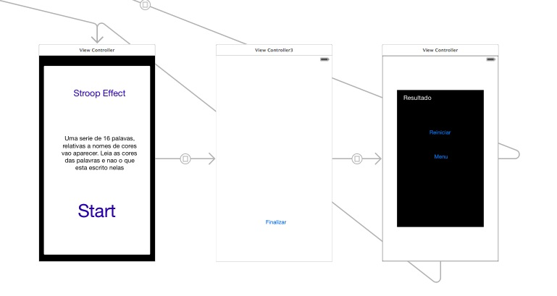

Figure 8 – Storyboard of activity 2 – Stroop Effect

**Source: NeuroGameXcode Project, 2014.**

Figure 8 shows the storyboard of the second activity. It shows the initialization screen, game screen (white screen with a board appearing with color names of different font colors) and final screen.

**Activity 3 – Memory Test**

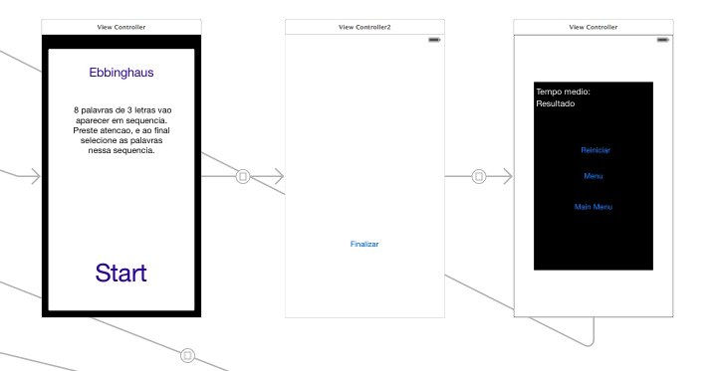

Figure 9 – Storyboard of activity 3 – Memory Test

**Source: NeuroGameXcode Project, 2014.**

Figure 9 shows the storyboard of the third activity. It shows the initialization screen and the game screen – a screen with eight words randomly generated and then the options for the user to select those exact same eight words. Codes regarding this activity were attached to consult in Annex D.

**3.5 Tests**

Tests in each activity can be seen in two aspects: technical and analytical. Regarding NeuroGames, there were only made tests of technical aspects using the XCode IDE. It is true that were some bugs in the application programming however programming with storyboard is usually very simple. A usability questionnaire is suggested for tests on the app in Annex C.

**3.6 Launch**

The app launch was made in three steps, following Apple Application Deployment Guide: registration, development and distribution. First and last processes are made in registration at the online platform. NeuroGames was not published yet in the Apple platform, However, a restricted version of activity 1, i.e. PVT, was already launched in Google Store (PVT test - Frank dev team).

**3.7 Maintenance**

The app maintenance might be necessary if errors were found or there were a need to launch a new version, which may or may not contain new features. An eventual second version could for example feature the inclusion of two more activities: psychometric tests (drawing lines) and sequentially tests.

**3.8 Documentation**

The user's app manual is described in Annex C. The app manual contains basic instructions, the app operations and how to use app’s activities.

# 4 Results and Discussion

Results can be evaluated in two ways: according to technical aspects of the app development or to Neuroscience, but regardless of the way, both are quite successful ways of evaluation. Now, regarding the app itself, the result was a functional, presentable, simple application, which does not consume many device resources, as there is no database attached to the app or the use of internet connection.

From a Neuroscience point of view, the mobile app was successful considering the implementation of the app requirements, shown also in other similar tests. Regarding app development, a meaningful assessment of the activities was made in order not to distort the original concept brought by that activity.

There has also been success in the app development what regards to the techniques used: Marvel and XCode through Trello.

As a final result, the availability of the app for the general public was beneficial to science in a very broadly way. With that being said, it is interesting to address this discussion on science divulgation and be able to include current concepts in our everyday situations as on mobile phone apps.

**Evaluative questionnaire**

A test form is attached on Annex C indicating restrictions and formal details on the mobile app regarding the test framework used with neuroscience targeting a scientific public. The questionnaire was based on the “Questionnaire template for User Interface Satisfaction, QUIS” (CHIN, DIEHL and NORMAN, 1988)

During development and conclusion, opinions from users can be used to improve the app and focus the development more to the user (BEVAN, 1997). There is a similar work which also uses a questionnaire for app evaluation but it regards to public transport domain (LUCIO, 2011).

**4.1 Application as psychological tests**

The mobile app should not be used as evaluation parameter since neither a rigorous concept evaluation nor psychological criteria were used, mainly for the sake of time. This would surpass the scope of this computer science project and surpass available time to develop the app.

Other factors have to be considered to validate this app, and these factors may interfere in the final result, for example, the screen size as explained by Thomas Rocha (DA SILVA, 2011). There is no consensus however on the influence of the device size on the test. One of the earliest studies on the subject is the work of (BRUIJN, MUL, and OOSTENDORP, 1992).

Regarding the application and clinical psychological tests, a detailed comparison and practical application have to be done further with teams of psychologists and psychiatrists.

Considering the verification done with this app, the app might be tested with children from ages 5 to 7, young people or even elders with the aim of measuring and comparing the results. These tests might also be applied to complement other types of tests that also involve learning and memory.

# 5 Conclusion

This mobile app enables scientific divulgation of Neuroscience concepts through playful tasks and engage users in learning the causes and effects of these concepts underlying each app. Not only that, but the mobile app can be used as a personal checking device in order to evaluate the effects of sleeping, fatigue and stress, therefore, bringing closer psychology concepts to the general public.

Mobile apps can be used for science divulgation. There is an extensive use of mobile apps nowadays if compared to other types of media. This is an important aspect in terms of accessing the general public and of scientific divulgation that makes the developed app interesting. Science divulgation is very important but a complex activity. As stated by the Brazilian National Council for Scientific and Technological Development (CNPq, 2014), scientific and technological knowledge (within mobile apps) are provided to the public for general use.

The development process followed in this project was successful. It validates the approach taken and its stages: design, requirements gathering, wireframe, encoding, publishing and divulgation, which includes the Trello tool to check weekly project tasks. In this sense, this process has appropriate tools and can be applied to other processes as well.

Throughout development, decisions were made to maximize the development considering simplicity and practicality criteria. Usability was the driving character in the developed application. This justifies the questionnaire developed in Annex C and its application on real practice. Thus, this is a valid process for app design motivated on user interaction.

A future project might implement formal tests with patients under strict conditions with appropriate guidance of experts. It is valid also to expand the scope to other tests as well, e.g. polytechnics or psychomotor tests assessments. Regarding scope expansion, the following consideration can be made: it is possible to use mobile applications to aid diagnosis of this public, as the research Phil Enock and McNally (2013) did from Harvard University about treating anxiety through ABMT concept (HAKAMATA et al. 2010).

**5.1 Divulgation**

A part of this project was presented at “The Developer's Conference” (TDC) in the track “Games” held in Florianopolis, Brazil. The lecture considered neuroscience aspects and games that were already being developed in Saint Mary's University, Canada, which includes this application and its version for Android (PVT Test - Frank dev team).

Other channels in science communication, specialized or not to large public, can be used to divulge this mobile app. Some examples on such channels can be highlighted here, for instance, technology fairs, or websites such as the Brazilian Science Channel Ibict or Brazilian Science UOL Portal.

# 6 Bibliography

APPLE. **XCodeDeveloper**. 2014. Disponível em: <https://developer.apple.com/xcode/ide/>. Acesso em 22 nov. 2014.

APPLE**. iOS App Programming Guide**. Disponível em: [https://developer.apple.com/library/ios /navigation/](https://developer.apple.com/library/ios%20/navigation/). Acesso em 21 nov. 2014.

ANDROID TAPP. **Aplications Evolution**. fev. 2011. Disponível em: <http://www.androidtapp.com/wp-content/uploads/2011/02/Mobile-Application-Evolution-in-2010.jpg>. Acesso em: 16 set. 2014.

BASNER, M.; DINGES, D. F. Maximizing Sensitivity of the Psychomotor Vigilance Test (PVT) to Sleep Loss. **Sleep**, United States, v. 34, n. 5, p. 581-591, *may* 2011.Disponívelem: <<http://www.ncbi.nlm.nih.gov/pmc/articles/PMC3079937/>>. Acesso em: 16 set. 2014.

BEVAN, N., & CURSON, I. Methods for Measuring Usability. 1997, Esprit, p.3-4.

BELLO, J. L. D. P. Metodologia Científica: manual para elaboração de textos acadêmicos, dissertações e teses. 2008.

BRASIL. **Lei nº 11.196, de 21 de novembro de 2005**. Institui o Regime Especial de Tributação para a Plataforma de Exportação de Serviços de Tecnologia da Informação -REPES. Legislação Federal. Disponível em: <http://www.planalto.gov.br/ccivil_03/_ato2004-2006/2005/lei/l11196.htm>. Acesso em: 22 nov. 2014.

BRICKMAN, P., COATES, D., JANOFF-BULMAN, R.. “Lottery Winners and Accident Victims: Is Happiness Relative?”.**Journal of Personality and Social Psychology**, 1978, Vol. 36, No. 8, p. 917-927.

BRUIJN, D. de; MUL, S. de; OOSTENDORP, H. V. The influence of screen size and text layout on the study of text. **Behaviour and information technology**, United Kingdom, v. 11, issue 8, p. 71-78, 1992. Disponível em: <http://www.tandfonline.com/doi/abs/10.1080 /01449299208924322?journalCode=tbit20#preview>. Acesso em: 22 nov. 2014.

BUDIU, R. **Mobile: native apps, web apps, and hybrid apps**. Set 2013 Disponível em: <http://www.nngroup.com/articles/mobile-native-apps/>. Acesso em: 21 nov. 2014.

CAREY, Benedict. The Therapist May See You Anytime, Anywhere. Nytimes fevereiro de 2012. Disponivel em <http://www.nytimes.com/2012/02/14/health/feeling-anxious-soon-there-will-be-an-app-for-that.html?pagewanted=all&_r=1&>. Acesso em 22 nov. 2014.

CHIN, J.P., DIEHL, V.A., NORMAN, K.L. **Development of an Instrument Measuring User Satisfaction of the Human-Computer Interface**. 1988. ACM CHI'88 Proceedings, 213-218. Disponível em <http://hcibib.org/perlman/question.cgi?form=QUIS>. Acesso em 22 nov. 2014.

COCOS2D. Disponível em: <http://www.cocos2d-iphone.org/>. Acesso em Nov 2011

DA SILVA, Tomaz Rocha. **Um estudo de interação com displays grandes usando dispositivos iOS**. 2011. 45p. Trabalho de Conclusão de Curso (Bacharelado em Ciências da Computação) – Instituto de Informática, Universidade Federal do Rio Grande do Sul, Porto Alegre. Disponível em: [http://www.lume.ufrgs.br/bitstream/handle/10183/36928 /000819175.pdf?sequence=1](http://www.lume.ufrgs.br/bitstream/handle/10183/36928%20/000819175.pdf?sequence=1). Acesso em 21/11/2014.

ENOCK, Philip e MACNALLY, Richard. **How mobile apps and other web-based interventions can transform psychological treatment and the treatment development cycle**. The Behavior Therapist. Disponível: <http://www.abct.org/docs/PastIssue/36n3.pdf>. Acesso em 22/11/2014.

FLING, B. **Mobile design and development: practical concepts and techniques for creating mobile sites and web apps.**[S.I.]: O’Reilly Media, Inc, 2009.

FREEMAN & FREEMAN, Eric & Elizabeth***. Padrões de Projetos*:**Seu cérebro em padrões de projetos. Rio de Janeiro: ALTABOOKS, 2007.

GAMMA, E. HELM,R. JOHNSON,R VLISSIDES, J Design Patterns: Elements of Reusable Object-Oriented Software (GOF) Addison Wesley, 1995.

GAMMA, Erich et al. ***Padrões de Projeto:*** *Soluções reutilizáveis de software Orientado a Objetos.* Porto Alegre: Bookman, 2000.

G1.com. Nova York 18 outubro de 2006. Disponível em: <http://g1.globo.com/Noticias/Brasil /0,,AA1316100-5598,00-APPLE+COMECARA+COM+LANCAMENTO+DO+IPHONE+O+ CELULAR+INTELIGENTE.html> Acesso 22 nov. 2014.

HAKAMATA, Y. et al. **Attention Bias Modification Treatment: a meta-analysis towards the establishment of novel treatment for anxiety**. BiolPsychiatry, United States, v. 68, n. 11, p. 982-990, dec. 2010. Disponível em: <<http://www.ncbi.nlm.nih.gov/pmc/articles/PMC3296778/>>. Acesso em: 18 set. 2014.

HECK, Fernando Sehnem. **Sistema Móvel de Controle de Presença**. 2013. 47f. Trabalho de Conclusão de Curso (Bacharelado em Ciências da Computação) – Instituto de Informática, Universidade Federal do Rio Grande do Sul, Porto Alegre.

JOVANOVIC, Janko. **Designing User Interfaces for Business Web Applications**. 2010. Disponível em: <http://www.smashingmagazine.com/2010/02/25/designing-user-interfaces-for-business-web-applications/>. Acesso em: 24 nov. 2014.

JULIANI, Douglas Paulesky. **Compartilhando de conhecimento em um sistema: usabilidade e fatores individuais**. 2011. 104f. Dissertação (Mestrado em Engenharia e Gestão do conhecimento) – Programa de Pós-Graduação em Engenharia e Gestão do conhecimento. UFSC, Florianópolis.

KANTAR WORDPANEL. Disponível em: <http:http://www.kantarworldpanel.com/br /smartphone-os-market-share/>. Acesso em: 22 nov. 2014.

LECHETA, Ricardo R. **Desenvolvendo para iPhone e iPad**. 2 edição. 2013. 392f.

KHITROV, M. Y. et al. PC-PVT: a platform for psychomotor vigilance task testing, analysis, and prediction. **Behav Res Methods**, United States, v. 46, n. 1, p. 140-147, mar. 2014. Acesso em: 15 set. 2014.

LUCIO, Diego Rafael. **Um aplicativo para dispositivos móveis voltado para usuários de transporte público**. 2011. 45p. Trabalho de Conclusão de Curso (Curso Superior de Tecnologia em Sistemas para Internet) – Coordenação de Informática, Universidade Tecnológica Federal do Paraná, Campo Mourão. Disponível em: <http:// repositorio.roca.utfpr.edu.br/jspui/bitstream/1/247/1/CM_COINT_2011_2_03.pdf> Acessado em: 22/11/2014.

MACLEOD, C. M. 1991. John Ridley Stroop: Creator of a landmark cognitive task. **Canadian Psychology**, v.32, p.521-524. Disponível em: <http://arts.uwaterloo.ca/~cmacleod/Research /Stroopbiog.htm>. Acesso em: 22 nov. 2014.

MACLEOD, Colin e MATHEWS, Andrew. Cognitive Bias modification approaches to Anxiety. **Annu Rev Clin Psychol**. 2012. Disponível em: <http://www2.psychology.uiowa.edu/faculty /hollingworth/prosem/MacLeod-2012-Cognitive%20Bias%20Modif.pdf>. Acessado em: 22 nov. 2014.

MEDEIROS, M.A. ISO 9241: uma proposta de utilização da norma para avaliação do grau de satisfação de usuário de software. 1999. Dissertação de mestrado. Programa de Pós-Graduação em Engenharia de Produção. Universidade Federal de Santa Catarina (disponível no banco de teses do Programa de Pós-Graduação em Engenharia de Produção: <HTTP://teses.eps.ufsc.br/>).

MOBIFEED. **Pesquisa mostra as preferências dos usuários de smartphones no Brasil**. 09 set. 2014. Disponível em: <<http://www.mobifeed.com.br/pesquisa-mostra-as-preferencias-dos-usuarios-de-smartphones-no-brasil/>>. Acesso em: 22 nov. 2014.

MOHAN, KUMAR. Infosys. **Best Practices in Mobile Application Testing**. 2013.

Disponível em: <http://www.infosys.com/flypp/resources/Documents/mobile-application-testing.pdf>. Acesso em 22 nov 2014.

MUNIN, Leonardo. **IDC Analyze the Future**. Em: <http://www.idcbrasil.com.br/releases /news.aspx?id=1458>. Acesso em: 22 novembro 2014.

MY PARADOX DREAM. **Criatividade digital by adobe**. 15 out. 2014. Disponível em: <<http://myparadoxdream.com/category/design/>>. Acesso em: 19 set. 2014.

NAHAVANDIPOOR, Vandad. 2012. **iOS 5 Programming Cookbook**. O’Relly.

PRESSMAN, Roger S. ***Software Engineering: A Practitionerʼs Approach*.**São Paulo: Pearson Education do Brasil, 1995.

SCAPIN, Dominique L. BASTIEN, J. M. C.Ergonomic criteria for evaluating the ergonomic quality of interactive systems. **Behaviour and Information Technology**. Vol. 16, n.4/5, July-October, 1997, p220-231.

SMITH E. E.; JONIDES, J. Neuroimaging analyses of human working memory. **ProcNatlAcadSci**, United States, v. 95, p. 12061-12068, 1998.

STEELE, J.; TO, N. **The Android developer’s cookbook: building applications with android sdk.** [S.I.]: Person Education, 2010.

SCHAEFER, Carina. **Protótipo de aplicativo para transmissão de dados a partir de dispositivos móveis aplicados a uma empresa de transporte.** 2004. 53f. Trabalho de conclusão de Curso (Bacharelado em Ciências da Computação) – Centro de Ciências exatas e Naturais, Universidade Regional de Blumenau, Blumenau.

Royce, W. W., **Managing the Development of Large Software Systems**, Proc. 9th. Intern. Conf. Software Engineering, ,IEEE Computer Society, 1987 ,328-338 Originally published in Proc. WESCON, 1970.

TELEDUC. **Ambiente de Ensino à Distância.** Página do Projeto. Disponível em <http://teleduc.nied.unicamp.br/>. Acessado em 21 nov. 2014.

WASHINGTON EDUCATION**. Interactive Stroop Effect Experiment**. Disponível em: <https://faculty.washington.edu/chudler/java/ready.html>. Acesso em 24 nov. 2015. WELLS, Antonio. **AndroidApp**. Disponível em: <http://www.androidtapp.com/android-apps statistics-summary-for-2010/. Acesso em: 22 novembro 2014.

WOZNIAK, R. H. (1999). **Introduction to Memory: Hermann Ebbinghaus (1885/1913)**. In Classics in psychology, 1855-1914: Historical essays. Bristol, UK: Thoemmes Press.

1. Faculdade de Computação e Informática, Universidade Presbiteriana Mackenzie – Rua da Consolação, 930 – São Paulo - SP – Brasil - {40985563@mackenzista.com.br}
2. Faculdade de Computação e Informática, Universidade Presbiteriana Mackenzie – Rua da Consolação, 930 – São Paulo - SP – Brasil–{joaquim@mackenzie.br}