Statistical Inference - Assignment Project-Part 1

Francisco Mimica Porras

2/16/2021

# Overview

This project is about simulation of the exponential distribution and Central Limit Theorem in R. The exponential distribution will be simulated in R with rexp(n, lambda) where lambda is the rate parameter. The mean of exponential distribution is 1/lambda and the standard deviation is also 1/lambda.

Instructions provided:

Set lambda = 0.2 for all of the simulations. Investigate the distribution of averages of 40 exponentials. Do a thousand simulations.

# Simulations

The below code setup the parameters as outline in the course project instructions. This includes the rate (lambda), number of exponentials and the number of simulations we wish to run.

means_sims_exp is a numeric vector which contains the result of the simulations. In this case, our simulations are getting the mean.

Finally, we plot a histogram of the simulated mean values (‘means’).

## Setting seed for reproducability and sampling values according with the instructions.

set.seed(2021)  
lambda <- 0.2 # lambda  
n <- 40 # number of exponentials  
sims <- 1000 # number of simulations

## Simulations

sims_exp <- replicate(sims, rexp(n, lambda))

## Calculations: Means of exponential simulations

means_sims_exp <- apply(sims_exp, 2, mean)

## Plots

hist(means_sims_exp, breaks=40, xlim = c(2,9), main="Exponential Simulation Means", col = "blue")

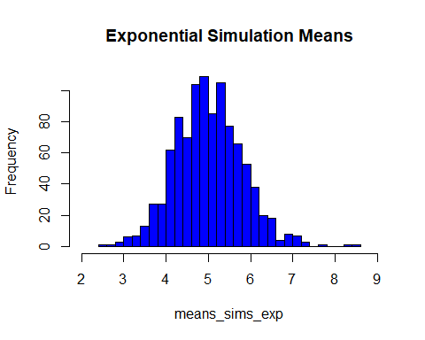

# Sample Mean versus Theoretical Mean:

## Plot histogram of the sample means.

hist(means_sims_exp, col="green", main="Sample Mean VS. Theoritical Mean", xlim = c(2,9),breaks=45, xlab = "Simulation Means")  
abline(v=mean(means_sims_exp), lwd="4", col="red")

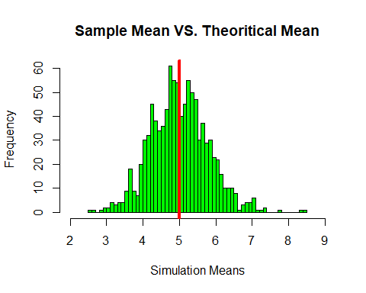

mean(means_sims_exp)

## [1] 5.008639

### The mean of the exponential distribution is 1/lambda. In this case, lambda is 0.2. The theoretical mean should result as 5. The code above shows us that our sample mean is 5. which is the same of our theoretical mean of 5.

# Sample Variance vs Theoretical Variance

## theoretical standard deviation vs. simulation standard deviation

print(paste("Theoretical standard deviation: ", round( (1/lambda)/sqrt(n) ,4)))

## [1] "Theoretical standard deviation: 0.7906"

print(paste("Practical standard deviation: ", round(sd(means_sims_exp) ,4)))

## [1] "Practical standard deviation: 0.7945"

print(paste("Theoretical variance: ", round( ((1/lambda)/sqrt(n))^2 ,4)))

## [1] "Theoretical variance: 0.625"

print(paste("Practical variance: ", round(sd(means_sims_exp)^2 ,4)))

## [1] "Practical variance: 0.6313"

### The formulas and codes show us that the variances are very close.

# Distribution

## General Plot with ditribution curve

hist(means_sims_exp, prob=TRUE, col="aliceblue", main="Exponential Simulation Means", breaks=45, xlim=c(2,9), xlab = "Simulation Means")  
lines(density(means_sims_exp), lwd=3, col="red")  
  
# Normal Distribution  
x <- seq(min(means_sims_exp), max(means_sims_exp), length=2*n)  
y <- dnorm(x, mean=1/lambda, sd=sqrt(((1/lambda)/sqrt(n))^2))  
lines(x, y, pch=22, col="black", lwd=2, lty = 2)

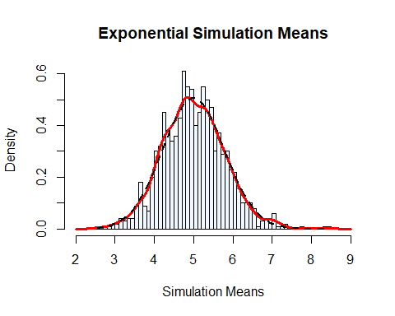

### The distribution of means of our sample appears to follow a normal distribution, due to the Central Limit Theorem.