Scirpt1_claseR.R

Usuario1

2024-08-20

#Francisco Javier Herrera   
#20/08/24  
  
#problema 1______________________________________________________________________  
  
#Ingresar en objetos la uperficie reforestacion por especie   
  
Pinus <- 3140   
Mezquite <- 1453   
Encinos <- 450   
Teka <- 1200   
Juniperus <- 720   
  
superficie <- c(Pinus, Mezquite, Encinos, Teka, Juniperus)  
sup <- c(3140, 1453, 450, 1200, 720)   
  
sup

## [1] 3140 1453 450 1200 720

superficie

## [1] 3140 1453 450 1200 720

#Operaciones________________________________________________________________________________  
#Transformar ha a m2   
 sup * 10000

## [1] 31400000 14530000 4500000 12000000 7200000

m2 <- superficie * 10000   
sup * 10000

## [1] 31400000 14530000 4500000 12000000 7200000

#Graficas________________________________________________________________________________  
barplot(superficie)

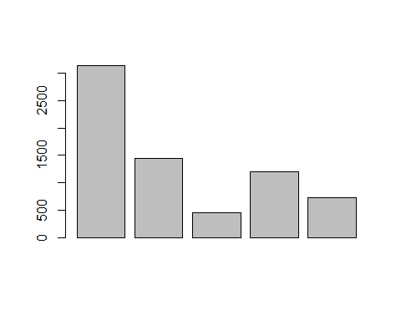

#color_______________________________________________________________  
barplot(superficie, ylim = c(0, 3500), col= "lightblue")

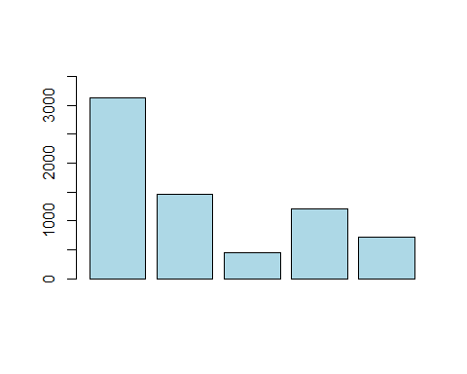

#Nombre_________________________________________________________________________________  
nombre <- c("Pinus", "Mez", "Teka", "Jun", "Encino")  
barplot(superficie, ylim = c(0, 3500), col= "lightblue", names.arg = nombre)

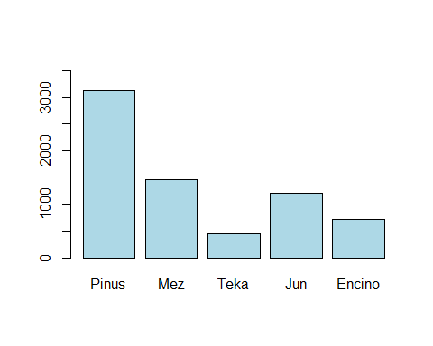

#Nombre de los ejes X y y________________________________________________________________________  
xlab = "Especie"  
ylab = "Superficie (ha)"  
sup2 <- sort(superficie, decreasing = T)  
barplot(sup2, ylim = c(0, 3500), col= "lightblue", names.arg = nombre, xlab = "Especies", ylab = "Superficie (ha)",   
 main = "Reportes CONAFOR")

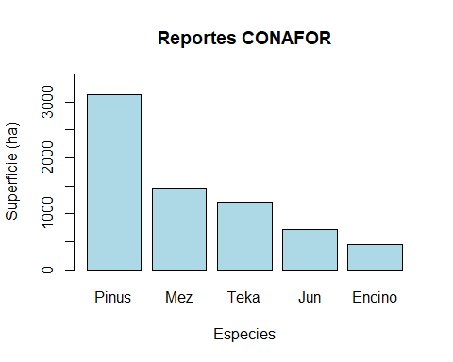

#Ordenar____________________________________________________________________________________________  
sup2 <- sort(superficie, decreasing = T)  
barplot(sup2, ylim = c(0, 3500), col= "lightblue", names.arg = nombre, xlab = "Especies", ylab = "Superficie (ha)",   
 main = "Reportes CONAFOR")