Report

In my game „Social Distancing the Game” the main task is to, by moving blue rectangle, that represents player, avoid all red rectangles, that represent other people who might be infected by Covid19. Player uses arrows or “WASD” keys to move his rectangle, while red rectangles appear randomly, and there appear more of them with time to the maximum number, so eventually player will touch one of them anyway what makes him lose, but there will never be situation that it is impossible to play due to too many enemies. Enemies move in the random direction with the random speed, so every round is different. They sometimes leave the main frame, so the player could have a little more free space, and also to simulate movement of people in the city, which the frame represents. The point of the game is to survive as long as possible and to get the best score for it.

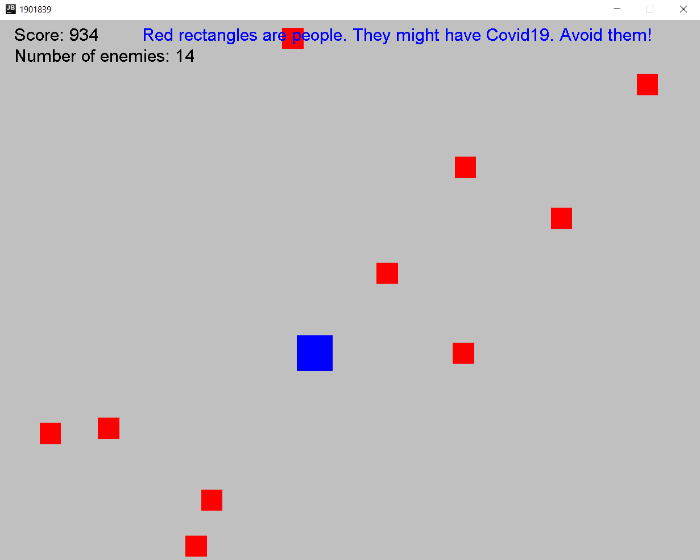

Screen of the main state – “Play”

When player loses game should change state form “Play” to “GameOver”, what would show specific communicate and information about your score, and five highest scores, however I failed to make this work, so the game just closes, when player loses.

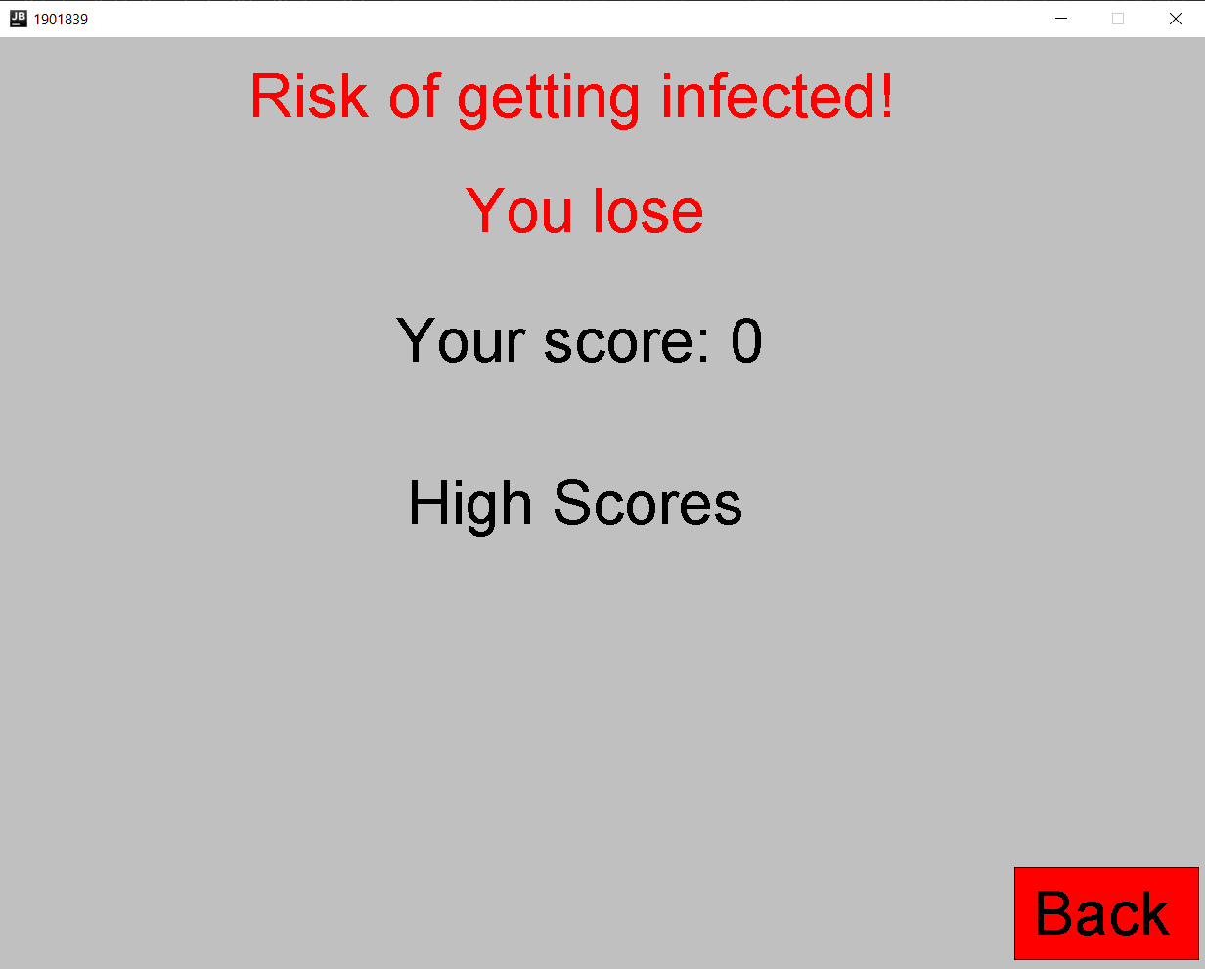

“GameOver” state screen

I also made state for menu, where are displayed 3 buttons and a title of the game, which I wanted to use to start the game, show high scores, and exit. The point of the game is to entertain, and to draw the player’s attention to the necessity of social distancing during pandemic.

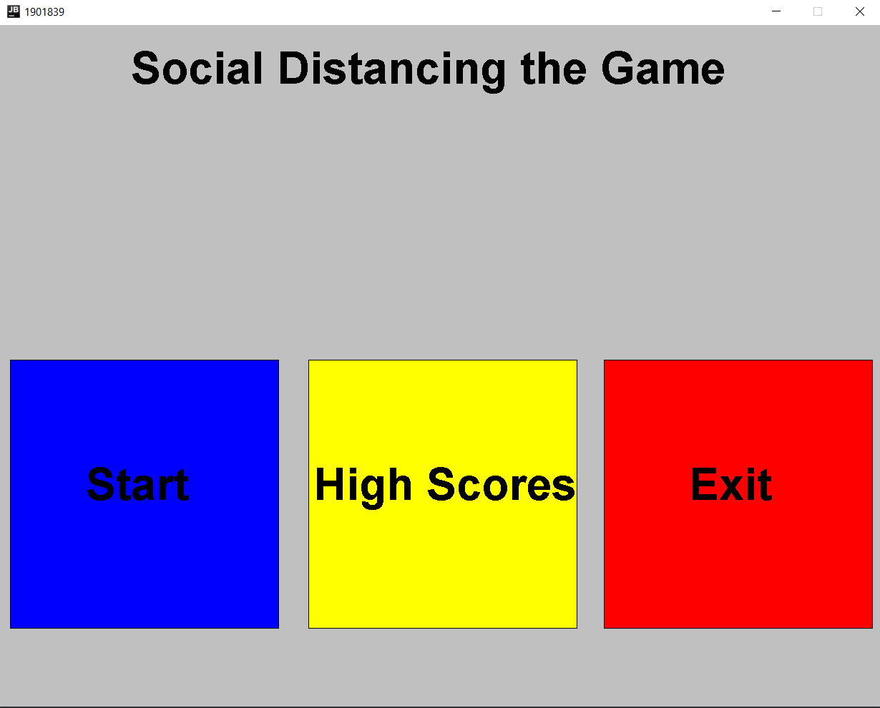

“Menu” state screen