Testing Data
Start-up State:
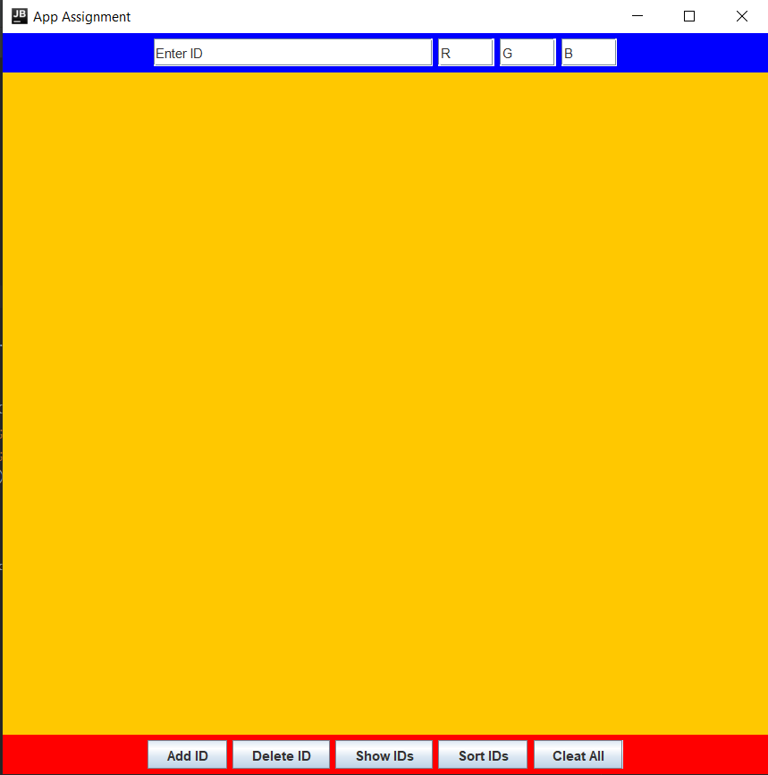

Adding proper ID numer:
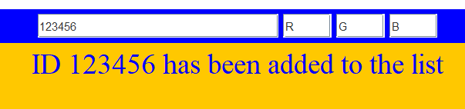

Adding not valid ID numer:


Incorrect data type entered in ID number:
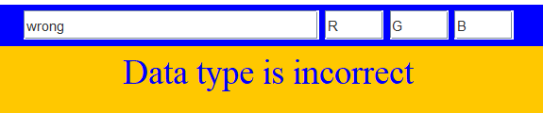

Removing ID number that belongs to the list:
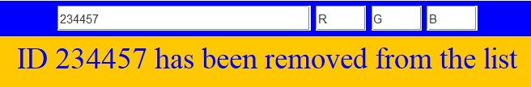

Removing ID number that does not belong to the list:
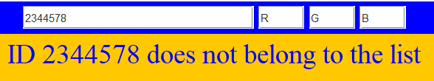

Trying to remove wrong data type from list:


Show ID numbers with correct red, green and blue values:
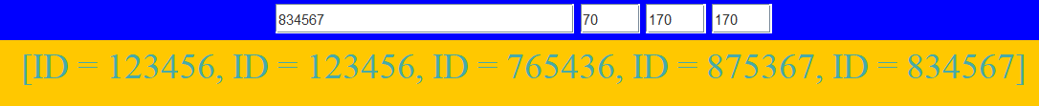

Sorting all ID numbers, and showing them:
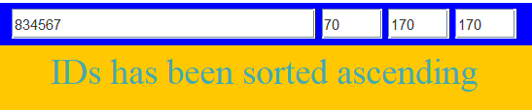

Trying to sort ID numbers, but with incorrect RBG data type:
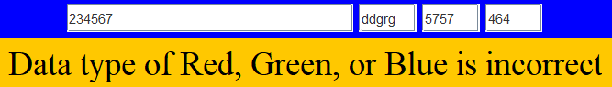

Trying to sort ID numbers, but with RGB values greater than 255 or less than 0:
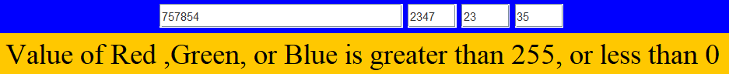

Removing value from empty list:
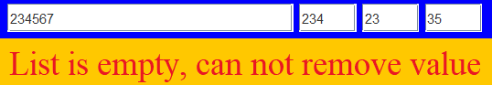

Trying to show empty list:
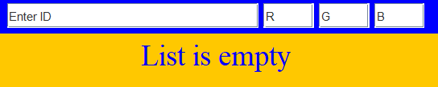

Sorting empty list:
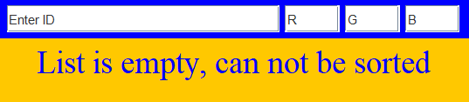

Clearing the list:
