Untitled

Francis

2018年1月31日

# 读取数据

# 自定义主题

#散点图

d_1 <- ggplot(stock,aes(x=mv17,y=change))+geom_point(aes(color=change),size=1)+  
 geom_hline(yintercept = 0,size=0.5,color='grey')+  
 labs(title='2017A股市值-涨跌幅分布图',x='2017市值/亿',y='涨跌幅/%')+  
 scale_color_gradient2(low='#006837',mid = '#F0FFFF',high='#A50026')+  
 theme_os(sd_size =1.8) %+replace% theme(legend.position = 'none')+  
 scale_x_log10(breaks=c(0,50,100,200,1000,2000,5000))+ylim(-100,200)+  
 stat_density2d(color='grey')  
d_1

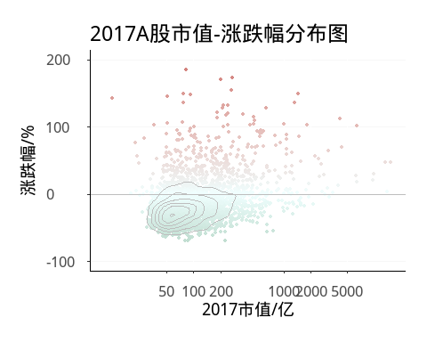

#指数分布

## 分页直方图

d2 <- ggplot(stock,aes(x=change,fill=board))+ #分组并列柱形图  
 geom_histogram(aes(y=..density..),bins=100)+facet_grid(board~.,scales='free_y')+  
 labs(title='沪深指数涨跌',x='涨跌幅',y='频率')+  
 scale_x_continuous(breaks=seq(-100,400,50),expand=c(0.02,0.02))+  
 theme_os(sd_size = 1.8)+guides(fill=FALSE)+  
 scale_fill_manual(values=c('#023858','#A6BDDB','#0570B0'))#  
d2_1 <- ggplot(stock_sz50,aes(x=change),alpha=0.2,size=0.2)+  
 labs(title='上证50涨跌')+  
 geom_histogram(aes(y=..density..),bins=30,fill='grey50')+  
 geom_vline(xintercept = 0,color='white')+  
 theme_os(sd_size = 1.2)  
library(grid)  
vp <- viewport(x=0.72,y=0.82,width=0.36,height=0.36)#用viewport函数指定子图的大小的位置  
d2  
print(d2_1,vp=vp)

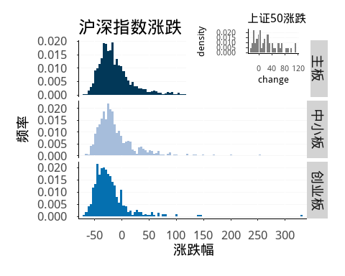

## 市值变化

library(plyr)  
stock_mv <- ddply(stock,.(board),summarise,mv17_t=sum(mv17),mv18_t=sum(mv18))%>%  
 rbind(.,cbind(board='上证50',ddply(stock_sz50,.(board),  
 summarise,mv17_t=sum(mv17),mv18_t=sum(mv18))[,2:3]))  
stock_mv$x2017 <- stock_mv$mv17_t/stock_mv[1,2]*100  
stock_mv$x2018 <- stock_mv$mv18_t/stock_mv[1,2]*100  
library(reshape2)  
stock_mv <- melt(stock_mv,id.vars = c('board','mv17_t','mv18_t'))  
stock_mv$ymax <- stock_mv$value*10/max(stock_mv$value)   
stock_mv$xmin <- rep(c(0,8),each=4)  
stock_mv$xmax <- rep(c(2,10),each=4)  
stock_mv$xlab <- (stock_mv$xmin+stock_mv$xmax)/2  
stock_mv <- plyr::arrange(stock_mv,-value)  
poly <- cbind(board=rep(as.character(unique(stock_mv$board)),each=4),  
 data.frame(matrix(c(8,10,8,3.96,2,3.1684,2,8.996,  
 2,3.1684,8,3.96,8,2.2757,2,2.2475,  
 8,2.2757,2,2.2475,2,1.1875,8,0.9946,  
 2,1.1875,8,0.9946,8,0,2,0),  
 nrow=16,byrow = T)))%>%  
 set_colnames(c('board','lat','long'))  
d3 <- ggplot()+  
 geom_rect(data=stock_mv,aes(xmin=xmin,xmax=xmax,ymin=0,ymax=ymax,fill=board),  
 colour='white')+  
 geom_text(data=stock_mv,aes(x=xlab,y=ymax-0.5,label=round(value/100*395902/10000,2)),  
 size=3.5,colour='white',vjust=0)+  
 geom_text(aes(x=c(1,9),y=c(9.3,10.3)),label=c('2017总市值','2018总市值'),size=4)+  
 geom_polygon(data=poly,aes(x=lat,y=long,fill=board),color='white')+  
 guides(fill=guide_legend(title=NULL))+  
 scale_fill_manual(values=c("#0579AD","#0899DA","#519F46","#C7C8CC"))+  
 labs(title="2017-2018指数总市值变化:万亿",caption="DataResoure:Wind")+  
 theme_os(base_size=10,base_family="myfzhzh") %+replace%  
 theme(legend.position=c(.3,.95),  
 legend.text = element_text(size=10),  
 legend.direction ="horizontal",  
 axis.line.x=element_blank(),axis.line.y = element_blank(),  
 axis.text.x=element_blank(),axis.text.y = element_blank(),  
 axis.ticks.x = element_blank(),axis.ticks.y = element_blank(),  
 axis.title.x = element_blank(),axis.title.y = element_blank(),  
 plot.title=element_text(size=16,hjust=0.08),  
 plot.caption=element_text(size=10,hjust=0),  
 plot.margin=margin(10,0,10,0,unit="pt"))  
d3

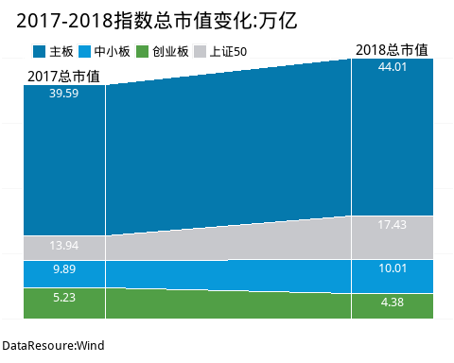

## 仪表盘图

library(sca)  
bardata<-seq(from=0,to=270,length=1000)  
rectdata<-seq(from=0,to=270,by=27)%>%c(360)  
target<- c(0.0800+0.057+0.126,0.067+0.051+0.113,0.04+0.031+0.074)  
assist <- target*270  
d4 <- ggplot(data=NULL)+  
 geom_rect(aes(xmin=rectdata[-12],xmax=rectdata[-1],ymin=5,ymax=10),  
 fill="#F2F2F2",col="white")+  
 geom_bar(aes(x=bardata,y=5,col=bardata),stat="identity",fill=NA,size=2)+  
 geom_text(aes(x=rectdata[-12],y=10,label=seq(0,100,by=10)),  
 vjust=.5,hjust=.5,size=3,col="#0F1110")+  
 geom_segment(aes(x=assist[1],y=-50,xend=assist[1],yend=-10),  
 arrow =arrow(length=unit(0.4,"cm")),size=1.2,col="#228B22")+  
 geom_point(aes(x=assist[1],y=-50),shape=21,fill="white",col="black",size=5)+  
 annotate("text",x=315,y=-30,label=percent(target[1]),size=4,hjust=.5,vjust=.5,  
 col=ifelse(target[1]>.5,"#F32626","#38E968"),fontface="plain")+   
 annotate("text",x=315,y=-15,label="上证",size=4,hjust=.5,vjust=.5)+   
 ylim(-50,12)+  
 coord_polar(theta="x",start=179.85)+  
 scale_colour_gradient(low="#38E968",high="#F32626",guide=FALSE)+  
 theme_minimal()+  
 theme(  
 text=element_blank(),  
 line=element_blank(),  
 rect=element_blank()  
 )  
d5 <- ggplot(data=NULL)+  
 geom_rect(aes(xmin=rectdata[-12],xmax=rectdata[-1],ymin=5,ymax=10),  
 fill="#F2F2F2",col="white")+  
 geom_bar(aes(x=bardata,y=5,col=bardata),stat="identity",fill=NA,size=2)+  
 geom_text(aes(x=rectdata[-12],y=10,label=seq(0,100,by=10)),  
 vjust=.5,hjust=.5,size=3,col="#0F1110")+  
 geom_segment(aes(x=assist[2],y=-50,xend=assist[2],yend=-10),  
 arrow =arrow(length=unit(0.4,"cm")),size=1.2,col="green3")+  
 geom_point(aes(x=assist[2],y=-50),shape=21,fill="white",col="black",size=5)+  
 annotate("text",x=315,y=-30,label=percent(target[2]),size=4,hjust=.5,vjust=.5,  
 col=ifelse(target[2]>.5,"#F32626","#38E968"),fontface="plain")+   
 annotate("text",x=315,y=-15,label="中小板",size=4,hjust=.5,vjust=.5)+   
 ylim(-50,12)+  
 coord_polar(theta="x",start=179.85)+  
 scale_colour_gradient(low="#38E968",high="#F32626",guide=FALSE)+  
 theme_minimal()+  
 theme(  
 text=element_blank(),  
 line=element_blank(),  
 rect=element_blank()  
 )  
d6 <- ggplot(data=NULL)+  
 geom_rect(aes(xmin=rectdata[-12],xmax=rectdata[-1],ymin=5,ymax=10),  
 fill="#F2F2F2",col="white")+  
 geom_bar(aes(x=bardata,y=5,col=bardata),stat="identity",fill=NA,size=2)+  
 geom_text(aes(x=rectdata[-12],y=10,label=seq(0,100,by=10)),  
 vjust=.5,hjust=.5,size=3,col="#0F1110")+  
 geom_segment(aes(x=assist[3],y=-50,xend=assist[3],yend=-10),  
 arrow =arrow(length=unit(0.4,"cm")),size=1.2,col="#00FF00")+  
 geom_point(aes(x=assist[3],y=-50),shape=21,fill="white",col="black",size=5)+  
 annotate("text",x=315,y=-30,label=percent(target[3]),size=4,hjust=.5,vjust=.5,  
 col=ifelse(target[3]>.5,"#F32626","#38E968"),fontface="plain")+   
 annotate("text",x=315,y=-15,label="创业板",size=4,hjust=.5,vjust=.5)+   
 ylim(-50,12)+coord_polar(theta="x",start=179.85)+  
 scale_colour_gradient(low="#38E968",high="#F32626",guide=FALSE)+  
 theme_minimal()+  
 theme(  
 text=element_blank(),  
 line=element_blank(),  
 rect=element_blank()  
 )  
library(Rmisc)  
multiplot(d4,d5,d6,cols=3)

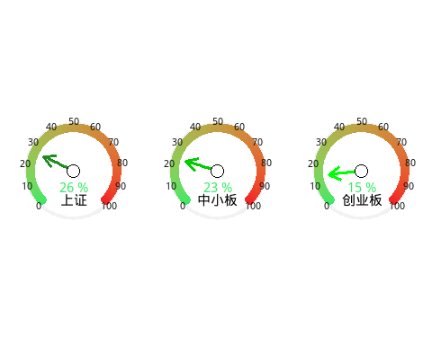

#行业分布

##树状图

library(treemapify)  
library(tweenr)  
library(gganimate)  
library(RColorBrewer)  
stock_ind <- ddply(stock,.(w_ind1,w_ind2),summarize,  
 mv_tot17=sum(mv17,na.rm = T),  
 mv_tot18=sum(mv18,na.rm = T),  
 pe_17=weighted.mean(pe17,na.rm = T),  
 pe_18=weighted.mean(pe18,na.rm = T),  
 counts=length(company)) %>%  
 set_colnames(c('WindOne','WindTwo','MV2017','MV2018','2017PE','2018PE','Counts'))  
d_7 <- ggplot(stock_ind,aes(area=MV2018,label=WindTwo,subgroup=WindOne))+  
 geom_treemap(aes(fill=Counts),color='white')+  
 geom_treemap_text(fontface='italic',size=12,colour='black',  
 place='topleft',reflow=T,alpha=0.9)+  
 geom_treemap_subgroup_border(colour='grey20',size=1)+  
 geom_treemap_subgroup_text(size=20,colour="grey20",  
 place="centre",reflow=T,alpha=0.5)+  
 scale_fill_distiller('',palette='Blues',direction=1)+guides(fill=FALSE)+  
 labs(title='2018上市企业市值行业分布',  
 captions='注:格子面积与行业市值正比,颜色深度与行业企业数正比')+  
 theme(plot.caption = element_text(hjust=0,size=8,color='grey50'),  
 plot.title = element_text(hjust=0.5,size=16))   
d_7

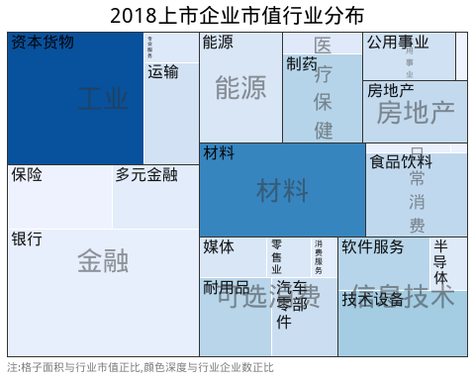

##直方图

library(plyr)  
library(tidyr)  
library(dplyr)  
library(scales)  
stock_ind2 <- ddply(stock,.(w_ind2,change_d),summarize,count2=length(company))%>%  
 plyr::join(.,ddply(stock,.(w_ind2),summarize,count=length(company)),  
 by='w_ind2',type='full')  
stock_ind2$per <- round(stock_ind2$count2/stock_ind2$count*100,2)  
d8 <- ggplot(data=stock_ind2,aes(x=w_ind2,y=per,fill=change_d))+  
 geom_bar(stat='identity',width=0.95)+  
 geom_text(aes(x=w_ind2,y=100,label=w_ind2),size=2.8,  
 color='grey6',angle=-90,vjust=0.2,hjust=1)+  
 scale_x_discrete(limits=plyr::arrange(stock_ind2,change_d,-per)$w_ind2[1:24])+  
 scale_fill_brewer('涨跌幅',palette = 'Blues')+  
 ylim(0,118)+  
 theme(text=element_text(size=8),  
 line=element_blank(),  
 rect=element_blank(),  
 axis.text=element_blank(),  
 axis.title=element_blank(),  
 legend.position='right',  
 legend.direction='vertical',  
 legend.justification = 0.1,  
 legend.text.align = 1,  
 legend.key.size=unit(.4,'cm'),  
 legend.key.height = unit(1,'cm'),  
 legend.box.margin = unit(c(0,0,0,0),'points'),  
 plot.title = element_text(size=12),  
 plot.margin = unit(c(0,0,1,2),'lines'))  
d8

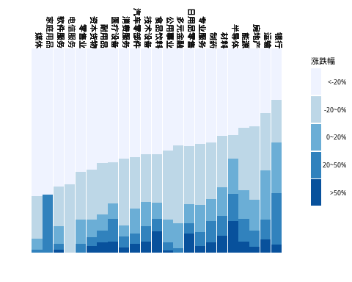

# 地图

#中国地图  
library(maptools)  
library(rgdal)   
map_data_china <- rgdal::readOGR('DataWarehouse-master/Rstudy/CHN_adm/bou2_4p.shp')

## OGR data source with driver: ESRI Shapefile   
## Source: "DataWarehouse-master/Rstudy/CHN_adm/bou2_4p.shp", layer: "bou2_4p"  
## with 925 features  
## It has 7 fields  
## Integer64 fields read as strings: BOU2_4M_ BOU2_4M_ID

map_province <- map_data_china@data %>% data.frame(.,id=seq(0:924)-1)#省份信息  
library(ggplot2)  
map_china <- fortify(map_data_china) %>% plyr::join(.,map_province,type='full')#地图转化为数据框  
#省会信息  
map_city_data <- read.csv('DataWarehouse-master/Rstudy/CHN_adm/chinaprovincecity.csv')%>% set_colnames(c('NAME','city','long','lat','index','class'))  
# CHN_adm <- rgdal::readOGR("DataWarehouse-master/Rstudy/CHN_adm/CHN_adm2.shp",encoding = 'gbk')  
# map_data_c2 <- readShapePoly('DataWarehouse-master/Rstudy/CHN_adm/bou2_4p.shp')   
library(plyr)  
stock_province_mv <- ddply(stock,.(province),summarize,mv_total=sum(mv18)) %>%   
 set_colnames(c('NAME','mv_total'))  
stock_count <- data.frame(table(stock$province)) %>% set_colnames(c('NAME','count')) %>%   
 plyr::join(stock_province_mv,.,by='NAME')  
library(stringr)  
map_china$NAME <- map_china$NAME %>% as.character(.) %>% str_sub(.,1,2) %>%   
 str_replace(.,'黑龙','黑龙江') %>% str_replace(.,'内蒙','内蒙古') %>% as.factor(.)  
stock_count$NAME <- stock_count$NAME %>% as.character(.) %>% str_sub(.,1,2) %>%   
 str_replace(.,'黑龙','黑龙江') %>% str_replace(.,'内蒙','内蒙古') %>% as.factor(.)  
map_city_data$NAME <- map_city_data$NAME %>% as.character(.) %>% str_sub(.,1,2) %>%   
 str_replace(.,'黑龙','黑龙江') %>% str_replace(.,'内蒙','内蒙古') %>% as.factor(.)  
map_china <- plyr::join(map_china,stock_count,by='NAME',type='full')  
map_city <- plyr::join(stock_count,map_city_data[,1:4],by='NAME',type='inner')  
#==============城市市值地图=====================  
library(ggplot2)  
library(ggthemes)  
d_map1 <- ggplot(map_china,aes(x=long,y=lat,fill=log(mv_total))) +  
 geom_polygon(aes(group=group),colour="grey40")+  
 scale_fill_distiller('总市值',breaks=c(7.6,9.21,9.90,10.82,11.51),  
 labels=c('2e3','1e4','2e4','5e4','1e5'),  
 palette = 'Blues',direction = 0)+#指定渐变填充色，可使用RGB  
 coord_map("polyconic")+ggtitle('中国上市公司总市值各省份分布')+  
 geom_text(data=map_city,aes(x=long,y=lat,label=NAME),size=3,colour='#8B0000',  
 fontface='bold',  
 alpha=0.8,check_overlap = T)+  
 theme_map() %+replace% theme(legend.position = c(0.9,0.4),  
 legend.key.width = unit(0.8,'lines'),  
 legend.text.align= 1,  
 legend.title = element_text(),  
 plot.margin = unit(c(0,0,0,0),'lines'),  
 plot.title=element_text(margin = margin(t=10),  
 hjust=0.5,face='bold',  
 size=rel(1.6)))  
d_map1

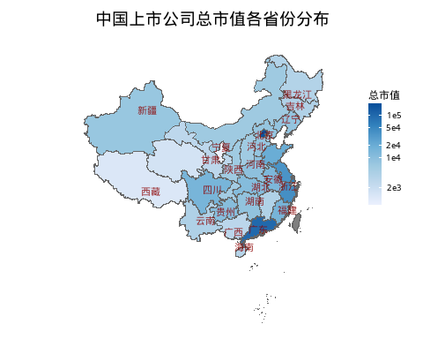

#地图2  
d_map2 <- ggplot(map_china,aes(x=long,y=lat,fill=log(mv_total)),colour='white')+  
 geom_polygon(aes(group=group),colour='grey40')+  
 scale_fill_distiller('总市值',breaks=c(7.6,9.21,9.90,10.82,11.51),  
 labels=c('2e3','1e4','2e4','5e4','1e5'),  
 palette = 'Blues',direction = 0)+  
 geom_point(aes(x=long,y=lat,size=count,colour=count),shape=16,data=map_city)+  
 scale_colour_gradient('企业数',low='white',high='#D73434')+  
 scale_size_area('企业\n数量',max_size=6,guide=FALSE)+  
 coord_map("polyconic")+ggtitle('中国上市公司总市值-企业数量各省份分布')+  
 theme_map() %+replace% theme(legend.position = c(0.9,0.25),  
 legend.key.width = unit(0.8,'lines'),  
 legend.text.align= 1,  
 legend.title = element_text(),  
 plot.title=element_text(margin = margin(t=10),  
 hjust=0.5,face='bold',size=rel(1.5)))  
d_map2

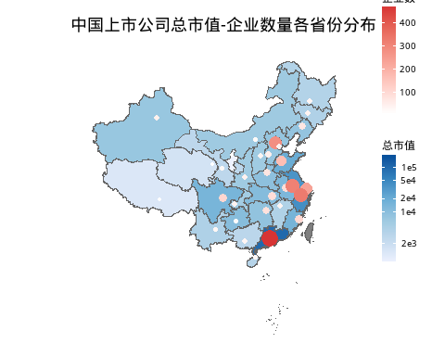

# ALLSTART

##红色版  
xs <- seq(16-1.75,16+1.75,length=1000);ys <- sqrt(1.75^2-(xs-16)^2)+9.5  
xs2 <- seq(16+1.75,16-1.75,length=1000);ys2 <- sqrt(1.75^2-(xs2-16)^2)+9.5  
poly1 <- data.frame(x=c(xs,xs2),y=c(ys,ys2))  
  
ys_1 <- seq(9.5-1.25,9.5+1.25,length=1000);xs_1 <- sqrt(1.25^2-(ys_1-9.5)^2)+7.8  
poly2 <- data.frame(x=xs_1,y=ys_1)  
poly3 <- data.frame(x=32-xs_1,y=ys_1)  
  
ys_2 <- seq(9.50-7.05,9.50+7.05,length=1000);xs_2 <- sqrt(7.05^2-(ys_2-9.50)^2)+2  
poly4 <- data.frame(x=c(xs_2[1:999],2),y=ys_2)  
poly5 <- data.frame(x=32-c(xs_2[1:999],2),y=ys_2)  
  
set.seed(0997)  
random <- data.frame(x=sample(5:24,5,replace = F)+2,  
 y=sample(3:15,5,replace=F)+2)%>%  
 data.frame(com=c('中科信息','寒锐钴业','江丰电子','方大碳素','华大基因'),  
 type=rep(1,5),.)  
random2 <- data.frame(x=sample(16:28,5,replace = F),  
 y=sample(2:17,5,replace=F))%>%  
 data.frame(com=c('贵州茅台','中国平安','招商银行','万科A','格力电器'),type=rep(2,5),.)  
data <- rbind(random,random2)  
data$type <- as.factor(data$type)  
ggplot()+xlim(0,32)+ylim(-1,20)+  
 geom_rect(aes(xmin=0,xmax=32,ymin=-1,ymax=20),fill='#8B1A1A',color='white',size=1.2)+  
 geom_rect(data=NULL,aes(xmin=2,xmax=30,ymin=1,ymax=18),  
 fill='#3A5FCD',color='white',size=1.2)+  
 geom_polygon(data=poly4,aes(x=x,y=y),fill='#3A5FCD',color='white',size=1.2)+  
 geom_polygon(data=poly5,aes(x=x,y=y),fill='#3A5FCD',color='white',size=1.2)+  
 geom_polygon(data=poly1,aes(x=x,y=y),fill='#8B1A1A',color='white',size=1.2)+  
 geom_polygon(data=poly2,aes(x=x,y=y),fill='#3A5FCD',color='white',size=1.2)+  
 geom_polygon(data=poly3,aes(x=x,y=y),fill='#3A5FCD',color='white',size=1.2)+  
 geom_polygon(data=NULL,aes(x=c(2,7.8,7.8,2),y=c(6.5,8.25,10.75,12.5)),  
 fill='#8B1A1A',color='white',size=1.2)+  
 geom_polygon(data=NULL,aes(x=c(30,24.2,24.2,30),y=c(6.5,8.25,10.75,12.5)),  
 fill='#8B1A1A',color='white',size=1.2)+  
 geom_line(data=NULL,aes(x=c(16,16),y=c(1,18)),color='white',size=1.2)+  
 annotate('text',x=3,y=9.5,label='中小创',hjust=0,size=6,color='orange')+  
 annotate('text',x=29,y=9.5,label='大蓝筹',hjust=1,size=6,color='orange')+  
 geom_point(data=data,aes(x=x,y=y,colour=type),size=5)+  
 geom_text(data=data,aes(x=x,y=y,label=com),size=4,color='white',  
 nudge_x = 0.5,nudge_y = 0.5)+  
 geom_point(data=NULL,aes(x=18,y=0),size=6,colour='white')+  
 geom_text(data=NULL,aes(x=20,y=0),color='white',label='CRSC: 进攻犯规！',  
 nudge_x = 1,hjust=0.3)+  
 geom_text(data=NULL,aes(x=16,y=9.5),label='2017',color='grey50',size=30,alpha=0.5)+  
 scale_color_manual(values = c('#FFF68F','grey66'),guide=FALSE)+  
 theme(plot.background = element_blank(),  
 plot.margin = unit(c(0,0,0,0),'points'),  
 panel.background=element_blank(),  
 axis.title.x = element_blank(),axis.title.y = element_blank(),  
 axis.text.x = element_blank(),  
 axis.text.y = element_blank(),  
 axis.ticks = element_blank())

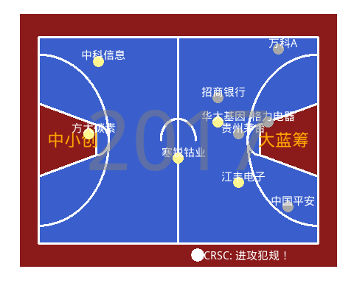

#紫金色  
#ys_2 <- seq(9.50-7.05,9.50+7.05,length=1000);xs_2 <- sqrt(7.05^2-(ys_2-9.50)^2)+2.5  
poly4 <- data.frame(x=c(2,xs_2[1:999],2.5,2),y=c(9.50-7.05,ys_2,9.50+7.05))  
poly5 <- data.frame(x=32-c(2,xs_2[1:999],2.5,2),y=c(9.50-7.05,ys_2,9.50+7.05))  
windowsFonts(myfont=windowsFont('New Time Roman'))  
ggplot()+xlim(0,32)+ylim(-1,20)+  
 geom_rect(aes(xmin=0,xmax=32,ymin=-1,ymax=20),fill='#FFFF00',color='#6959CD',size=1.2)+  
 geom_rect(aes(xmin=2,xmax=30,ymin=1,ymax=18),fill='#FFEC8B',color='#6959CD',size=1.2)+  
 geom_polygon(data=poly4,aes(x=x,y=y),fill='#FFEC8B',color='#6959CD',size=1.2)+  
 geom_polygon(data=poly5,aes(x=x,y=y),fill='#FFEC8B',color='#6959CD',size=1.2)+  
 geom_polygon(data=poly1,aes(x=x,y=y),fill='#CD9B1D',color='#6959CD',size=1.2)+  
 geom_polygon(data=poly2,aes(x=x,y=y),fill='#FFEC8B',color='#6959CD',size=1.2)+  
 geom_polygon(data=poly3,aes(x=x,y=y),fill='#FFEC8B',color='#6959CD',size=1.2)+  
 geom_polygon(data=NULL,aes(x=c(2,7.8,7.8,2),y=c(6.5,8.25,10.75,12.5)),  
 fill='#6959CD',color='#6959CD',size=1.2)+  
 geom_polygon(data=NULL,aes(x=c(30,24.2,24.2,30),y=c(6.5,8.25,10.75,12.5)),  
 fill='#6959CD',color='#6959CD',size=1.2)+  
 geom_line(data=NULL,aes(x=c(16,16),y=c(1,18)),color='#6959CD',size=1.2)+  
 annotate('text',x=3,y=9.5,label='中小创',hjust=0,size=6,color='orange')+  
 annotate('text',x=29,y=9.5,label='大蓝筹',hjust=1,size=6,color='orange')+  
 geom_point(data=data,aes(x=x,y=y,colour=type),size=5)+  
 geom_text(data=data,aes(x=x,y=y,label=com),size=4,color='black',  
 nudge_x = 0.5,nudge_y = 0.5)+  
 geom_point(data=NULL,aes(x=18,y=0),size=6,colour='grey20')+  
 geom_text(data=NULL,aes(x=20,y=0),color='grey20',label='CRSC: Foul！',  
 nudge_x = 1,hjust=0.3)+  
 geom_text(data=NULL,aes(x=16,y=9.5),label='2017',family='myfont',  
 color='#6959CD',size=20,alpha=0.5)+  
 scale_color_manual(values = c('#4F94CD','#8B5A2B'),guide=FALSE)+  
 theme(plot.background = element_blank(),  
 plot.margin = unit(c(0,0,0,0),'points'),  
 panel.background=element_blank(),  
 axis.title.x = element_blank(),axis.title.y = element_blank(),  
 axis.text.x = element_blank(),  
 axis.text.y = element_blank(),  
 axis.ticks = element_blank())

