NovaTech Solutions
On-Premises to AWS Cloud Migration
Project Scope and Phase Roadmap

Executive summary
This project takes a small but realistic business application from a traditional on-premises server room to a production-style architecture on Amazon Web Services. The subject of the work is the migration itself — the assessment, the design decisions, the networking, the security, and the operational practices — rather than the application, which is kept deliberately simple so that every part of it can be understood.
The work is organised into twenty phases across four stages. Each phase introduces a concept, applies it to the project, and is followed by a review of what was learned and what went wrong. Infrastructure is defined in code, deployment is automated, and every architectural decision is documented with its rationale and its trade-offs.
A guiding constraint runs through the whole project: nothing is deployed before it is understood. Managed services are used where they are the right answer, but never as a way of avoiding the underlying concept.

The scenario
NovaTech Solutions is a fictional software company that sells inventory and order management software to small and medium-sized businesses. The application runs on three physical servers the company owns and maintains: a web server, an application server, and a PostgreSQL database. NovaTech is responsible for the hardware, the network, the backups, the security, and the software on all three.
That arrangement works until it doesn't. Any one of those servers failing takes part of the product offline until somebody physically fixes it. Capacity was bought for an expected peak and cannot grow quickly if the customer base does. Backups depend on a procedure that few people know and nobody has recently tested. And the engineering team spends its time maintaining machines instead of improving the product.
The company has therefore decided to migrate to AWS, with four goals: improved availability, the ability to scale with demand, a stronger and more auditable security posture, and a disaster recovery capability that has actually been tested.

Where the system is today
The current architecture is a conventional three-tier stack in a single location. Requests flow from users to the web server, to the API server, and finally to the database. Each tier exists exactly once.
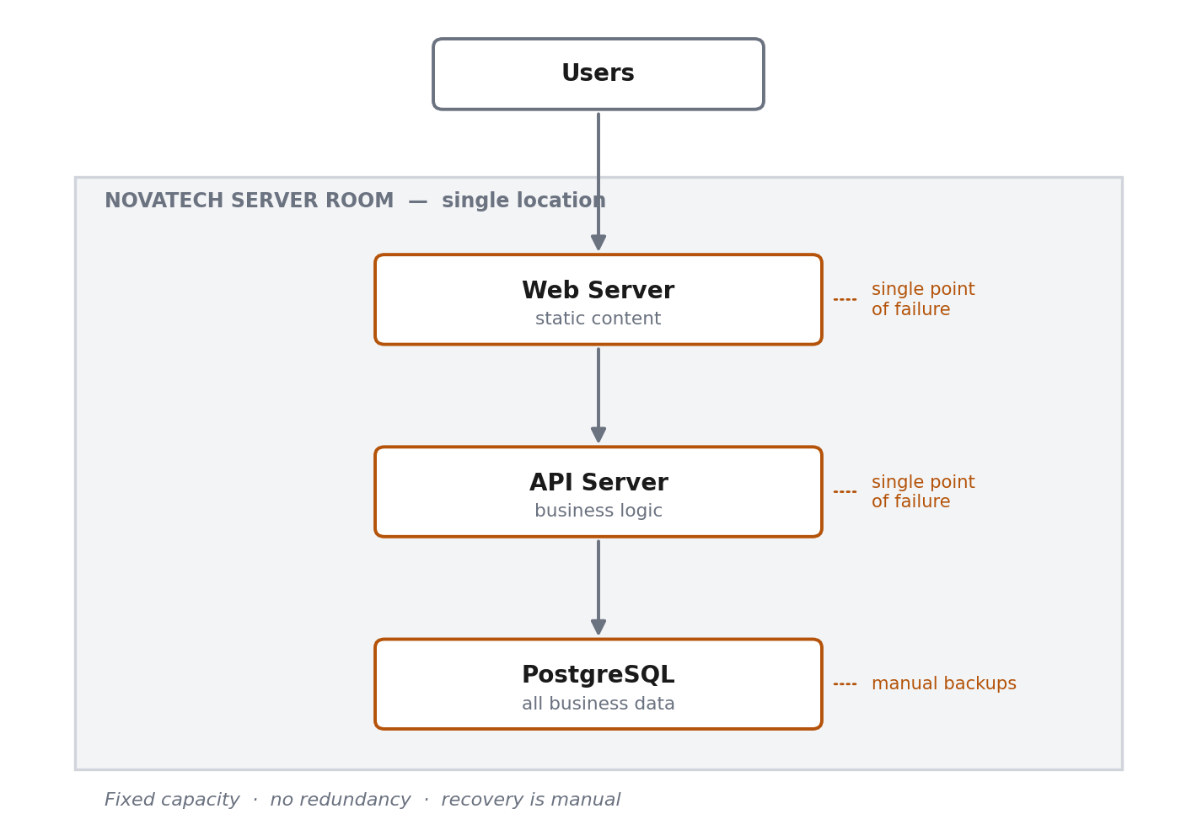
Figure 1 — Current on-premises architecture. Every tier is a single point of failure.
The weaknesses are structural rather than accidental. There is no redundancy at any tier, so any single failure is a user-visible outage. Capacity is fixed. Recovery is manual, and its duration depends on who is available and what they remember. Over years of operation these servers have also accumulated undocumented configuration — packages installed by hand, settings changed during past incidents — which means nobody can confidently rebuild them from scratch. That last point, more than any other, is what makes migrations difficult in practice.

Where the system is going
The target architecture keeps the same three logical tiers but changes what each one is made of. Public traffic reaches only a load balancer. The application runs as containers in private subnets across two Availability Zones — physically separate data centres — so the failure of one does not take the service down. The database is a managed PostgreSQL instance with automated backups and standby replication.
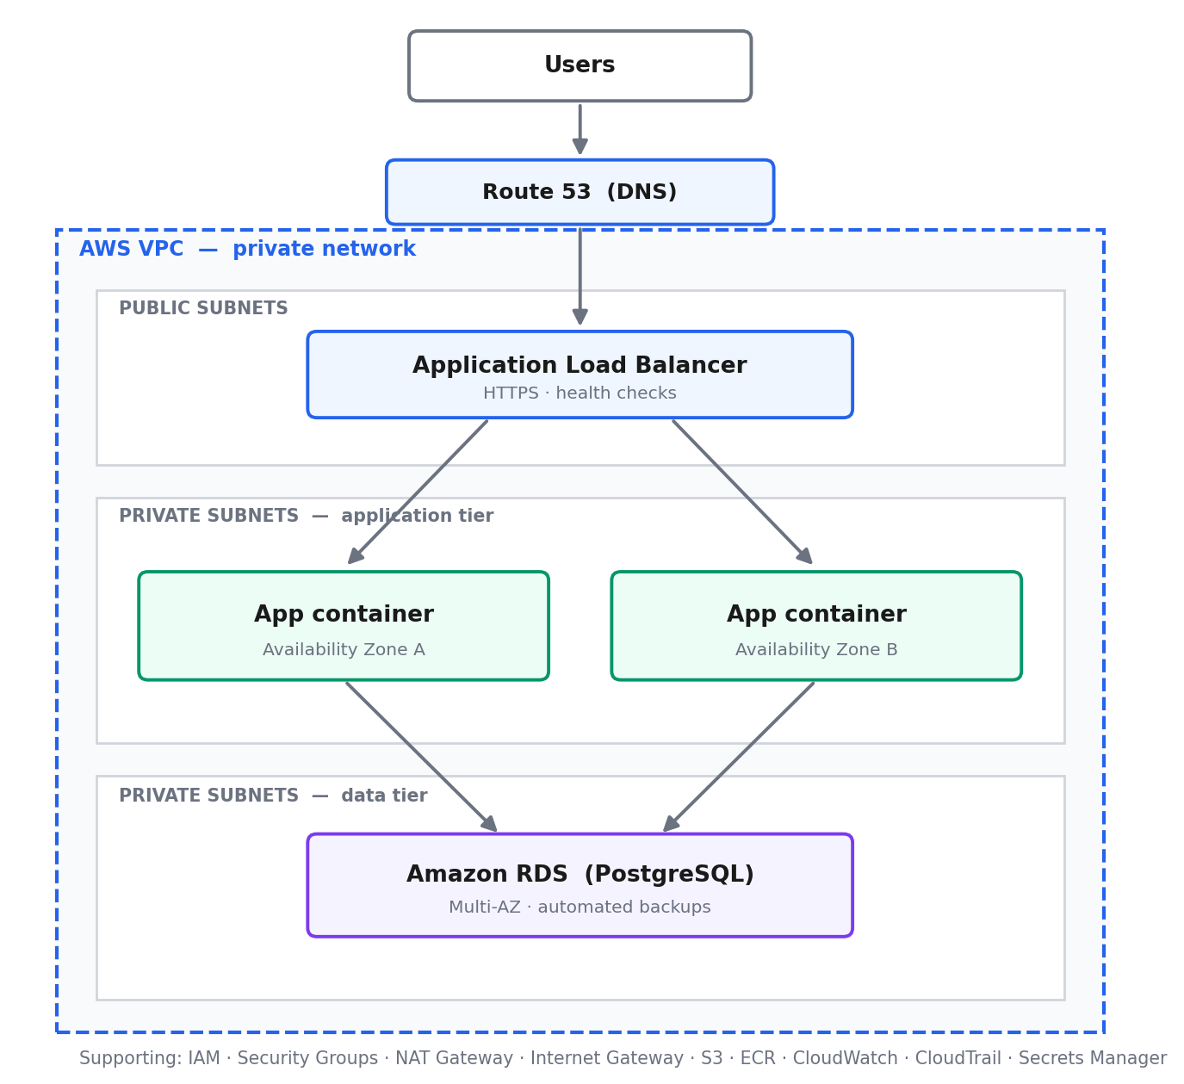
Figure 2 — Target AWS architecture. Only the load balancer is reachable from the internet.
The security principle visible in that diagram is defense in depth. The application and the database sit in private subnets with no route to the internet, so there is no path by which an inbound connection could arrive. Security groups then permit traffic only from the specific component that needs to send it. Credentials are held in a secrets manager rather than in code or configuration files. Every layer assumes the one above it might fail.

Scope
The application is intentionally small. Every feature added to it is one more thing to containerise, migrate, secure, monitor, and validate, and none of that additional work would teach anything new about migration.
In scope | Deliberately out of scope
Three data tables: users, products, orders | Payments and checkout
Token-based authentication | Customer self-service accounts
A REST API with a health endpoint | Product images and categories
Containerised application and database | Reporting dashboards
Full AWS network design, built with Terraform | Multiple products per order
Automated build, test, and deployment pipeline | Role-based permission systems
Monitoring, logging, backups, and recovery testing | Third-party integrations
Cost analysis and optimisation | Front-end polish

Every simplification is recorded in the design documentation as a decision with a reason, not left as a silent omission.

The roadmap
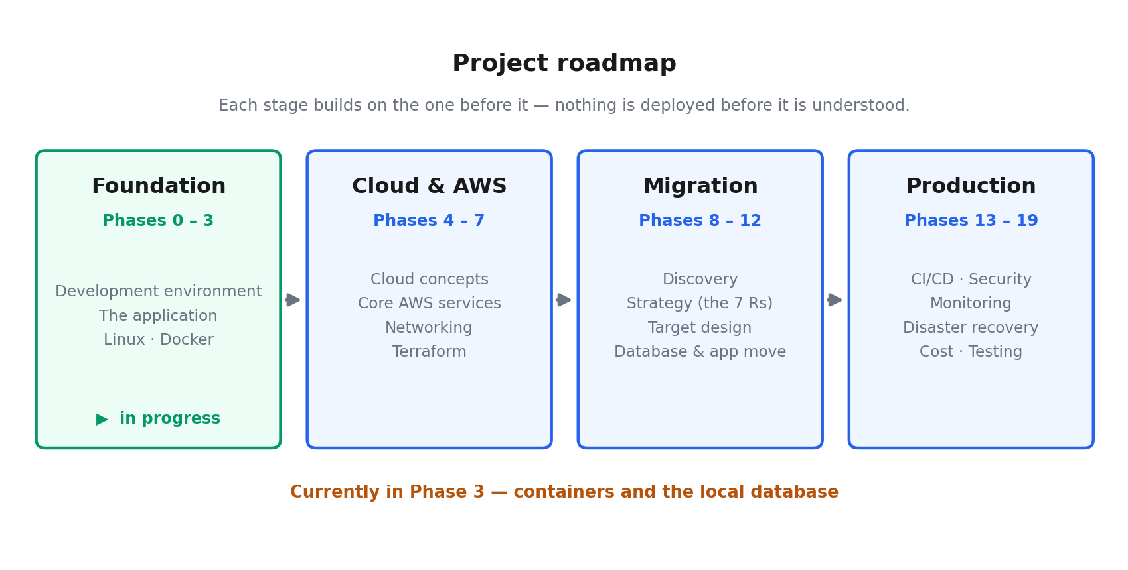
Figure 3 — Twenty phases across four stages.

Stage one — Foundation (Phases 0 to 3)
Build and understand what is being migrated. A verified development environment, the application itself, the Linux fundamentals that every server depends on, and containerisation. Containerising an application is often the single most valuable step in a migration regardless of where it ultimately runs, because it replaces an unrepeatable machine with a definition anyone can rebuild.

Stage two — Cloud and AWS (Phases 4 to 7)
Cloud computing concepts, the core AWS services, and then networking in depth: addressing, subnets, routing, gateways, and firewalls. Networking receives the most time of any topic, because most cloud failures and most cloud security incidents are ultimately networking problems. The stage ends with Terraform, so that infrastructure stops being something clicked into existence and becomes something written, reviewed, and version-controlled.

Stage three — Migration (Phases 8 to 12)
The migration proper, run as a consulting engagement would be. Discovery and assessment of the existing estate, a strategy chosen per component using the industry's seven standard approaches, a target design that must be defended rather than copied, and then the execution: the database moved and validated, and the application moved behind a load balancer.

Stage four — Production readiness (Phases 13 to 19)
What separates a demonstration from a system a business can rely on. An automated pipeline from commit to deployment, security hardening, monitoring and alerting, deliberate failure injection with practised recovery, cost analysis, and a testing strategy covering both the application and the infrastructure.

Progress to date
Phase | What it covers | Status
0 — Environment | Terminal, Linux, Git, SSH, tooling, verified installs | Complete
1 — The application | REST API, configuration, secrets, logging, health checks | Complete
2 — On-premises simulation | Linux services, processes, ports, logs, resource use | In progress
3 — Containers | Images, containers, volumes, networking, Compose | In progress
4 — Cloud fundamentals | Service models, regions, availability, shared responsibility | Not started
5 — AWS core services | IAM, EC2, VPC, S3, RDS, CloudWatch, ECR, and others | Not started
6 — AWS networking | CIDR, subnets, routing, gateways, security groups, DNS, TLS | Not started
7 — Infrastructure as code | Terraform: resources, variables, state, modules | Not started
8–9 — Assessment | Discovery, dependencies, risk, and the seven migration strategies | Not started
10 — Target design | Network layout, placement, secrets, logging, failure behaviour | Not started
11–12 — Execution | Database migration and validation; application migration | Not started
13 — CI/CD | Automated tests, image builds, scanning, deployment, rollback | Not started
14 — Security | Least privilege, encryption, secrets, segmentation, audit logging | Not started
15–16 — Operations | Metrics, alerting, high availability, backups, recovery drills | Not started
17–19 — Optimisation | Cost analysis, testing strategy, final architecture review | Not started

Achieved so far: a working REST API whose configuration comes entirely from its environment, a PostgreSQL database running in a container with persistent storage, a version-controlled repository with no secrets in it, a documented design, and a written record of every failure encountered and what caused it. No AWS resources have been created yet, and the project has so far cost nothing.

Key decisions made so far
Decision | Reason | Trade-off accepted
Stateless token authentication | Any application instance can verify a request, so the service scales horizontally behind a load balancer | A token cannot be revoked before it expires; mitigated by short lifetimes
Managed database rather than self-hosted | Transfers durability, backups, patching, and failover to the provider | Higher running cost and less control than operating it directly
Order price stored on the order | An order is a historical record; referencing a changing price would rewrite past revenue | One additional column and a small amount of duplication
Products retired rather than deleted | Orders reference products, and order history must remain valid | Every product query must filter retired items; codes cannot be reused
Health check tests the database | An instance that cannot reach the database cannot serve real requests | A database outage marks every instance unhealthy at once
Configuration supplied by the environment | One build artifact runs unchanged in every environment | Configuration must be managed outside the repository

Technology
Area | Tools
Application | Python, FastAPI, PostgreSQL
Containers | Docker, Docker Compose, Amazon ECR
Cloud platform | AWS — VPC, EC2, RDS, S3, Elastic Load Balancing, Route 53
Security and identity | IAM, Security Groups, Network ACLs, Secrets Manager, TLS
Infrastructure as code | Terraform
Automation | GitHub, GitHub Actions
Operations | CloudWatch, CloudTrail, automated backups
Working environment | Linux, Windows Subsystem for Linux, Visual Studio Code

Deliverables
The finished project is a public repository containing:
- The application source, containerised and configurable per environment.
- The complete AWS infrastructure defined in Terraform.
- An automated pipeline running from a commit through to a deployed, health-checked release.
- Architecture documentation covering the original estate, the target design, the network, the security model, and the deployment process.
- A migration plan recording the strategy chosen for each component and why.
- Disaster recovery documentation with tested recovery objectives.
- A cost analysis explaining what the architecture costs and how that cost could be reduced.
- A troubleshooting log of every failure encountered, its cause, and its resolution.
- Study guides written at the end of each stage, covering the concepts, the problems solved, and the questions they raise.

How the work is carried out
Each phase follows the same sequence: the concept is explained and justified, applied to the project through a small hands-on task, reviewed, and then deliberately broken so that the failure can be diagnosed and repaired. Failures are treated as the curriculum rather than as interruptions to it, because diagnosing a broken system is the skill the work actually requires.
Every significant decision is recorded with its reasoning and its trade-offs, so that the finished project can be explained and defended rather than merely demonstrated.
Document status: living. Updated at the end of each phase.

