
SOFTWARE ENGINEERING
CINS 5318
FALL 2026
Project Proposal
Panther Food Pantry Management System
Submitted By
Cecilio | Damario Johnson
Samuel | Alvi Anowar
Oluwafemi Bamidele | Joshua Gado
Franck Darole | Usman Jibril
Submitted To
Dr. Mary Kim
October 1, 2026
Project Proposal: Panther Food Pantry Management System
1 Problem Description
The university food pantry provides essential support, but its operations may rely on paper forms, spreadsheets, and in-person communication. Fragmented records make student requests, appointments, inventory, donations, distributions, and reports difficult to update and retrieve. Students also lack an online way to check available resources or track assistance requests. These limitations can cause delays, duplicated information, inventory errors, and unnecessary staff workload.
2 Vision for the Software
The Panther Food Pantry Management System will be a secure, accessible web application that centralizes pantry services. It will give students a convenient way to request assistance and give authorized staff current information for coordinating inventory, appointments, donations, distributions, and reporting.
3 Basic Goals and Key Features
The project will replace disconnected records with one role-based platform that improves accuracy, communication, accountability, and service delivery.
Feature | Description
Student Services | Registration, secure login, food availability, assistance requests, appointments, status updates, history, and notifications.
Inventory | Quantities, categories, locations, received and expiration dates, plus low-stock and expiring-item identification.
Donations and Distribution | Donation records, donor and quantity details, student distributions, and inventory adjustments.
Administration | Role-based access, request and appointment processing, dashboard summaries, searchable records, and operational reports.
4 How the Software Solves the Problem
Centralizing pantry activities will reduce dependence on paper records and separate spreadsheets. Inventory can be updated when donations arrive or food is distributed; students can submit requests and manage appointments online; and staff can search records, monitor activity, communicate updates, and produce reports from the same system.
5 New Functionalities and Improvements
The system introduces online food-availability viewing, digital requests and scheduling, request-status tracking, role-based access, notifications, donation and distribution management, inventory alerts, dashboards, and reports. It improves the existing process by replacing scattered paper records with a centralized database. Where current inventory information is available, it can be incorporated and updated after donations and distributions, helping reduce differences between recorded and actual stock.

6 Business Value
Students gain more convenient and transparent access to assistance without unnecessary uncertainty or repeated in-person inquiries. Staff spend less time on paperwork and can identify stock needs, expiration risks, requests, and appointments more quickly. Centralized records also support accountability, planning, reporting, funding requests, and efforts to reduce shortages and food waste.
7 Initial Plan of Work
The project will follow four phases from requirements through final demonstration, as shown in Figure 1.
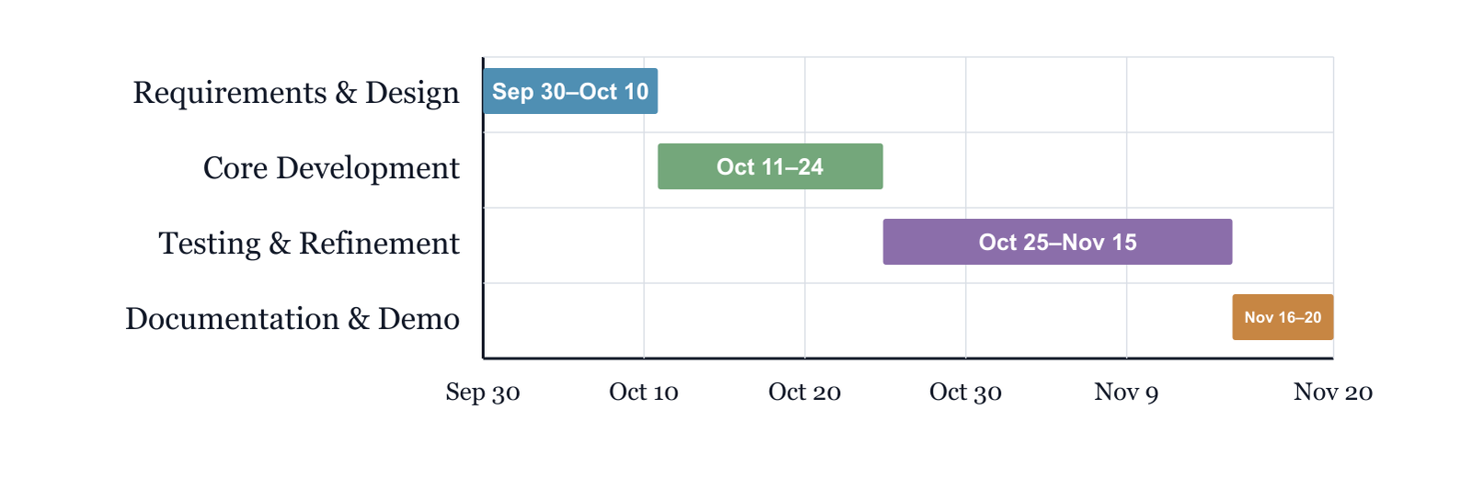
Figure 1: Project Development Timeline
8 Team Description
The eight-member team combines project planning, requirements analysis, interface design, application and database development, testing, documentation, deployment, and presentation skills. Members will coordinate regularly so the system, report, and demonstration remain aligned.
Team Member and Expertise | Team Member and Expertise
Cecilio — Project management and requirements | Damario Johnson — Project management and requirements
Samuel — UI/UX and frontend development | Alvi Anowar — UI/UX and frontend development
Oluwafemi Bamidele — Backend and database development | Joshua Gado — Backend and database development
Franck Darole — Testing, documentation, and deployment | Usman Jibril — Testing, integration, documentation, and presentation

