This system is a wake-up solution especially dedicated to frequent travellers. It embeds the best functions available at the time being in a very easy-to-use interface.

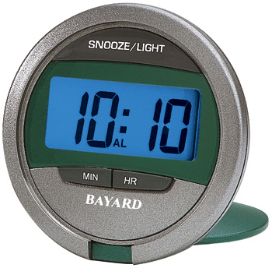
Figure Error! No text of specified style in document.-1: System external aspect

