From Transportable Tablespaces to Pluggable Databases

Franck Pachot

dbi services

Switzerland

Transporting data physically is faster and more predictable than a logical export/import. Therefore, it should be preferred for migration of large databases when possible. However, you may need more flexibility as the one offered by Data Pump when moving a subset, changing the version, or platform. In Oracle 8i was introduced Transportable Tablespaces which has the performance of physical transport for data, and the flexibility of logical export/import for metadata. And if you look at some of the initial APIs, you will see that it was initially called ‘Pluggable Tablespaces’. The resemblance with Pluggable Databases is not a coincidence, as this 12c feature is an evolution of Transportable Tablespaces.

If you have a very small database, then using a logical export/import may be sufficient. But this import is long and sometimes unpredicable. Even in direct-path, the import has to find free blocks, allocate and format them, and write rows. Then all indexes must be completely built. This takes time, with the need to read the table and sort rows. It requires lot of memory, and tempfiles. Finally the index built may fail with lack of TEMP space. When you want the data movement to be faster and more predicatable, you try to copy the data physically: copy the blocks without the need to do modifications on them, and copy the index blocks in the same way as the table ones, already built and usable.

History of Transportable Tablespaces

A database in Oracle 7 was monolithic. You had tablespaces to divide it, but their data is meaningless without the rest of the database for 4 reasons:
- Datafile numbers present in all blocks (in ROWID) are database absolute file IDs
- Extent metadata is stored outside of the tablespace, in the dictionary
- Undo information is stored in rollback segment, in the UNDO tablespace
- Metadata for your objects is stored in the dictionary
In order to be able to transport the tablespaces, several improvements were implemented to make tablespaces more self-contained.
In Oracle 8.0, the ROWID identifies the datafiles with a relative number within the tablespace rather than an absolute number within the database. This is the most important because otherwise moving one tablespace would require to do modifications on all blocks.
In Oracle 8i, Locally Managed Tablespaces were introduced to managed the extents with a bitmap in the tablespace rather than the UET$ table in the dictionary. Then the only physical information required to ship with tablespace transport is the segment header address.
That was already enough to introduce Transportable Tablespaces. But undo is still outside of the tablespace. You need UNDO because when you transport the tablespace, it holds some uncommitted data. From there comes the main limitation of transportable tablespaces: the tablespace must be put in READ ONLY to be sure that there are no on-going transactions.

Data Pump Transport Tablespaces

The metadata is now exported from the dictionary with Data Pump (it was exp/imp at that time). Basically, Data Pump exports the DDL to re-create the objects on the destination database where you move the tablespace to.
Here is an example where I export the tablespace USERS that I’ve put in read-only before:
expdp system/oracle@//localhost/PDB1 directory=VAR_TMP dumpfile=expdat.dmp transport_tablespaces=USERS exclude=table_statistics,index_statistics;

If you look at the log, you will see a mention of ‘PLUG_TS’ which means ‘Pluggable Tablespace’:
Processing object type TRANSPORTABLE_EXPORT/PLUGTS_BLK
Processing object type TRANSPORTABLE_EXPORT/POST_INSTANCE/PLUGTS_BLK
Processing object type TRANSPORTABLE_EXPORT/TABLE
Processing object type TRANSPORTABLE_EXPORT/CONSTRAINT/CONSTRAINT
Processing object type TRANSPORTABLE_EXPORT/CONSTRAINT/REF_CONSTRAINT
Master table "SYSTEM"."SYS_EXPORT_TRANSPORTABLE_01" successfully loaded/unloaded
******************************************************************************
Dump file set for SYSTEM.SYS_EXPORT_TRANSPORTABLE_01 is:
/u01/oradata/tmp/expdat.dmp
******************************************************************************
Datafiles required for transportable tablespace USERS:
/u01/oradata/CDB1/PDB1/users01.dbf

At the end, it mentions the tablespace’s datafile(s) to move to the destination, and it has exported a dump file containing metadata only.
As with any Data Pump dumpfile, you can look at it by importing it with the ‘sqlfile’ option:
impdp system/oracle@//localhost/PDB1 directory=VAR_TMP transport_datafiles=/u01/oradata/tmp/PDB1USERS2.dbf sqlfile=sqlfile.sql ;

This does not import any objects, but generates the DDL. Look at it and you will see all the DDL you may use to re-create the objects, with some additional attributes. For example, you can see something like that:
CREATE TABLE "SCOTT"."EMP"
…
STORAGE(SEG_FILE 12 SEG_BLOCK 146 OBJNO_REUSE 73315

When you create a table, you just mention the tablespace and Oracle chooses where, in the datafiles, to create the segment header. Here we ship the datafile, and then the DDL must mention where is the segment header: its relative file number (SEG_FILE) and offset (SEG_BLOCK). The segments also have an identifier, the Data Object ID, which is found in each block and the same number will be re-used in the target database (OBJNO_REUSE). Do not try this syntax yourself: it can be used only internally by Oracle for bootstrapping and transporting datafiles.
Once you have shipped the datafiles to the destination (which takes the time of physical copy, but may also be as fast as a simple filesystem unmount/mount when you are on the same storage) you run the impdp command above, without the ‘sqlfile’. You can change the tablespace_name with REMAP_TABLESPACE and change the schema name with REMAP_SCHEMA. This means that you can clone a set of tablespaces within the same database.

This is a job for RMAN

Having the source tablespace in read-only is a big limitation. You cannot use Transportable Tablespaces (TTS) to clone from production. When you want to clone the production, you use an RMAN DUPLICATE. It is also a physical transport, but less flexible than TTS: it’s the whole database (even if you can skip some tablespaces), you overwrite the destination database, you must be in the same version, etc. Then let’s do the following:
- DUPLICATE from backup to a temporary database
- Skip all tablespaces you don’t want, except SYSTEM/SYSAUX (for metadata) and UNDO (for ongoing transactions)
- expdp TRANSPORT_TABLESPACE to get the metadata dump file
- Remove all this temporary database, except your datafiles
- impdp TRANSPORT_DATAFILES to the destination
So, you can transport tablespaces from the production. It is a job for RMAN and since 10g RMAN has one command for that:
RMAN> transport tablespace PDB1:USERS
until time "timestamp '2017-12-04 12:00:00'"
auxiliary destination '/u01/oradata/tmp'
tablespace destination '/u01/oradata/tmp';

You will see RMAN doing everything: create an auxiliary instance, in the destination specified, restore the tablespace you want to transport, restore what is needed for metadata and recovery, st it read-only, export metadata. At the end, you get the datafiles, the dumpfile, and a script to run the Data Pump import. You can look at the script, which is a nice way to see all the PL/SQL API which is behind impdp, or run the impdp yourself.

There’s one thing to take attention to in the RMAN log:
…
current log archived
RMAN-05026: warning: presuming following set of tablespaces applies to specified point-in-time
List of tablespaces expected to have UNDO segments
Tablespace SYSTEM
Tablespace PDB1:SYSTEM
Tablespace UNDOTBS1
Tablespace PDB1:UNDOTBS1
Creating automatic instance, with SID='jCph'
…

The RMAN repository does not know where was the UNDO at the UNTIL TIME point-in-time and supposes that it is the same UNDO tablespace as the current one. If it is not the case, you can add the UNDO tablespace in the list of tablespace to restore.

Self-Contained tablespaces

As Transportable Tablespaces can move a subset of the database, you need to be sure that you will not create inconsistencies when you plug them. They must be ‘self-contained’, meaning that there are no objects straddling two tablespaces that are not all included in the transport set. Such objects can be referential constraints, nested tables, domain indexes, materialized views, XML schema, and so on. Oracle provides a procedure to check that from the source, with error messages going to a collection that we can query through a view:
SQL> exec dbms_tts.transport_set_check(ts_list=>'USERS',incl_constraints=>true);
PL/SQL procedure successfully completed.

SQL> select * from transport_set_violations;
no rows selected

It is recommended to check this before the export. You don’t need to have the tablespaces read-only for that. Just be sure that no straddling objects are created between the check and the export.

Full Transportable Tablespace

Now, only the metadata has to be transported logically. But when I’m talking about metadata for TTS, it covers only the metadata which is related to the data stored in the tablespace. This imports only the tables, and the indexes. But TTS may be used to clone or migrate a database and there’s a lot more metadata related to the schemas: user information, views, procedures, packages, etc. Until 12c you had to transport that separately:
- Conventional Data Pump to create the users, roles, etc.
- Transportable Tablespaces for tables and indexes
- Conventional Data Pump for all other objects
In 12c has been introduced Full Transportable Tablespaces which does both with the same command. You just add the FULL=Y:
impdp system/oracle@//localhost/PDB1
full=Y transportable=ALWAYS
transport_datafiles=/u01/oradata/tmp/USERS.dbf
network_link=PDB1 directory=VAR_TMP logtime=ALL

This example uses a database link to get the metadata, so that you only have to transport the datafiles mentioned.

Cross Platform Transportable Tablespace

One big advantage of TTS is the flexibility because the data blocks are compatible between different versions, different platforms and even different endianness. When lowering downtime for a cross-endianness migration you cannot use a Standby Database, because the dictionary and the redo stream is endian-dependent. But you can transport tablespaces given that you use the RMAN CONVERT on the datafiles. This conversion does not modify all blocks (which would not qualify for physical transport then) but converts mainly the headers and undo.
You cannot apply redo on them, but to lower the downtime, you can even apply incremental backups on them, so that you have only small files to copy and convert during the downtime. This is known as iXTTS (incremental Cross-Platform Transportable Tablespaces) and you have more detail in MOS Note 2005729.1

Pluggable Databases

Back to same endianness. We can transport user tablespaces physically, but the metadata must be exported logically. This can be very long when having 50000 tables as some ERPs have. The database is optimized for DML, not for DDL. This metadata resides in the SYSTEM and SYSAUX tablespaces. Then why not transport them? Because there’s a lot of internal stuff there. You never export/import SYS objects because they are already there in the destination database. Doing so would mess-up all the dictionary especially when going to different version or characterset.
This mix of system metadata with user metadata in the same dictionary tables has always been a problem which is now addressed in 12c multitenant architecture: system objects are in CDB$ROOT, and user objects are in Pluggable Databases. With multitenant architecture, thanks to the dictionary separation, we can now transport a Pluggable Database (PDB) containing both metadata (in the PDB SYSTEM/SYSAUX) and data (in the PDB user tablespaces).
In 12cR1 you have the same limitation about read-only because the UNDO is shared at CDB level and does not come with the transport of the PDB. Once the pluggable database is in read-only you can clone it within the same CDB or to another CDB if you mention a database links.
On the source database, I create a user with SYSOPER system role (There’s some discrepancy between privileges mentioned in the documentation and what actually works):
SQL> grant connect, sysoper to C##DBA identified by oracle container=all;
Grant succeeded.

On the destination, I create a database link to it:
SQL> create database link CDB1 connect to C##DBA identified by oracle using '//localhost/CDB1';

And clone the database:
SQL> create pluggable database PDB2 from PDB1@CDB1 file_name_convert=('CDB1/PDB1','CDB2/PDB2')

If you clone from 12cR1 to 12cR2 then the 12cR1 must have patch 18633374: COPYING ACROSS REMOTE SERVERS or you will get: ORA-17630: Mismatch in the remote file protocol version client server. However, usually the PDB clone to an higher version CDB is faster than TTS. You still have to run datapatch (for higher patchsets) or catupgrd (for higher releases).
I didn’t mention the ALTER PLUGGABLE DATABASE OPEN READ ONLY for the source because this is not required anymore in 12cR2 when in archivelog mode and in local undo mode.

Multitenant Local Undo

In 12cR2 the last limitation is relieved: no need to put the source PDB in Read-Only. The CDB can, and should, run in local undo mode. It is the default with DBCA, and you can check it with the presence of following property at TRUE:
SQL> select * from database_properties where property_name like '%UNDO%';

PROPERTY_NAME PROPERTY_VALUE DESCRIPTION
-------------------- -------------------- -----------------------------------
LOCAL_UNDO_ENABLED TRUE true if local undo is enable

With local undo, you can clone online: fuzzy datafiles are copied, redo is applied, ongoing transactions are rolled back thanks to the presence of the undo in the PDB. This means that you can clone a production PDB to get a test environment, with one command only.

Refreshable clones

When you clone production to test, you probably want to refresh it regularly. The clone I’ve done above uses the default ‘refresh mode none’, equivalent to:
create pluggable database PDB2 from PDB1@CDB1 file_name_convert=('CDB1/PDB1','CDB2/PDB2') refresh mode none;

If you want to be able to refresh it later, applying the redo from the source to roll forward it, you can:
create pluggable database PDB2 from PDB1@CDB1 file_name_convert=('CDB1/PDB1','CDB2/PDB2') refresh mode manual;

But this one cannot be opened read-write. You can open it read-only, but have to close it to refresh it:
23:17:52 SQL> alter pluggable database close;
Pluggable database CLOSE altered.
23:17:53 SQL> alter pluggable database refresh;
Pluggable database REFRESH altered.
23:17:55 SQL> alter pluggable database open read only;
Pluggable database OPEN altered.

You can also have the refresh scheduled, which will happen at the interval given that the clone PDB is closed:
create pluggable database PDB2 from PDB1@CDB1 file_name_convert=('CDB1/PDB1','CDB2/PDB2') refresh every 5 minutes;

Then why have a read-only clone? You can use it as a master for further clones. And if you are on a filesystem that allows snapshots, such as ACFS, those can be thin clones. Figure 1 show the idea: a master is refreshed frequently. When someone wants to provision one or several development environments, the master is closed, cloned as snapshot copy and re-opened.

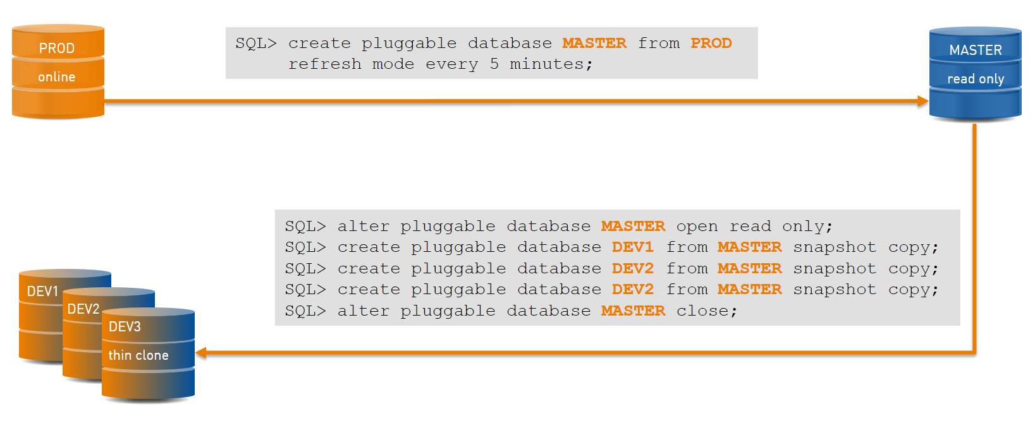
Figure 1- DBaaS thin clones with read-only master
However, in real-live a read-only master is not sufficient. There are some passwords to modify, some database links to change, and probably some data to anonymize, scramble or mask. Then one intermediate copy is needed. This is described in Figure 2.
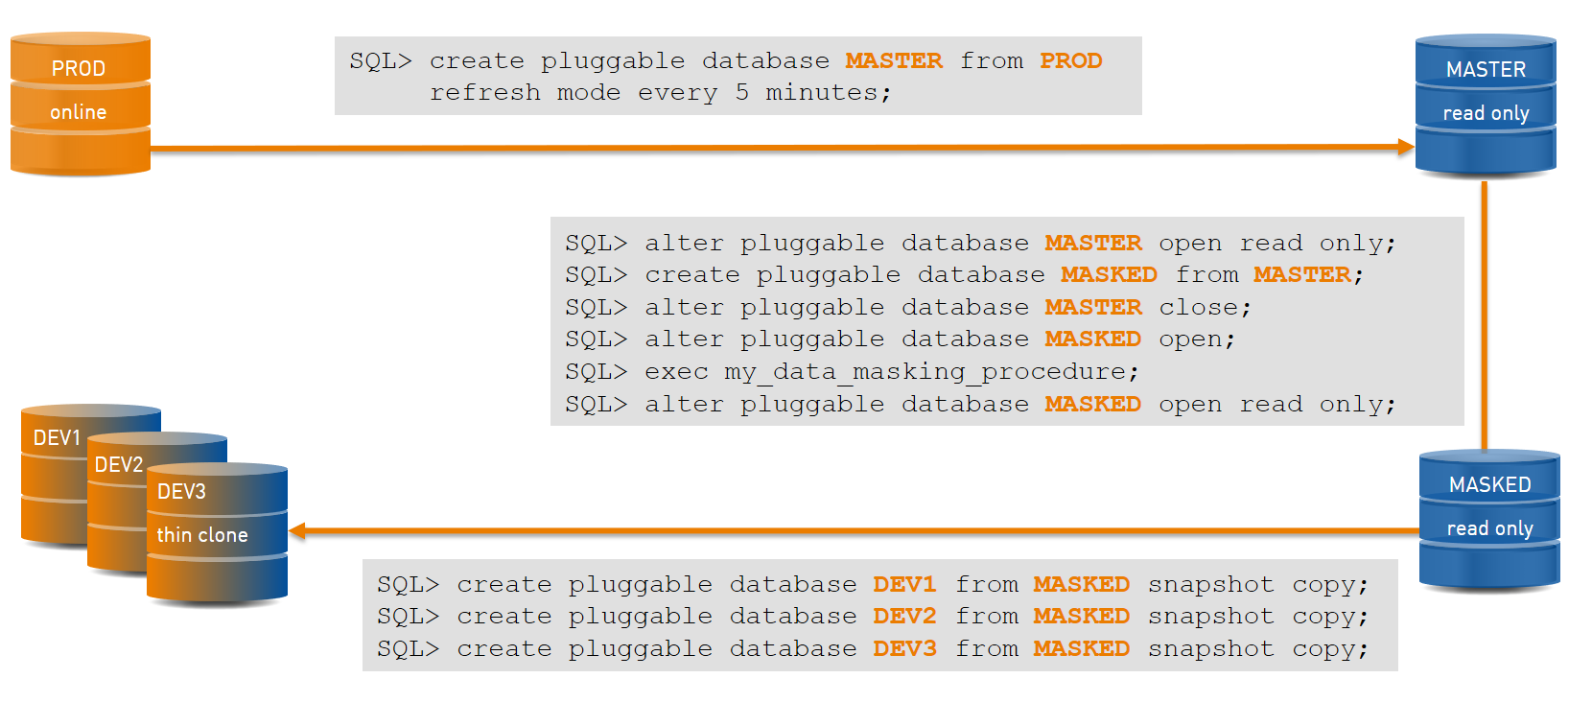
Figure 2- DBaaS thin clones with data masking

Relocate PDB

Because you can clone online, why not use that to move a PDB from one CDB to another one, maybe on different server and storage: stop the application, run the last refresh, and re-open the application on the new location. This is implemented as ‘relocate’:
SQL> create pluggable database PDB2 from PDB2@CDB1
file_name_convert=('CDB1/PDB2','CDB2/PDB2')
relocate availability normal;
Pluggable database PDB2 created.

The ‘availability normal’ is the default. When you open the target PDB, the transactions on the source are killed and then the application can re-connect to the target PDB. If you are on the same server, with the same listener, this is transparent: the service is opened for the target CDB.
When changing the connection string is needed to connect to the new CDB, you have the possibility to leave a ‘tombstone PDB’ on the source CDB which acts as a proxy and redirects connections to the new CDB. You achieve that with the:
SQL> create pluggable database … from … relocate availability max;

This is also called ‘near zero downtime’ because the sessions that are killed are able to re-connect immediately. Unfortunately, Application Continuity cannot be used here because the databases (CDB) are different.

Archive PDB

There is another use case for Transportable Tablespace: you can archive a set of tablespaces before dropping them. The interesting thing is that when you need to read them later, you can plug them into a newer version. This is more flexible that restoring a backup because then you must archive the Oracle software as well.
You have the PDB equivalent with PDB unplug. In 12cR1 the ‘unplug’ creates and xml file which you will ship with the datafiles:
SQL> alter pluggable database PDB1 unplug into '/var/tmp/PDB1.xml'

In 12cR2, just change the ‘.xml’ to ‘.pdb’ and you will get a zip file containing both the xmlfile and the datafiles.

Use-Cases and Conclusion

I suppose that you got the use-cases while reading the different technologies. The most interesting one is for migrations. Transportable Tablespaces is more flexible than PDB relocate because TTS allows endianness conversion, and different block size destination.
If you don’t have those specificities, PDB movement is a good alternative, especially in Standard Edition where you cannot export Transportable Tablespaces. PDB clone can go to different characterset CDB when the target CDB us in AL32UTF8. When going to a newer version, you will choose between TTS or PDB depending on the number of objects you have: the former has to build the dictionary for your objects, the latter has to upgrade the dictionary for system objects.
When migrating from 11g to 12c multitenant you have two choices, again with PDB or TTS:
- Upgrade to 12c non-CDB, and then plug this non-CDB as a PDB. However, this requires running the noncdb_to_pdb.sql script on the dictionary, in addition to the catupgrd.
- Export from 11g with Full Transportable Tablespace and import that in a newly created PDB on the 12c CDB.
The second use-case is cloning, and thin cloning, and refreshing all the test and dev environment your agile developers are requesting.
I used Transportable Tablespaces a lot to replicate operational data to datawarehouse Operational Data Store (ODS). This is a fast way. Combined with partition exchange, you can even do some incremental transport at partition level.
Then there’s are other reasons to export transportable tablespaces or unplug a PDB when you need to archive or publish a read-only subset of data. Here again. TTS can be combined with exchange partition.
I presented the Pluggable Databases as an evolution of the Transportable Tablespaces, but one does not supersede the other. Learn the different the tools and choose the one that fits your need.

Contact:
Franck Pachot
franck.pachot@dbi-services.com

Franck Pachot is principal consultant, trainer and technology leader at dbi-services in Switzerland. With more than 20 years of experience in Oracle databases, all areas from development, data modeling, performance, administration, and training, Franck is Oracle Certified Master 11g and 12c, an Oracle ACE Director and proud member of Oak Table.
Franck is co-author of 'Oracle 12cR2 Multitenant' (https://www.amazon.com/Oracle-Database-Release-Multitenant-Press/dp/1259836096).

LinkedIn: https://ch.linkedin.com/in/franckpachot  Twitter: @FranckPachot  Blog: http://blog.pachot.net |   