How to use Easy GNSS



Information 3

Easy GNSS menu 3

Rover mode 3

Base mode 14

Post-Processing 20

Quit/Shutdown 21

Information

* To connect with a NTRIP caster in the rover mode and to do post-processing, an Internet connection is needed.

Easy GNSS menu

You have 4 main options on the menu: - Use the Rover mode

- Use the Base mode

- Do post-processing

- Quit/Shutdown

## Rover mode

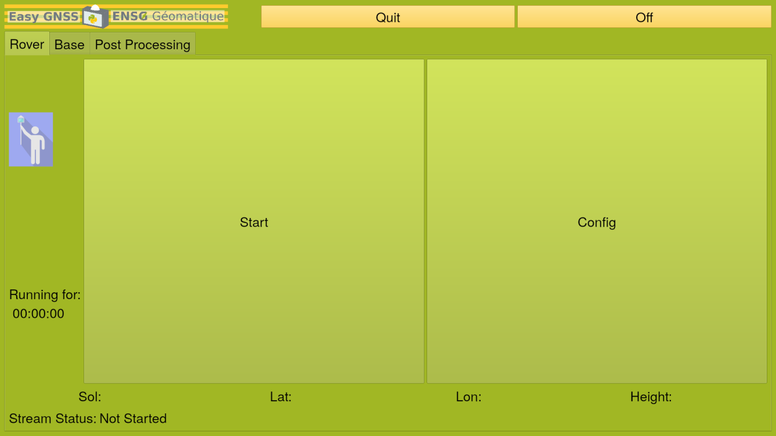

**Select “Rover” tab, and** **push “Config”.** **Now, configure the different parameters.**

* Conf file

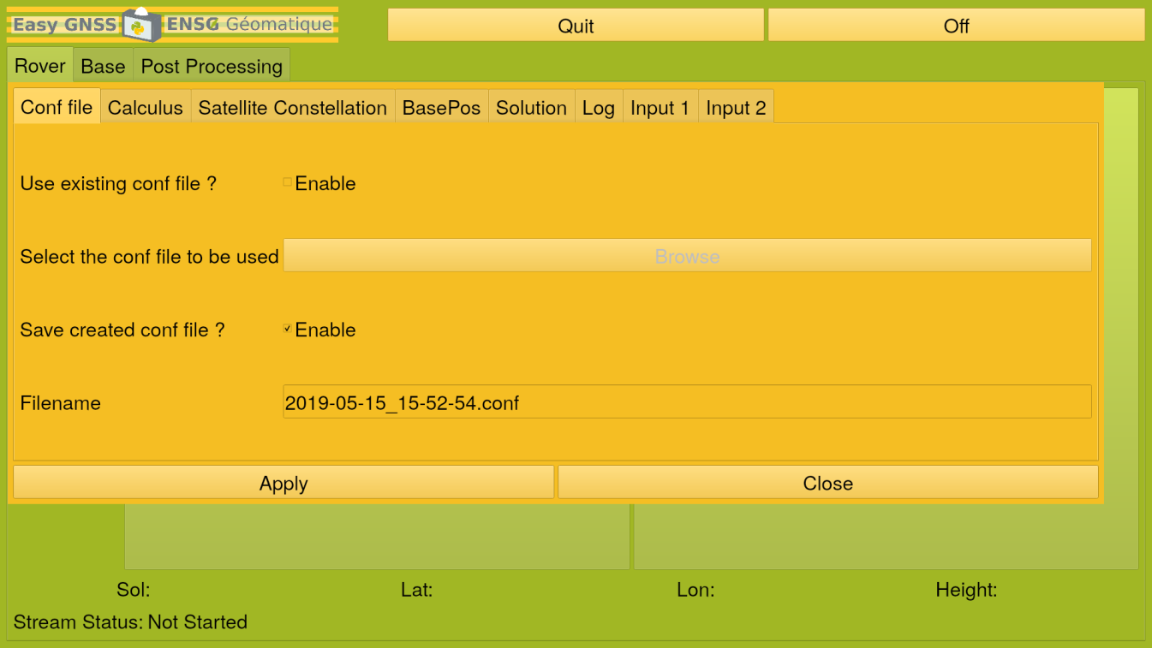

* + Use existing conf file ? : Tick to use an existing RTKLIB conf file with already defined parameters.
  + Select the conf file to be used: If you want to use an existing file, select the file here.
  + Save created conf file ? : Tick to save the parameters you will use for this acquisition to use them later for another one. Useful is you want to do post-processing.
  + Filename: If you want to save the parameters, enter the name of the new file here. It will be saved in the directory saved_conf.
* Calculus

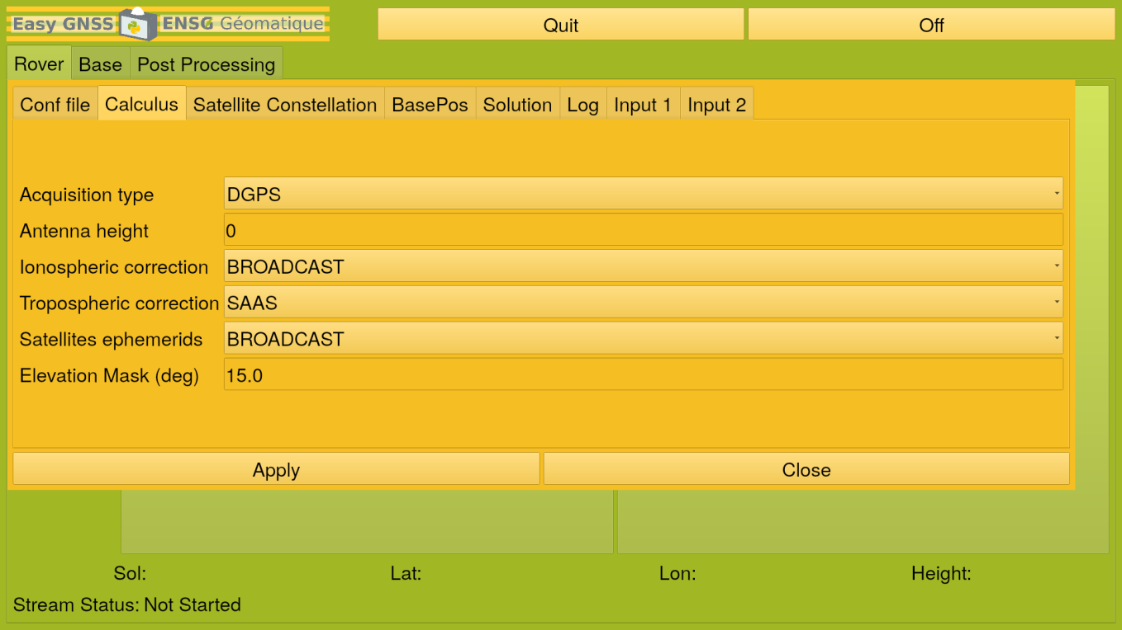

* + Acquisition Type: Choose the method to determinate the position of the Rover
    - Single: Single point positioning. Less precise (some metres), but you need only one receiver.
    - DGPS/DGNSS: Code-based differential GPS, which provides improved location accuracy, in the range of operations of each system, from nominal GPS accuracy. The rover can either move or be fixed, the base is fixed.
    - Kinematic: Carrier-based Kinematic positioning. The rover moves, the base is fixed.
    - Static: Carrier-based Static positioning. The rover and the base are both fixed.
    - Moving Base: The rover and the base move. Useful for GNSS with drones for example.
    - Fixed: Little used, thus not advised.
    - PPP-Kinematic: Precise Point Positioning with Kinematic mode. Precise Point Positioning (PPP) is a global navigation satellite system positioning method that calculates very precise positions (less than 80 cm), with errors as small as a few centimetres under good conditions. The rover moves, the base is fixed.
    - PPP-Static: Precise Point Positioning with Static mode. The rover and the base are fixed.
    - PPP-Fixed: Little used, thus not advised.
  + Antenna height: Height of the rover’s antenna, in meter.
  + Ionospheric correction: Set ionospheric correction options. If you set the parameter, Estimated. Vertical ionospheric delay for each satellite are estimated. For long baseline analysis, ionosphere estimation is effective to suppress ionosphere delay effects.
* OFF: Not ionospheric correction
* Broadcast: Apply broadcast ionospheric model
* SBAS: Apply SBAS ionospheric model
* Dual Freq: Apply ionosphere‐free linear combination with dual frequency measurements
* Est-STEC (Slant Total Electron Content): Estimate ionospheric parameter. For Single or PPP modes only.
* IONEX TEC: Use IONEX TEC grid data
* QZSS BRDC: Apply broadcast ionosphere model provided by QZSS
* QZSS LEX: Little used, thus not advised.
  + Tropospheric correction: Set whether tropospheric parameters (zenith total delay at rover and base positions) are estimated or not.
    - OFF : No tropospheric correction
    - SAAS: Apply Saastamoinen model
    - SBAS: Apply SBAS tropospheric model (MOPS)
    - Est-ZTD: Estimate ZTD (zenith total delay) parameters as EKF states. For Single mode only.
    - Est-ZTDGrad: Estimate ZTD and horizontal gradient parameters as EKF states. For Single mode only.
  + Satellites ephemeris: Set the type of satellites ephemeris.
    - Broadcast: Use broadcast ephemeris.
    - BRDC+SBAS: Broadcast with SBAS long-term and fast correction
    - BRDC+SSRAPC: Broadcast with RTCM SSR correction (antenna phase centre value)
    - BRDC+SSRCOM: Broadcast ephemeris with RTCM SSR correction (satellite centre of mass value)
  + Elevation mask: Set elevation mask angle in decimal degrees, satellites below that angle will be ignored.
* Satellite Constellation: Choose the constellations you want to use.

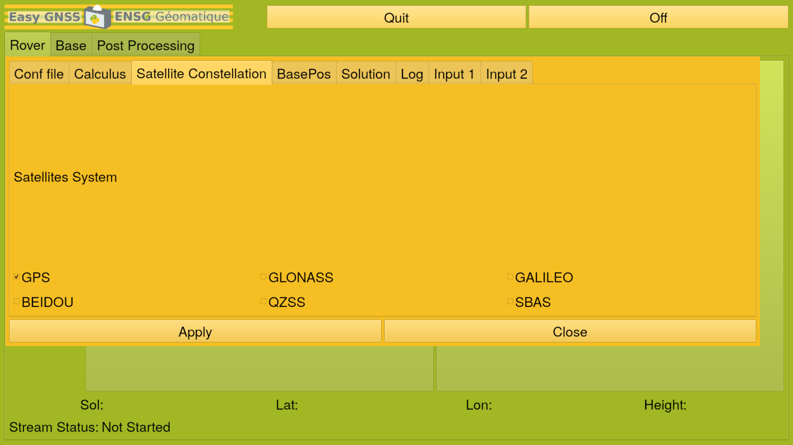

* + GPS: American satellite navigation system. It provides geolocation and time information to a GPS receiver anywhere on or near the Earth where there is an unobstructed line of sight to four or more GPS satellites. Obstacles such as mountains and buildings block the relatively weak GPS signals.
  + GLONASS: Russian satellite navigation system. It provides an alternative to GPS and is the second navigational system in operation with global coverage and of comparable precision.
  + GALILEO: European satellite navigation system. It provides horizontal and vertical position measurements within 1-metre precision, and better positioning services at higher latitudes than other positioning systems.
  + BEIDOU (COMPASS): Chinese satellite navigation system. It consists of two separate satellite constellations which offer limited coverage and navigation services, mainly for users in China and neighbouring regions.
  + QZSS: Japanese satellite augmentation system. It provides highly precise and stable positioning services in the Asia-Oceania region, compatible with GPS.
  + SBAS: Satellite augmentation system. It supports wide-area or regional augmentation through the use of additional satellite-broadcast messages. Using measurements from the ground stations, correction messages are created and sent to one or more satellites for broadcast to end users as differential signal. Thus, it should be used as a type of acquisition but RTKLIB mentions it as a satellite system.
* BasePos

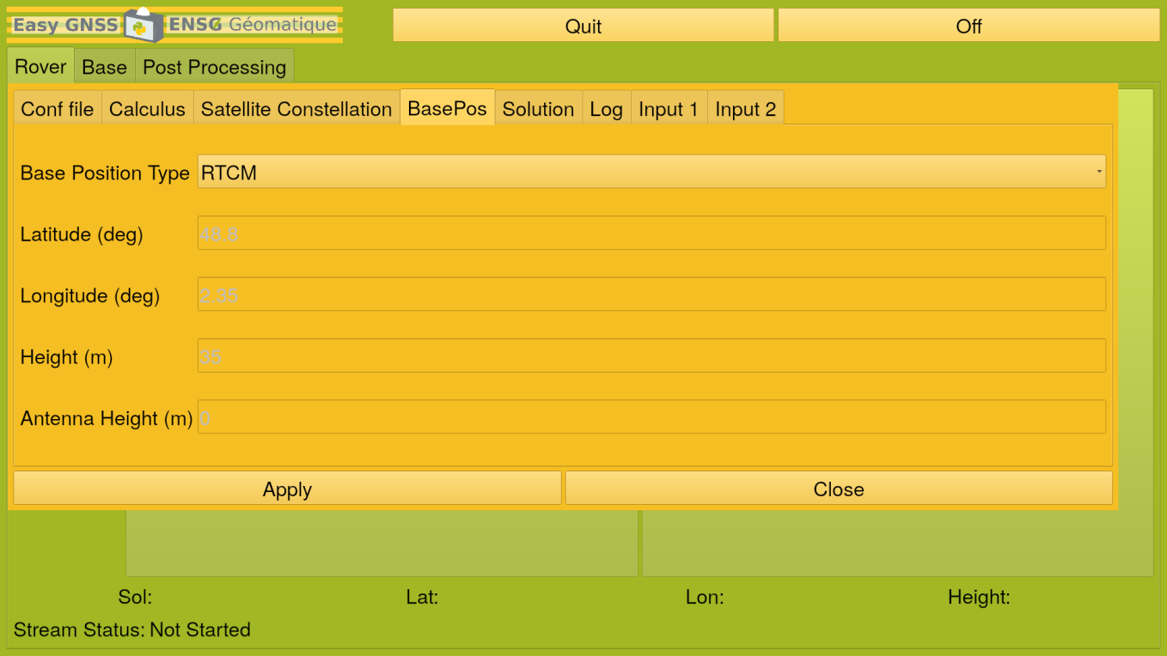

* + Base Position Type: Type of input of the base’s position
    - RTCM: the base communicates its position via radio.
    - LLH: the user needs to specify the base’s position with the next parameters.
  + Latitude: Latitude (in decimal degrees) of the base.
  + Longitude: Longitude (in decimal degrees) of the base.
  + Height: Height above the ellipsoid (in meters) of the base.
  + Antenna Height: Height of the base's antenna in relation to the ground (in meters)
* Solution

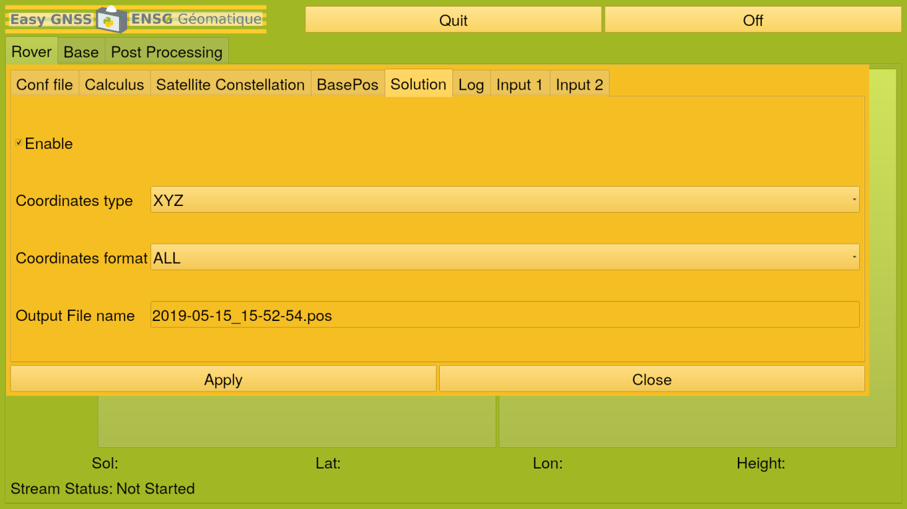

* + Enable: Permit to save the positions calculated with RTKLIB. Useful if you want to do post-processing afterwards.
  + Coordinates Type:
    - LLH: geographical coordinates (latitude, longitude, height above the ellipsoid)
    - XYZ: cartesian coordinates
    - ENU: planar coordinates in projection
  + Coordinates Format:
    - All: All measures
    - Single: Only one measure
  + Output File Name: Name of the solution file (.pos). It will be saved in the directory Results in the directory Solutions.
* Log

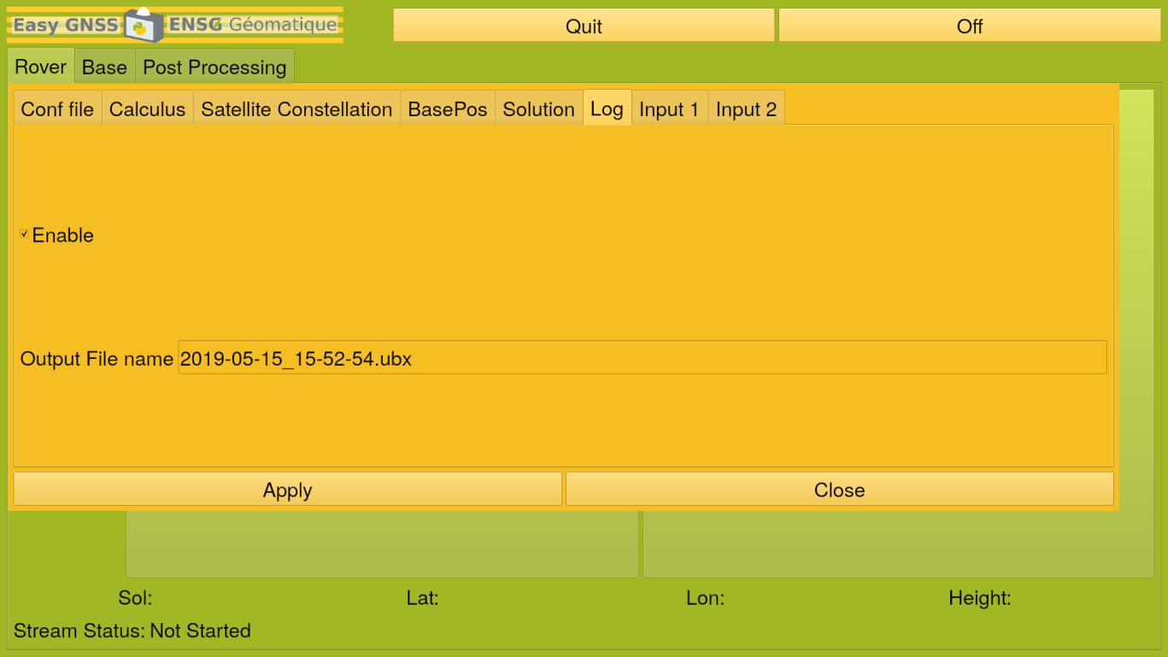

* + Enable: Permit to save the stream of observations. Useful if you want to do post-processing afterwards.
  + Output File Name: Name of the log file at the UBX format. It will be saved in the directory Results in the directory Logs.
* Input 1: **We recommend you not to change these parameters.**

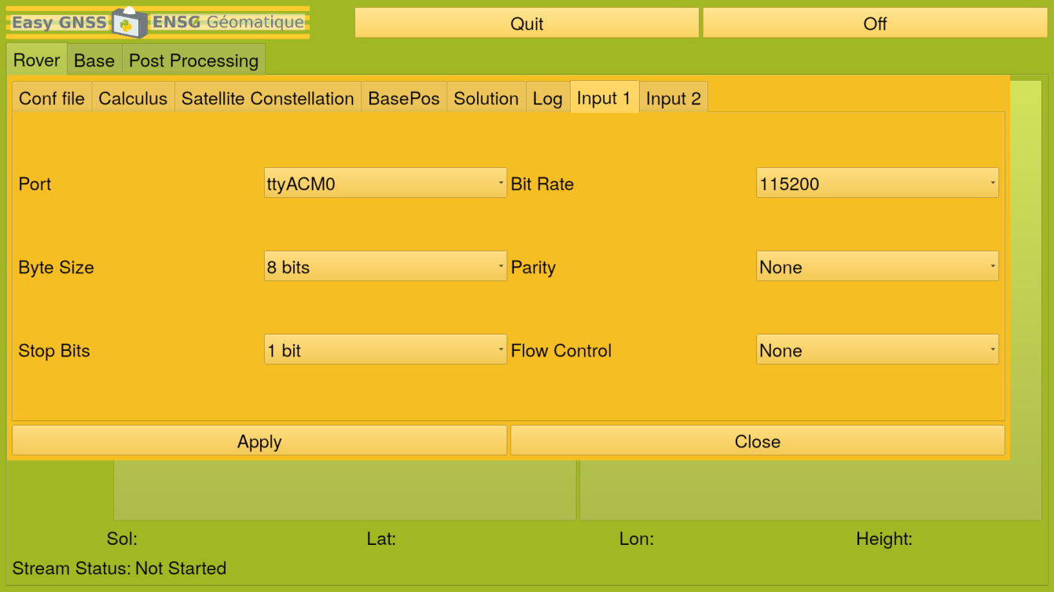

* + Port: Device associated with the port connected to Raspberry. By default, it is “ttyACM0”.
  + Bit Rate: Number of bits that are conveyed or processed per unit of time. By default, it is “115200”.
  + Byte Size: Number of bits in a byte. A byte made with 8 bits is an octet. By default, it is “8 bits”.
  + Parity: None, even or odd. The parity of pre-defined sets of bits is checked against a field containing the parity computed at transmission and sent within the navigation message. Any discrepancies would imply that there was at least one error in the message. By default, it is “None”.
  + Stop Bits: An extra stop bit can be a useful way to add a little extra receive processing time. By default, it is only 1 bit.
  + Flow Control: Process of managing the rate of data transmission between two nodes to prevent a fast sender from overwhelming a slow receiver. It provides a mechanism for the receiver to control the transmission speed, so that the receiving node is not overwhelmed with data from transmitting node. By default, it is “None”.
* Input 2: Information associated to the NTRIP

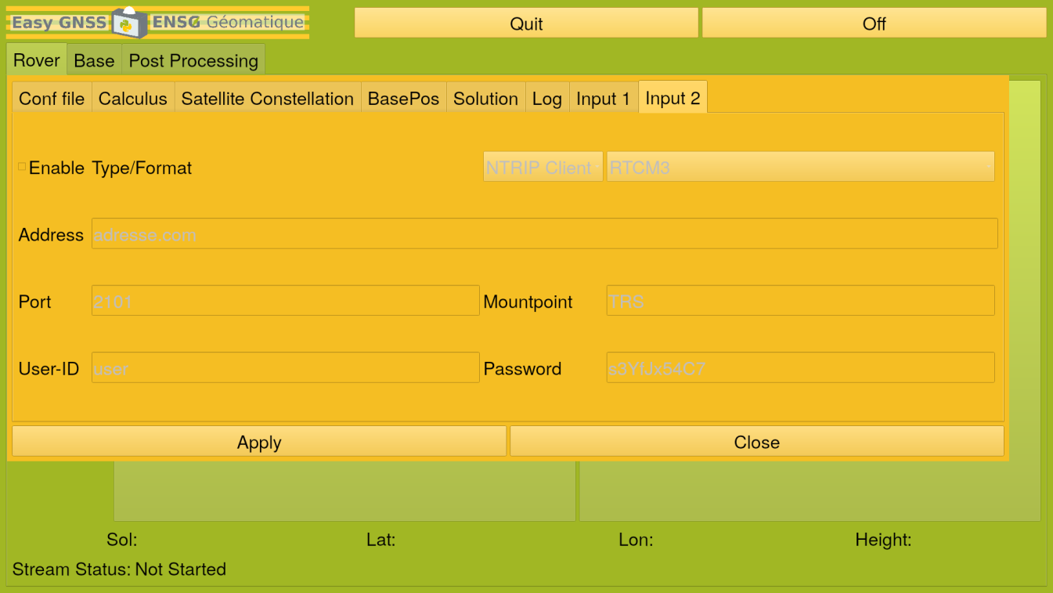

* + Enable: Permit to bring corrections from bases.
  + Type: Protocol used.
    - NTRIP Client: Real server element in the overall NTRIP system. It takes data from one or more data stream sources (Base Stations referred to as NTRIP Servers) and provides this data to one or more rovers, the NTRIP Clients.
    - TCP Client: Provides reliable, ordered, and error-checked delivery of a stream of octets (bytes) between applications running on hosts communicating via an IP network. Major internet applications such as the World Wide Web, email, remote administration, and file transfer rely on TCP.
  + Format: RTK Standards.
    - RTCM2 & RTCM3 (Radio Technical Commission for Maritime Services): The internationally accepted data transmission standards for DGNSS are defined by the RTCM. The protocol is a binary one designed to optimize the communication throughput.
    - BINEX (BINary Exchange): Binary format standard for GNSS research and operational purposes. The format has been designed to grow and allow encapsulation of any data or metadata allowed in the common ASCII exchange formats such as RINEX, IONEX, SP3, SINEX, and so on, including GNSS-related data and metadata as encountered.
    - UBX (U-Blox): Binary format standard for GNSS research and operational purposes.
  + Address: address of the NTRIP Caster
  + Port: port used on the Caster
  + Mountpoint: Data Flow
  + User-ID: login to connect to the NTRIP Caster
  + Password: password to connect to the NTRIP Caster

**Push "Apply" to save the parameters. A pop-up window will appear. Push "ok" to close it.**



**Push “Start”.**

The processing with RTKLIB will start and positioning results will be shown on the bottom of the screen. You will have the latitude, the longitude, the height above the ellipsoid of the rover, a quality code from 1 (best positioning quality) to 5 and the calculus mode really used by RTKLIB for the processing. A log file and a position file will be created at the specified path if the user enabled it in the parameters.

**Push “Stop”.**

The processing with RTKLIB will stop.

## Base mode

### D:\Capture d’écran de 2019-05-15 18-40-15.png

**Select “Base” tab, and push “Config”. Now, configure the different parameters.**

* BasePos

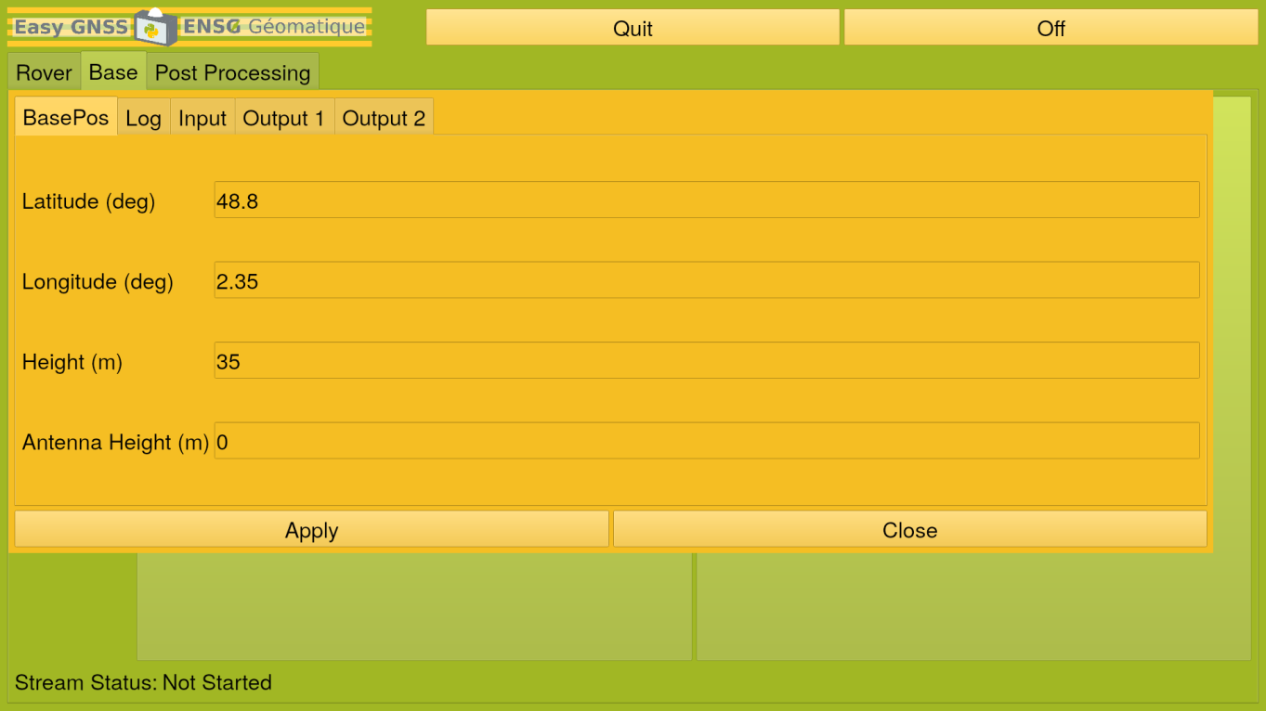

* + Latitude: Latitude (in decimal degrees) of the base.
  + Longitude: Longitude (in decimal degrees) of the base.
  + Height: Height above the ellipsoid (in meter) of the base.
  + Antenna Height (in meter): height of the base's antenna in relation to the ground.
* Log

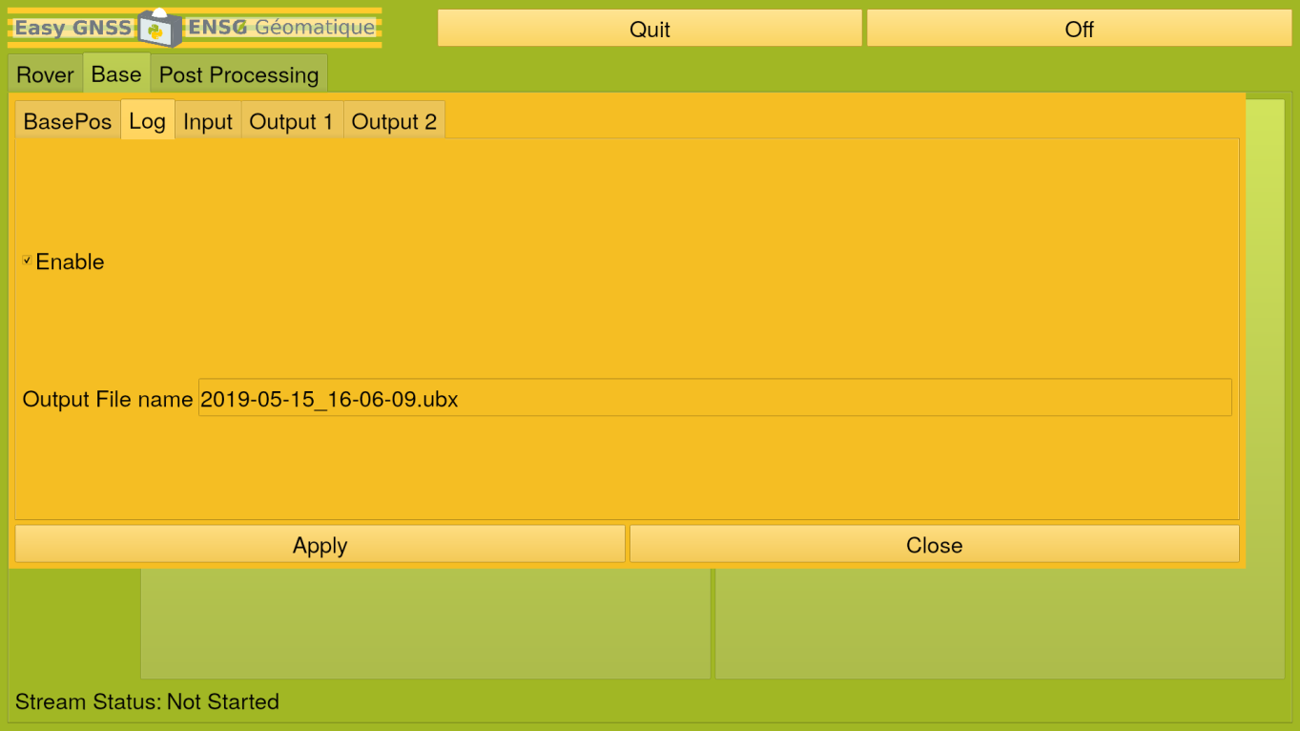

* + Enable: Permit to save the stream of observations.
  + Output File Name: Name of the log file at the UBX format. It will be saved in the directory Results in the directory Logs.
* Input: **We recommend you not to change these parameters.**

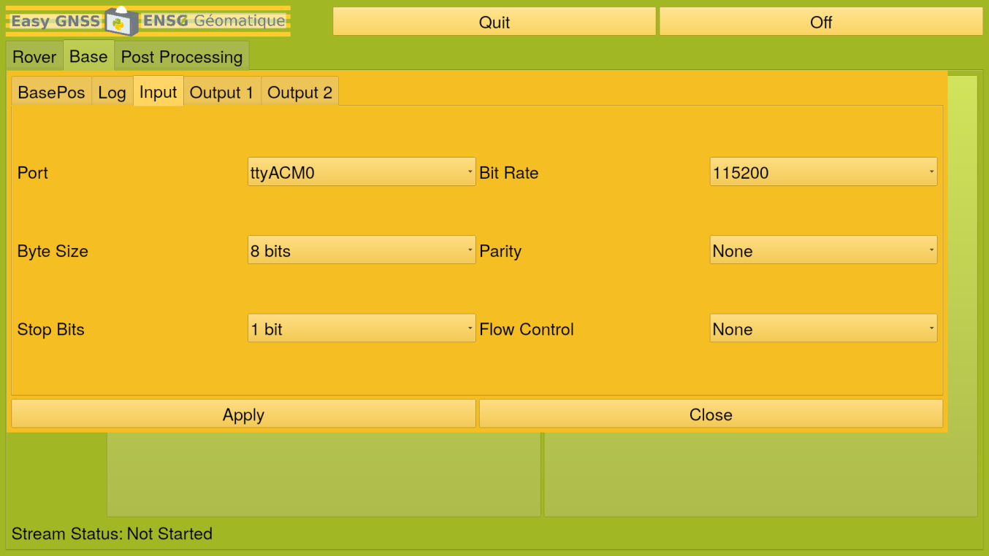

* + Port: Device associated with the port connected to Raspberry. By default, it is “ttyACM0”.
  + Bit Rate: Number of bits that are conveyed or processed per unit of time. By default, it is “115200”.
  + Byte Size: Number of bits in a byte. A byte made with 8 bits is an octet. By default, it is “8 bits”.
  + Parity: None, even or odd. The parity of pre-defined sets of bits is checked against a field containing the parity computed at transmission and sent within the navigation message. Any discrepancies would imply that there was at least one error in the message. By default, it is “None”.
  + Stop Bits: An extra stop bit can be a useful way to add a little extra receive processing time. By default, it is only 1 bit.
  + Flow Control: Process of managing the rate of data transmission between two nodes to prevent a fast sender from overwhelming a slow receiver. It provides a mechanism for the receiver to control the transmission speed, so that the receiving node is not overwhelmed with data from transmitting node. By default, it is “None”.
* Output 1

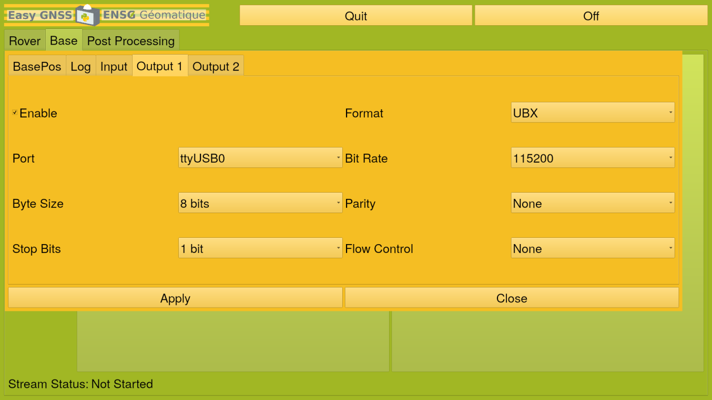

* + Enable: Permit to use the first output.
  + Format: RTK Standards. By default, it’s “UBX”
    - RTCM2 & RTCM3 (Radio Technical Commission for Maritime Services): The internationally accepted data transmission standards for DGNSS are defined by the RTCM. The protocol is a binary one designed to optimize the communication throughput.
    - BINEX (BINary Exchange): Binary format standard for GNSS research and operational purposes. The format has been designed to grow and allow encapsulation of any data or metadata allowed in the common ASCII exchange formats such as RINEX, IONEX, SP3, SINEX, and so on, including GNSS-related data and metadata as encountered.
    - UBX (U-Blox): Binary format standard for GNSS research and operational purposes
  + Port: Device associated with the port connected to Raspberry. By default, it is “ttyACM0”.
  + Bit Rate: Number of bits that are conveyed or processed per unit of time. By default, it is “115200”.
  + Byte Size: Number of bits in a byte. A byte made with 8 bits is an octet. By default, it is “8 bits”.
  + Parity: None, even or odd. The parity of pre-defined sets of bits is checked against a field containing the parity computed at transmission and sent within the navigation message. Any discrepancies would imply that there was at least one error in the message. By default, it is “None”.
  + Stop Bits: An extra stop bit can be a useful way to add a little extra receive processing time. By default, it is only 1 bit.
  + Flow Control: Process of managing the rate of data transmission between two nodes to prevent a fast sender from overwhelming a slow receiver. It provides a mechanism for the receiver to control the transmission speed, so that the receiving node is not overwhelmed with data from transmitting node. By default, it is “None”.
* Output 2

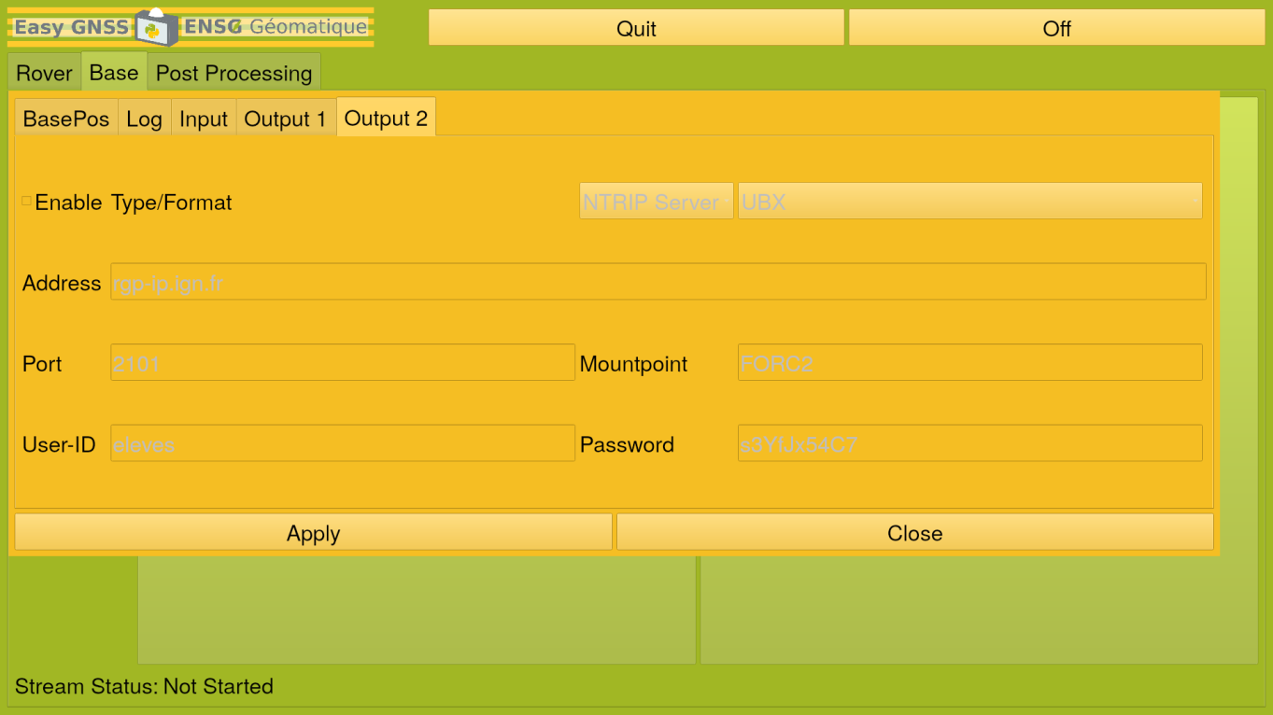

* + Enable: Permit to bring corrections to rovers.
  + Type: Protocol used.
    - NTRIP Server: Real server element in the overall NTRIP system. It takes data from one or more data stream sources (Base Stations referred to as NTRIP Servers) and provides this data to one or more rovers, the NTRIP Clients.
    - TCP Server: Provides reliable, ordered, and error-checked delivery of a stream of octets (bytes) between applications running on hosts communicating via an IP network. Major internet applications such as the World Wide Web, email, remote administration, and file transfer rely on TCP.
  + Format: RTK Standards.
    - RTCM2 & RTCM3 (Radio Technical Commission for Maritime Services): The internationally accepted data transmission standards for DGNSS are defined by the RTCM. The protocol is a binary one designed to optimize the communication throughput.
    - BINEX (BINary Exchange): Binary format standard for GNSS research and operational purposes. The format has been designed to grow and allow encapsulation of any data or metadata allowed in the common ASCII exchange formats such as RINEX, IONEX, SP3, SINEX, and so on, including GNSS-related data and metadata as encountered.
    - UBX (U-Blox): Binary format standard for GNSS research and operational purposes.
  + Address: address of the NTRIP Caster
  + Port: port used on the Caster
  + Mountpoint: Data Flow
  + User-ID: login to connect to the NTRIP Caster
  + Password: password to connect to the NTRIP Caster

**Push "Apply" to save the parameters. A pop-up window will appear. Push "ok" to close it.**

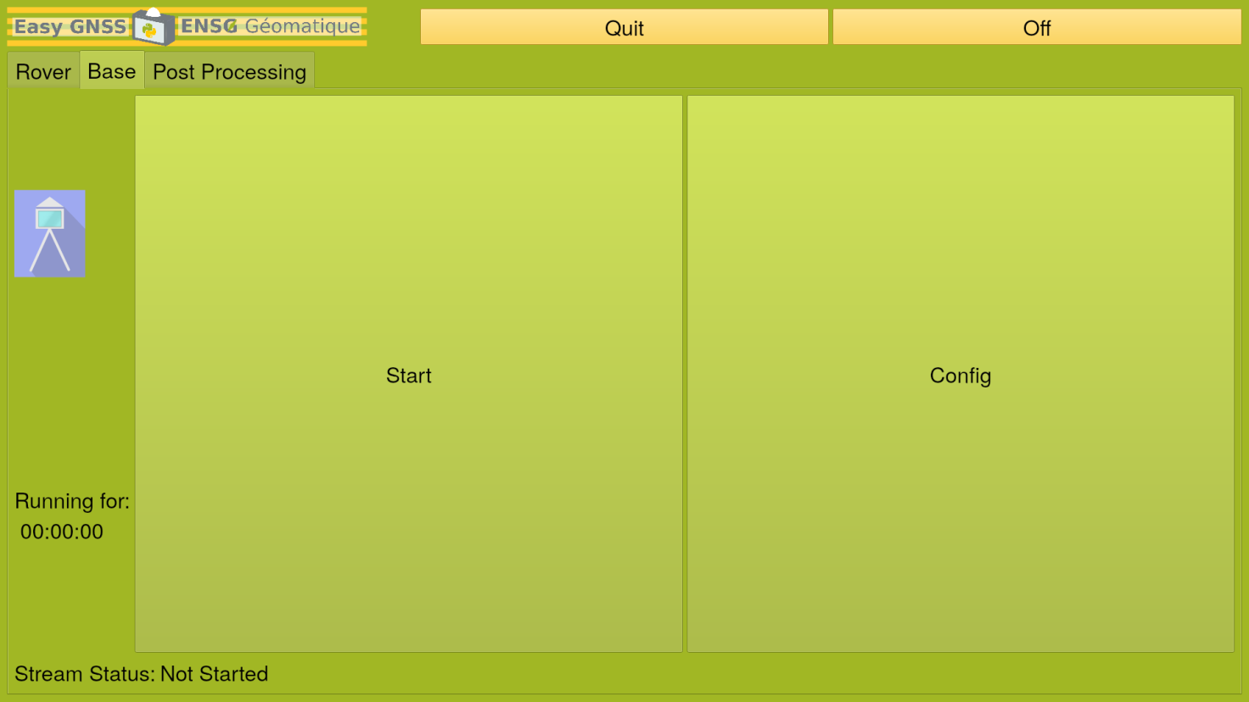

**Push “Start”.**

The base will start and corrections will be sent to rovers.

**Push “Stop”.**

The base will stop.

## Post-Processing

**Once the processing is done with the Rover mode, you can directly do post-processing with the application.**

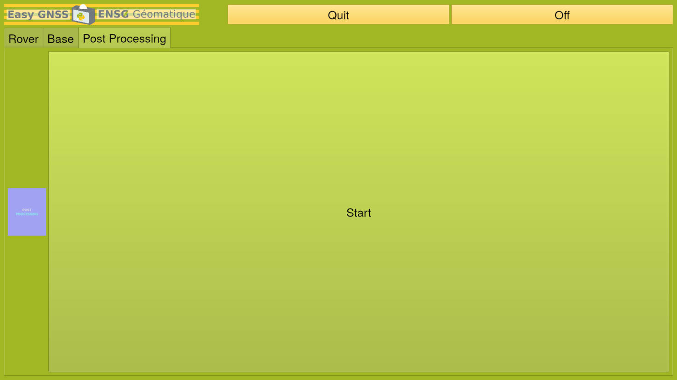

**Push “Start”. The configuration menu will appear. Now, configure the different parameters.**

* Options

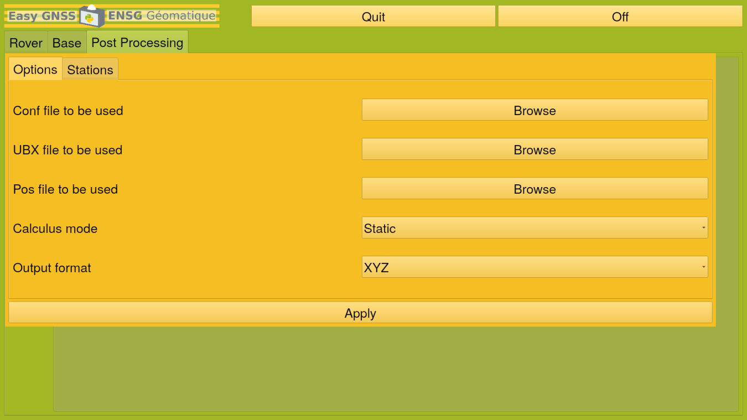

* + Conf file to be used: Select the last conf file
  + UBX File to be used: Select the last observations file at the UBX format.
  + Pos File to be used: Select the last positions file.
  + Calculus mode:
    - Static: The rover has not moved during the acquisition.
    - Kinematic: The rover has moved during.
  + Output format:
    - LLH: Latitude, Longitude, Height
    - XYZ: Cartesian coordinates (in meters)
* Stations

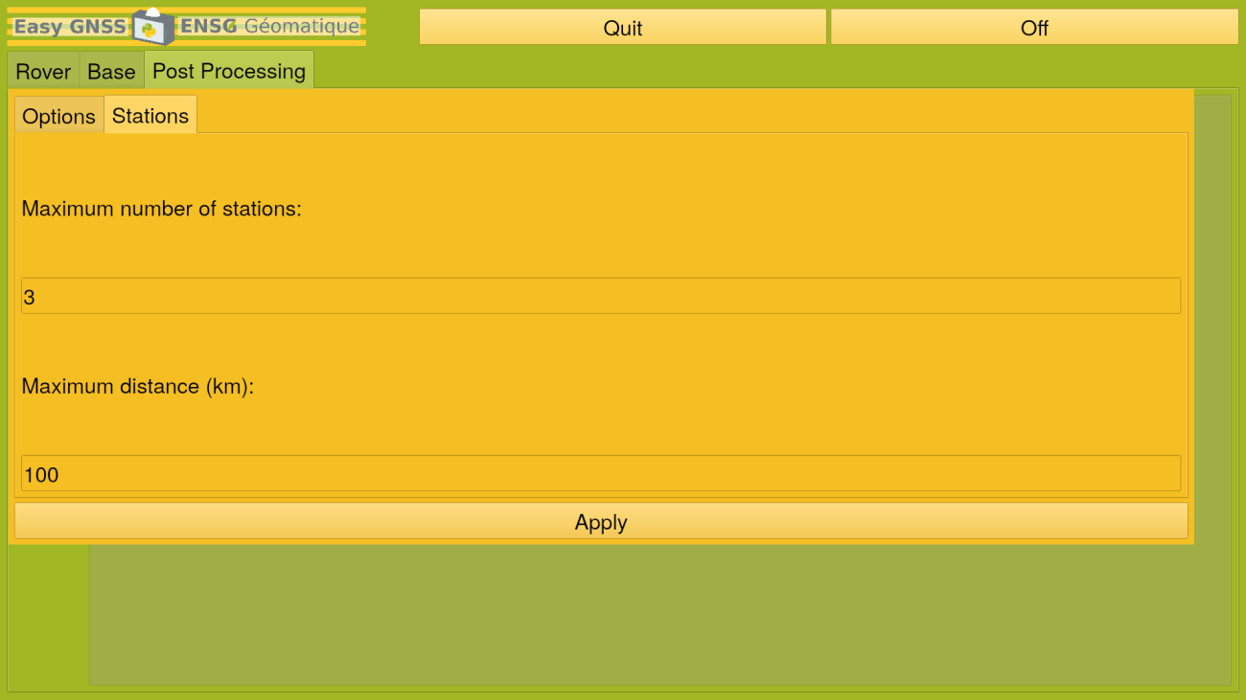

* + Maximum number of stations: Limit to a certain number the stations that are used
  + Maximum distance: Limit to a certain distance the stations used.

## Quit/Off

After the acquisition, push “Quit” to exit from EasyGNSS and return to the Raspberry Pi menu.

You can also push “Off” instead, to quit and turn off the GNSS directly. Do not forget to turn off the switch after.