Project is in the “MVC” folder on branch

Database stuff:

**BEFORE ADDING DATA INTO TABLE MAKE PRIMARY KEY TABLE AUTO INCREMENT, LINK =** [**https://stackoverflow.com/questions/10990347/how-to-set-auto-increment-column-with-sql-developer**](https://stackoverflow.com/questions/10990347/how-to-set-auto-increment-column-with-sql-developer)

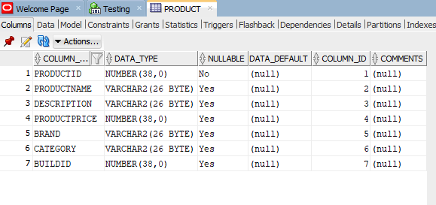

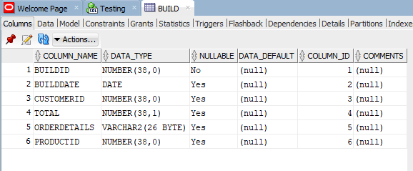

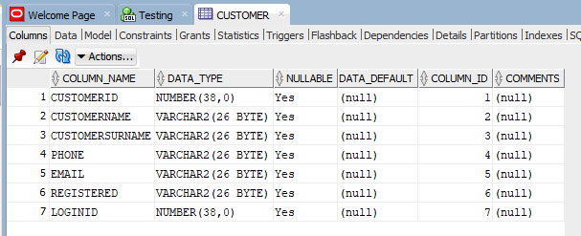

Tutorial link - <https://www.c-sharpcorner.com/blogs/crud-operation-in-asp-net-core30-with-oracle-database2>