Ionescu Franco Andrei Daniel

Electronic Signatures Project

Section 1: Initial setup and virtual machine configuration
- Download Alice VM
The virtual machine (Alice VM) was downloaded to provide a pre-configured and isolated environment for the project, containing the necessary software like the EJBCA application and tools.
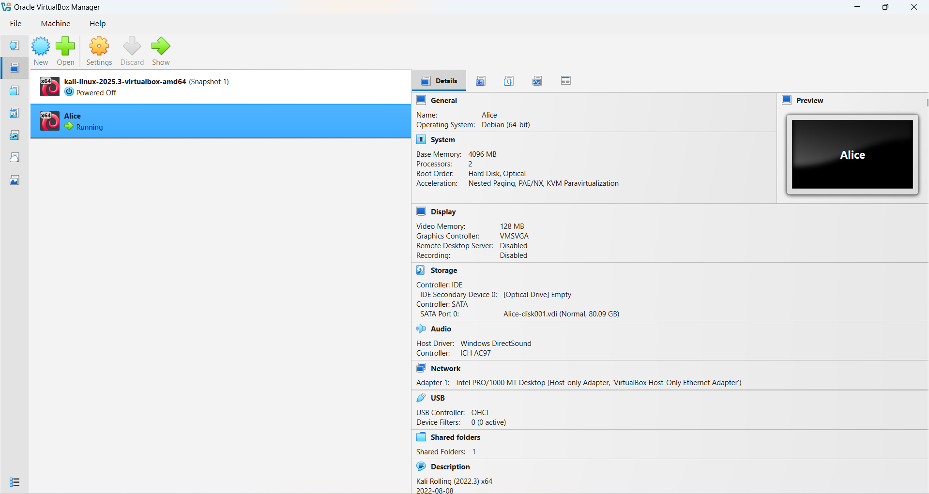
Figure 1.1 Alice VM in Oracle VirtualBox Manager

- Use Virtual Box to start it
The VM was loaded into Oracle VirtualBox Manager and started, providing a fully operational desktop environment for the subsequent steps.
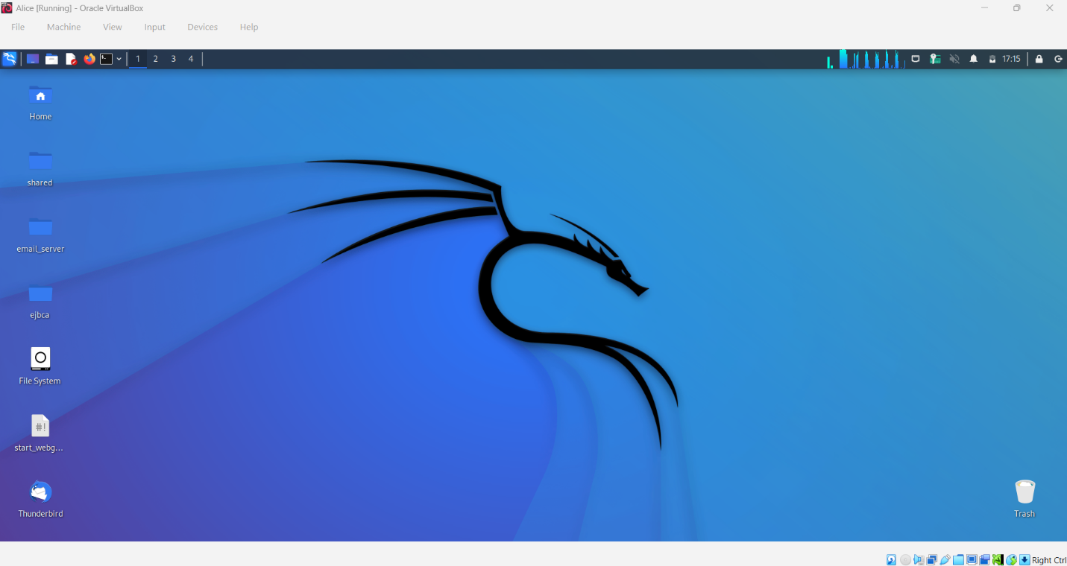
Figure 1.2 Alice VM Desktop

- Start EJBCA application
The EJBCA (Enterprise Java Bean Certificate Authority) application, which acts as the Certificate Authority (CA) in the project, was initiated using the provided startup commands within the VM's terminal.
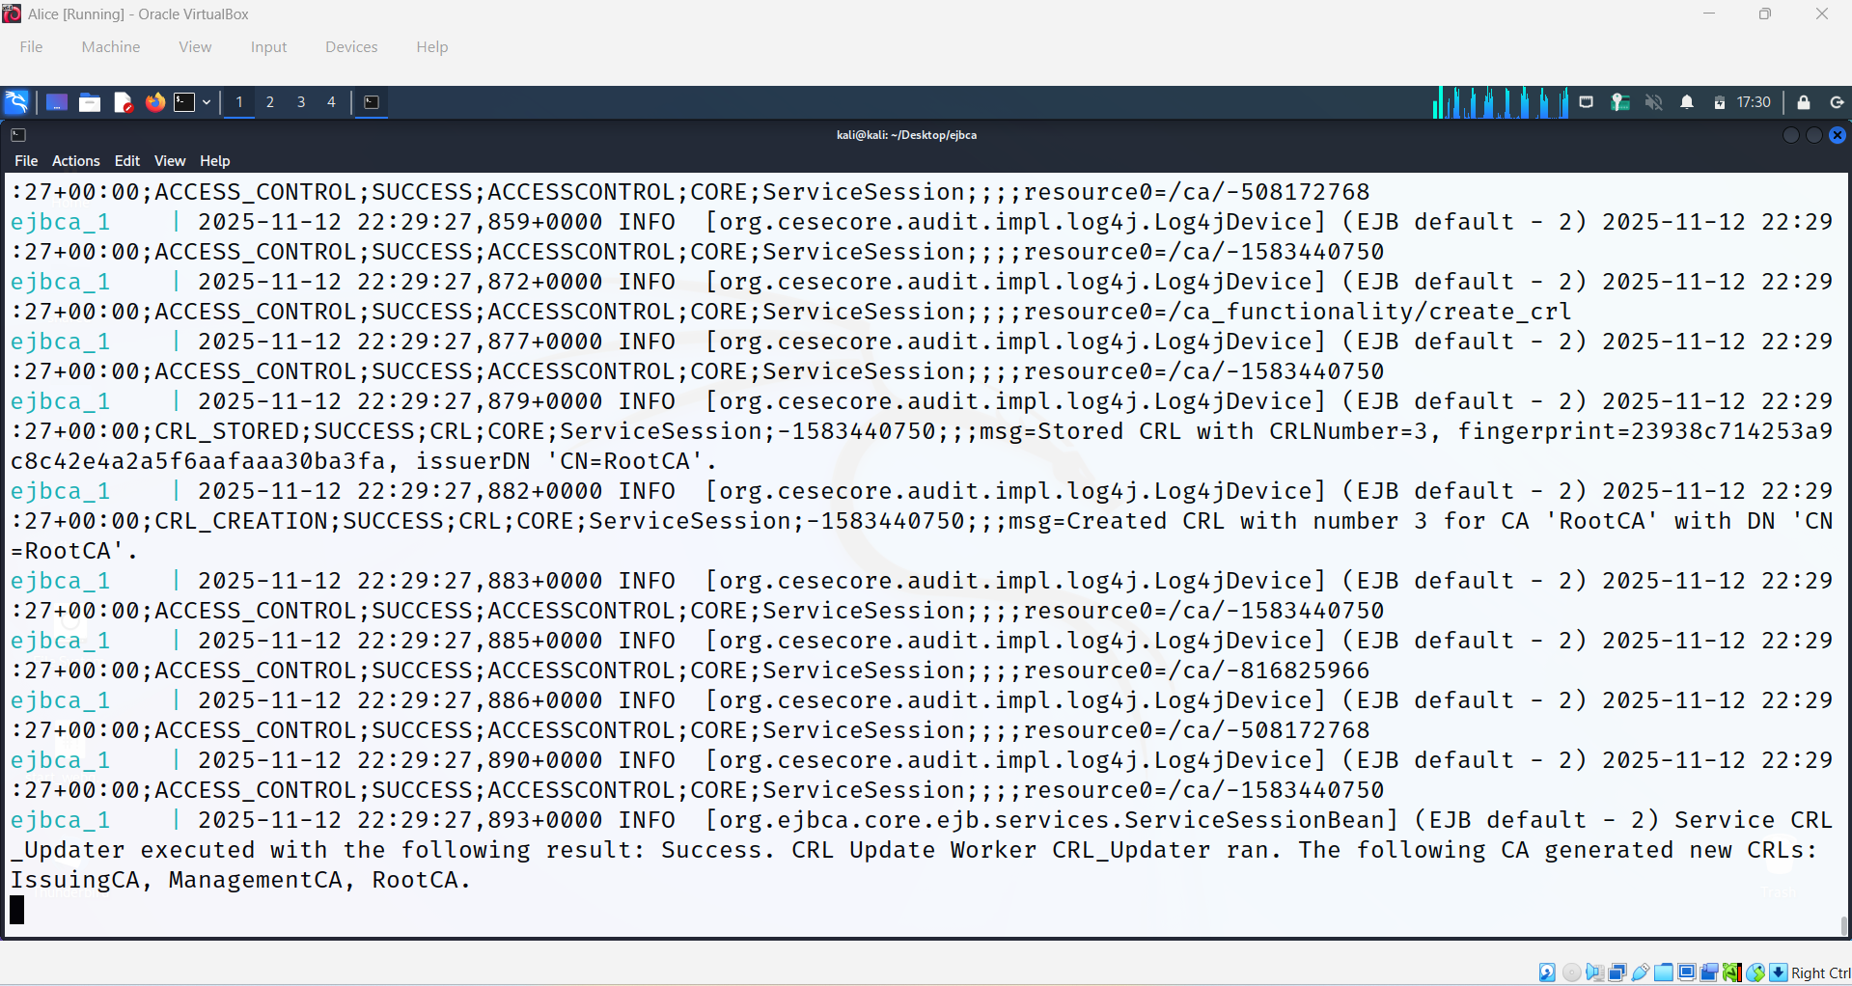
Figure 1.3 EJBCA startup commands

- Get SuperAdmin Certificate and install it
The SuperAdmin Certificate was retrieved from the EJBCA instance and installed in the browser's or operating system's certificate store (e.g., certmgr). This certificate is essential for accessing and managing EJBCA's administrative interface.
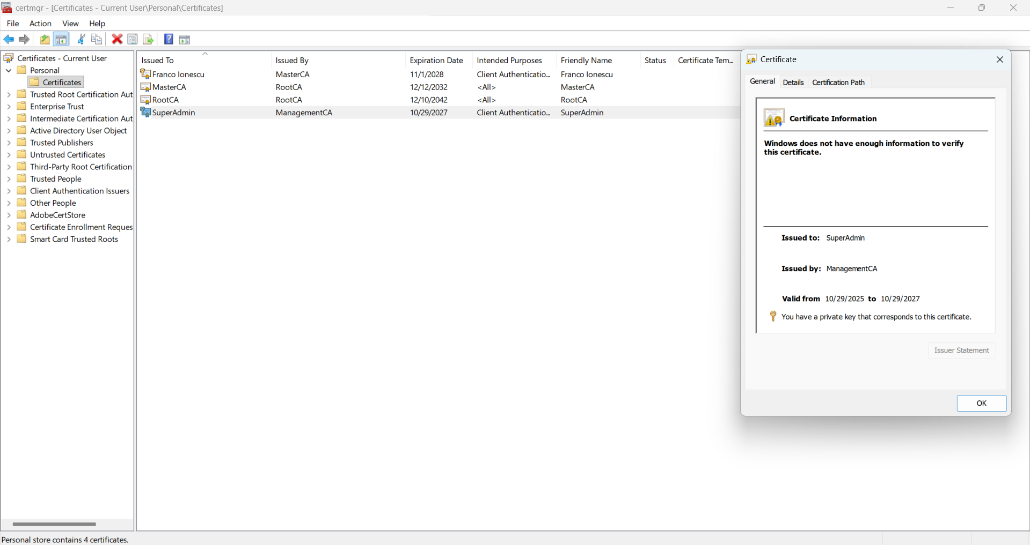
Figure 1.4 SuperAdmin Certificate in certmgr
- Access EJBCA’s public interface
The public web interface of the EJBCA CA was accessed to confirm its operational status and to perform public functions, such as retrieving CA certificates or certificate revocation lists (CRLs).
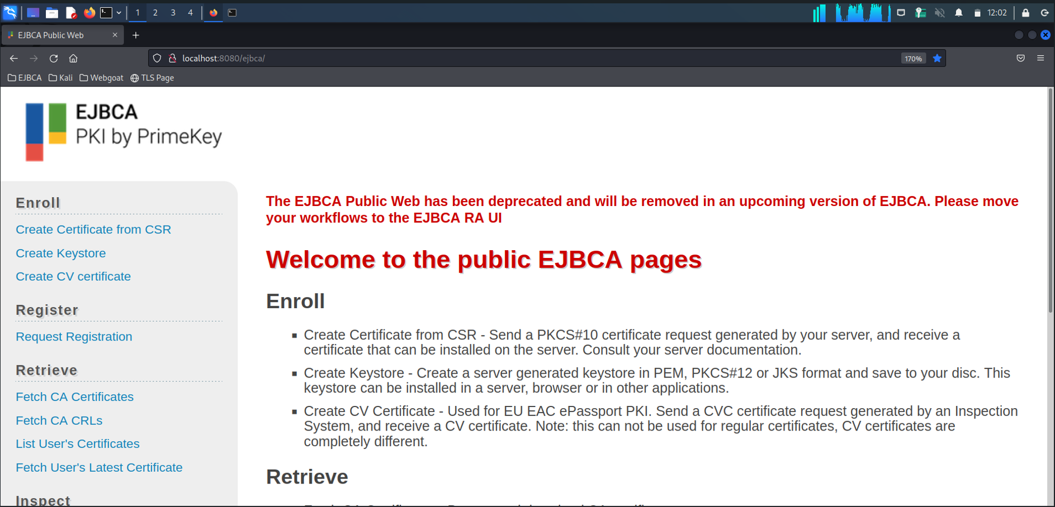
Figure 1.5 EJBCA’s public interface
- Access EJBCA’s administrative interface
The administrative interface was accessed using the installed SuperAdmin Certificate. This interface is used for managing CAs, creating end-entities, and issuing certificates for the project's testing purposes.
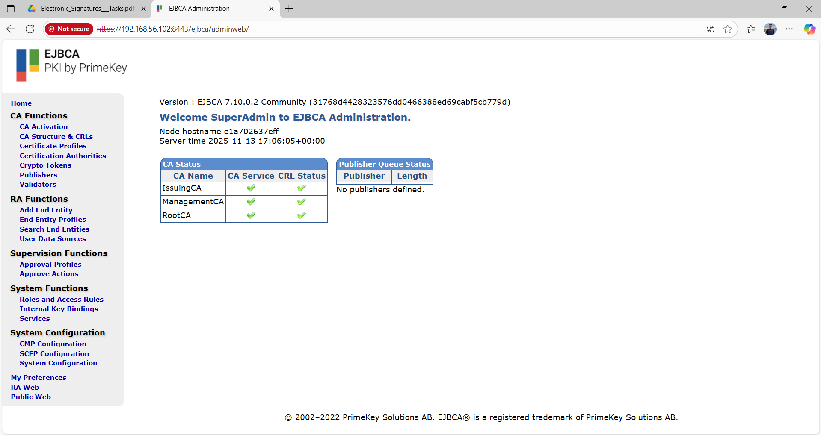
Figure 1.6 EJBCA's administrative interface

Section 2: Certificates - Verification and Inspection
- Download the cert.cer certificate
The target end-entity certificate, named cert.cer, was downloaded from the EJBCA instance or a specified location. This certificate is the primary subject for verification in the following steps.
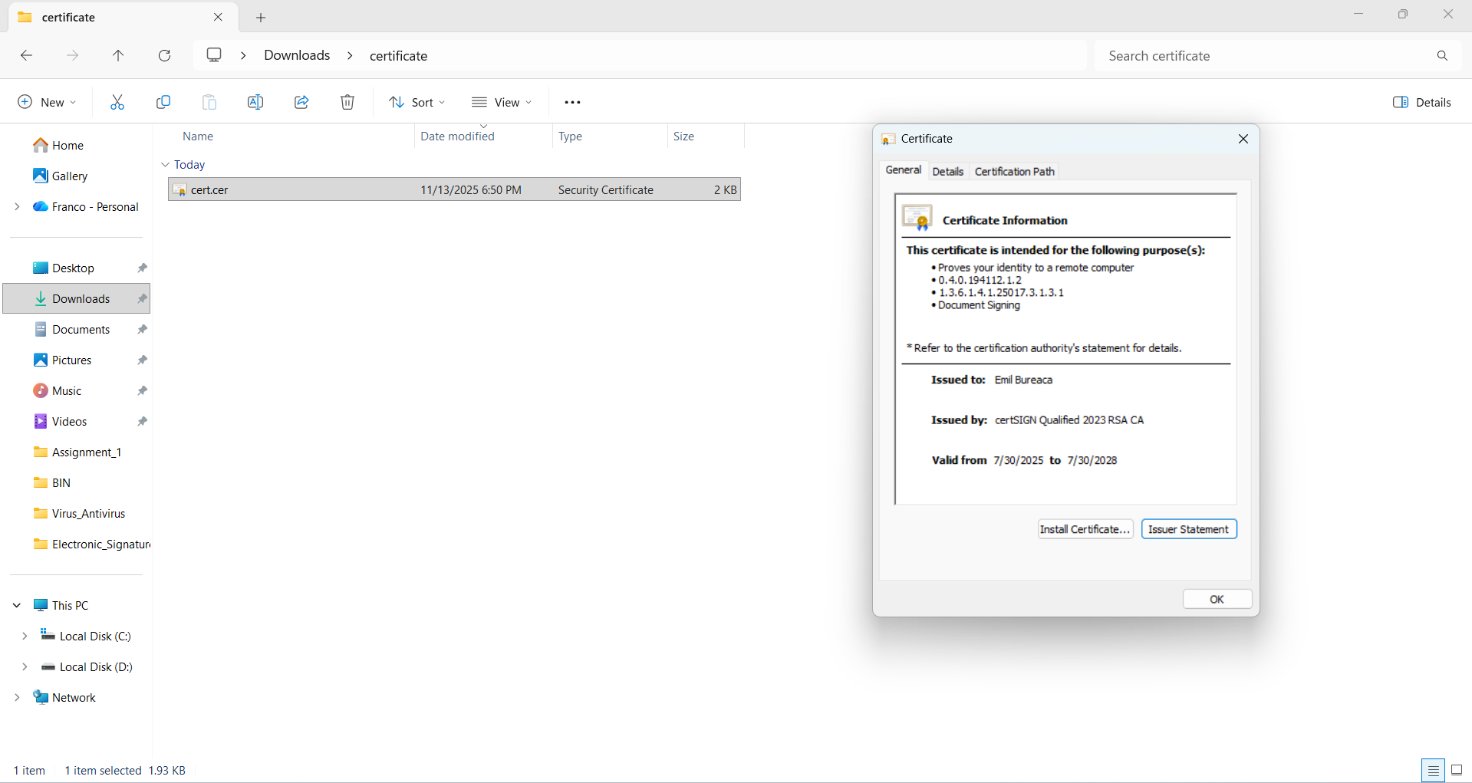
Figure 2.1 Cert.cer in file manager
- Download all the certificates in the certification path
To perform complete path validation, all certificates forming the chain of trust—including the root CA (Root.cer) and any intermediate CAs (e.g., Qualified.cer) up to the end-entity certificate—were downloaded.
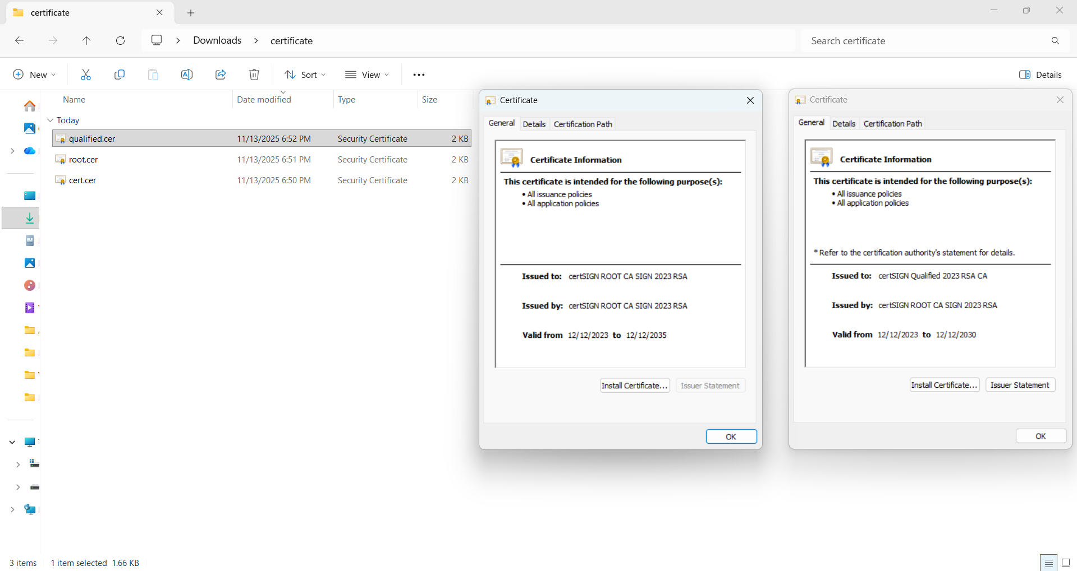
Figure 2.2 Cert.cer, Root.cer, Qualified.cer in file manager

- Download the CRL manually
The Certificate Revocation List (CRL) was manually downloaded from the Distribution Point (DP) specified within the certificate. The CRL is necessary for verifying that the certificate has not been revoked.
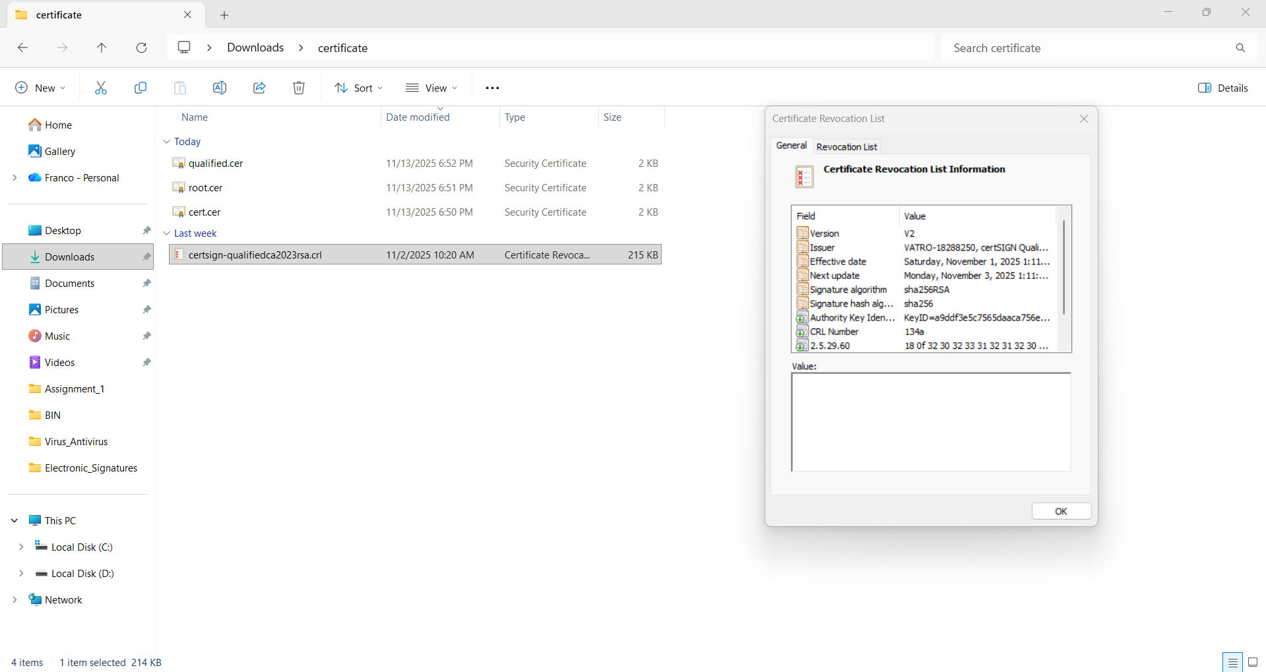
Figure 2.3 CRL manually downloaded

- Verify the certificate using certutil and CRL
The certutil tool (a command-line utility for managing certificates and CRLs) was used to verify the certificate's validity and chain of trust, specifically incorporating the locally downloaded CRL for revocation status check.
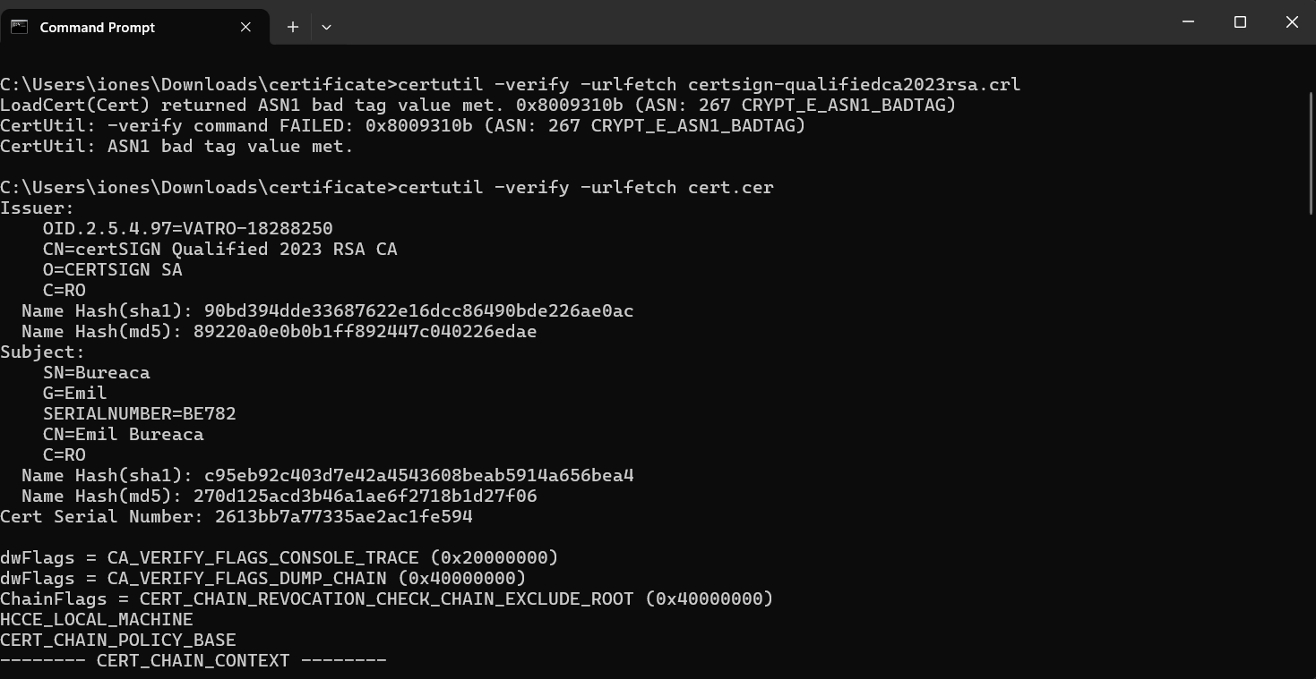
Figure 2.4 Certificate verification using certutil and CRL
- Verify the certificate using certutil and OCSP
The certutil tool was used again to verify the certificate, but this time leveraging the Online Certificate Status Protocol (OCSP) for real-time revocation checking, which is a modern alternative to the CRL.
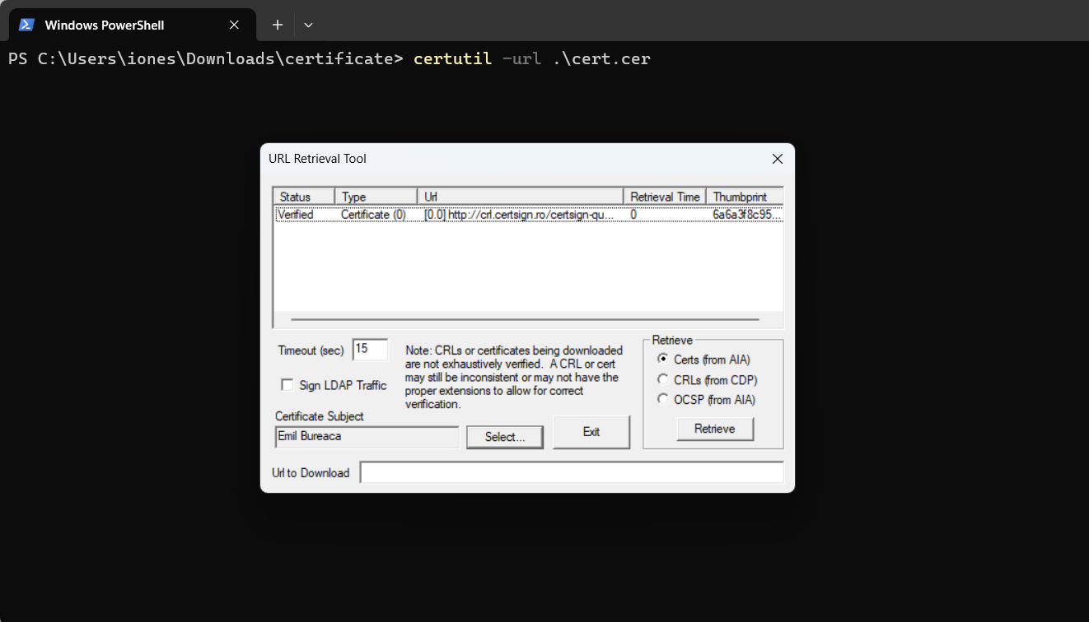
Figure 2.5 Certificate verification using certutil and OCSP
- Verify the certificate using openssl
The industry-standard OpenSSL command-line toolkit was used to perform an independent verification of the certificate chain, including checking its trust against the CA certificates.
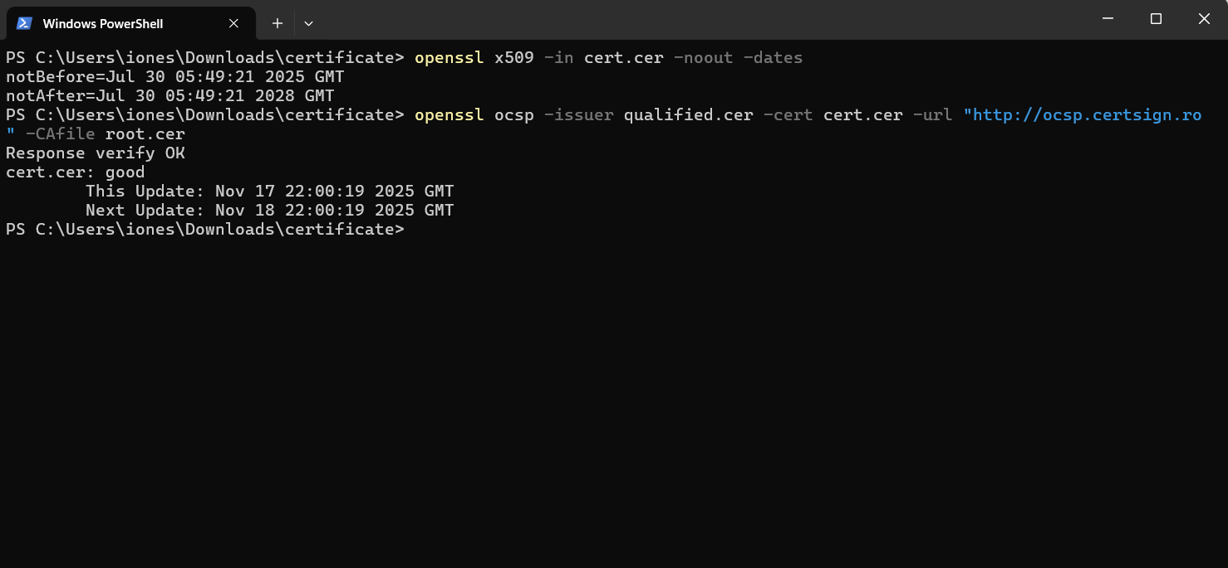
Figure 2.6 Certificate verification using openssl
- View certificate using an ASN.1 viewer
An online ASN.1 viewer (lapo.it) was used to decode the certificate's structure. This allowed for a detailed, low-level inspection of all fields and extensions as defined by the Abstract Syntax Notation One (ASN.1) standard.
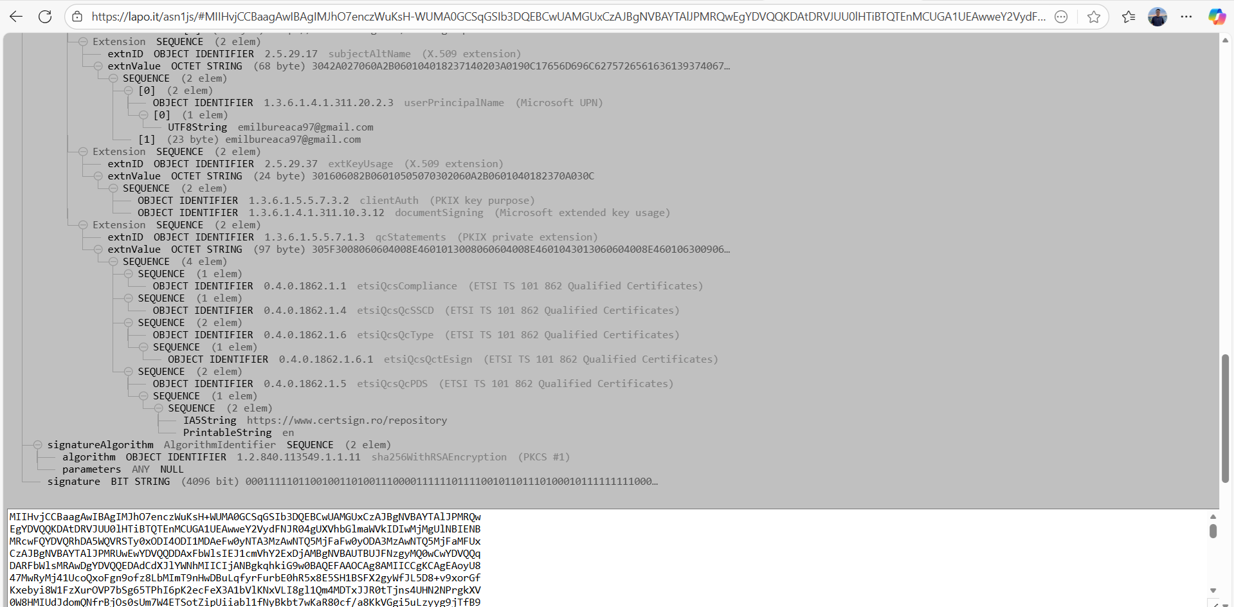
Figure 2.7 Certificate view using lapo.it
- Extract the OID of an atribute from Subject extension
I used the command openssl x509 -in cert.cer -text -noout to view the certificate's structure in a human-readable format. From the Subject section of the output, I chose the Common Name (CN) attribute, whose value is "Emil Bureaca". The standard Object Identifier (OID) corresponding to the Common Name attribute is 2.5.4.3.
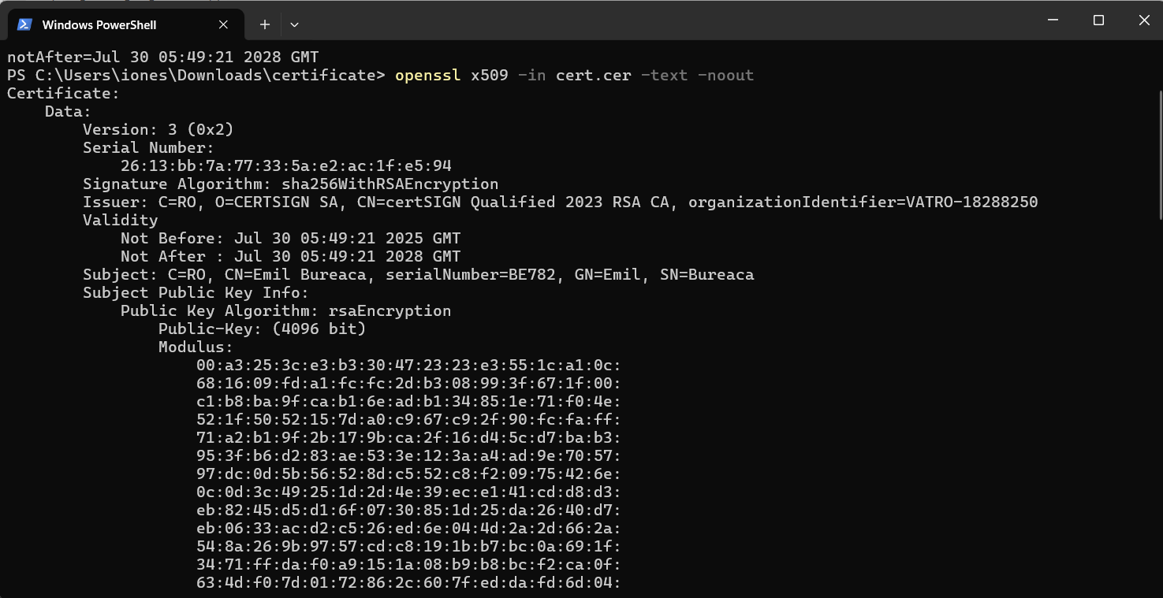
Figure 2.8 OID from Subject extension extraction
Section 3: End Entity Creation and Certificate Issuance
- Creating a New End Entity in the Admin Interface
I accessed the EJBCA Administration Web interface: https://192.168.56.102:8443/ejbca/adminweb/ (using the superadmin.p12 certificate). Then, I navigated to “Add End Entity” section.
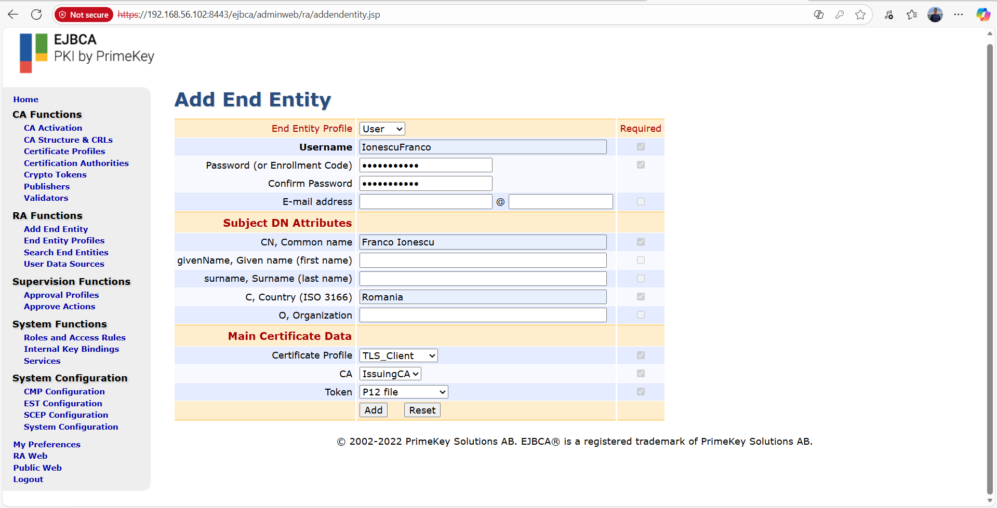
Figure 3.1 Creation of End Entity Profile
- Generating and Obtaining the Certificate (.p12 file)
I accessed the EJBCA Public Web interface: http://192.168.56.102:8080/ejbca/. Then navigated to the > Create Keystore page.
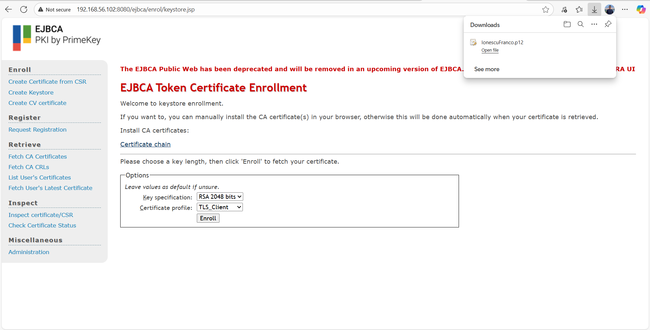
Figure 3.2 Public Interface PKCS#12 Certificate Enrollment

- Importing the Certificate into the Windows Store
Double-click the downloaded IonescuFranco.p12 file to launch the Certificate Import Wizard on the Windows host. I placed the certificate in the personal store.
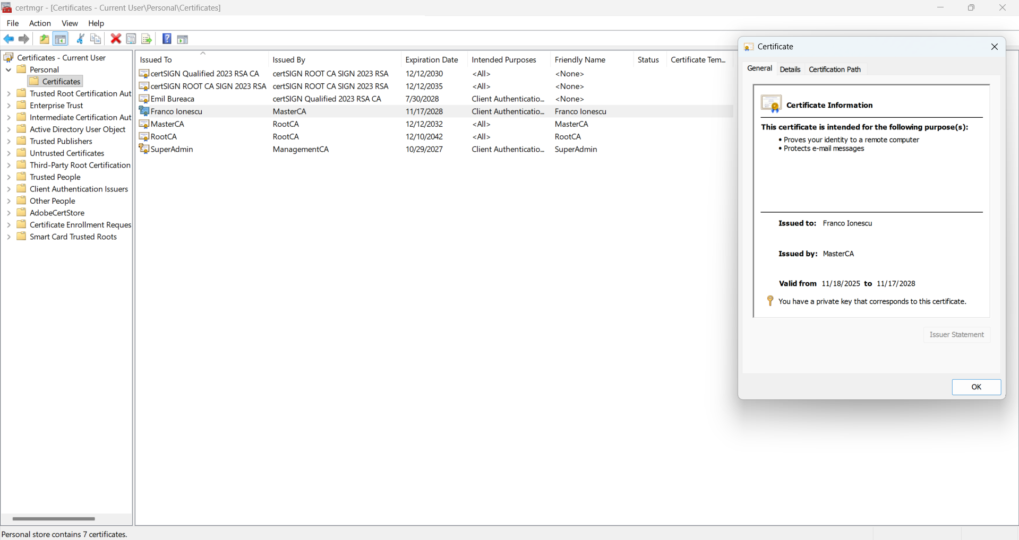
Figure 3.3 Successful Import and Display of PKCS#12 Certificate

Section 4: PDF Signatures
- Signing the document
I selected a PDF document for signing. As a software for signing and applying the digital signature, I used Adobe Acrobat, with the IonescuFranco.p12 file.

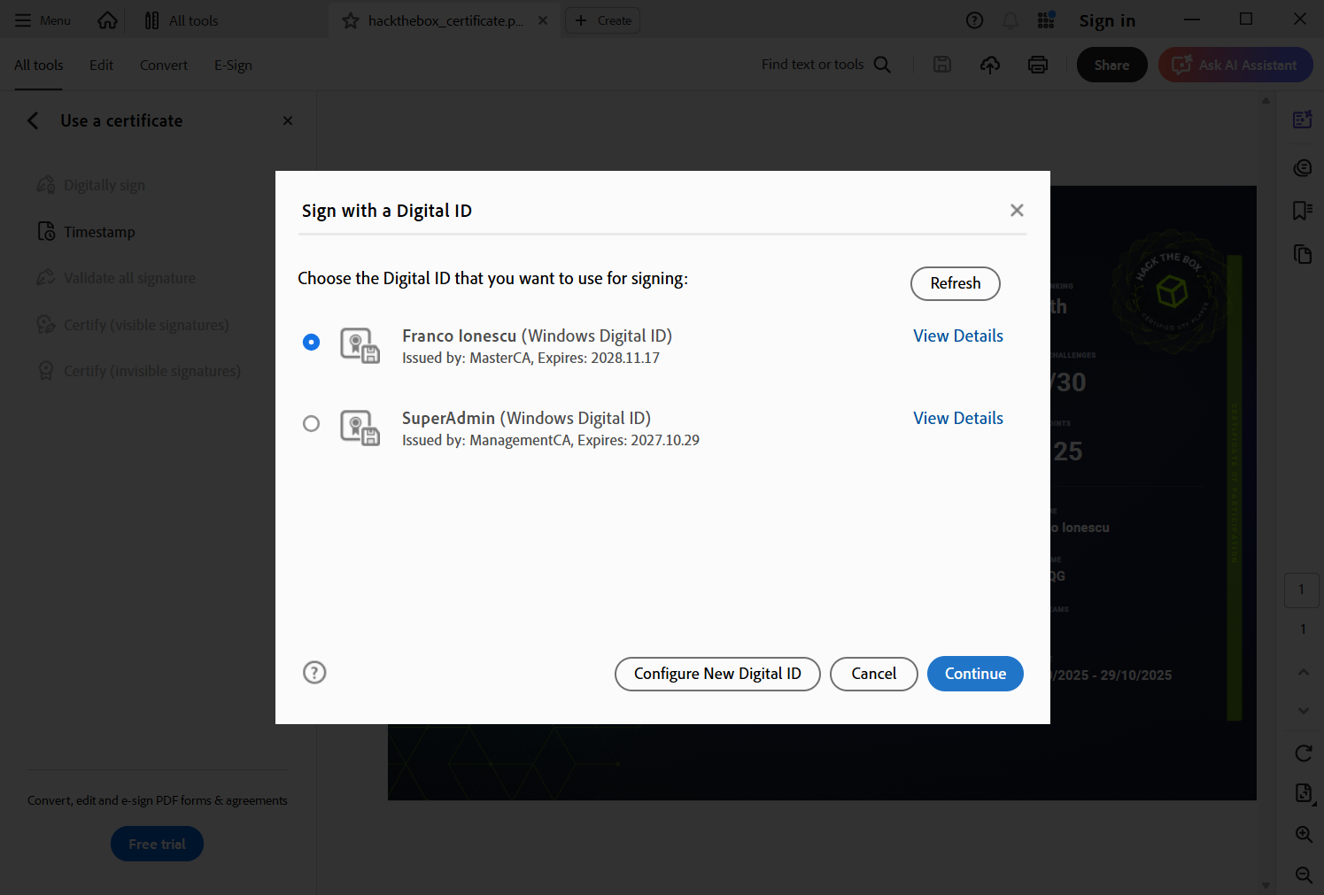Figure 4.1 Signing a PDF document with a Digital ID

- Validate the signature
I Opened the signed PDF in Adobe Acrobat and inspected the signature properties to confirm: 1. The signature is valid. 2. The signer's name matches the certificate's Common Name.
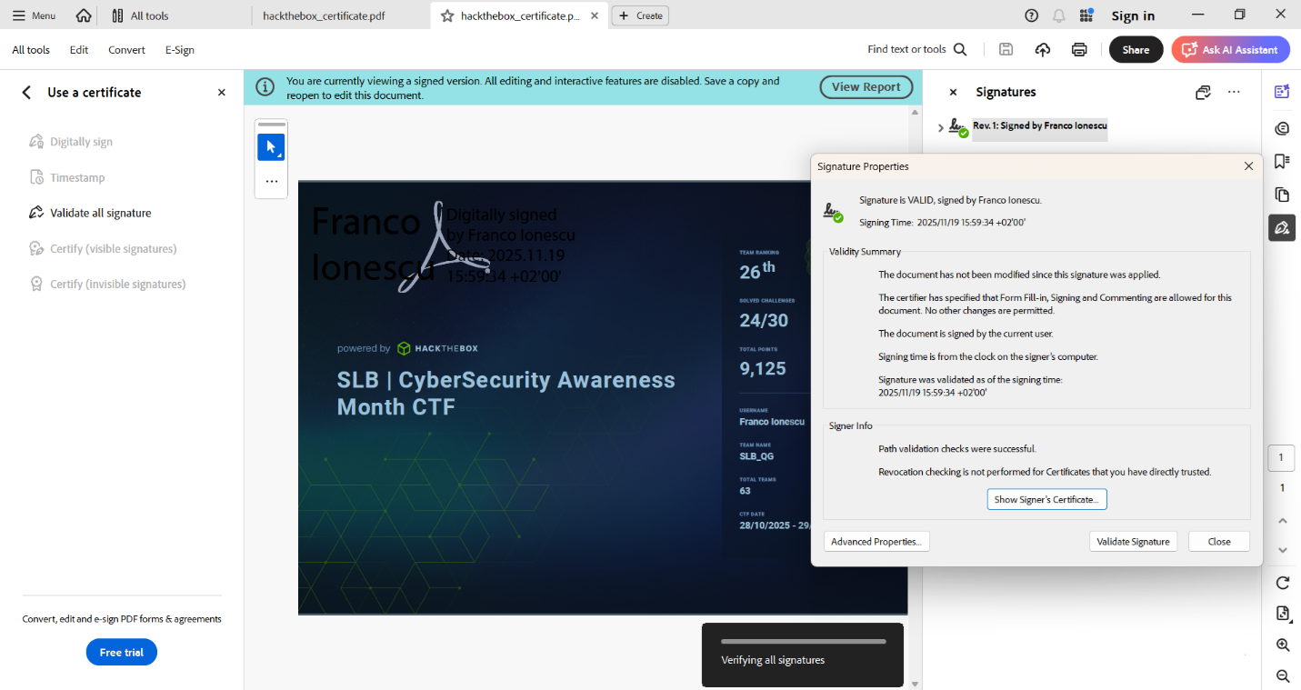
Figure 4.2 Document signature validation

- Search for a Free Timestamp Server
I searched for a reliable publicly available timestamping authority and I decided to use http://freetsa.org/tsr
Below, I showed how I applied the timestamp and connected the document to the timestamp server.
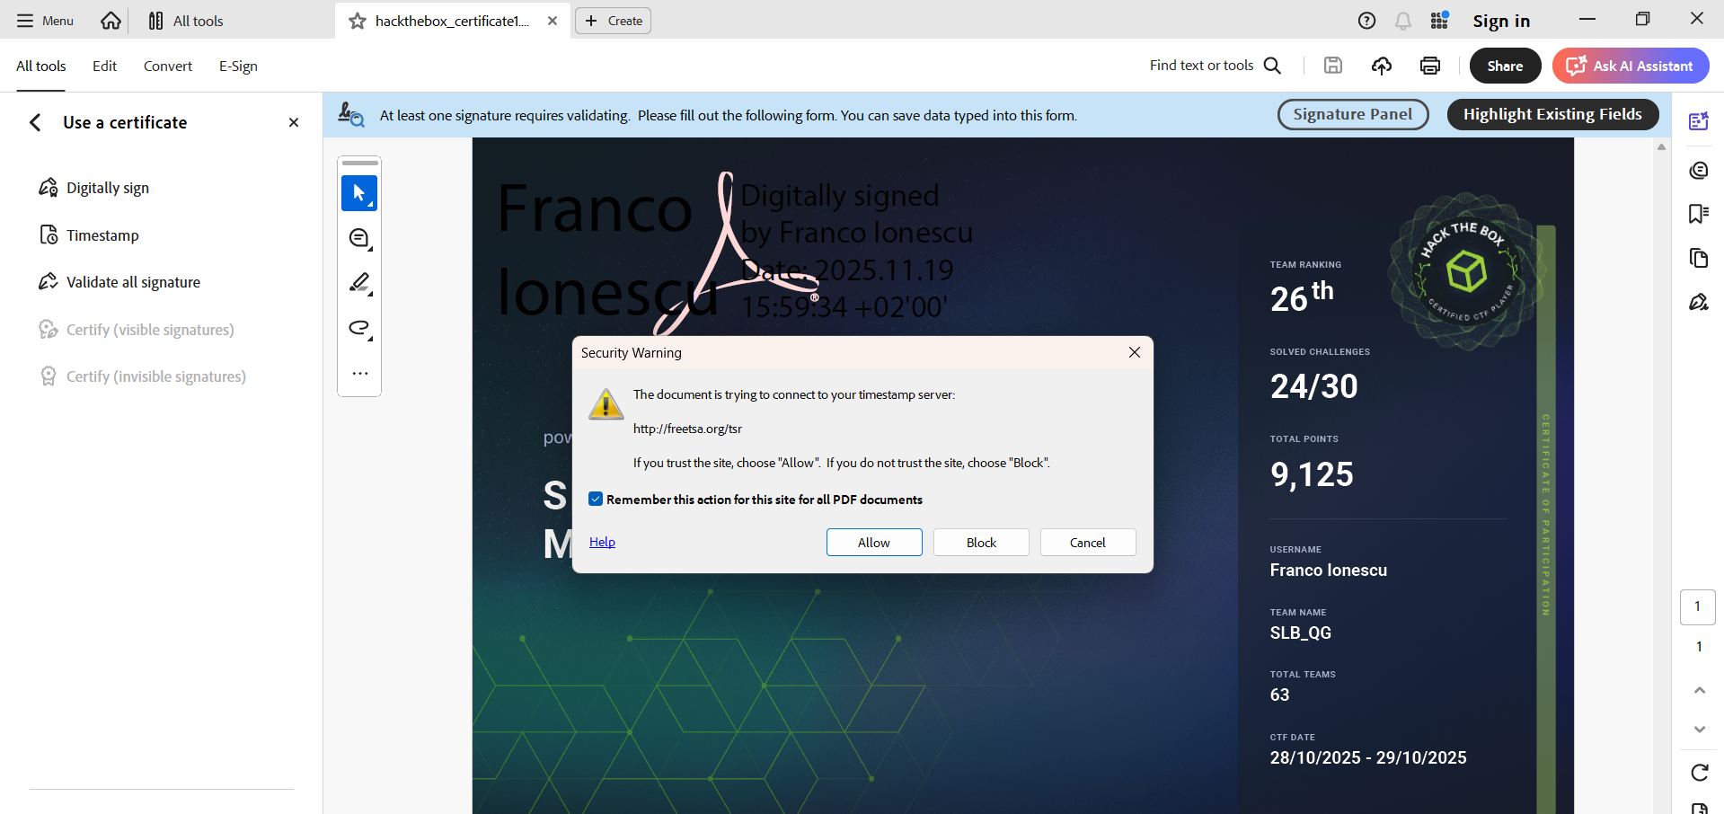
Figure 4.3 Document timestamping

- Validating and checking signature format
I opened the final signed document in Adobe Acrobat and inspected the signature properties again. The status is valid, and the signature details explicitly show the presence of the timestamp (www.freetsa.org).
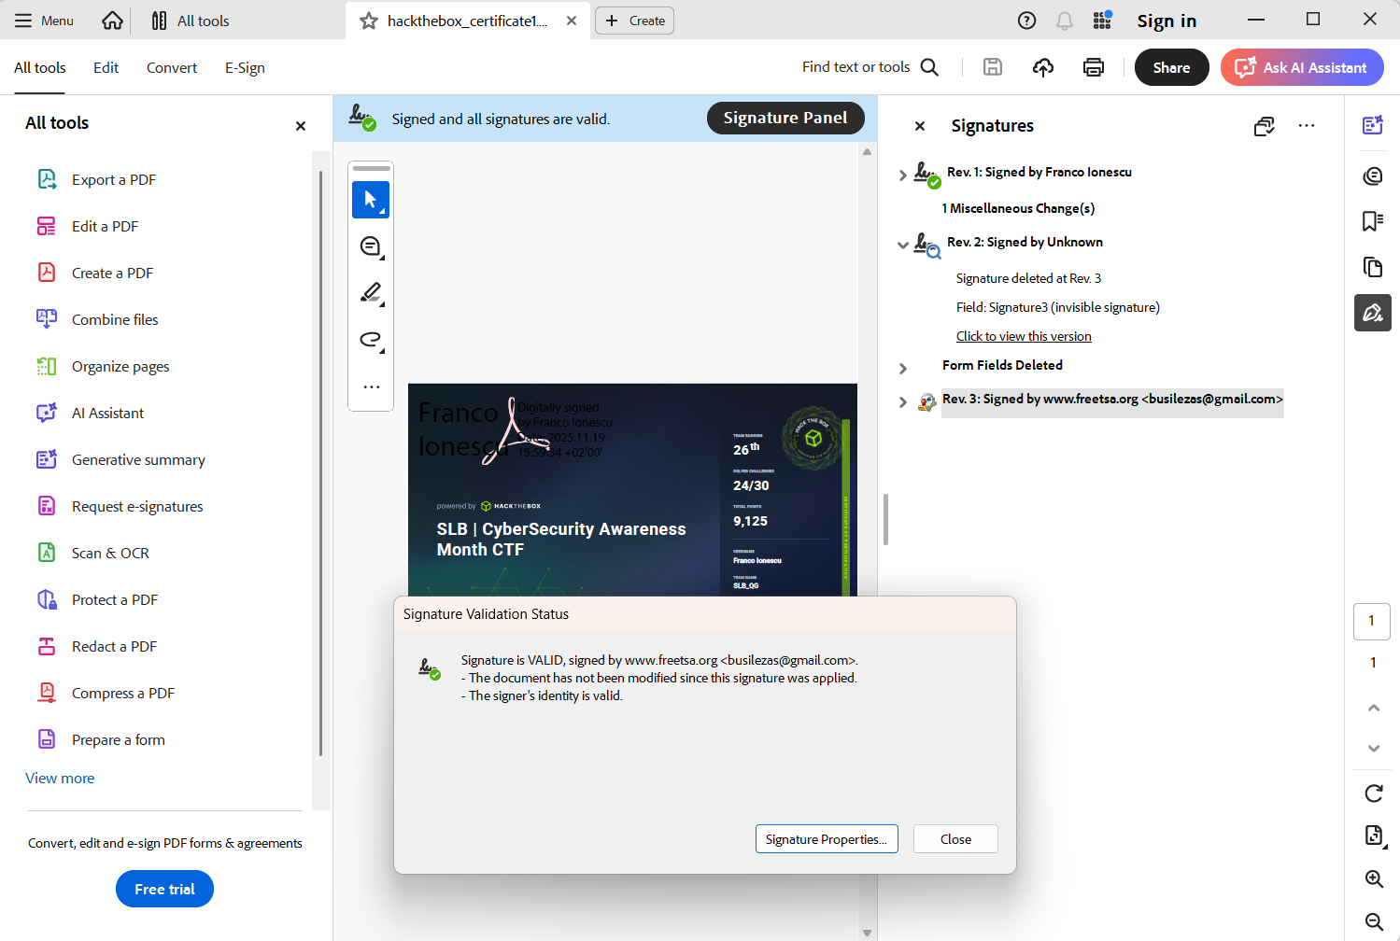
Figure 4.4 Document timestamping validation

Section 5: XML Signatures
- Signing an XML Document
First, I downloaded the installer XMLSigner.msi from the resource provided by the instructor. I used a personal digital certificate named IonescuFranco.p12. The certificate was imported into the Windows Certificate Store. I selected the file named recipe.xml and selected the digital certificate from Windows Certificate Store.
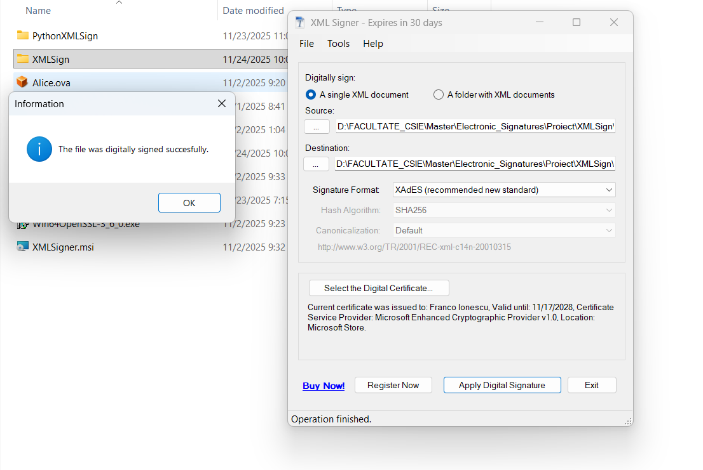
Figure 5.1 XML document successfully signed

- Validating the signed XML document
To validate the signed XML document, I used XML Signer Viewer. I opened the signed XML document and checked that the certificate and signature integrity are both valid.
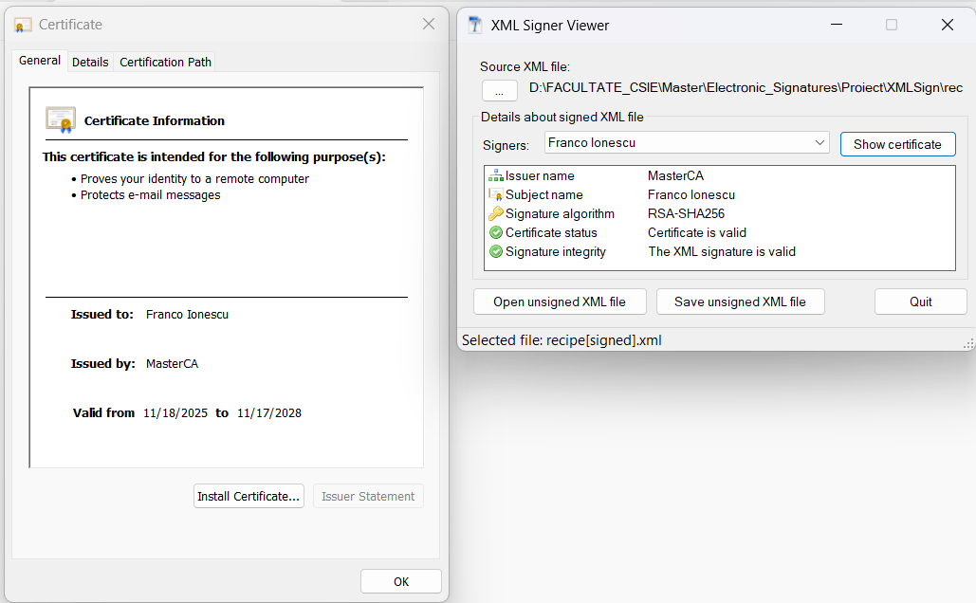
Figure 5.2 Signed XML Document validation

- Validating an altered version of the signed XML document
After I changed the content of the signed XML document, I opened that altered version of the file in the XML Signer Viewer. Since the content is different, the signature will not be valid.
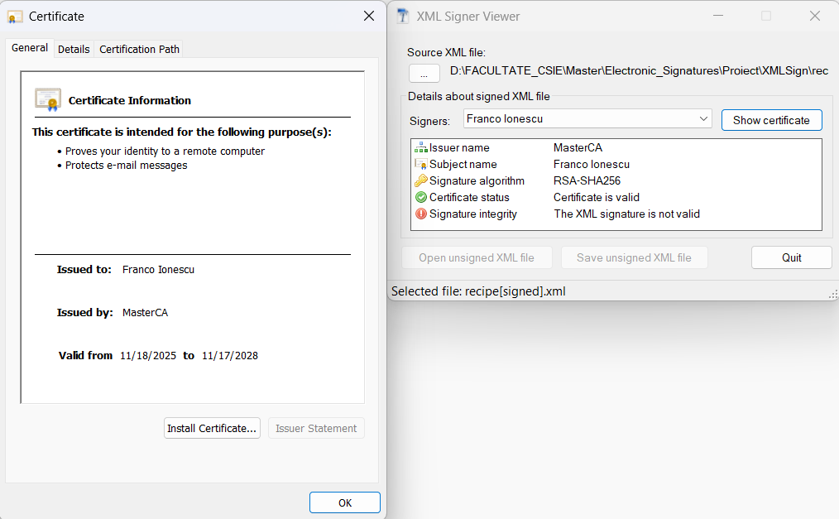
Figure 5.3 Altered version of the signed XML document in XML Signer Viewer

