**CHAPTER 1**

**Introduction**

Invertebrates are animals without a vertebral column also known as backbone or spine. They occur in great numbers living in both fresh and marine waters of lakes, swamps, marshes, rivers and oceans. Familiar examples are crabs, lobsters and their kin, snails, clams, octopuses and their kin, starfish etc. Many fresh and marine water invertebrates, however, including the copepods which constitute the secondary producers of the marine environments and a fundamental step in the trophodynamics of the oceans, are so tiny that they need special attention to collect and observe them. Thus, making them unnoticeable by casual visitors to aquatic habitats (Boehler, 2012). Many studies have been conducted in almost all aspects of copepods from its population, abundance, morphology, taxonomy, diet, diversity, ecology etc. but most of these studies employed conventional techniques especially in identification and classification where manual process is used and expertise is the primary requirement. To address this problem, scientists have started using Image processing as a tool for automatic identification of these species and Artificial Neural Networks for classification.

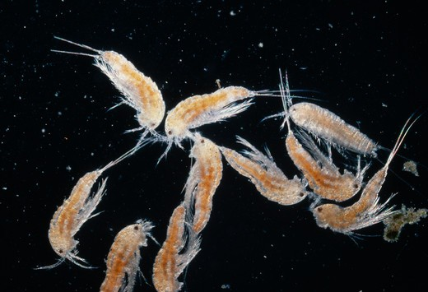

Figure 1: Copepods under a compound microscope

The digital image processing according to Gonzales and Woods refers to processing digital images by means of a digital computer. Furthermore, it is also a method to perform some operations on an image, in order to get an enhanced image or to extract some useful information from it. Nowadays, it is among rapidly growing technologies and act as a core research within engineering and computer science disciplines. Although the conventional and widely used image processing utilizes a square sampling lattice, many studies have proved to consider using hexagonal over square due to two simple reasons: **geometry** and **nature**. Hexagonal lattices are studied for over two millennia and geometers and Pythagorean times have found that it has special properties, including the membership on the exclusive set of three regular polygons with which one can tile the plane, the other two being a square and a triangle (Middleton, 2005). A very popular 2-D example of a hexagonal lattice in nature is the honeycomb which fascinated the people, including scientists, and lead them to study it. Furthermore, Middleton also said in his book that “The best way to partition a plane into regions of equal area is with a region that is regular hexagon”. This inspired the researcher to ask “What happens when you use hexagonal (instead of a conventional square) lattice to gather visual information for the automated identification of copepods?”.

Now, Image content often represents curved structures that may not be well represented on a standard rectangular pixel-based image, and the characteristics of which may not be well captured by feature extraction operators based on principal horizontal and vertical directions(Gardiner,2018). The properties used in rectangular pixel are often influenced by the underlying Cartesian structure and may be dominated by the preferred directions along x and y axes, which leads to anisotropic properties inheritance. This anisotropy is reflected in the spectral properties of the operators, and improvements can be achieved by switching to operators that consider “Circularity” (Coleman et.al, 2004; Davies, 1984; Scotney et.al, 2007).

These Problems can be solved thru switching from square lattice to hexagonal lattice, where both spatial and spectral advantages can be derived such as **Equidistance** for all neighbours and **improved spatial isotropy** of spectral response which will be discussed thoroughly in section 1.4.2.

The ANN or artificial Neural Network is computational model inspired by human brain’s structure and function. It is considered a nonlinear statistical data modeling tool where the complex relationships between inputs and outputs are modeled or patterns are found (https://www.investopedia.com/terms/a/artificial-neural-networks-ann.asp). Many advancements in science and technology including biology, computer vision, speech recognition, machine translation, social network filtering, video games, medical diagnosis and artificial intelligence esp. in robotics use this model to perform specific tasks such as clustering, classification, pattern recognition, etc.(Gill, 2017).

**1.4 Background of the Study**

**1.4.1 Importance of studying copepods**

Copepods are microscopic crustaceans which ranges 200μm to 2mm in total length. They can be found in a large number approximately 60,000 individuals per cubic meter of water. Studying the community structure and abundance of the copepods in relation to their environment is important to evaluate their contribution to mangrove trophodynamics and coastal fisheries. They act as a linking factor between phytoplankton which are the primary producers of the aquatic environments and main food of the copepods and organisms of higher trophic level. They also act as a bioindicator for changes in water quality because their distribution and abundance can be affected by both abiotic and biotic factors such as salinity, temperature, food quantity and quality. Thus, copepods are one of most studied species in both marine and freshwater ecosystem (Leow, 2015). The routine in identification of copepods is very technical, needs taxonomical expertise to do, and takes so much time and effort (Leow, 2015). Hence, a need to develop an advanced method using new technologies today to automate the identification and classification of these samples.

**1.4.2 Hexagonal lattice’s advantages over square lattice for Feature extraction and Edge detection**

The main advantages of hexagonal lattice that overcome the problem of representing curved structures of the images and storage are Equidistance and Better spatial sampling density respectively.

1. **Equidistance**

According to Gardiner, Pixel spatial equidistance facilitates the implementation of circular symmetric kernels that are associated with an increase in accuracy of circular and near circular image processing operators. In other words, Equidistance between hexagons in a hexagonal pixel means that all 6 neighbours of a center hexagon has the same distance from each other to the center hexagon with a shared edge. In contrast, the square has only four equidistant neighbours which makes it inferior from hexagonal lattice thus, this implies that curvy images can be represented in a better fashion on the hexagonal lattice and further implies an easier edge detection.

1. **Better spatial sampling Efficiency**

Aliasing is an effect usually in signal processing where different signals become indistinguishable or aliases of one another when sampled. In image processing’s view, it when a sampled image’s signal is different from the original continuous signal. Peterson and Middleton found out that square lattice is not the best due to the fact that the least samples are required for the reconstruction of a wave number limited signal in hexagonal lattice.

Additionally, better spatial sampling efficiency is achieved using hexagonal structure compared with rectangular or square lattice of similar pixel separation. Mersereau concluded that signals in Fourier space requires only 13.4% lesser samples to represent the same image data in hexagonal grid compared to the other lattice. Hence, storage space required and computational expense will become less. This conclusion was also supported by Vitulli in his work, where he said that wider spectra of signal can be sampled without aliasing with fewer amounts of samples.

The advantages stated above are related to copepod due to its body structure which will be discussed in the following section while the other advantages of hexagonal lattice over the square will be discussed further in the next chapter.

**1.4.3 General copepod body Structure**

The physical structure of copepods varies greatly, however, the free-living forms of copepods have certain physical traits in common. The body is usually short and **cylindrical**, composed of a head, thorax, and abdomen. The lower part of the copepod's head is generally fused with its thorax; the front of its head often juts forward, like a tiny beak. Its thorax is divided into about **six segments**; each segment is connected to two appendages.

It is obvious to quote that the copepod’s body is composed of many curves and segments which gives the hexagonal lattice a greater advantage over the square in terms of Equidistance. This property can also produce a more accurate edge detection result thus implying a better segmentation and feature extraction performance.

While the Equidistance advantage caters the copepod’s curvy body, the second advantage which is the better sampling efficiency can cater the need for storage space in this study because neural network training requires a lot of images for system’s optimal performance. It can also address the aliasing problem in most images and can outperform square image processing in identifying sampled images.

**1.4.4 The Conventional way of Identification and Classification of Copepods**

The identification and classification of copepods which is summarized as: Collection from sampling sites, Preservation, Sorting, Examination and preparation which requires information of their morphology can be very time consuming and may require taxonomic expertise which is not readily available for undergraduate students and even some graduate biologist which does not specialize in copepods. Specific requirements for identification also include the Body shape to characterize the genera and Appendages such as fifth legs for species level. Thus, image processing tools of copepods are very useful for error-less digital recognition and may save up time and energy.

**1.4.5 Latest Advancement in Copepod Research**

Although there is an existing technique such as ZOOSCAN digital imaging system which uses image processing and yields semi-automatic recognition system (Grosjean et. al, 2004) for zooplankton, copepods were only covered in a few categories from the entire zooplankton community (Plourde et. al, 2008). Another technique which uses diffraction patterns as a tool for identification was also conducted by various researchers such as Zavala-Hamz et. al in 1996, Castro-Longoria et. al in 2001, Alvarez-Borrego et. al in 2001, and Castro-Longoria et. al in 2003 but it only caters calanoid copepods. The latest advancement in copepod recognition is in 2015 where Lee Kien Leow and his colleagues used image processing and artificial neural network to produce a computer software where the automatic recognition takes place of eight species of copepods but his technique uses only the conventional square grid lattice in image sampling using MATLAB’s Image processing toolbox R2013a. This gives inspiration for the researcher to venture more in image processing using other known technique to outdo the current research using hexagonal lattice.

**1.4.5 Neural Network for copepod Classification**

Classification methods for image identification systems have been used such as neural network, structural, fuzzy, and transform based techniques for many biological specimens but not with copepods. Artificial Neural Networks have shown promising results in classifying various specimens of insects (Wang et. al, 2012), dinoflagellates by Culverhouse in 1996, metazoans and protozoans by Ginoris et. al in 2007, and many more.

**1.5 Statement of the Problem**

The current problem that Biologists face in copepod research is the conventional way of identification but this was addressed by previous studies. Now, the problem with those works is that it uses square lattice which is inferior in terms of Equidistance of pixels and sampling Efficiency.

**1.6 Research Objectives**

**1.6.1 General Objectives:**

The study aims to utilize hexagonal lattice sampling in recognition and classification of a copepod sample down to species level.

**1.6.2 Specific Objectives:**

1. Design an application which caters automatic identification of copepods down to species level.

2. Utilize hexagonal lattice in image processing techniques.

3. Use ANN algorithm as a tool for classifying the copepods.

4. Use performance evaluation schemes to evaluate the system and compare results from the novel method by Leow.

**1.7 Scope and Limitations of the Research**

The research will focus in developing an application which will identify the copepod species for the users. The number of copepod species will limit based on the copepod species used in previous studies which is Eight species for efficient system evaluation. The system will utilize the proposed Hexagonal image processing framework by Middleton and will develop an algorithm for the classification using the Artificial Neural Network model.

**1.8 Significances of the Study**

This study will improve the conventional way of recognizing copepod species which uses square grid lattices by using a hexagon which has its own advantages as stated above. It will also lessen the workload for any researchers which currently studies copepod. This will also serve as proof that hexagonal image processing yields more promising result compared to the widely used image processing technique today in terms of biological microscopic samples.

**CHAPTER 2**

**Review of Related Literature**

**2.1 Novel Study in Copepod Automatic copepod identification and Classification**

One study about the Identification and Classification of copepods by L.K. Leow et.al in 2015 uses Image processing and neural network. The researchers used the conventional image processing using the square lattice and it was made through Matlab’s image processing software. They used eight species of copepods namely *Acartia spinicauda, Bestiolina similis, Oithona aruensis, Oithona dissimilis, Oithona simplex, Parvocalanus crassirostris, Tortanus barbatus and Tortanus forcipatus*. The researcher used 240 samples which were then divided into three sets, the training set (168 samples, or 70% of samples), validation set (36 samples, 15%) and testing set (36 samples, 15%). The data from the training set were used for network training; the validation set for measuring network generalization and terminating training before overfitting; and the testing set for independent measure of network performance during and after training. The overall approach demonstrated not only a fast and automated technique for copepod identification and classification but also an accuracy rate of 93.13%. The performance evaluation of the system was evaluated using MSE or the Mean Square Error and Confusion matrices. The other 160 independent samples (20 samples from each species) were used for system performance evaluation. The trained network was simulated using the testing data as input and the output was then compared to the predicted data and recorded in a confusion matrix.

His approach demonstrated an overall classification accuracy of 93.13% (100% for A. spinicauda, B. similis and O. aruensis, 95% for T. barbatus, 90% for O. dissimilis and P. crassirostris, 85% for O. similis and T. forcipatus).

**2.2 Advantages of Hexagonal Sampling Vs Square Sampling**

The summary of the advantages of hexagonal lattice are summarized below:

|  |  |
| --- | --- |
| **Aspect** | **Advantages** |
| Isoperimetry | As per the isoperimetric theorem, a hexagon encloses more area than any other closed planar curve of equal perimeter, except a circle. This implies that the sampling density of a hexagonal lattice is higher than that of a square lattice. |
| Additional equidistant neighbours | Every hexagon in the lattice and hence a hexagonal pixel in an image has six equidistant neighbours with a shared edge. In contrast, a square pixel has only four equidistant neighbours with a shared edge or a corner. This implies that curves can be represented in a better fashion on the hexagonal lattice and following an edge will be easier. |
| Uniform Connectivity | There is only one type of neighbourhood, namely N 6 , possible in the hexagonal lattice unlike N 4 and N 8 in the square lattice. This implies that there will be less ambiguity in defining boundaries and regions. |
| Smaller Quantization Error | Quantization is compulsory for the image pro  -cessing operations because of the limited capable  Sensors to represent the real-world scenes. Quantization error is an important measure to analyze the Merits of the configurations of the different types of Sensors. Here the hexagonal sampling gives lesser Quantization error when compared to square |
| Greater Angular Resolution | For representing curved images, hexagonal Grid is efficient. Adjacent pixels in hexagonal grid are Separated by sixty degrees instead of ninety degrees in square. So, curved images can be represented in a Better way. Main reason behind this is the consistent Connectivity. Human eyes have a special visual preference of seeing the lines which are at oblique angle. So, this is another reason for representing lines also in a better way in hexagonal grid |
| Higher Symmetry | Hexagonal lattice is proven to have higher symmetry by Serra in his morphological operations. He also concluded that hexagonal lattice has more simpler operations than the square. |

**Table 1**. Summarized advantages of hexagonal lattice over square lattice (Asharindavida et.al, 2005).

One aspect of the sensing method used in computer vision is sampling using the square lattice. In this study, the lattice will be changed to hexagon due to various reasons above but the main ones are geometry and nature (Middleton, 2005). According to Gupta and Pahwa in their study “Comparison of Image enhancement techniques on square and hexagonal lattice structures”, hexagonal representation resembles human vision system and it was agreed by other dozens of researchers such as Tirunelveli in “Comparison of Square-pixel and Hexagonal-pixel” on 2002 where he said that hexagonal pixels have greater advantage in terms of rotational symmetry, he explained further about the packed structure that the pixel has, and a great resemblance to circular pixel. Many reasons were also proposed by He and Jia in their study the “Hexagonal Structure for intelligent Vision” these include that Hexagonal representation has more efficient Sampling Schemes, Smaller quantization Error, Equidistance, great Angular resolution, Higher symmetry, etc. Middleton also explained in his monograph in 2005 about his thought on Hexagonal lattice in image processing and said that there are three main reasons why hexagon outstands the square lattice and those are Isoperimetry, Additional equidistant neighbours, and Uniform connectivity. He also made a framework in python which programmers can use as a substitute from conventional square image processing.

Although the world uses the conventional image processing, there are researches which take more effort to apply a new approach (Hexagonal Image Processing) such as Sharif et.al in 2012 where they used the new technology in Facial Detection and Recognition and proved the superiority of the said technology. The technology was also used in Local Binary Pattern in codes which was designed for texture classification, human detection and other fields (He et.al,2007). Another paper by Jiang in 2008 sighted that Hexagonal lattice has greater symmetry then it is applicable in filter banks which is designed for multiresolution. The latter also investigated the construction of orthogonal and PR FIR (Prefect Reconstruction, Filtering and Image Processing) hexagonal filter banks with 6-fold symmetry. Other Image processing steps such as edge detection, shape extraction and feature extraction, were also applied using hexagonal lattice. Researches include the “Multi-scale Feature Extraction in a sub-pixel Virtual hexagonal Environment” by Bryan Gardiner et.al in 2008. A study “Shape extraction in a hexagonal-image processing framework” was also made by Lee middleton in 2000. Edge detection using hexagonal lattices were also made by many researchers such as Vidyapeetham in 2011 where they made a Hardware implementation of edge detection on hexagonal sampled image grids, Mostafa et.al in 2015 where they studied “Fuzzy noise removal and edge detection on hexagonal image”.

**2.3 Hexagonal structure for pattern/object recognition**

Local Binary Pattern is a type of visual descriptor used for classification in computer vision. It was designed for efficient and accurate texture classification. Uniform LBPs play an important role for LBP-based pattern /object recognition as they include majority of LBPs. He at.al in 2007 presented LBPs on hexagonal structure for pattern/object recognition. They concluded that LBPs defined on square structure have less potential for more accurate description of texture than the hexagonal structure. They further explained that the number of LBP types and their uniform subset have been greatly reduced on hexagonal structure than on square which means that object recognition is far greater in hexagonal lattice than in square.

**2.4 Hexagonal lattice in shape extraction**

Lee Middleton proposed a framework in hexagonal-image processing for this particular field. His work proposes a convenient and efficient way in query of images in a database. Generally, these queries will be based upon a number of broad classes which can be extracted from the image. This can be done by looking at a class of image, shape and extracting the shape from the image. The approach is based upon the use of window to extract local information to generate description of the object’s shape. They concluded that the proposed scheme produced promising beginnings and that future works could include wider class of recognition problems. They also explain that The manipulation aspect gives it a significant advantage over representations based on primitives (such as geons or generalised cones) which can be computationally expensive.

**2.5 Hexagonal lattice in Edge detection**

Edge detection in image processing is an image processing technique for finding the boundaries of objects within images. It works by detecting discontinuities in brightness. Edge detection is used for image segmentation and data extraction in areas such as image processing, computer vision, and machine vision. Although there are many studies about edge detection, few have applied hexagonal lattice in their work and one example is “Hardware implementation of Edge Detection on Hexagonal Sampled Image Grids” by S. Veni in 2011. Their paper describes Edge detection operation on hexagonally sampled images and its hardware implementation based on cellular Logic Array Processing algorithm. Their architecture decreases the computational complexity by building up a virtual hexagonal grid system on the memory space of computer and processing algorithms can be implemented on such virtual spiral space. They compared their result to rectangular sampled grid and found less hardware utilization compared to the latter and concluded that the addressing scheme used which is half pixel shift method does not introduce distortions to the image.

**2.6 Artificial Neural Networks**

There are many types of neural networks such as Hopfiled Neural Network,Radial Basis Function Neural Network, Probabilistic Neural Network, Convolution Neural Network,Fuzzy Neural Network but one of the most famous used for image segmentation is the Feed Forward Neural Network (Z. Shi and L. He, 2010). Shi and He also noted in their study (“Application of Neural Networks in Medical Image Processing”) that the said network is less sensitive to the selection of the training sets than the Maximum Likelihood classifier.

Neural networks have been utilized in many fields of science especially in image or samples of species’ detection, recognition and classification. It is used in Insect classification by J. Wang et.al in their study “A new automatic identification system of insect images at the order level”. It was also utilized in other species or groups organisms such as Macroinvertebrates by S. Kiranyaz et.al in their study “Classification and retrieval on macroinvertebrate image databases using evolutionary RBF neural networks”; Algae by P. Coltelli et.al in their study “Water monitoring: automated and real time identification and classification of algae using digital microscopy” in 2014; Fishes in the study “Fish recognition based on robust features extraction from size and shape measurements using

neural network” by MK Alsmadi et.al in 2010 and other groups of organisms such as protozoa and metazoa (Y.P. Ginoris et.al, 2007), dinaflagellates (PF Culverhouse et.al, 1996), etc. However only Leow and his colleagues have use neural network for copepod classification.

In Leow’s study, A two-layer (hidden and output layer) feed-forward network was trained using a back-propagation algorithm which is based on ten neurons at the hidden later and eight neurons at the output layer. They used a total of 240 sample images for training set with 30 for each class. They obtained seven selected features of each species which is used as input data presented to the input nodes of the network from the training set, whereas eight desired output classes were defined by the target data. The results showed 97.90% correct classification from the confusion matrix of all 240 samples in the training, validation, and testing sets.

**CHAPTER 3**

**Theoretical Framework**

This chapter will discuss the basic concepts and framework that will be used In implementing Hexagonal Image Processing such as Resampling, Interpolation, Addressing and Storage, Display of hexagonal Image in a screen and Edge detection.

**3.1 Hexagonal Image Processing using Hexagonal Image Processing Framework**

The current scenario in image processing as what discussed in the previous sections of this study is only applicable for the square-image. To fit the hexagonal-image to the current scene, two ways can be implored. One, is to develop a full hexagonal image processing approach and use various known solutions for image acquisition and visualization. Two, is to develop a mixed approach where one can utilize the advantages of hexagonal images while the remaining parts will be done using square image. The general methodology that will be used in this study for hexagonal image processing will based from Middleton and Sivaswamy’s monograph “Hexagonal Image Processing: A Practical Approach” where they made a Hexagonal Image Processing framework implemented in Python on 2005.

The stated solutions can only be achieved by converting square image to hexagonal and vice versa. But for this study we will use a mixed approach in order to use current image processing techniques for square images.

**3.2 Image Resampling**

The process on which an image is converted from one lattice to another is called resampling. There are two types of resampling: One is resampling an image from square to hexagonal while the other is from hexagonal to square Image. In this study, we will use both resampling methods for we are using a mixed approach. After the resampling, the resulting hexagonal image could be a True Hexagonal Lattice which will have a regular hexagon shaped pixels or Irregular Hexagonal Lattice which will not be a regular hexagon.

**3.2.1 Square-to-hexagonal-image Conversion**

Let *f* (*x*) represents an image where *x =* (*x1 , x2*) is a spatial variable. To generate a sampled image, *fs*(*x*), an appropriate sampling kernel *h*(*x*) should be used. This process can be written as :

*fs* (*x1, x2*) = , *x*2 *– k*2)

However, in practice the commonly available sampled image is obtained using square lattice, *fss*(*x*) (Wolberg, 1990). From this *fss*(*x*), one can generate a hexagonal image thru resampling and yields a reconstructed image calculated implicitly within the resampling scheme shown below.

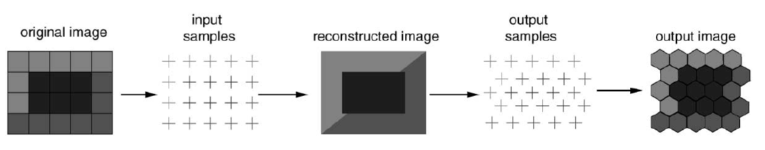**Figure 3.1** Hexagonal sampling (Middleton,2005).

There are problems that can arise in image resampling but the main one is determining the locations of input and output samples relative to the reconstructed image. These are the points in the square and hexagonal lattices, respectively.

A lattice or commonly known as grid is defined as the set of points which are the centers of the periodic tilings of the plane. Let **B** = {*b1,b2*} be a set of basis vectors for the plane. The set **B** will define a lattice defined by:



Different basis vector sets will also lead to different lattices that’s why many ways in generating a lattice can be used.



However, in this study we will use two convenient ways in generating a Hexagonal lattice, these are:

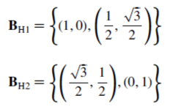

Both of the above sets are related by a simple rotation but the latter will be used to generate the desired lattice due to the issue of displaying the resulting data. Also, in examining the relationship between **B**H1 and **B**S it is noted that only *b2* is different which means that horizontal spacing in the two lattices square and hexagonal respectively is the same which is shown below.

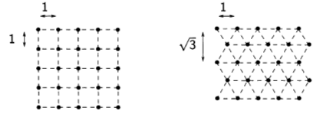

**Figure 3.2** Vertical and Horizontal spacing (Middleton,2005).

In both **B**H1 and **B**H2 the individual basis vectors are dependent on each other. This will result in redundancy. Take for example, in **B**H1 the second basis vector depends on the first. If an image is re-sampled from an *n* x *n* square-image then the choice of **B**H1 will result in one of the two possibilities:

1. Fixed horizontal lattice spacing
2. Fixed vertical lattice spacing

If the first possibility will occur to give *n* points, it will yield 15% extra vertical lattice points due to its closer packing (due to second basis vector). If a naïve approach will be utilized to display, then this would result to an elongated image. On the other hand, if the second possibility will occur to give *n* points then it will result to an inappropriate aspect ratio. Although this problem can be lessened through taking advantage of the display device’s geometry shown by Her et.al in their study “Resampling on a Pseudohexagonal Grid”. The best option is the First possibility where we will take measure to avoid elongation effect.

The last issue relating to the resampling of an image is the sampling kernel to be used. A very good review about kernel is done by Wolberg on 1990 in his research about “Digital Image Warping” and another review about the choice of kernel for hexagonal lattice is done by Her in the same research mentioned above (Resampling on a Pseudohexagonal Grid” where we observed that the effective kernel for most application is the bi-linear kernel shown below.

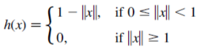

Where *x* is as defined above and || || is the standard Euclidean norm.

**3.2.1 Conversion back to square Image**

After the edges are detected, the image will then undergo thru segmentation but to do that we will convert the image back to square-image for this study’s approach is a mixed-hexagonal image processing.

The conversion process will be done through the Hexagonal image processing framework by Middleton for they have provided an algorithm and implementation for converting hexagonal images back to square. The input image is in hexagonal lattice while the output would be in square lattice. This process will require several steps: Given a HIP image, first we need to determine the equivalent size of the target square image for this will make the square and HIP image to be of the same size. Second, the square sampling lattice needs to be defined thru the size information from the first step. Last, the values of the pixel at the square lattice points need to be computed by interpolation, based on the pixel values in the hexagonal image.

**3.3 Interpolation using Gabor filter**

During the conversion from square to hex-image, a considerable amount of image quality loss is common. So, in order to solve this problem and maintain the quality we need to use interpolation techniques for image reconstruction. This process is a routine in every image processing tasks during all transformation that is made on an image. In this study, Gabor filter will be used for image interpolation and will be used on the image not only once because the researcher will convert the image not only once (Jeevan and Krishnakumar, 2016).

Gabor filter (Ji et al., 2004) is the only filter with orientation selectivity that can be expressed as a sum of two separable filters. In the spatial domain, a 2D Gabor filter is a Gaussian kernel function

modulated by a sinusoidal plane wave. The following equations represent the 2D-Gabor function which was proposed by Daugman in 1985. The first equation represents the real part of the function while the second represents the imaginary part.

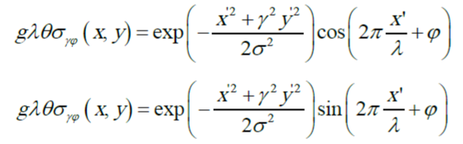

Where ‘x’ and ‘y’ are the position of x and y coordinate of the image. The sigma (σ) of the Gaussian factor which determines the size of the receptive field. The gamma (γ) as the aspect ratio specifies the ellipticity of the Gaussian factor. The value of γ vary in a limited range of 0.23 < γ < 0.92. The lambda(λ) is the wavelength. 1/λ the spatial frequency of the cosine factor.

**3.4 Addressing and Storage**

If a square image is converted to hexagonal image, addressing scheme for the pixels need to be devised. It is rather difficult to address all points from the hexagonal lattice defined from the converted image due to the fact that these points are aligned in two orthogonal directions. There various approaches that are known today such as using Two skewed Axes just like in Rosenfeld, Serra, Staunton, etc. The other is using Three Skewed Axes (Her , 1995 and 1994). Another approach was proposed by Overington in 1992 where the entire Hexagonal array is treated as if it is a rectangular array and Cartesian coordinates are directly employed to address all points. There are other ways in addressing a hexagonal lattice but this study will implore an alternate approach based on the symmetry of the hexagon (Middleton, 2000).

Consider a single hexagon to be a tile at layer 0. Six hexagons can be aggregated in each side by moving anti-clockwise direction. The new structure forms a new layer called layer 1, with the new tile being the super-tile of layer 0. Similarly, this process can be done repeatedly according to any number of layers. An example by Middleton will be found below. The number of hexagons that are contained in a layerL supertile can be computed as 7*L*. Each hexagon can then be numbered uniquely as a sequence of numbers each one giving its position in a given tile. The highlighted hexagon in the figure below is the fourth tile in layer 2 and the second tile at layer 1. Thus, all hexagons in Layer L super-tile can be addressed uniquely by a L-digit base 7 number and this will also encode the location of the hexagon. This indexing scheme implies that all point in the image can be represented by a single coordinate and this is a modified form of the GBT system (Gibson, 1982).

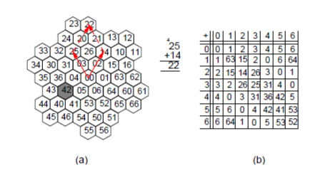

**Figure 3.3** Addressing on Hexagonal lattice (Middleton,2005).

This single-index system for pixel addresses has several advantages. It promotes a full exploitation and manipulation of the symmetry in hexagonal lattice. It also allows the image to be stored using a vector. It makes the processing of the resampled square image more efficient because the Conversion of the Cartesian Coordinate into indices requires only one loop. It is also possible to use a single index for square-sampled images as well. This is done by reordering the rows or columns into a vector and manipulating the pointer into this vector.

Storage requirements for Hexagonal lattice depends on two factors: Resolution and Colour levels that are being used in the image. For a square-image with *M* X *N*  size with 24 bit colour will have a size of 3*MN* bytes. For the hexagonal-image’s required storage space using *L* where total pixel is 7*L* layers would be 3 X 7*L* bytes. For *M = N =* 2*m* , the relationship between *L* and *m* can also be computed as below.

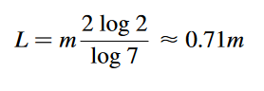

**3.5 Image Processing Operations**

In conducting common image processing operations, one must know the neighbourhood of a pixel. It is the given distance from a central pixel. Therefore, the first hexagonal neighbourhood *N1*contains 6 pixels and the next *N*2 contains 19 pixels. Another neighbourhood *Ng(i)* permitted by the data structure is which is defined as the aggregations of tiles at a given level and appears to be approximately circular in shape.

The balanced ternary arithmetic (Her, 1994) is required in finding the neighbours of a given point in a hexagonal lattice, hence it is analogous to the vector addition. To get *N1* a balanced ternary addition of the numbers 1 to 6 o the central pixel is used. *N*2 and *Ng(i)* can also be found via the same process.

Convolution with a mask is a simple operation that uses neighbourhoods. Compared to the square-image which requires four nested loops, convolution in hexagonal-image requires only two nested loops.

The boundary of the image is easy to compute since hexagonal-image have index less than 7*L* (where L is the number of layers). Another task the derivation of an image pyramid should be performed by starting at the origin and averaging all the pixels in the *Ng(i)* neighbourhoods. Increasing the value of *i* can locate the layers of the pyramid.

**3.6 Display of Hexagonal-images**

**3.6.1 Coordinate Conversion**

In displaying the hexagonal-image on a screen one must address the issue of conversion of unique index to a screen location. This process is straightforward as what Middleton did in his study “Shape extraction in a hexagonal-image processing framework” and “Edge detection in a hexagonal-image processing framework”, where he utilized polar coordinates. As the index can be written *dn-1…d0,* each number, *d1,* causes a change in the coordinates as shown below:

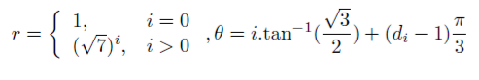

Take the figure below as an example for conversion of 327 to a pair of Cartesian coordinates.

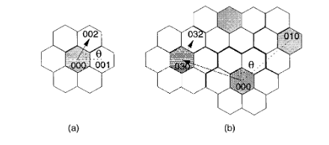

**Figure 3.4** Coordinate Conversion (Middleton,2005).

A number in the Balanced Ternary system can be written as *dn-1…d0.* Examination of successive digits starting from *d0* show an increase in radius. This increase can be seen by examining the sequence {17,107,1007,…}. For each point, the Cartesian Coordinates is expressed as a vector as shown below:

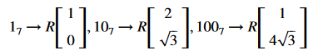

R is the inter-pixel spacing. The specific value of each digits are the rotation of this vector about the origin. The angle of rotation is illustrated below.

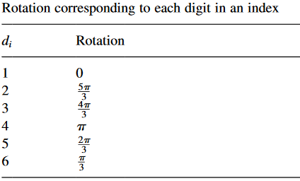

**Table 3.1** Angle of rotation

A matrix can be formed for these rotations using the standard rotation matrix for Cartesian space. In the case a digit is equal to zero, this digit introduces no offset.

For index 327 from the above illustration, the 2 after suitable rotation and scaling generates the following coordinates (1/2. √3/2), and the 3 generates (-5/2, √3/2). These offsets are then added together to generate the final Cartesian coordinates (-2, √3).

**3.6.2 Constructing a Hyperpixel**

The image will be then displayed on the screen right after the computation of the Cartesian Coordinates. This can be done using the Hyperpixel an aggregation of pixels that when put together looks hexagonal in shape and is more pleasing to the eye as it takes into account the oblique effect in human vision.

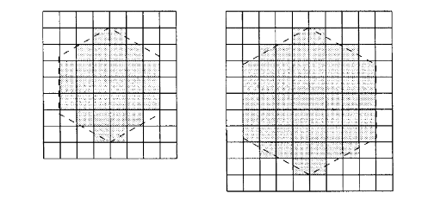

**Figure 3.5** Two types of Hyper pixel (Middleton,2005).

There are two possible choices from above figure of a hyperpixel but the larger one is chosen for it represents hexagon’s shape better than the smaller one. A consequence when using the hyperpixel is the lesser screen resolution.

**3.7 Edge Detection and Smoothing of Hex-image**

To prepare the images of the copepods for segmentation an Edge detection filter is to be applied. The basic assumption used in most edge detection techniques is that the edges are characterized by large changes in intensity. Hence, at the location of an edge, the first derivative function should be a maximum or the second derivative should have a zero-crossing (Middleton, 2002). There are many edge detection techniques but Canny edge detector is what we’ll be using in this study.

The said technique is design to be an optimal edge detector under the following criteria: Detection, localization, and single response. It uses Gaussian smoothing and then directional derivatives to estimate the edge directions. It is somewhat a combination of Prewitt and LoG edge detection algorithms.

The operation of the canny first involves derivative computations in the horizontal and vertical directions using 7 x 7 masks. The squared responses are combined to generate a candidate edge map which is thresholded to generate the final edge map.

**Chapter 4**

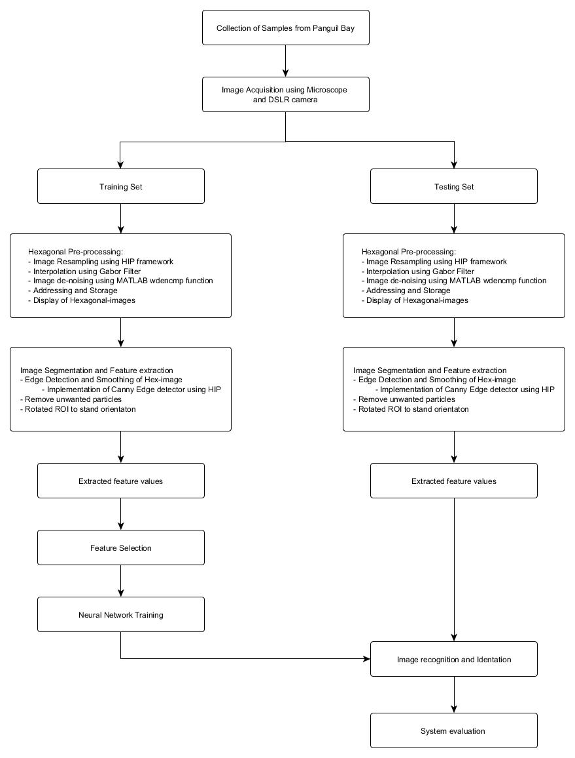 **Methodology**

**Figure 4.1** Process Flowchart

**4.1 Sample Collection and Image Acquisition**

Five genera of marine copepods commonly encountered in mangrove waters will be examined: Acartia (A. spinicauda), Bestiolina (B. similis), Oithona (O. aruensis, O. dissimilis and O. simplex), Parvocalanus (P. crassirostris) and Tortanus (T. barbatus and T. forcipatus). Copepods will be sampled from four stations from the upper estuary in the Panguil bay to near shore waters of Marandin Lala Lanao Del Norte. Horizontal plankton tows (0.5-1 m depth) using paired 45 cm-diameter bongo nets (180 μm) will be made and collected plankton will be preserved in buffered 10% formaldehyde. In the laboratory, collected copepods will then be sieved through stacked Endecott sieves of 1,000 μm, 500 μm, 250 μm and 125 μm mesh sizes, and the sieved fractions will be preserved in 80% alcohol in individual vials for a long-term preservation.

**4.2 Image acquisition**

Specimens of copepod will be randomly pipetted onto a microscope slide from the preserved samples and each identified to species level under a compound microscope (Olympus BH2). To enable the dorsal aspect of the identified copepod to be imaged, often the copepod body had to be rotated. Body rotation could be easily achieved by first placing two short nylon fishing lines (0.36 mm diameter) on either side of the specimen and gently moving a cover slip placed over them by using the tip of the index finger. The desired view of the copepod body will be acquired by an Olympus digital camera (DP26) connected to a computer installed with an imaging software (Olympus cellSens Standard ver. 1.12) for real-time viewing, capturing and storing of the images. The built-in function in cellSens called Extended Focus Imaging (EFI) will be used to create a single plane image with sharp, in-focus details and high contrast. The EFI function recorded the image data as the sample was gradually focused through from top to bottom to obtain single dorsal image of the copepod with all body parts. Besides, the contrast and brightness of the images were set to the best before they were captured using cellSens software. The resolution of the captured images was standardised (2448 × 1920 pixels) and all the images were saved in uncompressed Tagged Image File Format (TIFF) by renaming them according to the date when the images were captured.

**4.3 Hexagonal Pre-processing**

**4.3.1 Image Resampling using HIP framework**

The regular image will undergo resampling to obtain a hexagonal image using the framework proposed by Middleton in 2005. It used the Python Imaging Library (PIL) to handle images. The proposed code can handle both grayscale images and coloured images. The requirement for the code to run would be as follows:

1. The image should be a valid PIL image
2. The layers in the image should be determined.
3. The spacing between point in the hex lattice should be determined
4. A kernel should be decided



**4.3.2 Interpolation using Gabor Filter**

The interpolation is done by using Gabor filter using following manner. Hexagonal sampled grid has 3 directional symmetry in 0o, 60o and 120o orientations. Due to these three axes of symmetry of hexagonal grid, we select three different orientation of Gabor filter along in 0o, 60o and 120o and the filtering is done in these three orientations. The three filtered images will be superimposed to get the interpolated image. The interpolated image is then used for wavelet based de-noising (Jeevan and Krishnakumar, 2016).

**4.3.3 Image de-noising scheme**

a. Perform wavelet decomposition of image obtained after interpolation.

b. Perform de-noising using the MATLAB function ‘wdencmp’**.**

**4.4.4 Addressing and Storage**

This process will be made using the HIP framework code where the latter provides a class that implements HIP arithmetic via new data type known as a Hexint. The method to be used is somewhat a modified form of the GBT system by Gibson in 1982.

After the Addressing process, the images will be stored in the local machine for further processing.

**4.4.5 Display of Hexagonal-images**

For the visualization of the hexagonal images the HIP framework will be used where the code requires that the Python OpenGL extension be installed as part of Python installation. The provided code is a simple viewer that allows rotation and scaling of the resulting images. This will handle both spatial and frequency domain HIP images.

**4.5 Canny edge detector using HIP**

The Canny edge detector will be used for segmentation and feature extraction due to the reasons discussed in the previous chapter. The algorithm for this operation is as follow.To compute two masks *h2* and *h3,* oriented as in Prewitt edge detector the Gaussian smoothing and derivative operations are combined. The HIP address is converted to Cartesian coordinates before computing the oriented masks. The specific mask weights are found using the directional derivatives of the Gaussian function at the Cartesian coordinates.

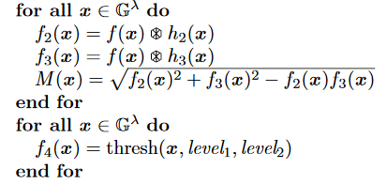

The smoothing process is a built-in function of the Canny edge detector and can be utilized to denoise the image from salt-and-pepper noise from the water.

**4.6 Image resampling from Hex to Square image**

The image will be converted back to square lattice in order to perform the remaining steps. The HIP will be used and will require the following:

The requirement for the code to run would be as follows:

1. The HIP image
2. Radius to resample
3. The spacing between point in the hex lattice should be determined
4. A kernel should be decided

**4.6 Image segmentation and Feature extraction**

The following general steps will be used to perform segmentation and to ready the image for segmentation. We will introduce Matlab software used by Leow in 2015 in his Novel study “Automated identification of copepods using digital image processing and artificial neural network”

* + 1. The images will be converted to binary images with appropriate threshold.
    2. Using the *imclearborder* function from the matlab, borders will be cleared and the holes that occurred during the process of converting the grayscale image into binary image will be filled using the *imfill* function.
    3. Small particles below 50000 pixels will be excluded to ensure only the copepods are segmented for feature.
    4. Orientation represented by the angle between the x-axis and the major axis of the ellipse that has the same second-moments as the region of interest (ROI) will be obtained using region properties function in Matlab. Image rotation will be done using the *imrotate* function so that the ROI has an orientation of 90 degrees.
    5. The ROI of the copepod will be cropped by getting the coordinates of the boundary of copepods.
    6. Features will be extracted from the shape descriptors represented by the binary images of the ROI using region properties function in Matlab. The measurements like area, convex area, eccentricity, major axis length, minor axis length, perimeter, solidity, equivdiameter (sqrt(4*area/pi)), extent and orientation will be determined.
    7. As seen in the ROI images of copepod, the lower part showed distinct shapes across the eight species. In view of this distinct attribute, a secondary feature will be derived by assigning 60% of the ROI image height measured from the posterior end (end of urosome) to the anterior end (head of copepod) of copepod body as the lower part of ROI image. This ratio will be selected after conducting several tests using a set of ratios (90%, 80%,70%, 60% and 50%). This derived feature will be calculated as:

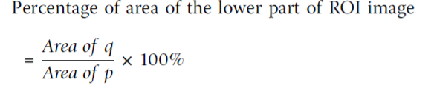

Where p is the total area of ROI image and q is the area of the lower part of ROI image.

**4.7 Feature Selection**

To avoid overfitting in the Neural Network training and to increase performance, not all the 11 extracted features will be used. The extracted features will be evaluated to make sure that only significant features will be selected to classify the copepods into their respective taxa. Forward stepwise discriminant analysis (FSDA) was used to aid the selection of the most useful features (StatSoft Inc.). In order to visualize how well a selected feature clustered the specimens in the training set into the eight classes (species), 2D and 3D scatter plots will be graphed with different combinations of features as the axes.

**4.8 Gabor and Wavelet de-noising Evaluation**

For the performance analysis, Mean Square Error (MSE) and Peak Signal to Noise Ratio (PSNR), two commonly used measures for quantifying the error between images, will be used. MSE indicate the average difference of the pixel throughout the image. If MSE is higher the difference of the pixel between the original and the processed image is also higher. The MSE between two images P and Q is defined by,

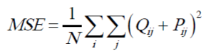

where, the sum over i and j denotes the sum over all pixels in the images, and N is the number of pixels in each image. The PSNR between two images is given by,

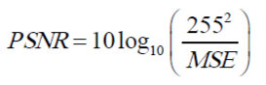

**4.9 Artificial Neural Network Training and Performance Evaluation**

An Artificial Neural Network (ANN) will be used as the pattern recognition tool to classify the extracted features values into the eight classes (species). The architecture of the ANN is a two-layer feed-forward network with sigmoid hidden (ten nodes) and output (eight nodes) neurons and the network will be trained with scaled conjugate gradient backpropagation. A total of 240 sample images will be used in the training set with 30 images from each class. The input data for the input nodes of the network will have seven selected features of each specimen from the training set, whereas the target data defined eight desired output classes. The 240 samples will be divided into three sets, the training set (168 samples, or 70% of samples), validation set (36 samples, 15%) and testing set (36 samples, 15%). The data from the training set will be used for network training; the validation set for measuring network generalization and terminating training before overfitting; and the testing set for independent measure of network performance during and after training. The performance of the network training will be evaluated using Mean Square Error (MSE) and confusion matrices. The training stopped when the MSE of the samples in the validation set started to increase indicating that the network generalization stopped improving. The network will be trained several times to get the trained network with best performance. Another 160 independent samples (20 samples for each species) will be used for system performance evaluation. The trained network will be simulated using the testing data as input and the output will be then compared to the predicted data and recorded in a confusion matrix.

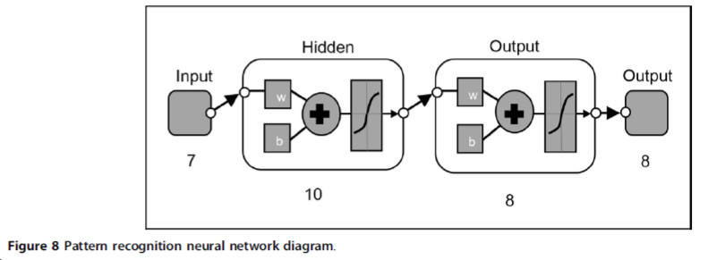

**Figure 4.3** Pattern recognition neural network diagram

**References**

A. B. Watson and A. J. Ahumada, Jr., “A hexagonal orthogonal-oriented pyramid as a model of image representation in the visual cortex,” IEEE Transactions on Biomedical Engineering, vol. BME-36, pp. 97–106, Jan 1989.

R. C. Staunton and N. Storey, “A comparison between square and hexagonal sampling methods for pipeline image processing,” Proc. SPIE, vol. 1194,pp. 142–151, 1989.

R. C. Staunton, “The processing of hexagonally sampled images,” Advances in imaging

and electron physics, vol. 119, pp. 191–265, 2001.

R. M. Mersereau, “The processing of Hexagonally Sampled Two-Dimensional

Signals,” Proceedings of the IEEE, vol. 67, pp. 930–949, June 1979.

A. Rosenfeld and J. L. Pfaltz, “Distance Functions on Digital Pictures,” Pattern

Recognition, vol. 1, pp. 33–61, 1968.

A. Rosenfeld, “Connectivity in Digital Pictures,” Journal of the Association

for Computing Machinery, vol. 17, no. 1, pp. 146–160, 1970.

L. Middleton, “The co-occurrence matrix in square and hexagonal lattices,”in Proceedings

of the 6th International Conference on Control, Automation, Robotics and Vision, 2002.

L. Middleton, “Markov Random Fields for Square and Hexagonal Textures,” in Proceedings

of the 6th International Conference on Control, Automation,Robotics and Vision, 2002.

L. Middleton and J. Sivaswamy, “A framework for practical hexagonal-image processing,”

Journal of Electronic Imaging, vol. 11, no. 1, pp. 104–114, 2002.

L. Middleton and J. Sivaswamy, “Edge Detection in a Hexagonal-image Processing

Framework,” Image and Vision Computing, vol. 19, no. 14, pp. 1071–1081, 2001

L. Middleton and J. Sivaswamy, “The FFT in a Hexagonal-image Processing Framework,”

in Proceedings of Image and Vision Computing New Zealand, pp. 231–236, 2001.

L. Middleton, J. Sivaswamy, and G. Coghill, “Shape Extraction in a Hexagonal-Image

Processing Framework,” in Proceedings of the 6th International Conference on

Control, Automation, Robotics and Vision, ICARV, 2000.

R. C. Gonzalez and R. E. Woods, Digital Image Processing. Prentice Hall (NewJersey),

2nd ed., 2001.

L. Middleton and J. Sivaswamy, “Hexagonal Image Processing A Practical Approach”,

in Proceedings of the 6th International Conference on Control, ISBN, 2005

P. Gupta and K. Pahwa, “ Comparison of Image enhancement techniques on square

and hexagonal lattice structures”, 2001.

M. Sharif , A. Khalid, M. Raza, S. Mohsin, “Face Detection and Recognition Through

Hexagonal Image Processing”, Sindh University Research Journal(Science Series), 2012.

X. He, J. Li. W. Jia, Q. Wu, and T. Hintz, “Local Binary Patterns on Hexagonal Image

Structure”, Seventh International Conference on Computer and Information Technology, 2007.

Q. Jiang, “Orthogonal and Biorthogonal FIR Hexagonal Filter Banks With Sixfold Symmetry” , IEEE Transactions on Signal Processing, 2008.

K. Mostafa, J. Chiang, W. Tsai and I. Her, “Fuzzy noise removal and edge detection

on hexagonal image”, 2015.

S. Veni and K.A. Narayanankutty, “Hardware Implementation of Edge detection on

Hexagonal Sampled Image Grids”, nternational Journal of Computer Applications , June 2011.

T. Shima. S. Sugimoto, M. Okutomi, “Comparison of image alignment on hexagonal

and square lattices”,Proceedings of 2010 IEEE 17th International Conference on Image Processing, 2010.

R. C. Staunton and N. Storey, “A comparison between square and hexagonal sampling

methods for pipeline image processing,” Proc. SPIE, vol. 1194, pp. 142–151, 1989.

R. C. Staunton, “The processing of hexagonally sampled images,” Advances

in imaging and electron physics, vol. 119, pp. 191–265, 2001.

S. Dakhore, K.B. Bijwe, “Review on Performance Analysis of Square Pixel and

Hexagonal Pixel Structure in Image Processing”, Review on Performance Analysis

of Square Pixel and Hexagonal Pixel Structure in Image Processing, 2017.

**CHAPTER 5**

**Schedule**

|  |  |
| --- | --- |
| **Activities** | **Due of Date** |
| Final Revision of Proposal | May 27-31 |
| Implementation | June to September |
| Gathering Training set and Storage of samples | October 1-12 |
| Chapter 5: Evaluation and Revision | October 13-20 |
| Chapter 6: Discussion and Conclusion, and Revision | October 21-27 |
| Overall Revision | November 12-16 |
| Final Revision | November 12-16 |
| Sumbmission of Final Paper | November 26-30 |

**Table 5.1** Research Schedule