**🡺 5 BSOD episodes regsitered in Minidump PC folder & analyzed with BlueScreenView tool**

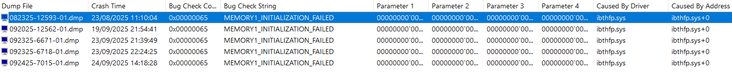

+

**🡺 #4 BSOD episodes catched from EventViewer**

**=**

**Total : #9 crashes documented from July 17th to Sep. 24th**

