**C.V.**

**Francois Ronin Greeff**

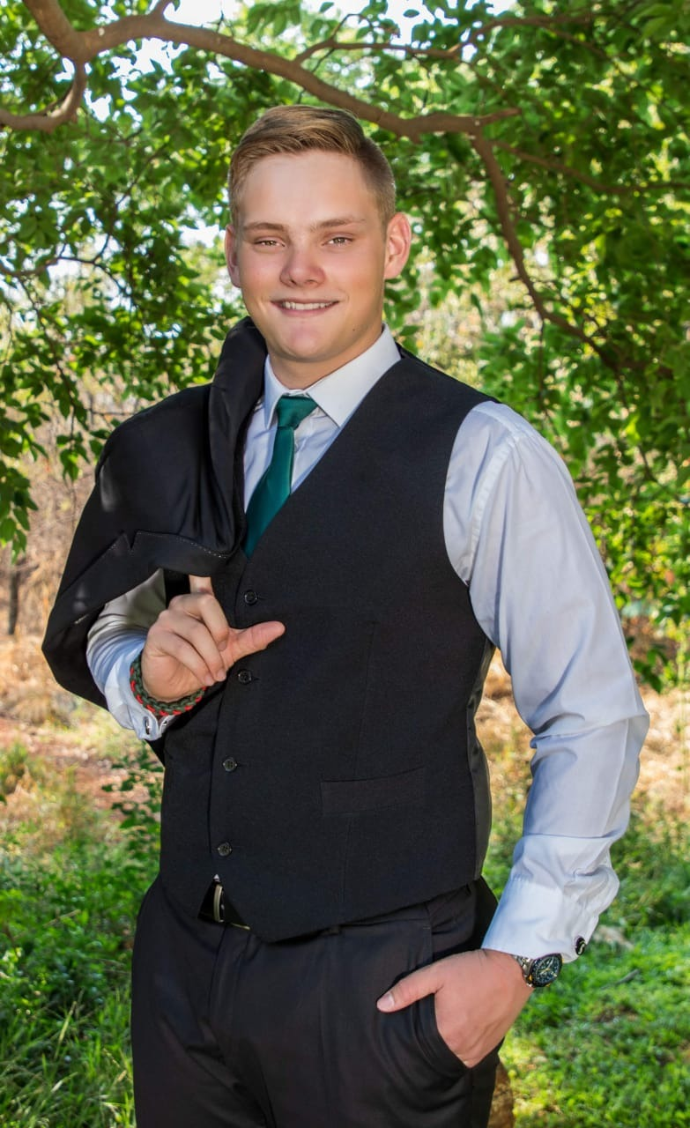

|  |
| --- |
| fRANCOIS R. Greeff  178 Alectra Street · DoornPoort · Pretoria · 081 794 0319  Francoisgreeff16@gmail.com |
| **Personal Profile:**  I am currently in my second year of studying Software engineering at Belgium Campus ITversity. My Passion is IT and to develop solutions in an IT environment, and learning as I do it, I’m experienced in C# and python RAD languages as well as SQL, Java Script, html and CSS to aid with the problem solving.  I am a positive, self-motivated trust worthy individual, I enjoy working in a Team, or independently to build my career in IT, I feel strongly about empowering our young generation to become independent well-educated young adults.  I believe that Education is the cornerstone of any Child’s life, to grow and learn to become a responsible Adult, with proper and good quality education we are not only empowering our young minds but also bringing forth entrepreneurs and responsible business owners that might just be the future, with the current unemployment rate.  I’m a leader that is not afraid to take responsibility, I partake in helping people around me, I’m focused but still remain curios to exploration. I believe in leadership structure but I am not afraid to confront authority if I disagree. eXPERIENCE2015 - 2019wAITER – SPUR * fUNDRAISER I was part of a group that Shadowed at Spur, as part of a fundraiser for a trip to Mozambique with a scope of charity.  **2015-2017** wEIGHING MARSHALL AT SWARTKOPS RACEWAY GO-KART TRACK 2017  * I Assisted overall with the event, learned allot while having a great time.   **2019** GRIT Procurement Warehouse  * Worked as a temp, aiding organization and labor in the warehouse.   **ACTIVITIES** sTUDENT REPRESENTATIVE COUNCIL (SRC)  * It is my second year as a SRC at Belgium Campus, this year I have been elected as a head of the Student relations Committee. I partook in the organizing of various projects and activities on Campus, such as Lan events, Movie Nights, open day and fun day.  Voortekkers Voortrekkers and survival camps, being pushed to my limits and pushing my limits. Mountain biking, getting in-touch with nature. Learning new things every day end weaving it into my life.   * To work with others to conquer the insurmountable, and spread thin vexations with problems and people. Taking part in mountain biking races and taking new courses in voortrekkers never stopping the learning process. Thaba veldwerkkamp-voortrekkers is the place where I earned my leadership, and survival skills. Being chosen as one of the best leaders of 55 candidates meant leading my group and interacting with other groups under extreme pressure, with risk of Injuries, starvation and dehydration. * I have the highest rank that can be earned as a student in high school, namely “Presidents verkenner”.  Reading and Writing  * Reading books and learning new software development languages. I enjoy the art of writing, and expression through written words. Writing poems and short stories   **SPORT** Mountain Biking  * I was part of the School’s A Team; I have great passion for this sport and enjoyed my time as part of the School Team * Taking part in mountain bike races like the 94.7 annual race, the last race I ended 247 out of 2001 competitors. |

|  |
| --- |
|  |

# Education

**2nd year B. Comp. student at Belgium Campus ITversity**

Software Engineering specialization.

Ended first year with an average of 81.2%

Achieved distinction in 12 of the 14 subjects

Academic Writing 181 67%

Business Management 181 69%

Computer Architecture 181 80%

Database development 181 84%

Information systems 181 81%

Innovation and leadership 181 78%

Innovation and leadership 102 80%

Linear Programming 181 86%

Mathematics 181 80%

Network Development 181 81%

Programming 181 81%

Programming 182 95%

Statistics 181 77%

Web Programming 81%

### Grade 12 Student Montana High

Afrikaans 1st

English 2nd

Mathematics

Biology

Physical Science

Information technology

2018 Gr 11 – Average of 65%

2019 Gr 12 – Average of 68%

# SKILLS

* Read and Write English & Afrikaans
* Computer literate - excel, word, PowerPoint etc.

|  |  |
| --- | --- |
| * Leadership skills and presentations skills * Disciplinary performance * Creative writing * Basic first aid * Survival skills * Leadership * Voortrekker’s discipline * Presidents verkenner status * Camp security courses * Completed a presentation skills course * Basic self-defense * Entry level cyber security * Programming * Project management * Database development * Sign language- SASL * Customer relations * Entry level batch scripting for windows * Entry level knowledge about computer architecture |  |

**REFERENCE**

Church – Corne Coetzee – 083 564 3475

Montana H/S-zennobia du toit

Spur waiter shadow- chané gous- 083 454 7015

Swartkops raceway -Nico Roets

Blessed Rapudi – Belgium campus SRC president- +27 76 811 2373