## CHAPTER FIVE: SYSTEM IMPLEMENTATION AND TESTING

**5.1 Introduction**

Chapter 5 delves into the implementation and testing phase of an AI-powered chatbot system designed to provide mental health support to university students in Zimbabwe. This chapter outlines the process of implementing the system and discusses the strategies employed to ensure its effectiveness and functionality. The focus is on two key components: the model used by the chatbot to understand and respond to user queries and the user interface that facilitates seamless interactions. Additionally, comprehensive testing procedures are described to ensure the reliability, accuracy and overall performance of the chatbot system. The chapter concludes by highlighting the significance of this implemented system in offering crucial mental health support to students in Zimbabwean universities.

**5.2 System Implementation**

During the system implementation phase, significant effort was directed towards developing and integrating various components to establish a resilient and effective chatbot system. This phase encompasses a multifaceted approach aimed at realizing the envisioned functionality and performance of the system. Two pivotal components pivotal to the system implementation are elaborated upon in this section. These components represent critical building blocks that form the foundation of the chatbot system, contributing to its overall functionality and responsiveness. Through meticulous design and integration, the system implementation phase strives to ensure seamless interaction between users and the chatbot, facilitating efficient communication and problem solving.

**5.2.1 Model**

The AI-powered chatbot relies on a sophisticated model to understand and respond to user queries and provide appropriate mental health support. The implementation details of the model, including the choice of AI algorithms and techniques, are discussed in this subsection. The following screenshot shows the code for the node.

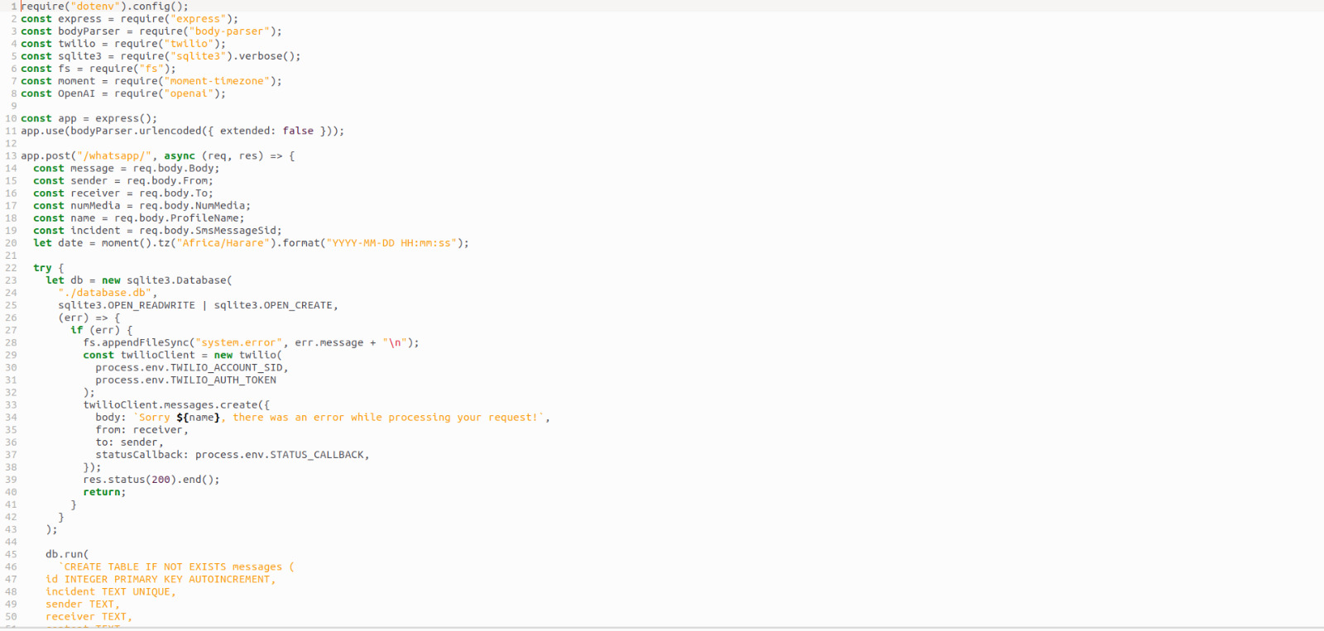

Figure 5.1: Node JS backend to configure Twilio and Open AI.

The implementation of the system involved the development of a robust Node.js backend, which served as the backbone for configuring both Twilio and OpenAI integration. This backend infrastructure provided the necessary framework to seamlessly connect and orchestrate communication between the Twilio messaging platform and the OpenAI language model. Leveraging the flexibility and scalability of Node.js, intricate configurations were set up to enable smooth data exchange and processing between the two platforms. This backend architecture facilitated the seamless integration of Twilio's messaging capabilities with OpenAI's advanced natural language processing capabilities, ensuring a cohesive and responsive chatbot experience for users.

The following Figure 5.2 shows the code for Node JS configuration to customise the bot.

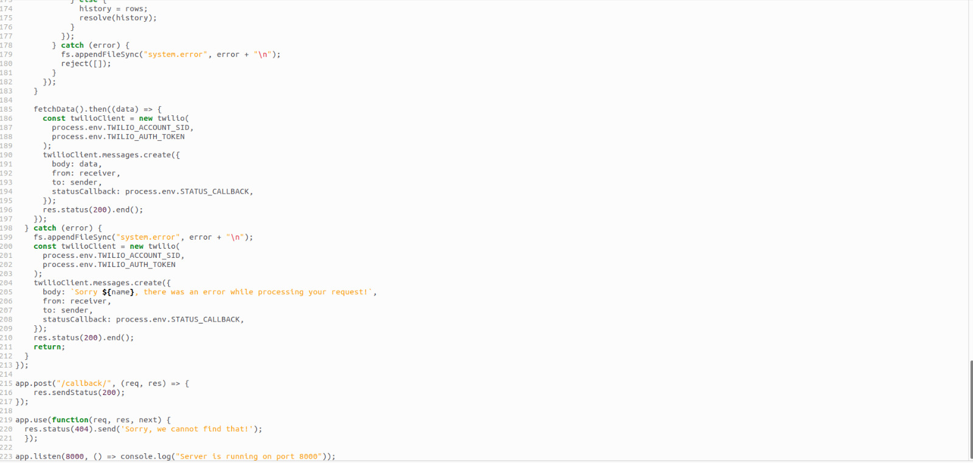

Figure 5.2: Node JS configuration to customise the bot.

**5.2.2 User Interface**

The user interface serves as the gateway for users to engage with the chatbot system, shaping their entire experience. This subsection delves into the intricate details of the user interface implementation, encompassing not only its design aesthetics but also the thoughtful integration of features and functionalities. Emphasis was placed on intuitive navigation, clear presentation of information and accessibility across various devices and platforms. Furthermore, the incorporation of interactive elements and personalized features aimed to enhance user engagement and satisfaction. Through this holistic approach, the user interface emerges as more than just a visual aspect; it becomes a conduit for meaningful interactions, fostering a seamless and enriching experience for users navigating the chatbot system.

**5.3 System Testing**

Ensuring the reliability, accuracy and overall performance of the chatbot system demanded rigorous testing procedures. This section offers a detailed insight into the testing phase, outlining the comprehensive strategies employed to scrutinize every aspect of the system's functionality. From initial functionality tests to more complex scenarios, each testing strategy was tailored to assess the system's responsiveness and robustness. Emphasis was placed on evaluating not only the accuracy of responses but also the system's ability to handle various user inputs and scenarios effectively. Moreover, stress testing and performance benchmarking were conducted to gauge the system's scalability and resilience under different workload conditions. By employing a multifaceted approach to testing, the section underscores the unwavering commitment to delivering a chatbot system of the highest quality, poised to meet the diverse needs and expectations of its users with unwavering reliability and precision.

**5.3.1 Unit Testing**

Unit testing played a crucial role in assessing the functionality and reliability of each component within the chatbot system. This subsection provides insights into the meticulous unit testing process, which involved systematically evaluating the performance of individual system components. By subjecting each component to rigorous testing scenarios, potential bugs and issues were identified and addressed promptly. Through meticulous examination and debugging, any inconsistencies or flaws within the system were rectified, ensuring optimal performance and seamless integration of the chatbot system. This comprehensive unit testing approach was essential in verifying the robustness and effectiveness of the chatbot system, ultimately enhancing its overall reliability and user experience.

**5.3.2 Integration Testing**

Integration testing served as a pivotal phase in evaluating the collective performance of the chatbot system, encompassing the seamless integration of all individual components into a unified framework. This subsection delves into the meticulous integration testing process, which focused on validating system functionalities and identifying any potential inconsistencies or compatibility issues that may arise from the integration of diverse components. By subjecting the fully integrated system to comprehensive testing scenarios, including simulated user interactions and data exchanges, the integration testing phase aimed to ensure smooth operation and optimal performance across all system functionalities. Through rigorous validation and troubleshooting, any discrepancies or compatibility challenges were promptly addressed, ensuring the seamless functionality and reliability of the integrated chatbot system.

**5.3.3 User Acceptance Testing**

User acceptance testing marked a pivotal phase in the chatbot system's development, involving the presentation of the system to Zimbabwean university students for comprehensive evaluation of its usability, effectiveness and overall user satisfaction. This subsection sheds light on the user acceptance testing process, detailing the methodology employed and the invaluable insights garnered for system enhancement. By soliciting feedback and observations from end-users, the testing phase aimed to gauge the system's alignment with user expectations and requirements. Through iterative testing sessions and feedback collection, significant attention was devoted to identifying areas for improvement and refining system functionalities to better meet user needs. The insights gleaned from user acceptance testing provided invaluable guidance for fine-tuning the chatbot system, ultimately enhancing its usability, effectiveness and overall user satisfaction. Activating the chatbot was done as follows:

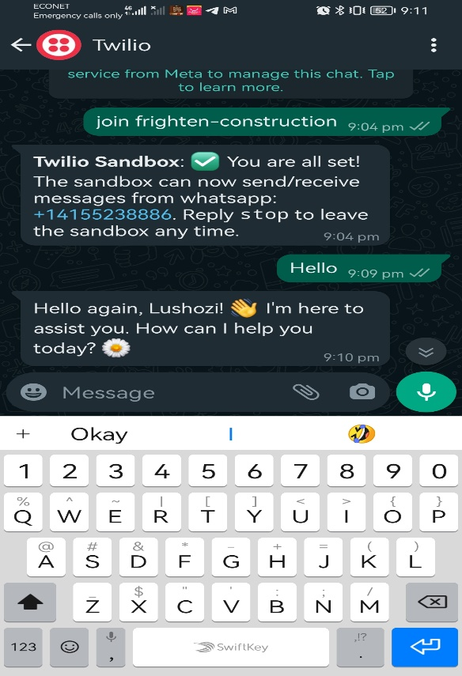

Figure 5.3: Step one - Activation the chatbot on sand box

The next step was for Chatting and also referring to human counsellor as shown in Figure 5.4.

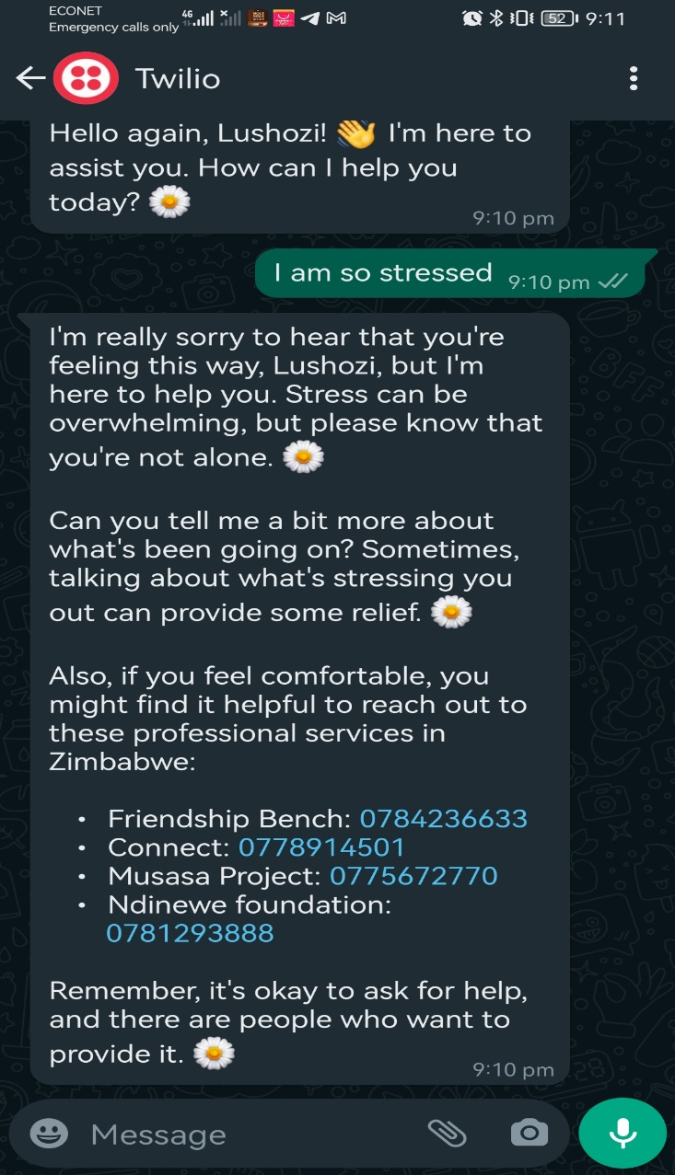

Figure 5.4: Chatting and also referring to human counsellor

The following screenshots shows results for further interactions with the chatbot.

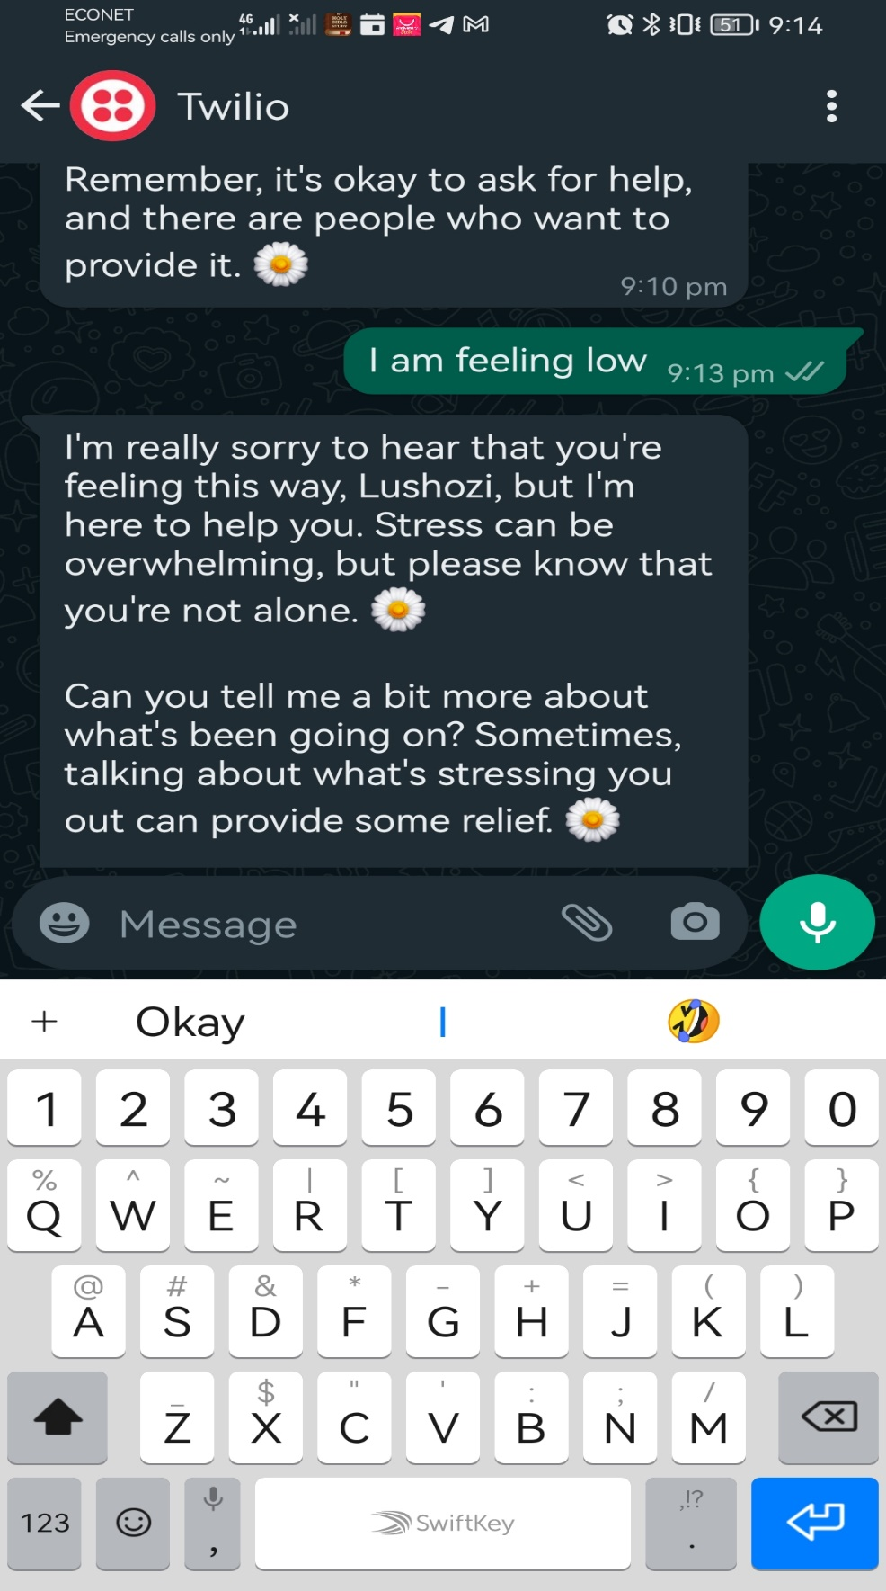

Figure 5.5: Question and answer demonstration

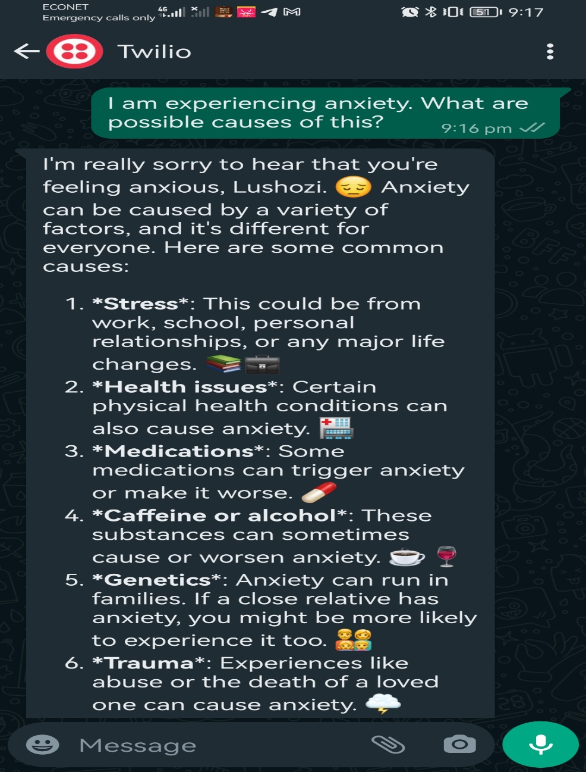

Figure 5.6: Question and answer demonstration



Figure 5.7: Question and answer demonstration

**5.4 Conclusion**

In conclusion, this chapter has underscored the pivotal stages of system implementation and testing for the AI-powered chatbot, tailored to provide vital mental health support within Zimbabwean universities. Through meticulous attention to detail, both in model development and user interface design, coupled with rigorous testing protocols, the chapter has highlighted the unwavering commitment to ensuring the system's seamless functionality and effectiveness. The successful integration of these components stands as a testament to the dedication towards delivering a reliable and accessible mental health resource for Zimbabwean university students. The chapter reaffirms the profound significance of the implemented system in addressing the critical mental health needs of Zimbabwean youth within higher education settings, marking a significant stride towards fostering holistic well-being and support within university communities.