**Reporter**: F. Franek

**Webpage:** <https://www.avast.com/business/products/qa-intern-business-antivirus-pro-plus#noaction>

**Browsers used:** Chrome version 79.0.3945.130 (64bit), Mozilla Firefox version 72.0.2 (64 bit), Opera version 66.0.3515.44. All bugs occur in all of them, if I won’t write otherwise.

1. Major severity

One of the white images of lines is aligned too much into right. It is hard to see so I highlighted it with red square. It should probably be in the green bubble.

1. Minor severity

In the very end of the footer is typo which probably caused code to be visible and not be executed. This will happen when you will click “I agree” with cookies.

1. Major

When you have a browser opened for some time (more than 2 minutes or so), half of the image will basically disappear and will be replaced with icon of the image called AV-desktop. This is not happening when using Mozilla Firefox. In Opera it is shortly after loading page and in Chrome that happens instantly.

1. Minor severity

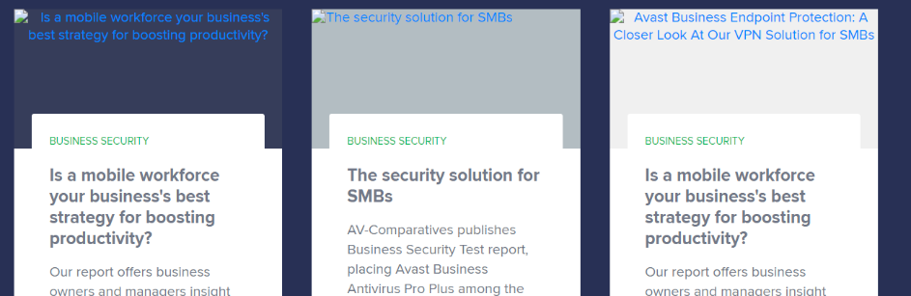I can see little icons of images next to headers of tabs. This problem did not occur in Mozilla Firefox.

1. Major severity

When you have a browser opened for some time (more than 2 minutes or so), half of the image will basically disappear and will be replaced with icon of the image called AV-desktop. This is not happening when using Mozilla Firefox. In Opera it is shortly after loading page and in Chrome that happens instantly.

1. Trivial severity

Arrows in section What People Are Saying About Us are not functioning.

1. Trivial severity

****Incorrect spelling. Business should include double “ss”

1. Trivial severity

In the footer of the webpage the name of the company is written as: 1988-2020 Copyright Avast Software s.r.o. which is incorrect. By language rules you should write s. r. o. with spaces but legislation says, that you should write what is in ARES.  
For more information see: <http://prirucka.ujc.cas.cz/?id=780> or <https://www.ajina.cz/psani-zkratek-spolecnosti-s-r-o/>

1. Trivial severity

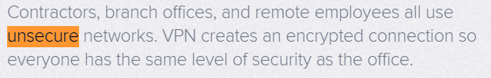I would rather use unsecured than unsecure.

1. Trivial severity

Typo - Double colon.

1. Trivial severity

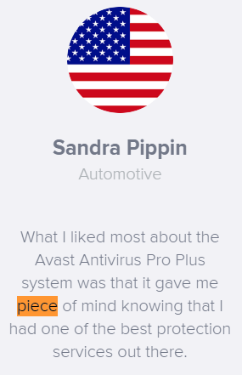Typo - wrong spelling of peace.

1. Trivial severity

Typo-Missing hyphen in User-friendly

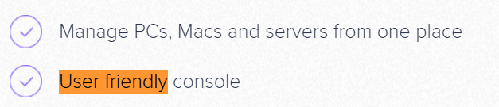

1. Enhancement

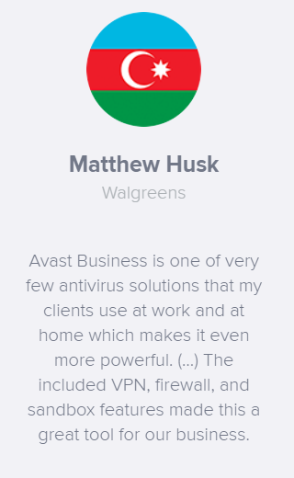Mr. Husk should stick with singular “my clients” or with plural “our business”. Is he representing himself or whole company? It is not a big issue but, I would consider changing it.