Roteiro 2 DDM

fun main() {

var l:MutableList<String> = mutableListOf("angelo","arhur","felipe","messa","ana")

println("Lista abaixo")

for (i in l){

println(i)

}

println("")

l.remove("ana")

println("Valor removido")

for (i in l){

println(i)

}

println("")

l.add("heloisa")

println("Valor adicionado")

for (i in l){

println(i)

}

println("")

var mapa = mapOf("angelo" to 19, "arthur" to 18, "felipe" to 15,"messa" to 16,"ana" to 12)

println("Mapa de Idedes:")

for (k in mapa){

println(k)

}

}

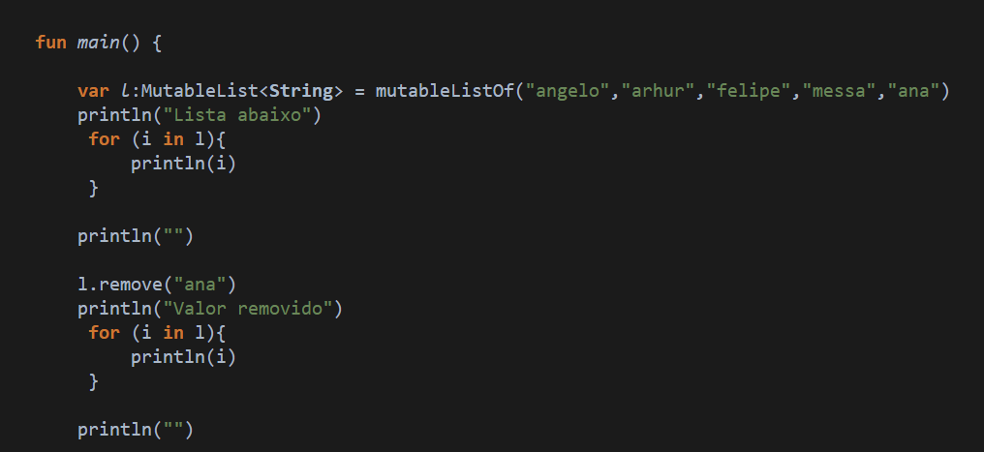

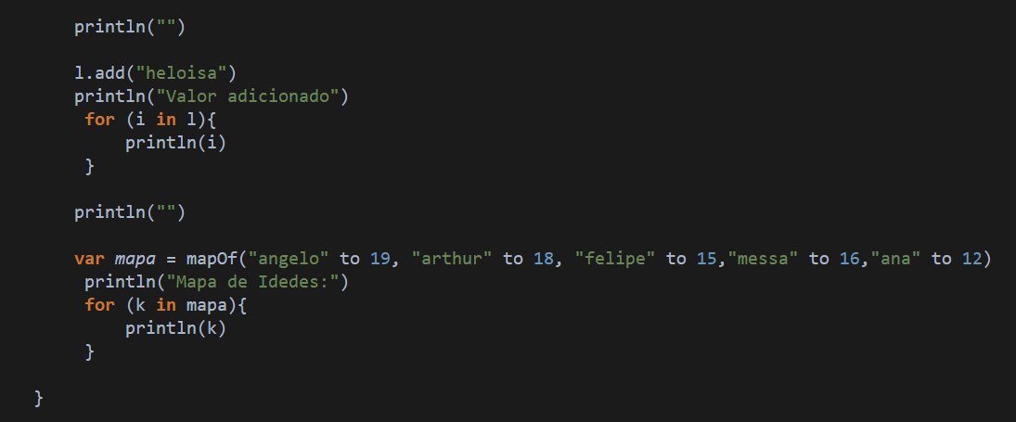

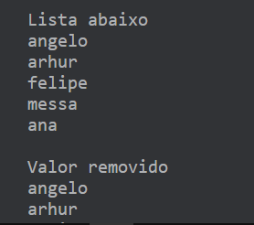

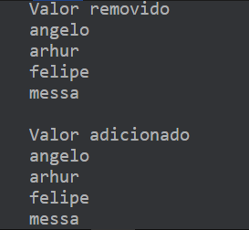

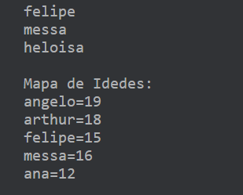

Roteiro 3 DDM

fun media(nota1: Double, nota2: Double): Double{

val mediafinal = ((nota1 + nota2)/2)

if (mediafinal>=7){

println("Aprovado com media final $mediafinal")

} else {

println("Reprovado com media final $mediafinal")

}

return mediafinal

}

fun main() {

media(8.0, 7.3)

}

