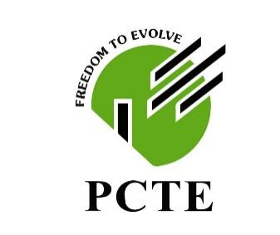 | PUNJAB COLLEGE OF TECHNICAL EDUCATION, JHANDE

BACHELORS OF MEDICAL LAB. SCIENCES

SEMESTER 2ND

EVS
PRESENTATION TITLE :REDUCE REUSE RECYCLE
STUDENT’S NAME:CELINA A. DORBOR
UNIVERSITY ROLL NUMBER: 2025MLS2930
OFFICIAL E-MAIL ADDRESSES: celinadobor1@gmail.com
TABLE OF CONTENTS:
- Introduction
- Reduce
- Reuse
- Recycle
- Avantages
- Uses
- Conclusion

Introduction
Is a waste management hierarchy designed to minimize environment impact. It emphases reducing consumption first ,reusing items to extend their life-spam second,and recycling material last.This approach saves resources,reduce landfill waste
and promotes sustainability in daily life.

REDUCE(Minimizing Waste)
The most effective step focusing on purchasing less and avoiding single use item.Including buying items with less packaging turn off water and buying reusable bags.
ADVANTAGES
Environmental Protection-minimizing waste creation lower the need for harvesting raw materials.
Cost Savings-consuming less saves money on purchasing new items,while businesses benefits from reduced packaging and raw materials cost.
Examples
- Using reusable bags,bottles instead of single use plastic.
- Buying products with less packaging.
- Repairing items instead of replacing.

REUSE(Repurpose Items)
Extending the life of products instead of discarding them.Examples include using refillable bottles,re-purposing glass jar for storage and buying second hand items

ADVANTAGES
-Containers and Packaging- use reusable water bottles grocery bags and food containers instead of single-use.
-Repairing- fix broken electronic furniture or clothes rather than buying or replacing.
-Buy used products.
EXAMPLES
Reduce Consumption-reusing lower demand for new products
Less Waste- it prevents item from becoming trash

RECYCLE(Process Materials)
Turning waste into new material
ADVANTAGES
Conservation of Natural Resources-reduces the need to extract harvest ,and process raw material.
Pollution Reduction-decreases air and water pollution caused by waste incineration and mining.
Economic Benefits-creates jobs and is often more cheaper.

Conclusion
The 3R concepts are essential in waste management because it enables us to know exactly what need to be done in protecting our environment and saving for our well beings.

