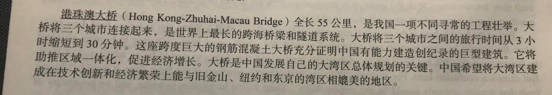

The Hong Kong-Zhuhai-Macau Bridge, 55 kilometers long, is a great and special construction in China. Connecting three cities, it’s the world’s longest bridge across the ocean and tunnel system. It shortens the travel time between the 3 cities from 3 hours to 30 minutes. This giant bridge strong prove that China has the capability to build giant construction that strikes the record. It will contribute to uniting the areas and develop economy. The bridge is essential for China to develop the general plan of its Dawan area. China hope to build the Dawan area into a place that can compare with the Wan area in San Francisco, New York and Tokyo in technological innovation and economical prosperity.