# 中文题目：大学生电子化学习接受程度影响因素调查研究

# 英文题目：A Research on the Factors Affecting E-learning Acceptance of College Students

# Chapter 1 Introduction

**1.1 Background of the study**

**1.1.1 Increasing focus on e-learning acceptance**

 Since the beginning of this century, the continuous development of information technology has challenged the traditional teaching mode. The voice of combining the new technology with the teaching content is getting louder (Ginns & Ellis 2007). The use of electronic devices and network platforms for teaching is not limited by time and space, and COVID-19 also makes electronic learning(e-learning) the only feasible teaching means. In recent years, the trend of e-learning in Chinese universities has

Figure 1 MOOC platform

become increasingly significant. Various teaching platforms such as MOOCs, Ismart and Rain Class have been widely used, which provides an opportunity for the research to study the acceptance of e-learning among college students. There is a close relationship between e-learning acceptance and e-learning. Tsain Lin (2001) believes that students' acceptance of e-learning directly determines their learning behaviors and effects. In the last decade, there has been an increasing interest in the factors affecting e-learning acceptance. Exploring these factors can improve the efficiency of students' e-learning, and provide constructive suggestions for schools, teachers and electronic platforms to optimize the education model.

**1.1.2 Research gap and necessity**

Many previous researches on e-learning acceptance have been conducted at home and abroad. However, most of the research were carried out before the full liberalization of pandemic in China, which may not truly reflect the current e-learning acceptance among Chinese college students.

On December 7, 2022, China was fully released from the epidemic control system, marking the transition of students from the mode of comprehensive online learning and combination of online and offline learning during the epidemic to the mode of comprehensive offline learning. In this context, it is reasonable to believe that students' attitude towards e-learning has changed. Before, students were required to take online courses by the school, so they were more forced to accept e-learning. Now, students have more autonomy to choose whether to e-learn and how to e-learn. It is unknown whether students can keep effectively using electronic devices and media to improve learning efficiency. There has been a dearth of research on this issue since the liberalization of pandemic in China.

In Chongqing University, the difference of students' e-learning acceptance is obvious. This gap is more prominent in students of different majors and grades. Therefore, it is very necessary to explore factors affecting e-learning acceptance in Chongqing University.

**1.2 Hypothesis and research question**

**1.2.1 Definition of e-learning**

E-learning is defined as ‘‘a method of teaching and learning that fully or partially signifies the educational model used, based on the use of electronic media and devices as tools for enhancing availability of training, communication, and interaction, and that helps in accepting novel ways of com-prehending and establishing learning’’ (Krishnan, 2017). According to this definition, the key elements of e-learning are electronic media and devices, with the purpose of improving the effectiveness of learning, which helps us to conclude the factors affecting e-learning acceptance.

**1.2.2 TAM module**

The Technology Acceptance Model (TAM) proposed by Davis (1989) has been employed in various researches of e-learning acceptance and has proved its effectiveness as compared with the other theoretical models (Qaysi, 2018). This research apply TAM to study the e-learning acceptance of students in CQU.

According to TAM, two personal beliefs will affect the attitude towards e-learning. One is perceived usefulness, which indicates whether one thinks e-learning is useful. Another is perceived ease of use, which indicates one thinks how easy e-leaning is to use. Perceived usefulness and attitude toward using will both affect behavior intention to e-learning, which finally determine the actual system use.

**1.2.3 External variables of TAM**

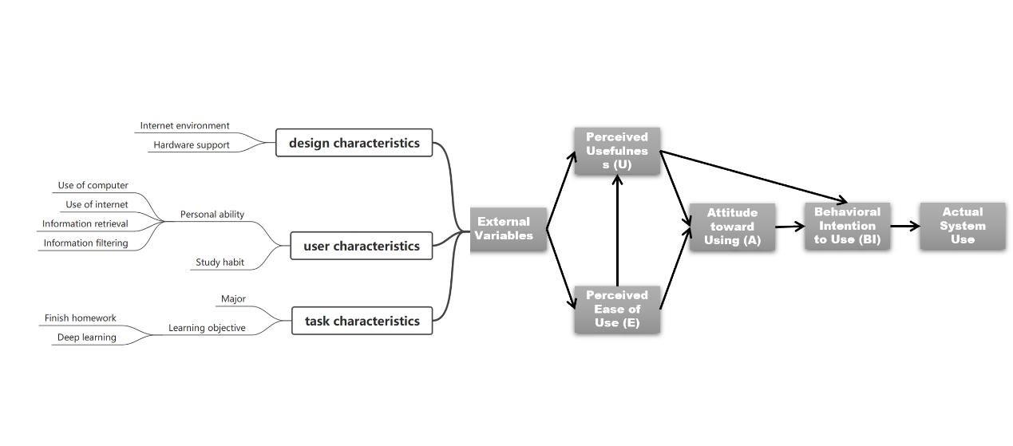Davis(1989) considered that many external variables affect two personal beliefs in TAM. Abdullah and Ward (2016) identified 152 external factors by reviewing 107 published articles in the duration of ten years. They abstracted the characteristics of three external variables, namely design characteristics, user characteristics and task characteristics. Based on their research and the preliminary observation of this research, external variables are further refined into several factors (see figure 2). Those are the factors that we're looking at, factors affecting e-learning acceptance. The research question is to study the impact of these factors on e-learning acceptance and how to explain the impact of different factors.

Figure 2 TAM and external variables

**1.3 Research methods**

This study uses a questionnaire to study e-learning acceptance. Factors affecting e-learning acceptance will be specific in the form of questions. The questionnaire will be released on a software called "问卷星". It is expected that 70 people will be covered, among which 50 will be students of various majors and grades in Chongqing University. In order to make the research more generalized, no more than 20 questionnaires will be sent to non-Chongqing University students. The questionnaire will collect students' majors, grades and their self-evaluation of e-learning acceptance as well as their specific performance in factors affecting e-learning. The answers to the questions will be designed by likert scale. The answers to questions related to different factors are used as one of the scores for each factor. Finally, the score of each factor is summarized, and the average value is taken for principal component analysis and linear fitting.

**1.4 Research purpose**

This study aims to explore the influence of different factors on e-learning acceptance, discuss the results and explain the internal relationship of such influence.

The results of this study can provide constructive suggestions supported by data for schools, teachers, students and e-learning platforms. This project divides the student groups according to different e-learning acceptance, considering grade, major and other factors, so that the teaching administrator can cross the restrictions of his own discipline and explore the e-learning acceptance of the entire student group from a broader research perspective. So that they can generally innovate teaching mode and popularize e-learning.

At the same time, this project excavates the factors that have a great influence on students' e-learning, which can help teaching managers focus on some more practical points in the complicated schemes for the popularization of e-learning and the improvement of teaching mode, making targeted teaching schemes.

**References**

1. A. Rhema, ‘‘An analysis of experiences and perceptions of technology-based learning in higher education institutions in Libya: Informing the advancement of e-learning,’’ Ph.D. dissertation, Victoria, Melbourne, VIC, Australia, 2013.
2. Chamberlin, W. S. 2001. Face-to-face vs. cyberspace: Finding the middle ground[J]. Campus Technology
3. F. Abdullah and R. Ward, ‘‘Developing a general extended technology acceptance model for e-learning (GETAMEL) by analyzing commonly used external factors,’’ Compute. Hum. Behavior., vol. 56, pp. 238–256, Mar. 2016.
4. F. D. Davis, ‘‘Perceived usefulness, perceived ease of use, and user acceptance of information technology,’’ MIS Quart.
5. Ginns, P. & R. Ellis. 2007. Quality in blended learning: Exploring the relationships between on-line and face-to-face teaching and learning [J]. The Internet and Higher Education
6. N. Al-Qaysi, N. Mohamad-Nordin, and M. Al-Emran, ‘‘A systematic review of social media acceptance from the perspective of educational and information systems theories and models,’’ J. Educ. Compute. Res.,2018.
7. K. S. T. Krishnan and H. Hussin, ‘‘E-learning readiness on Bumiputera SME’s intention for adoption of online entrepreneurship training in Malaysia,’’ Management, vol. 7, no. 1, pp. 35–39, 2017.