**最小化安装机器情况下，安装mysql5.6**

1. 初始化机器环境
2. 安装阿里云yum源
3. 备份原来的yum源

cp /etc/yum.repos.d/CentOS-Base.repo /etc/yum.repos.d/CentOS-Base.repo.bak

1. 设置aliyun的yum源：

Wget -O /etc/yum.repos.d/CentOS-Base.repo <http://mirrors.aliyun.com/repo/Centos-7.repo>

1. 添加EPEL源:

wget -P /etc/yum.repos.d/ <http://mirrors.aliyun.com/repo/epel-7.repo>

1. 清理缓存并生成新的缓存:

sudo yum clean all

sudo yum makecache

1. 挂载数据盘
   1. 查看当前是否有磁盘可挂载
      1. fdisk –l
      2. 若是没有发现可挂载的硬盘，需要重启机器

reboot

重启后发现，我们需要的数据盘

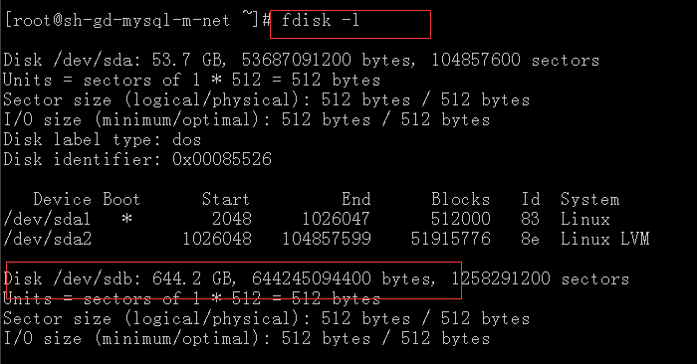

* 1. 开始格式化硬盘并且挂载
     1. mkfs.xfs /dev/sdb
     2. 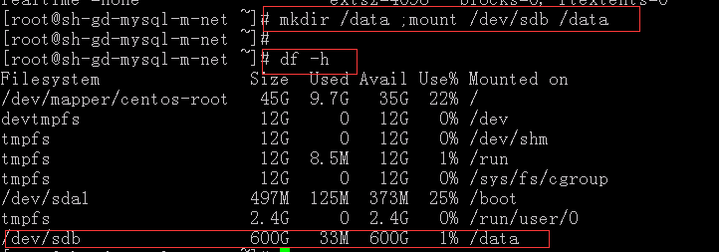
     3. 放到开机启动内，以便机器开机后，可以第一时间进行挂载动作

vim /etc/rc.local

添加：mount /dev/sdb /data

1. 安装vim工具
   1. Yum install vim
2. 卸载centos7自带的firewall服务，安装iptables服务
   1. systemctl stop firewalld.service
   2. yum remove firewall*
   3. yum install iptables-services
   4. 编辑iptables初始规则

# Firewall configuration written by system-config-firewall

# Manual customization of this file is not recommended.

*filter

:INPUT ACCEPT [0:0]

:FORWARD ACCEPT [0:0]

:OUTPUT ACCEPT [0:0]

-A INPUT -m state --state ESTABLISHED,RELATED -j ACCEPT

-A INPUT -p icmp -j ACCEPT

-A INPUT -i lo -j ACCEPT

-A INPUT -m state --state NEW -m tcp -p tcp --dport 22 -j ACCEPT

-A INPUT -m state --state NEW -m tcp -p tcp --dport 80 -j ACCEPT

-A INPUT -m state --state NEW -m tcp -p tcp --dport 3306 -j ACCEPT

-A INPUT -j REJECT --reject-with icmp-host-prohibited

-A FORWARD -j REJECT --reject-with icmp-host-prohibited

COMMIT

* 1. 启动并且配置开机启动

systemctl restart iptables.service #最后重启防火墙使配置生效

systemctl enable iptables.service #设置防火墙开机启动

1. 内核优化
   1. [root@sh-gd-mysql-m-net scripts]# cat /etc/sysctl.conf

# System default settings live in /usr/lib/sysctl.d/00-system.conf.

# To override those settings, enter new settings here, or in an /etc/sysctl.d/<name>.conf file

# For more information, see sysctl.conf(5) and sysctl.d(5).

icmp_echo_ignore_broadcasts = 1

net.ipv4.icmp_ignore_bogus_error_responses = 1

net.ipv4.ip_forward = 0

net.ipv4.conf.all.send_redirects = 0

net.ipv4.conf.default.send_redirects = 0

net.ipv4.conf.default.rp_filter = 1

net.ipv4.conf.default.accept_source_route = 0

kernel.sysrq = 0

kernel.core_uses_pid = 1

net.ipv4.tcp_syncookies = 1

kernel.msgmax = 65536

kernel.shmmax = 68719476736

kernel.shmall = 4294967296

net.ipv4.tcp_max_tw_buckets = 6000

net.ipv4.tcp_sack = 1

net.ipv4.tcp_window_scaling = 1

net.ipv4.tcp_rmem = 4096 87380 4194304

net.ipv4.tcp_wmem = 4096 16384 4194304

net.core.wmem_default = 8388608

net.core.rmem_default = 8388608

net.core.rmem_max = 16777216

net.core.wmem_max = 16777216

net.core.netdev_max_backlog = 262144

net.ipv4.tcp_max_syn_backlog = 262144

net.ipv4.tcp_timestamps = 0

net.ipv4.tcp_synack_retries = 1

net.ipv4.tcp_syn_retries = 1

net.ipv4.tcp_tw_recycle = 1

net.ipv4.tcp_tw_reuse = 1

net.ipv4.tcp_mem = 94500000 915000000 927000000

net.ipv4.tcp_fin_timeout = 1

net.ipv4.tcp_keepalive_time = 30

net.ipv4.ip_local_port_range = 1024 65000

net.ipv4.conf.all.accept_redirects = 0

net.ipv4.conf.default.accept_redirects = 0

net.ipv4.conf.all.secure_redirects = 0

net.ipv4.conf.default.secure_redirects = 0

* 1. 修改limit限制

/etc/security/limits.conf

* soft nofile 65535

* hard nofile 65535

* soft npoc 65535

* hard npoc 65535

1. **安装mysql5.6**
   1. 由于centos7默认的mysql数据库为其分支，mariadb，我们需要添加mysql的yum源
      1. rpm -Uvh <http://dev.mysql.com/get/mysql-community-release-el7-5.noarch.rpm>
      2. 查看可安装的mysql版本
         1. yum repolist enabled | grep "mysql.*-community.*"
      3. 安装mysqlserver
         1. yum -y install mysql-community-server
      4. 优化server的配置文件

# For advice on how to change settings please see

# http://dev.mysql.com/doc/refman/5.6/en/server-configuration-defaults.html

[client]

default-character-set=utf8

[mysqld]

#

# Remove leading # and set to the amount of RAM for the most important data

# cache in MySQL. Start at 70% of total RAM for dedicated server, else 10%.

# innodb_buffer_pool_size = 128M

#

# Remove leading # to turn on a very important data integrity option: logging

# changes to the binary log between backups.

# log_bin

#

# Remove leading # to set options mainly useful for reporting servers.

# The server defaults are faster for transactions and fast SELECTs.

# Adjust sizes as needed, experiment to find the optimal values.

# join_buffer_size = 128M

# sort_buffer_size = 2M

# read_rnd_buffer_size = 2M

datadir=/data/mysql

socket=/var/lib/mysql/mysql.sock

# Disabling symbolic-links is recommended to prevent assorted security risks

symbolic-links=0

innodb_buffer_pool_size = 128M

###################################

#innodb

user=mysql

innodb_buffer_pool_size=6G

innodb_log_file_size=4G

innodb_log_buffer_size = 8M

innodb_flush_log_at_trx_commit=2

innodb_file_per_table=1

innodb_file_io_threads=4

innodb_flush_method=O_DIRECT

innodb_io_capacity=2000

innodb_io_capacity_max=6000

innodb_lru_scan_depth=2000

innodb_thread_concurrency = 0

innodb_additional_mem_pool_size=16M

innodb_autoinc_lock_mode = 2

##################################################

# Binary log/replication

log-bin

sync_binlog=1

sync_relay_log=1

relay-log-info-repository=TABLE

master-info-repository=TABLE

expire_logs_days=7

binlog_format=ROW

transaction-isolation=READ-COMMITTED

#################################################

#cache

tmp_table_size=512M

character-set-server=utf8

collation-server=utf8_general_ci

skip-external-locking

back_log=1024

key_buffer_size=1024M

thread_stack=256k

read_buffer_size=8M

thread_cache_size=64

query_cache_size=128M

max_heap_table_size=256M

query_cache_type=1

binlog_cache_size = 2M

table_open_cache=128

thread_cache=1024

thread_concurrency=8

wait_timeout=30

join_buffer_size = 1024M

sort_buffer_size = 8M

read_rnd_buffer_size = 8M

#################################################

#connect

max-connect-errors=100000

max-connections=1000

#################################################

explicit_defaults_for_timestamp=true

sql_mode=NO_ENGINE_SUBSTITUTION,STRICT_TRANS_TABLES

[mysqld_safe]

log-error=/var/log/mysqld.log

pid-file=/var/run/mysqld/mysqld.pid

* 1. 配置mysql主从
     1. 安装另外一台机器，配置方法和master一样，直到安装完成mysql，并且完成相应优化
     2. Master配置文件内更改，没有就添加,在my.cnf内
        1. log-bin=master-bin.log
        2. server-id=1
     3. slave配置文件内更改，没有就天津，在my.cnf内
        1. log-bin=slave-bin.log
        2. server-id=2
     4. master/slave 进行重启
        1. systemctl restart mysqld
     5. master上面创建用于同步的帐号

mysql> GRANT REPLICATION SLAVE ON *.* TO 'slave'@'10.32.30.231' IDENTIFIED BY '123456';

Query OK, 0 rows affected (0.00 sec)

mysql> flush privileges;

Query OK, 0 rows affected (0.00 sec)

* + 1. 由于是环境，所有，不需要停掉master的写，去同步数据
       1. 查看master的状态

mysql> show master status;

+-------------------+----------+--------------+------------------+-------------------+

| File | Position | Binlog_Do_DB | Binlog_Ignore_DB | Executed_Gtid_Set |

+-------------------+----------+--------------+------------------+-------------------+

| master-bin.000001 | 409 | | | |

+-------------------+----------+--------------+------------------+-------------------+

1 row in set (0.00 sec)

* + 1. 在slave上面，设置master向slave同步的细节，注意标红部分
       1. mysql> CHANGE MASTER TO MASTER_HOST='10.32.30.230',MASTER_USER='slave',MASTER_PASSWORD='123456',MASTER_LOG_FILE='master-bin.000001',MASTER_LSTER_LOG_POS=409;
       2. 启动slave进行复制
          1. mysql> start slave;

Query OK, 0 rows affected (0.00 sec)

* + - * 1. 查看slave的状态，如果标红的均为yes，表示主从成功

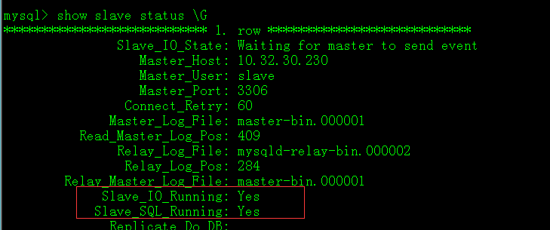

* + 1. 数据测试

Master上面创建test库，然后去从库上面查看，若有，则验证成功



