**最小化安装centos7情况下，安装zabbix3.0**

1. 初始化机器环境
2. 安装阿里云yum源
3. 备份原来的yum源

cp /etc/yum.repos.d/CentOS-Base.repo /etc/yum.repos.d/CentOS-Base.repo.bak

1. 设置aliyun的yum源：

Wget -O /etc/yum.repos.d/CentOS-Base.repo <http://mirrors.aliyun.com/repo/Centos-7.repo>

1. 添加EPEL源:

wget -P /etc/yum.repos.d/ <http://mirrors.aliyun.com/repo/epel-7.repo>

1. 清理缓存并生成新的缓存:

sudo yum clean all

sudo yum makecache

1. 挂载数据盘
   1. 查看当前是否有磁盘可挂载
      1. fdisk –l
      2. 若是没有发现可挂载的硬盘，需要重启机器

reboot

重启后发现，我们需要的数据盘

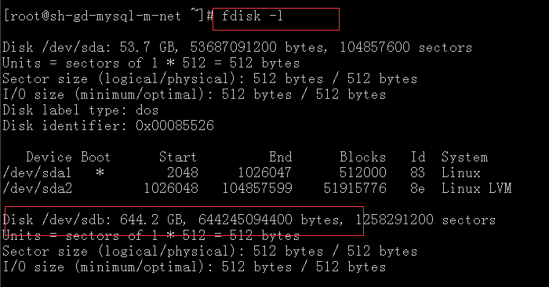

* 1. 开始格式化硬盘并且挂载
     1. mkfs.xfs /dev/sdb
     2. 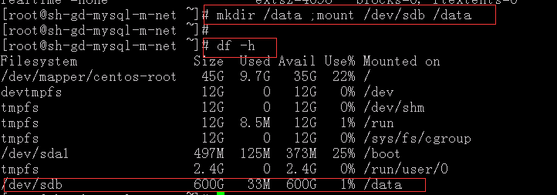
     3. 放到开机启动内，以便机器开机后，可以第一时间进行挂载动作

vim /etc/rc.local

添加：mount /dev/sdb /data

1. 安装vim工具
   1. Yum install vim
2. 卸载centos7自带的firewall服务，安装iptables服务
   1. systemctl stop firewalld.service
   2. yum remove firewall*
   3. yum install iptables-services
   4. 编辑iptables初始规则

# Firewall configuration written by system-config-firewall

# Manual customization of this file is not recommended.

*filter

:INPUT ACCEPT [0:0]

:FORWARD ACCEPT [0:0]

:OUTPUT ACCEPT [0:0]

-A INPUT -m state --state ESTABLISHED,RELATED -j ACCEPT

-A INPUT -p icmp -j ACCEPT

-A INPUT -i lo -j ACCEPT

-A INPUT -m state --state NEW -m tcp -p tcp --dport 22 -j ACCEPT

-A INPUT -m state --state NEW -m tcp -p tcp --dport 80 -j ACCEPT

-A INPUT -m state --state NEW -m tcp -p tcp --dport 3306 -j ACCEPT

-A INPUT -j REJECT --reject-with icmp-host-prohibited

-A FORWARD -j REJECT --reject-with icmp-host-prohibited

COMMIT

* 1. 启动并且配置开机启动

systemctl restart iptables.service #最后重启防火墙使配置生效

systemctl enable iptables.service #设置防火墙开机启动

1. 内核优化
   1. [root@sh-gd-mysql-m-net scripts]# cat /etc/sysctl.conf

# System default settings live in /usr/lib/sysctl.d/00-system.conf.

# To override those settings, enter new settings here, or in an /etc/sysctl.d/<name>.conf file

# For more information, see sysctl.conf(5) and sysctl.d(5).

icmp_echo_ignore_broadcasts = 1

net.ipv4.icmp_ignore_bogus_error_responses = 1

net.ipv4.ip_forward = 0

net.ipv4.conf.all.send_redirects = 0

net.ipv4.conf.default.send_redirects = 0

net.ipv4.conf.default.rp_filter = 1

net.ipv4.conf.default.accept_source_route = 0

kernel.sysrq = 0

kernel.core_uses_pid = 1

net.ipv4.tcp_syncookies = 1

kernel.msgmax = 65536

kernel.shmmax = 68719476736

kernel.shmall = 4294967296

net.ipv4.tcp_max_tw_buckets = 6000

net.ipv4.tcp_sack = 1

net.ipv4.tcp_window_scaling = 1

net.ipv4.tcp_rmem = 4096 87380 4194304

net.ipv4.tcp_wmem = 4096 16384 4194304

net.core.wmem_default = 8388608

net.core.rmem_default = 8388608

net.core.rmem_max = 16777216

net.core.wmem_max = 16777216

net.core.netdev_max_backlog = 262144

net.ipv4.tcp_max_syn_backlog = 262144

net.ipv4.tcp_timestamps = 0

net.ipv4.tcp_synack_retries = 1

net.ipv4.tcp_syn_retries = 1

net.ipv4.tcp_tw_recycle = 1

net.ipv4.tcp_tw_reuse = 1

net.ipv4.tcp_mem = 94500000 915000000 927000000

net.ipv4.tcp_fin_timeout = 1

net.ipv4.tcp_keepalive_time = 30

net.ipv4.ip_local_port_range = 1024 65000

net.ipv4.conf.all.accept_redirects = 0

net.ipv4.conf.default.accept_redirects = 0

net.ipv4.conf.all.secure_redirects = 0

net.ipv4.conf.default.secure_redirects = 0

* 1. 修改limit限制

/etc/security/limits.conf

* soft nofile 65535

* hard nofile 65535

* soft npoc 65535

* hard npoc 65535

1. 安装zabbix server
2. 安装服务器端包

rpm -ivh http://repo.zabbix.com/zabbix/3.0/rhel/7/x86_64/zabbix-release-3.0-1.el7.noarch.rpm

#yum clean all

#yum install zabbix-server-mysql zabbix-web-mysql

1. 创建zabbix数据库
   1. 由于zabbix和mysql做了拆分，需要将sql文件放到mysql的master上面

cd /usr/share/doc/zabbix-server-mysql-3.0.4

scp create.sql.gz [root@10.32.30.230:/tmp/](mailto:root@10.32.30.230:/tmp/)

* 1. 在master上面进行数据导入

cd /tmp/

gzip -d create.sql.gz

mysql> create database zabbix character set utf8 collate utf8_bin;

Query OK, 1 row affected (0.00 sec)

mysql> grant all privileges on zabbix.* to zabbix@'10.32.30.229' identified by '123456';

Query OK, 0 rows affected (0.01 sec)

mysql> grant all privileges on zabbix.* to zabbix@'localhost' identified by '123456';

Query OK, 0 rows affected (0.00 sec)

mysql> flush privileges;

Query OK, 0 rows affected (0.00 sec)

[root@sh-gd-mysql-m-net tmp]# mysql -uzabbix -p123456 zabbix < create.sql

至此，导入完成，验证master和slave上面的表数量

Master

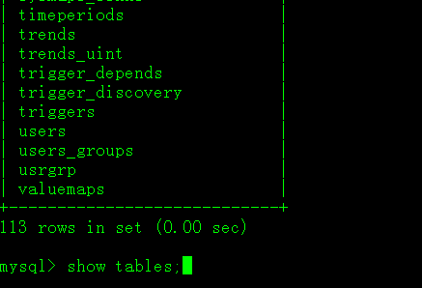

Slave

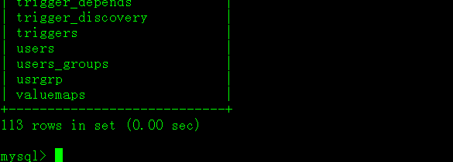

1. 修改zabbix配置

DBHost=10.32.30.230

DBName=zabbix

DBUser=zabbix

DBPassword=123456

SNMPTrapperFile=/var/log/snmptrap/snmptrap.log

HistoryCacheSize=256M

HistoryIndexCacheSize=128M

TrendCacheSize=128M

ValueCacheSize=256M

Timeout=4

1. 修改webserver服务配置

php_value max_execution_time 300

php_value memory_limit 128M

php_value post_max_size 16M

php_value upload_max_filesize 2M

php_value max_input_time 300

php_value always_populate_raw_post_data -1

php_value date.timezone Asia/Shanghai

1. 启动相关服务
2. 启动zabbix-server

[root@sh-gd-zabbix-net ~]# systemctl start zabbix-server

[root@sh-gd-zabbix-net ~]# systemctl status zabbix-server

● zabbix-server.service - Zabbix Server

Loaded: loaded (/usr/lib/systemd/system/zabbix-server.service; disabled; vendor preset: disabled)

Active: active (running) since Thu 2016-08-18

添加开机启动

[root@sh-gd-zabbix-net ~]# systemctl enable zabbix-server

1. 启动webserver

[root@sh-gd-zabbix-net ~]# systemctl start httpd

[root@sh-gd-zabbix-net ~]# systemctl status httpd

● httpd.service - The Apache HTTP Server

Loaded: loaded (/usr/lib/systemd/system/httpd.service; disabled; vendor preset: disabled)

Active: active (running) since Thu 2016-08-18 18:10:36 CST; 35s ago

添加开机启动

[root@sh-gd-zabbix-net ~]# systemctl enable httpd

1. 进行页面配置
   1. 浏览器输入

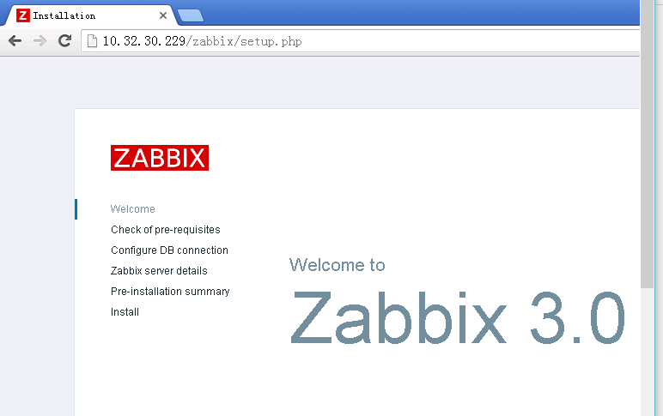

* 1. 查看各个组件的状态，全部OK的情况下，点击next

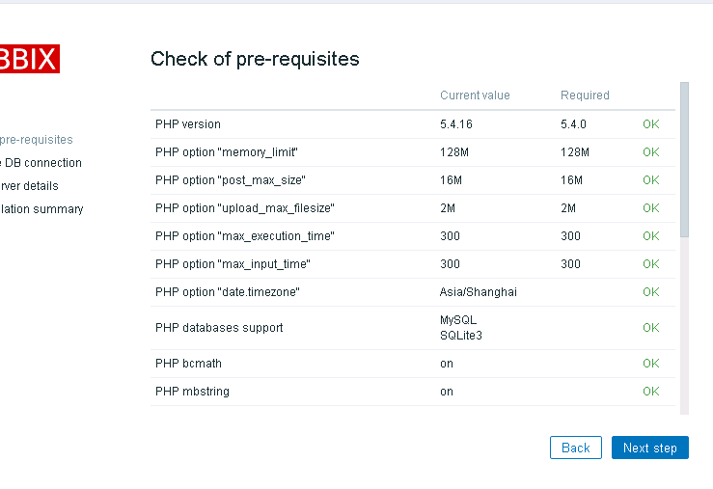

* 1. 填写相应信息

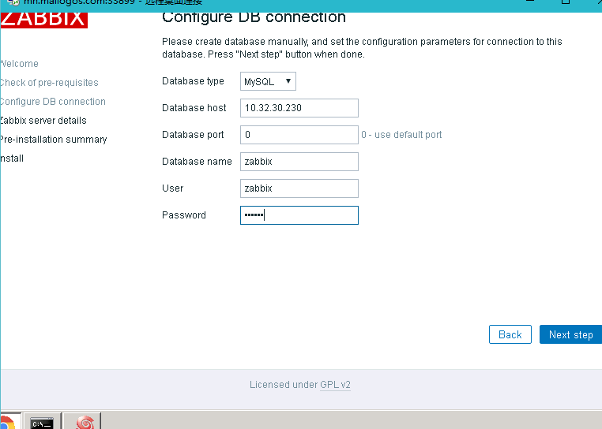

* 1. 继续，验证后，生成配置信息

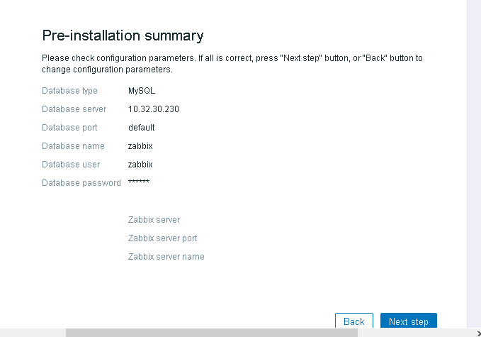

* 1. 全部完成后，显示的是成功状态

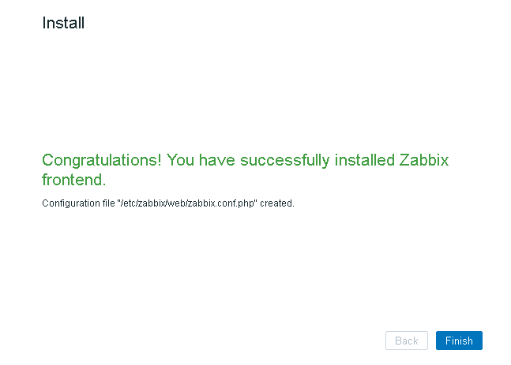

* 1. 点击finish，完成配置。

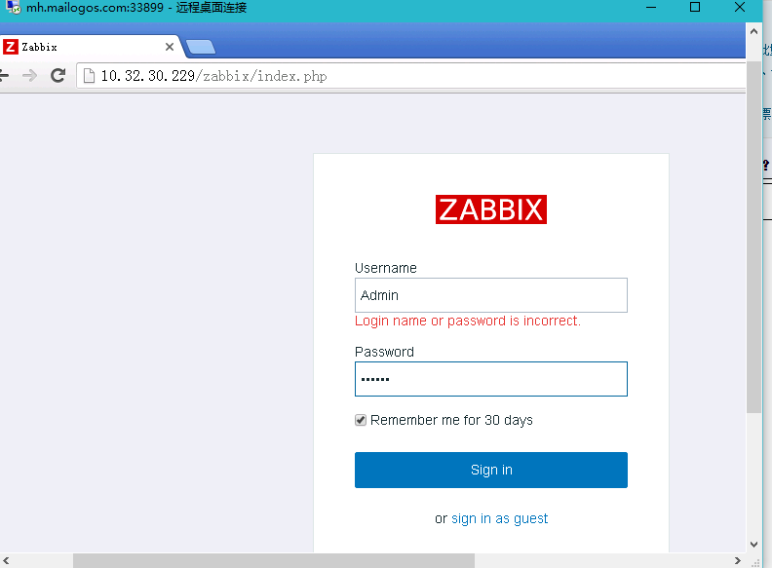

* 1. 点击登录，查看信息

