North Carolina Data Profile

UW PHI

3/30/2022

# 1. State-level trends

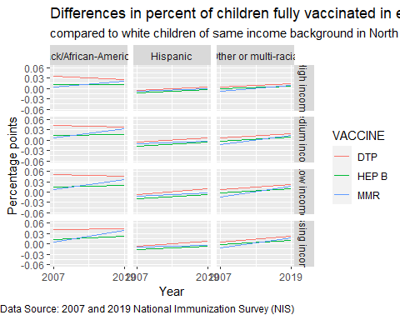

We calculated percent coverage using data from the National Immunization Survey which provides information on how many children in the state received all recommended vaccines. For each year we compared the vaccination coverage among children who were Black, Hispanic, or Other/multiple-race background to White children of the same income level. A gap greater than 0 suggests that white children are being vaccinated at a higher rate than the group of non-white children they are compared with. In the graphs above, a positive slope indicates increasing differences (worse gap), and a negative slope indicates decreasing differences (an improvement in the gap).

*What this graphic shows is that children that were Black had the highest gap compared to White children, but that gap seemed to improve at least for the DTP vaccine between the two time periods. For the other racial/ethnic groups the gap was close to 0, meaning no disparity compared to White children. For the MMR vaccine however, the gap between Black and White children only seemed to worsen between the two time periods.*

# 2. State-level trends by race/ethnicity and income

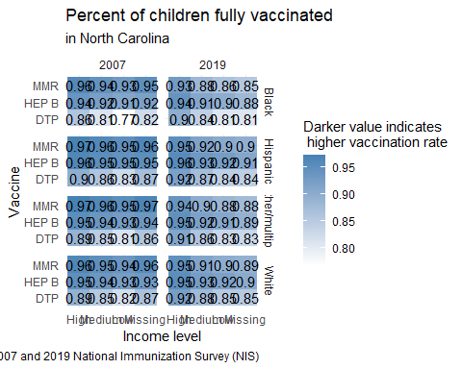

This graphic provides the actual immunization rates as estimated using the NIS Survey and used in calculating the gaps according to race and ethnicity from the first graphic.

*What this graphic shows is that North Carolina had relatively high vaccination coverage among all racial/ethnic groups for the HEP B and MMR vaccines in 2007. Several racial/ethnic groups saw lower vaccination coverage estimates in 2019. However, the reduction in the gap for the DTP vaccine among Black children is mostly due to the greater improvement among Black children than among White children.*

# 3. Map of county locations and populations

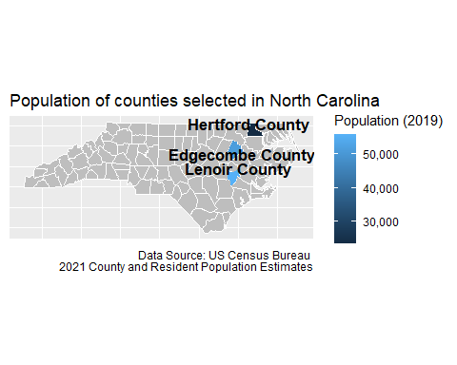

*Counties we selected are all in the Northeastern part of the state.*

# 4. Demographics of children under 4 in each county

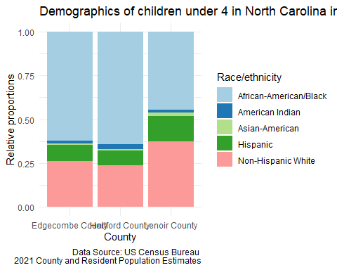

# Childhood Vaccination data

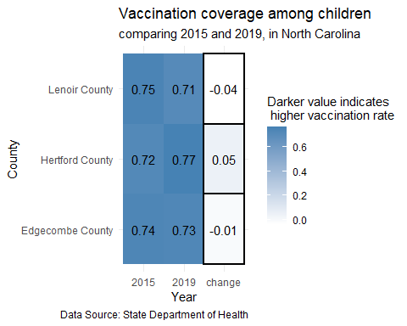

Negative “change” values indicate that the proportion of children vaccinated decreased between the two time periods.

*Hertford County saw an improvement of 5 percentage points, a high value compared to other counties in the state.*

# 5. Covid vaccination among adults

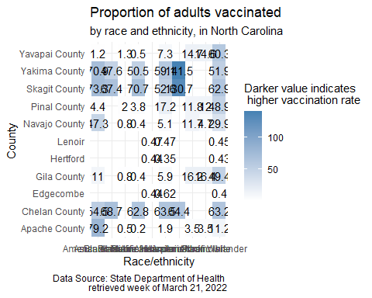

*What this graphic shows is that at the county level, White adults had lower Covid-19 vaccination coverage than other racial/ethnic groups. This contrasts with childhood immunization rates in the state (See Graphic 2 above) where white children tended to have higher vaccination coverage than other racial/ethnic groups.*

# 6. County rankings

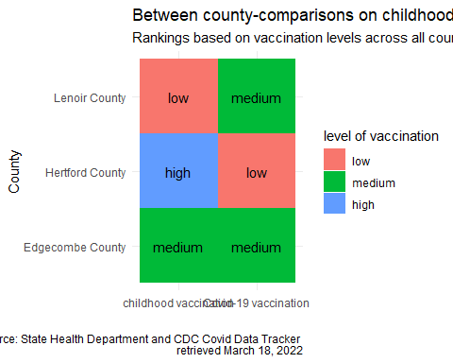

County grouping was determined by ranking all counties according to the proportion of population vaccinated and dividing them into three groups: those in the top 25% were classified as high performers, those in the bottom 25% were classified as low performers, and the remaining were medium performers. The same process was used for both routine childhood immunization data and Covid-19 vaccination data.

*What this graphic shows is that level of childhood vaccination does not always coincide with levels of vaccination for Covid-19. Edgecombe County was the exception as it seemed to fall within the “medium” group for both.*