Arizona Data Profile

UW PHI

04/01/2022

# 1. State-level trends

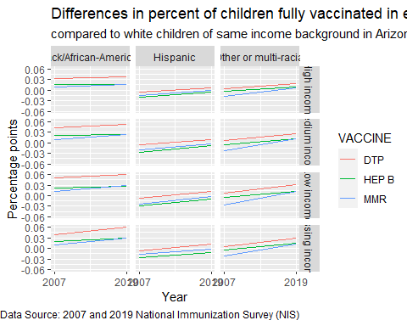

We calculated percent coverage using data from the National Immunization Survey which provides information on how many children in the state received all recommended vaccines. For each year we compared the vaccination coverage among children who were Black, Hispanic, or Other/multiple-race background to White children of the same income level. A gap greater than 0 suggests that white children are being vaccinated at a higher rate than the group of non-white children they are compared with. In the graphs above, a positive slope indicates increasing differences (worse gap), and a negative slope indicates decreasing differences (an improvement in the gap).

*What this graphic shows is that there is trend of an increasing gap in vaccination coverage for Black children compared to White children for the DTP vaccine. For the MMR Vaccine, White children had lower vaccination coverage rates in 2007 than Hispanic children, but the gap has decreased in 2019. For children that are in the “other” or “multi-racial” category the gap is growing for all three vaccines however. Unfortunately, lack of further race/ethnicity disaggregation makes it difficult to identify the background of the children in these categories.*

# 2. State-level trends by race/ethnicity and income

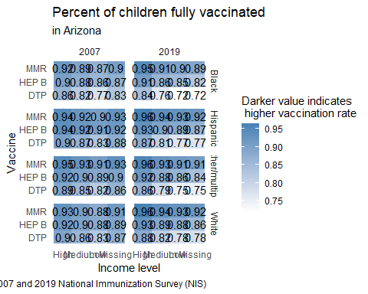

This graphic provides the actual immunization rates as estimated using the NIS Survey and used in calculating the gaps according to race and ethnicity from the first graphic.

*What this graphic shows is that for some vaccines such as DTP and Hep B, coverage levels dropped in 2019. The pattern is similar across racial/ethnic and income groups. However, Black children had slightly larger drops in coverage than White children for the DTP vaccine in particular, resulting in an increased vaccination gap pointed out in Figure 1. Similarly, although vaccination coverage improved among White children for the MMR vaccine, among children in the “Other/multi-race” group, MMR coverage actually stayed the same or slightly decreased.*

# 3. Map of county locations and populations

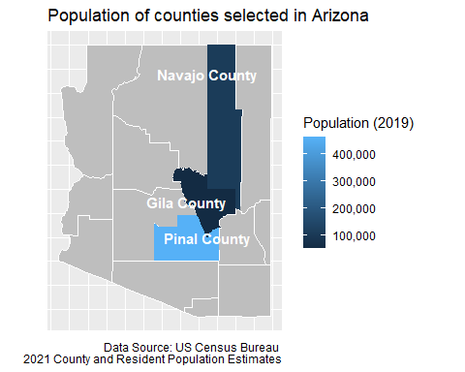

*Counties we selected are all in the central part of the state.*

# 4. Demographics of children under 4 in each county

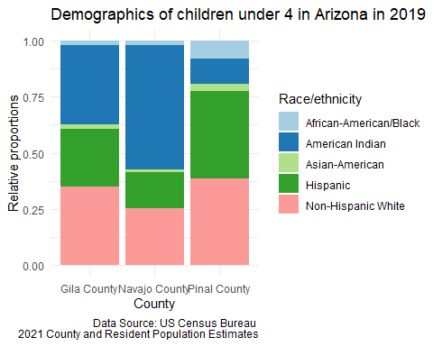

# Childhood Vaccination data

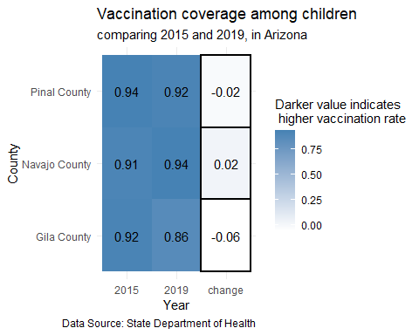

Negative “change” values indicate that the proportion of children vaccinated decreased between the two time periods.

*Navajo County’s improvement of 2 percentage points is high compared to the average change seen in counties across the state.*

# 5. Covid vaccination among adults

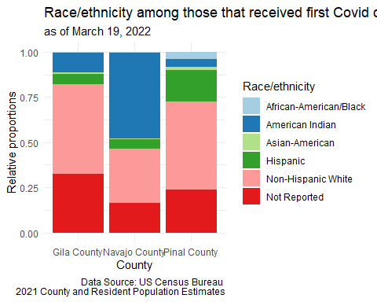

*In Arizona, county vaccination levels are not available by race/ethnic group. What this graphic shows instead is how the first vaccination dose has been distributed so far. At the county level, vaccination distribution mostly aligns with population distribution. The only exception seems to be Gila county. Although Native American’s make up the majority of the adult population in Gila County (20% of the population is Native American), only about 13% of the first doses went to Native Americans.*

# 6. County rankings

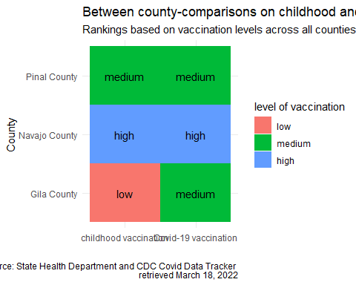

County grouping was determined by ranking all counties according to the proportion of population vaccinated and dividing them into three groups: those in the top 25% were classified as high performers, those in the bottom 25% were classified as low performers, and the remaining were medium performers. The same process was used for both routine childhood immunization data and Covid-19 vaccination data.

*What this graphic shows is that level of childhood vaccination coincided with levels of Covid-19 vaccination in at least two cases: Navajo County was in the “high” group for both childhood and Covid-19 vaccination rates and Pinal County was in the “medium” grouping for both.*