Washington Data Profile

UW PHI

04/01/2022

# 1. State-level trends

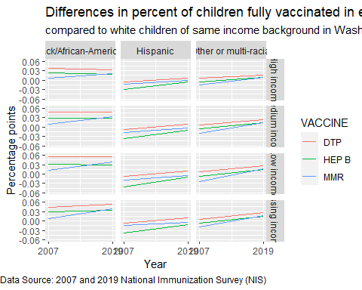

We calculated percent coverage using data from the National Immunization Survey which provides information on how many children in the state received all recommended vaccines. For each year we compared the vaccination coverage among children who were Black, Hispanic, or Other/multiple-race background to White children of the same income level. A gap greater than 0 suggests that white children are being vaccinated at a higher rate than the group of non-white children they are compared with. In the graphs above, a positive slope indicates increasing differences (worse gap), and a negative slope indicates decreasing differences (an improvement in the gap).

*African-American children are vaccinated at lower rates than White children in Washington state and that seems to have changed very little during the two time points for DTP and HEP B vaccines. However, for MMR the vaccination gap seems to be increasing. In 2007, Hispanic children seemed to have higher vaccination coverage than White children, although that gap has narrowed in recent years and both groups have similar coverage in the most recent survey. Children from other racial backgrounds have a slight gap in vaccination coverage, but it’s not as large as the gap between African-American and White children.*

# 2. State-level trends by race/ethnicity and income

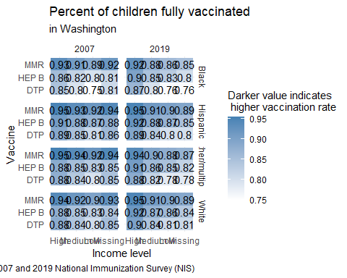

This graphic provides the actual immunization rates as estimated using the NIS Survey and used in calculating the gaps according to race and ethnicity from the first graphic.

*What this graphic shows is that DTP vaccines consistently have the lowest rates of coverage among children from all races or ethnicity compared to other vaccines in the 2007 and 2019 surveys. In the most recent survey, both Black and White children from a high-income background have seen improved vaccination coverage for the HEP B and DTP vaccines.*

# 3. Map of county locations and populations

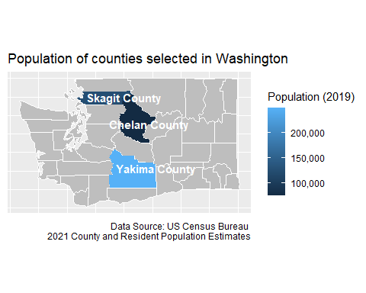

*Counties we selected are all in the north or eastern part of the state.*

# 4. Demographics of children under 4 in each county

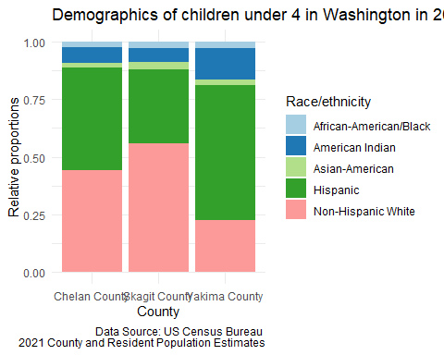

# 5. Childhood Vaccination data

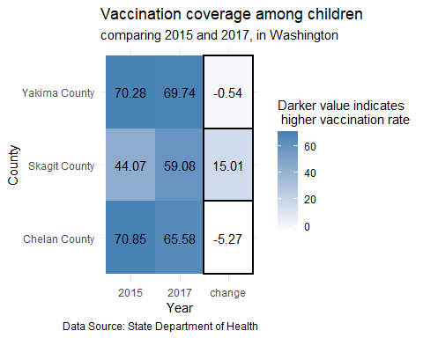 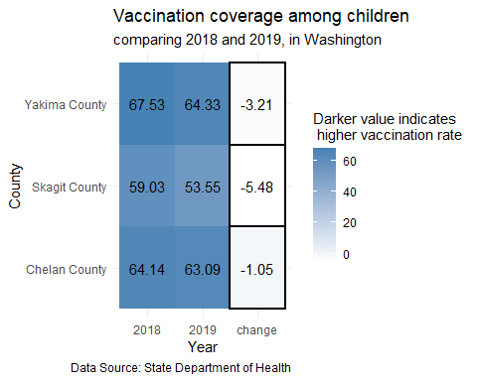

Negative “change” values indicate that the proportion of children vaccinated decreased between the two time periods. Technical Note: Numbers for 2018 are not comparable to past years due to a change in how population data was measured.

*Skagit County saw an improvement of 15 percentage points between 2015 and 2017, a high value compared to other counties in the state. But a decrease of about 5% between 2018 and 2019.*

# 6. Covid vaccination among adults

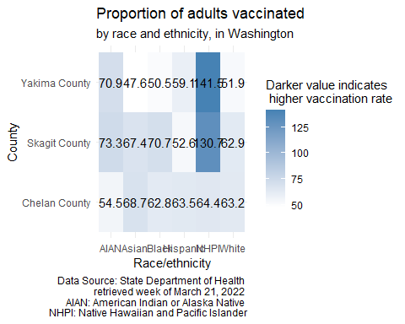

*What this graphic shows is that at the county level, there existed some large differences in Covid vaccination rates between racial/ethnic groups as well as between counties. In Yakima, Asian, Black, and White residents had the lowest vaccination rates (around 50%). While in Skagit county, Hispanic residents had the lowest vaccination rates. In Chelan county, most racial/ethnic groups has similar vaccination rates, except for American Indian residents which had lower rates (between 9 and 14 percentage points lower than other racial/ethnic groups).*

# 7. County rankings

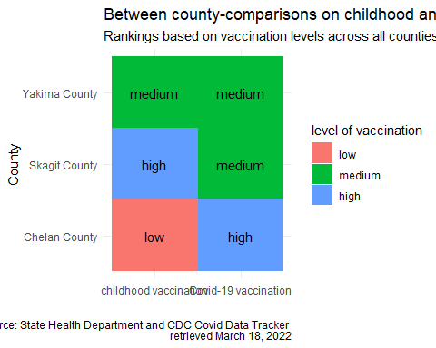

County grouping was determined by ranking all counties according to the proportion of population vaccinated and dividing them into three groups: those in the top 25% were classified as high performers, those in the bottom 25% were classified as low performers, and the remaining were medium performers. The same process was used for both routine childhood immunization data and Covid-19 vaccination data.

*What this graphic shows is that level of childhood vaccination does not always coincide with levels of vaccination for Covid-19. Yakima County was the exception as it seemed to fall within the “medium” group for both. Chelan county was in the “low” group for childhood vaccination but considered a county with high vaccination coverage for Covid-19 vaccines.*