03_north_carolina_data_profile

Francisco Rios Casas

3/28/2022

# State-level trends

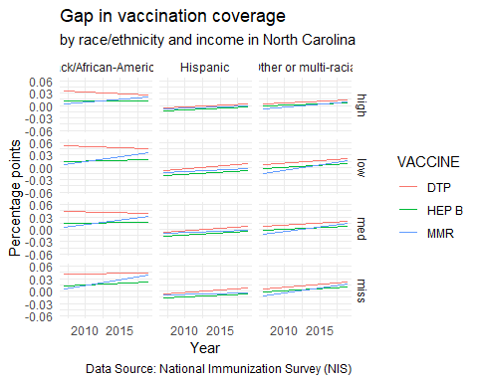

In the graphs above, a positive slope signals increasing differences (worse gaps), and a negative slope signals decreasing differences (an improvement in the gap).

# State-level trends by race/ethnicity and income

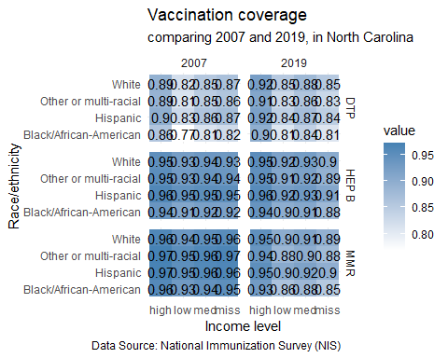

# Map of county locations and populations

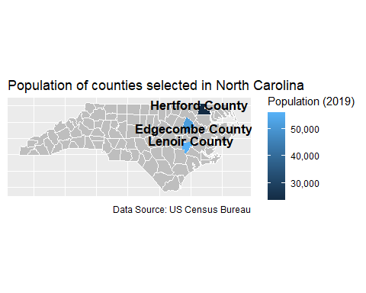

# Demographics of children under 4 in each county

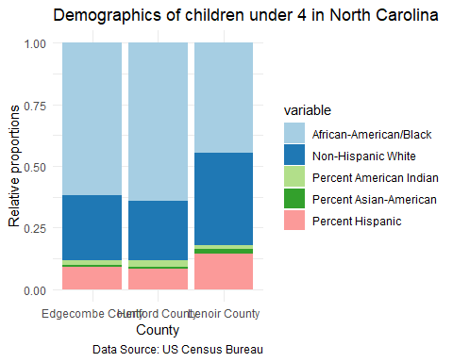

# Childhood Vaccination data

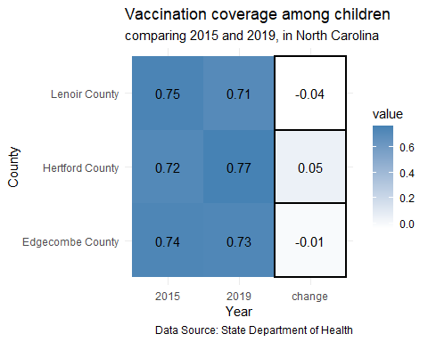

# Covid vaccination among adults

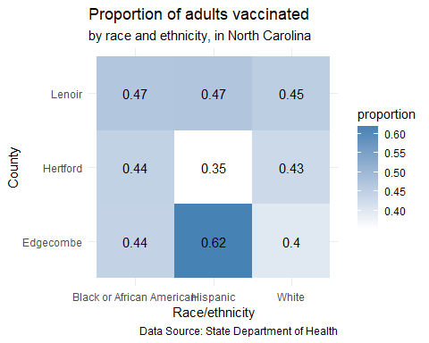

# County rankings

