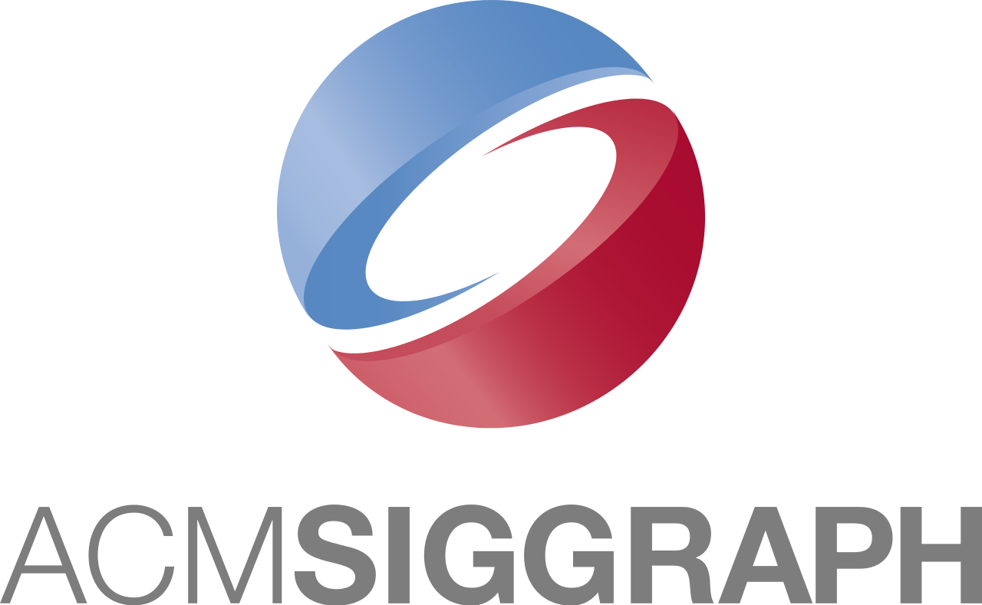



Francisco Teigas Ferra Inácio



I'm a technical leader and entrepreneur with a PhD in computer science, specialized in rendering, who has led projects to launch in both the games and the web3 industries. I have 12+ years of experience programming games and game engines in C++, including commercial work with Unreal Engine, 2 years of experience developing smart contracts for Cosmos, and 4+ years of technical leadership.
Contact & Personal Details
Location: | Vancouver, BC, Canada  (willing to relocate and work remotely) | Phone Number: | +12363347740
Location: |  | Website: | www.drcisco.com (portfolio)
E-mail: | francisco@drcisco.com | Driving License: | Full (clean)
Credited: | Elite Dangerous, Planet Coaster, Jurassic World Evolution, Squad
Work Experience
Date | Occupation | Employer
11/2021 – now | CTO & Co-Founder: Neptune Finance, Smart Contracts in Rust | Cryptech, Canada
11/2018 – 11/2021 | Senior/Lead Engineer: UE4, networked ragdolls, core tech project owner, led Squad through release and after. | Offworld Industries, Canada
12/2017 – 11/2018 | Software Engineer: Rendering and skeleton animation. Interim CTO. | Ososim, UK
11/2015 – 12/2017 | Engine/Render Programmer: DX12, XB1, PS4, engine and rendering. | Frontier Developments, UK
09/2012 – 05/2015 | Lab Demonstrator: Instructing BSc/MSc students in C++ and graphics. | University of Hull, UK
Education & Training
Date | Title | Institution | Results
2012-2017 | PhD in Interactive Computer Graphics | University of Hull, UK | Finished
- “Reducing Geometry-Processing Overhead for Novel Viewpoint Creation” SIGGRAPH 2015

2011-2012 | MSc in Games Programming | University of Hull, UK | Distinction
2008-2011 | BSc in Computer Science | NOVA University of Lisbon, Portugal | 16 of 20
Skills & Competences
Languages | - English (fluent) | - Portuguese (fluent) | - Spanish (fluent) | - French (basic)
Platforms | - Windows | - Xbox One | - PS4 & Cell (PS3) | - Linux & OSX
Fields | - Computer Graphics | - Physics | - Networking | - Unreal Engine 4
Fields | - Cross-Platform | - Software Engineering | - Algorithm Analysis | - Compilers
Fields | - Artificial Intelligence | - Multi-threading | - Smart Contracts | - Research & Dev
Proficiency | C++, C#, C, Java, Rust, GLSL, HLSL, Cg, Typescript, Python, Jam, Prolog, HTML5, CSS3  OpenGL, DX11, DX12, CosmWasm
Workflow | - Excellent task organisation and planning skills, through sprint planning, planning poker, creation of roadmaps, retrospectives and use of task management systems like JIRA, Notion, Linear, and Trello  - Proven ability to meet deadlines and work under pressure  - Version control experience in large shared code bases (SVN, P4, Git) and build systems (TeamCity)
Technical | - Blockchain and smart contract development experience  - Cross-platform game engine programming experience (PS3, XB1, PS4, OSX and PC) and UE4  - Affinity and interest for solving problems and for abstract and top level thinking  - Experience with resource compilation in various formats for models, rigging and animation.
Soft Skills | - Entrepreneurship and startup founding experience including fundraising and investor relations  - Peer-recognized leadership and motivational skills  - Great communication skills, including teaching and public presentations (SIGGRAPH 2015 Poster)
Achievements
Date | Description
2012 | Awarded a PhD scholarship at University of Hull
2011 | Best final year undergraduate project by Opensoft and offered a merit scholarship

